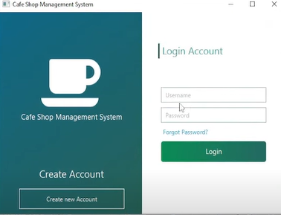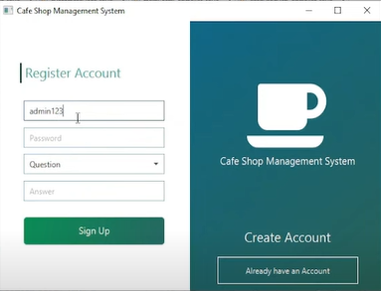

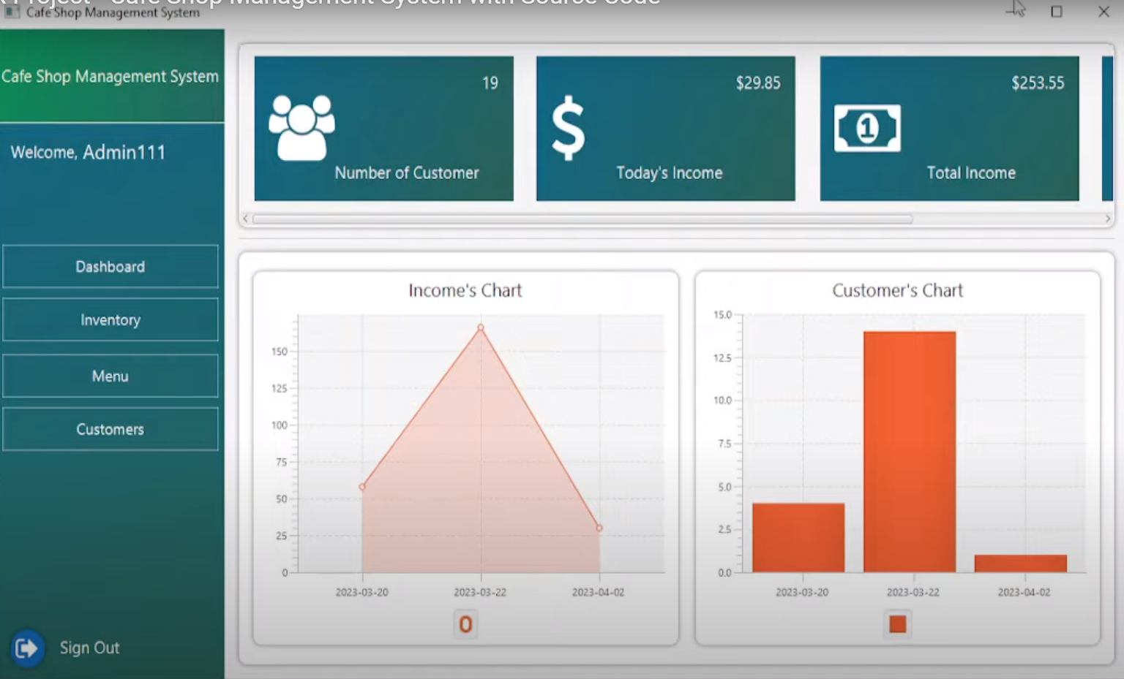

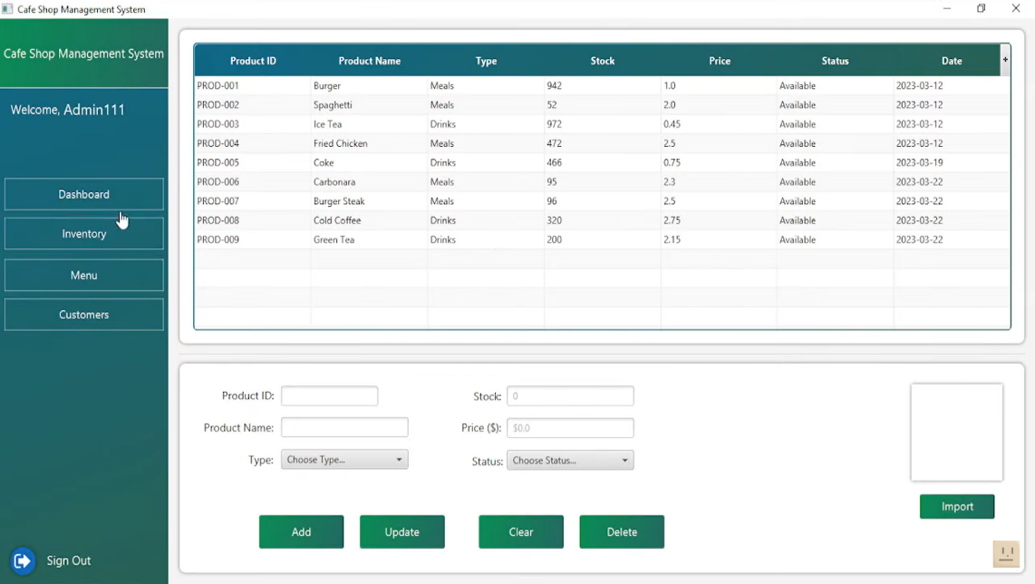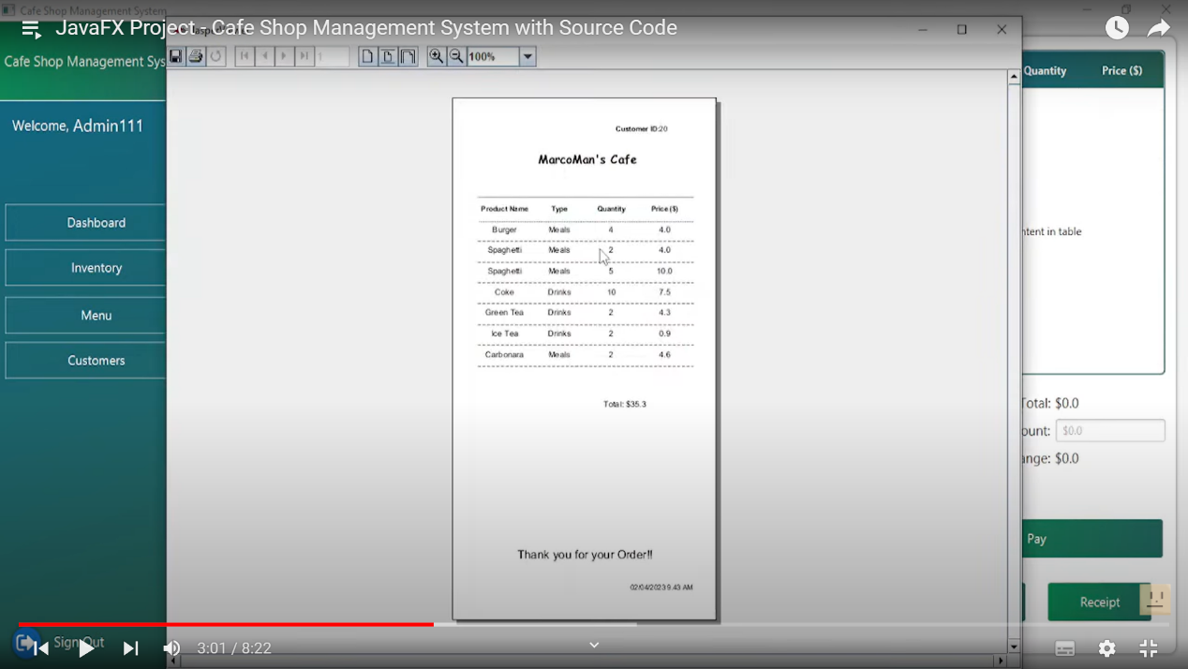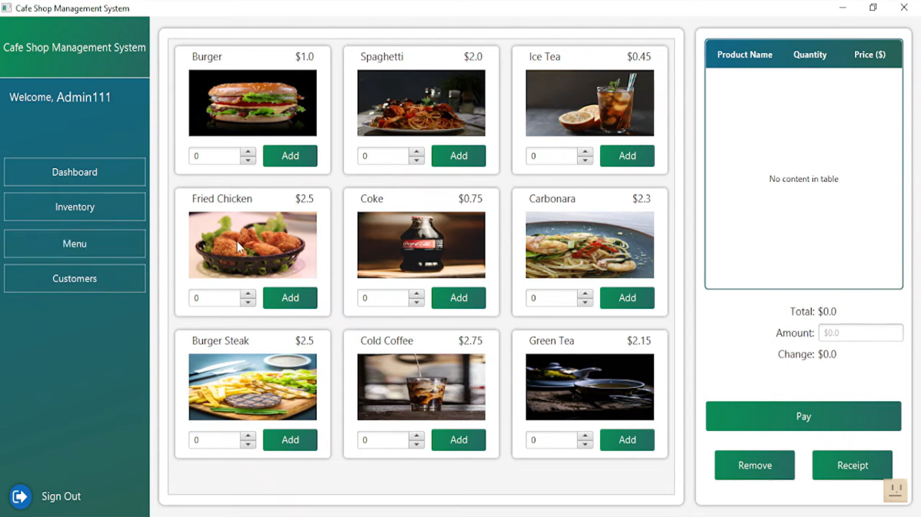

// Create a dialog to show the receipt

Dialog<String> dialog = new Dialog<>();

dialog.setTitle("Receipt");

// Set up a VBox for the receipt layout with proper padding and spacing

VBox receiptLayout = new VBox(5);

receiptLayout.setAlignment(Pos.TOP_CENTER); // Align to the top center for the header

receiptLayout.setPadding(new Insets(10, 10, 10, 10));

receiptLayout.setStyle("-fx-font-family: 'Courier New'; -fx-font-size: 10pt;");

// Add header with restaurant information centered

Text headerText = new Text("Big Bite Restaurant\n123, Jalan 123, One Heights,\nJohor, Malaysia\nTEL : 123456789\n\n");

headerText.setTextAlignment(TextAlignment.CENTER);

receiptLayout.getChildren().add(headerText);

// Use a TextFlow to achieve left and right alignment on the same line for the table and pax info

TextFlow infoFlow = new TextFlow();

Text tableText = new Text("Table: 1 ");

Text paxText = new Text("Pax: 4\n");

infoFlow.getChildren().addAll(tableText, paxText);

infoFlow.setTextAlignment(TextAlignment.CENTER); // Center the table and pax info

receiptLayout.getChildren().add(infoFlow);

// Add a separator line

receiptLayout.getChildren().add(new Text("----------------------------------------\n"));

// Calculate the longest product name length for alignment

int maxNameLength = orderItems.stream().mapToInt(item -> item.getProductName().length()).max().orElse(0);

// Add each item to the receipt

for (OrderItem item : orderItems) {

String formattedItem = String.format("%-" + maxNameLength + "s x%-2d %7.2f\n", item.getProductName(), item.getQuantity(), item.getPrice());

receiptLayout.getChildren().add(new Text(formattedItem));

}

// Add subtotal, service charge, and tax lines

double subtotal = orderItems.stream().mapToDouble(item -> item.getPrice() * item.getQuantity()).sum();

double serviceCharge = subtotal * 0.10; // Assuming 10% service charge

double tax = subtotal * 0.06; // Assuming 6% tax

double total = subtotal + serviceCharge + tax;

String subtotalLine = String.format("SUBTTL%29.2f\n", subtotal);

String serviceChargeLine = String.format("10%% SVC CHG%26.2f\n", serviceCharge);

String taxLine = String.format("6%% GOVT TAX%27.2f\n", tax);

String totalLine = String.format("TTL%32.2f\n", total);

// Cash and change assuming static values for example

double cashGiven = 120.00;

double change = cashGiven - total;

String cashLine = String.format("CASH%31.2f\n", cashGiven);

String changeLine = String.format("CHANGE%28.2f\n", change);

// Add a separator line before the totals

receiptLayout.getChildren().add(new Text("----------------------------------------\n"));

// Add the totals text to the layout

receiptLayout.getChildren().addAll(

new Text(subtotalLine),

new Text(serviceChargeLine),

new Text(taxLine),

new Text("----------------------------------------\n"),

new Text(totalLine),

new Text(cashLine),

new Text(changeLine)

);

// Footer centered

TextFlow footerFlow = new TextFlow();

DateTimeFormatter dateFormatter = DateTimeFormatter.ofPattern("dd/MM/yyyy");

DateTimeFormatter timeFormatter = DateTimeFormatter.ofPattern("HH:mm:ss");

Text footerText = new Text(String.format("Date: %s Time: %s\n", LocalDate.now().format(dateFormatter), LocalTime.now().format(timeFormatter)));

footerFlow.getChildren().add(footerText);

footerFlow.setTextAlignment(TextAlignment.CENTER);

receiptLayout.getChildren().add(footerFlow);

// Add button to close the dialog

ButtonType closeButton = new ButtonType("Close", ButtonBar.ButtonData.CANCEL_CLOSE);

dialog.getDialogPane().getButtonTypes().add(closeButton);

// Set the content for the dialog

dialog.getDialogPane().setContent(new ScrollPane(receiptLayout));

// Show the dialog

dialog.showAndWait();