**Appendix I. Regression Analysis**

|  |  |  |
| --- | --- | --- |
| **New York** | | |
| **Variables** | **Coefficient** | **Sig** |
| (Intercept) | 2.446e+02 | *** |
| **Room type** |  |  |
| Private room | -1.067e+02 | *** |
| Shared room | -1.439e+02 | *** |
| **Neighbourhood group** |  |  |
| Brooklyn | 3.109e+01 | *** |
| Manhattan | 8.301e+01 | *** |
| Queens | 1.197e+01 | *** |
| Staten Island | -4.717e+00 |  |
| **Bedrooms** | 3.694e+01 | *** |
| **Property type** |  |  |
| Apartment | -1.832e+02 | *** |
| Bed and breakfast | -1.739e+02 | *** |
| Boat | -1.959e+02 | *** |
| Boutique hotel | -8.135e+01 | * |
| Bungalow | -1.843e+02 | *** |
| Cabin | -2.066e+02 | *** |
| Camper/RV | -3.125e+02 | *** |
| Castle | -1.950e+02 | ** |
| Condominium | -1.580e+02 | *** |
| Cottage | -1.269e+02 | ** |
| Earth house | -1.772e+02 | * |
| Guest suite | -1.925e+02 | *** |
| Guesthouse | -2.018e+02 | *** |
| Hostel | -1.863e+02 | *** |
| Hotel | -1.603e+02 | *** |
| House | -1.808e+02 | *** |
| Houseboat | -1.034e+02 |  |
| Loft | -1.419e+02 | *** |
| Nature lodge | -1.601e+02 | * |
| Other | -1.756e+02 | *** |
| Resort | -7.214e+01 |  |
| Serviced apartment | -1.411e+02 | *** |
| Tent | -1.086e+02 |  |
| Tiny house | -1.837e+02 | *** |
| Townhouse | -1.782e+02 | *** |
| Treehouse | -2.041e+02 | ** |
| Villa | -1.544e+02 | *** |
| **Guests included** | 9.406e+00 | *** |
| **Cancellation policy** |  |  |
| Moderate | 3.080e+00 | * |
| Strict | -4.588e+01 |  |
| Strict with 14 days grace period | 1.638e+01 | *** |
| Super strict 30 | 1.915e-01 |  |
| Super strict 60 | 1.454e+02 | *** |
| **Total listings count** | 9.734e-02 | *** |
| **Number of reviews** | -1.385e-01 | *** |
| **Scores rating** | 6.111e-01 | *** |
| **Host is superhost** | 3.635e+00 | *** |
| **Host response time** |  |  |
| Within a day | 2.036e+00 |  |
| Within a few hours | 1.186e+00 |  |
| Within an hour | -1.788e+00 |  |
| **Extra people** | 7.698e-02 | *** |

|  |  |  |
| --- | --- | --- |
| **Singapore** | | |
| **Variables** | **Coefficient** | **Sig** |
| (Intercept) | 1.026e+02 | *** |
| **Room type** |  |  |
| Private room | -8.654e+01 | *** |
| Shared room | -1.516e+02 | *** |
| **Bedrooms** | 4.060e+01 | *** |
| **Extra people** | 6.746e-01 | *** |
| **Host is superhost** | 2.912e+01 | *** |
| **Guests included** | 1.245e+01 | *** |
| **Total listings count** | -1.668e-01 | *** |
| **Number of reviews** | -1.644e-01 | *** |
| **Neighbourhood group** |  |  |
| East Region | -1.025e+01 | * |
| North Region | -3.236e+01 | *** |
| North-East Region | -2.493e+01 | *** |
| West Region | -1.655e+01 | *** |
| **DayDiif reviews** | 1.400e-02 | ** |
| **Scores rating** | 2.799e-01 | ** |
| **Host response time** |  |  |
| Within a day | 8.947e-01 |  |
| Within a few hours | 4.160e+00 |  |
| Within an hour | -1.746e+00 |  |

**Appendix II. Residuals Analysis**

**Singapore**

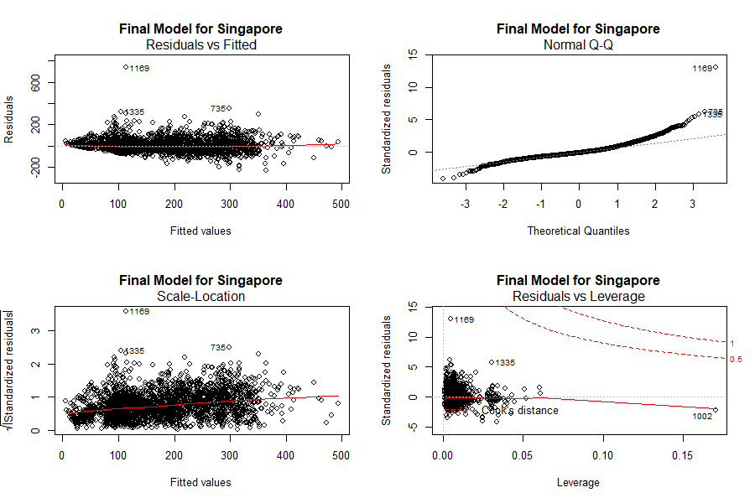

Figure 1. Residuals Analysis for Singapore data

**New York**

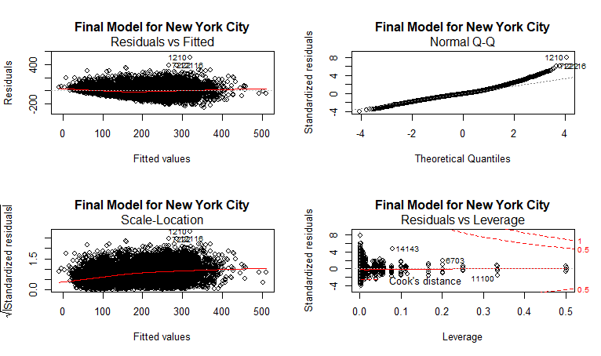

Figure 2. Residuals Analysis for New York data