KIANDA SCHOOL
Admissions Portal
Administrator User Manual
Version 1.0 | May 2026

Prepared by Ecorenet Business Solutions | For Internal Use Only

1. Introduction

The Kianda School Admissions Portal is a purpose-built digital platform that manages the complete student admission lifecycle, from the moment a parent submits an application to the final acceptance decision. This manual is intended for school administrators and staff who will operate the system.

By the end of this guide, you will be able to:
- Configure and manage academic cycles (application windows).
- Create and maintain grade-level settings, vacancies, and assessment structures.
- Review, filter, and act on student applications.
- Export and import assessment score sheets to and from teachers.
- Schedule and record interviews for shortlisted candidates.
- Upload process documents (joining instructions, fee structures, etc.) for parents.

1.1 Navigating the Portal
The left-hand sidebar provides access to all major sections of the admin portal. The sidebar can collapse using the arrow icon at the top-right of the panel. The sections are:

Dashboard | High-level KPIs, charts, and recent application activity.
Applications | The master list of all student applications with filtering and bulk actions.
Grade Management | Configure grade levels, vacancy spots, assessment dates, and assessment criteria.
Assessments | The Assessment Book — export blank grading sheets and imports completed scores.
Interviews | Schedule and manage oral interviews for shortlisted candidates.
Process Documents | Upload PDF documents (joining instructions, fee structures) visible to parents.

2. Admission Cycles

An Admission Cycle defines the academic year window during which parents can submit applications on the public portal. You must have at least one active cycle for the portal to accept applications.

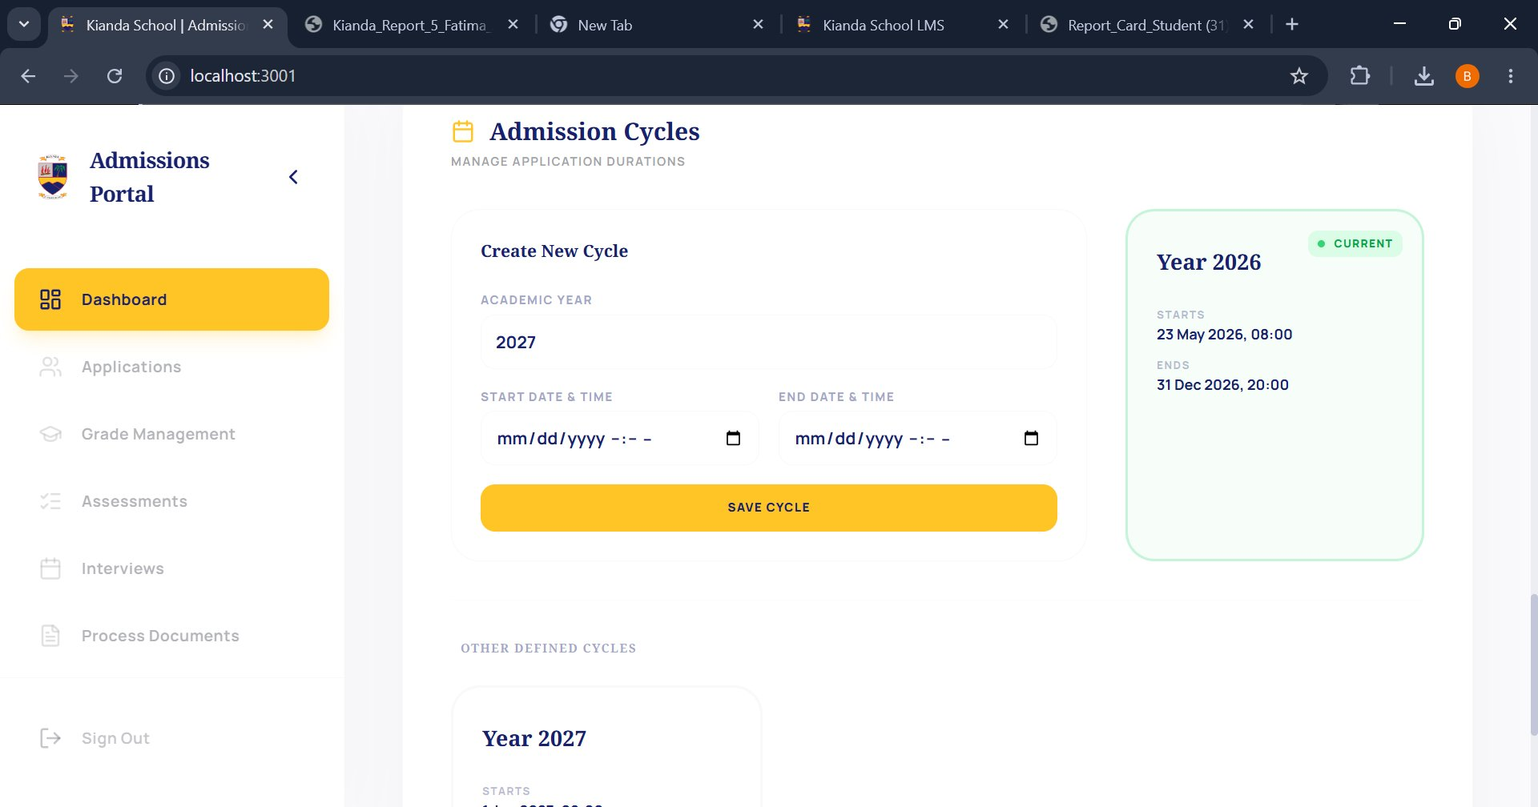
Figure: Admission Cycles page — create and manage academic year windows

2.1 Understanding the Cycles Page
The page is split into two areas:
- Create New Cycle form (left/center) where you define a new academic year window.
- Current Cycle card (top right, green badge) always shows the active cycle briefly.
- Other Defined Cycles (below the form) list all previously created cycles.

2.2 Creating a New Admission Cycle

1 | Set the Academic Year  The Academic Year field auto-increments from the current year. Adjust it if needed (e.g. type '2027' for the next intake year).

2 | Set the Start Date & Time  Click the calendar icon next to the START DATE & TIME field and select the date and time when the application portal should open to parents.

3 | Set the End Date & Time  Click the calendar icon next to the END DATE & TIME field. This is when the application window closes. Parents will not be able to submit new applications after this point.

4 | Save the Cycle  Click the yellow SAVE CYCLE button. The new cycle will appear in the 'Other Defined Cycles' list below. If the start date is now or in the past and no other cycle is current, it will automatically become the current cycle.

💡 Tip
Only one cycle can be 'current' at a time. Once a cycle is created, its academic year cannot be changed. If you need to correct a mistake, delete the cycle and recreate it — but only if no applications have been submitted under it yet.

3. Grade Management

Grade Management is the configuration hub for each intake. Here you define which grades are open, how many students can be admitted, where assessments will take place, and what subjects will be tested.

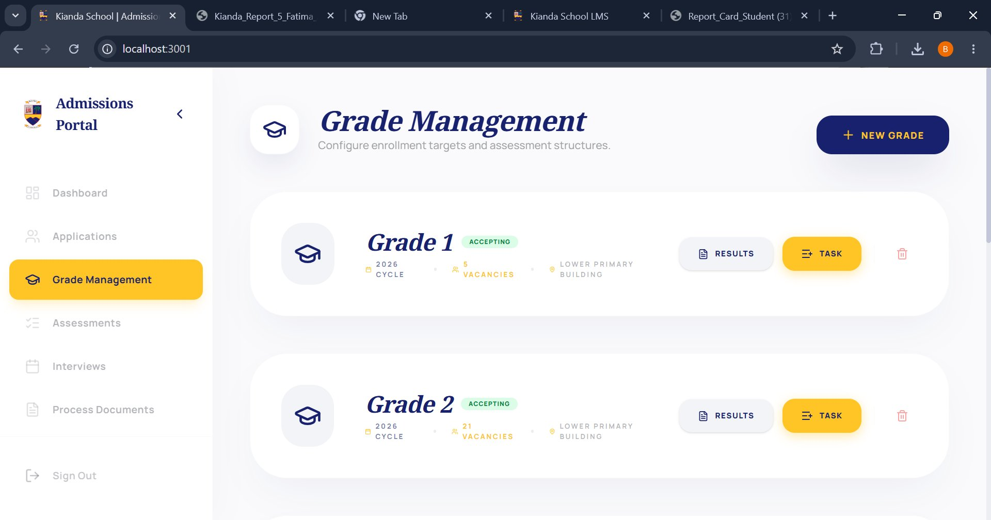
Figure: Grade Management — view of configured grade intake cards

3.1 Reading a Grade Card
Each grade is displayed as a card showing:
- Grade Name (e.g. Grade 1, Grade 2) in large italic text.
- ACCEPTING badge (green) visible when the grade is open for applications on the public portal.
- Cycle — the academic year this grade belongs to (e.g. 2026).
- Vacancies — the maximum number of students that can be admitted.
- Venue — the building or location of the institutional assessment.
- RESULTS button — view assessment scores for this grade's applicants.
- TASK button — opens the grade configuration drawer to edit all settings.

3.2 Creating a New Grade

1 | Click '+ NEW GRADE'  Located at the top right of the Grade Management page. A drawer or modal will open.

2 | Enter the Grade Name  Type the grade level, e.g. 'Grade 3', 'PP1', or 'Grade 10'.

3 | Assign to an Academic Cycle  Select the academic year this grade's intake belongs to from the dropdown.

4 | Set Vacant Enrollment Spots  Enter the maximum number of students you are willing to accept for this grade.

5 | Set Assessment Date & Venue  Enter the date of the institutional assessment and the physical venue (e.g. 'Lower Primary Building').

6 | Toggle Accepting Applications  Switch this on to make the grade visible and open to applications on the parent-facing portal. You can turn this off at any time to pause applications for this grade only.

7 | Save  Click Save. The new grade card will appear on the Grade Management page.

3.3 Adding Assessment Criteria to a Grade
Assessment criteria define the subjects or areas that students will be tested on during the institutional exam (e.g. Mathematics, English, Kiswahili).

1 | Open the Grade  Click the TASK button on the relevant grade card to open the configuration drawer.

2 | Navigate to the Assessment Builder section  Scroll down within the drawer to find the assessment criteria list.

3 | Add a Criterion  Click '+ Add Assessment'. Enter the subject name (e.g. 'Mathematics') and the Max Marks (e.g. 100).

4 | Repeat for all subjects  Add as many criteria as needed. These will become columns in the exported grading sheet.

5 | Save  Save the drawer. The criteria are now tied to this grade and will appear in the Assessment Book.

💡 Tip
Max Marks is important — the system will reject any imported score that exceeds this value. Set it carefully before distributing the grading sheet to teachers.

4. Applications

The Applications page is the master list of every student submission in the system. From here you can search, filter, review, and act on individual or multiple applications.

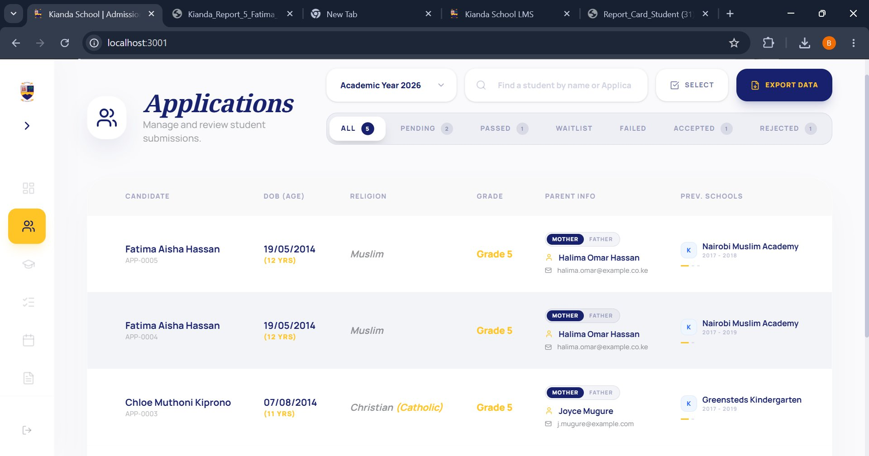
Figure: Applications page — master list with filtering by status and academic year

4.1 Understanding the Application List
Each row in the list displays:
- Candidate — student name and unique Application ID (e.g. APP-0005).
- DOB (Age) date of birth and calculated age at time of application.
- Religion — as provided by the parent during application.
- Grade — the grade level the student is applying for, highlighted in amber.
- Parent Info — primary contact (Mother or Father tag) with name and email.
- Prev. Schools — most recent previous school with the years attended.

4.2 Filtering Applications
Three filter tools are available at the top of the page:
- Academic Year dropdown (top left) switch between intake years to see applications from previous cycles.
- Search bar — type a student name or Application ID for instant results.
- Status tabs — click ALL, PENDING, PASSED, WAITLIST, FAILED, ACCEPTED, or REJECTED to filter the list to that status only. The number badge on each tab shows the count.

4.3 Opening an application
Click on any candidate row to open the full Application Details view. From there you can:
- Review all personal, parent, sibling, and medical information submitted.
- View uploaded documents (birth certificate, report cards, passport photo).
- See assessment results if the student has been graded.
- Manually change the application status using the action buttons: Mark as Reviewed, Accept, Reject, or Waitlist.

4.4 Exporting Application Data
1 | Apply your filters  Filter by academic year and/or status so that only the applications you need are visible.

2 | Click 'EXPORT DATA'  The dark blue button at the top right opens the export modal.

3 | Choose export format  Select ZIP Archive (individual PDF dossiers per candidate) or Excel Spreadsheet (flat file with all structured data fields).

4 | Download  Click Export/Download. Your browser will save the file.

💡 Tip
Use the Excel export for bulk data analysis (e.g. feeding into fee management or the LMS). Use the ZIP/PDF export when you need printable candidate dossiers for review committees.

5. Assessments — The Assessment Book

The Assessment Book is the bridge between the digital portal and the physical exam process. It allows you to export a blank grading sheet to teachers and then import the completed marks back into the system, triggering automated pass/fail notifications to parents.

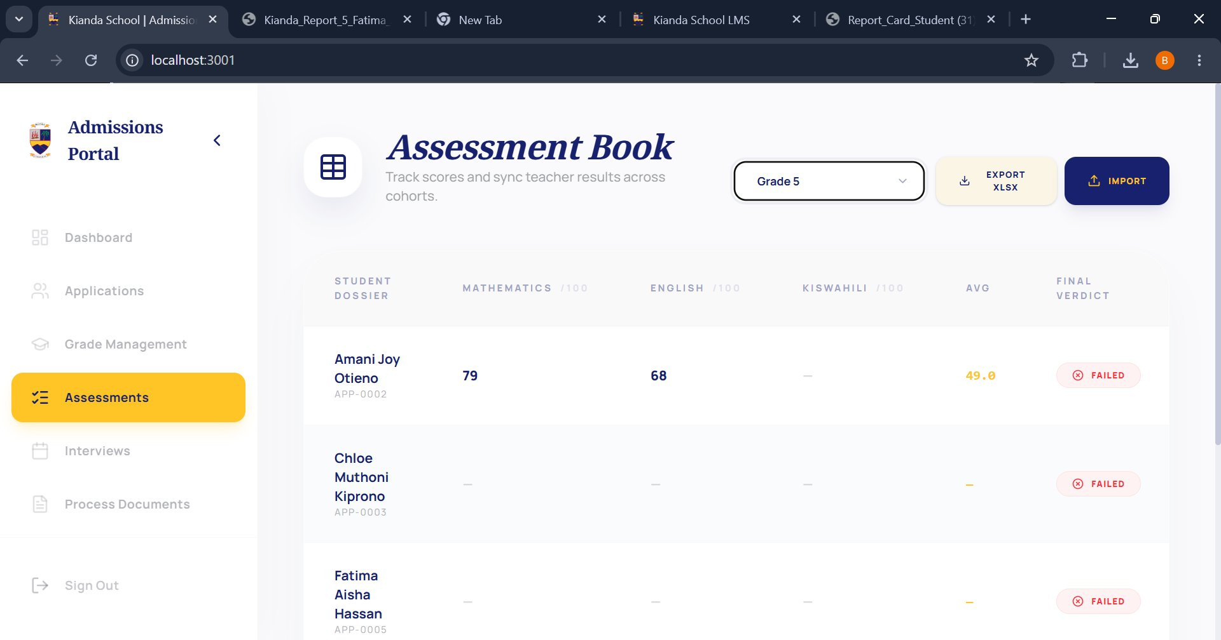
Figure: Assessment Book — candidate scores per subject with Export and Import controls

5.1 Reading the Assessment Book
Select a grade from the dropdown at the top of the page. The table will display:
- Student Dossier — candidate name and Application ID.
- One column per assessment criterion (e.g. MATHEMATICS /100, ENGLISH /100, KISWAHILI /100).
- AVG — the average score across all subjects (highlighted in amber if below passing threshold).
- Final Verdict — PASSED (green) or FAILED (red badge) based on the Qualified (Y/N) field in the imported sheet.
A dash (-) in a score column means the mark has not yet been recorded.

5.2 Workflow: Exporting Grading Sheet

1 | Select the target Grade  Use the grade dropdown at the top of the Assessment Book page.

2 | Click 'EXPORT XLSX'  The system generates an Excel file containing all active applicants for the selected grade. Columns are created automatically for each assessment criterion you defined in Grade Management, plus a final 'Qualified (Y/N)' column.

3 | Distribute to teachers  Print the sheet or share the Excel file with the teaching staff responsible for conducting the assessments.

5.3 Workflow: Importing Completed Scores

1 | Receive the completed sheet from teachers  Teachers fill in each student's marks and the Qualified (Y/N) column (Y = passed, N = failed) in the Excel file.

2 | Click 'IMPORT'  The dark blue Import button is at the top right of the Assessment Book page.

3 | Upload the complete Excel file  Select the file from your computer. The system validates every score against the defined Max Marks — any score exceeding the maximum will be flagged as an error.

4 | Review the summary  The import preview shows how many students Passed (Qualified = Y) and how many Failed (Qualified = N). Check these numbers before confirming.

5 | Confirm the sync  Click Confirm/Sync. The system maps all scores to the database and automatically sends email notifications to parents informing them whether their child passed or failed the assessment.

⚠ Warning
Do not modify the Application ID column or the column headers in the exported Excel file. The import process uses these to match rows to the correct candidates. Altering them will cause imports to fail.

📋 Note
If a parent reports not receiving their notification email, check their email address in the Application Details view for typos before re-triggering notifications.

6. Interviews

The Interviews section manages the final stage of the admissions process — oral interviews for candidates who have passed the assessment phase. You can schedule interviews, record outcomes, and make the final admission decision here.

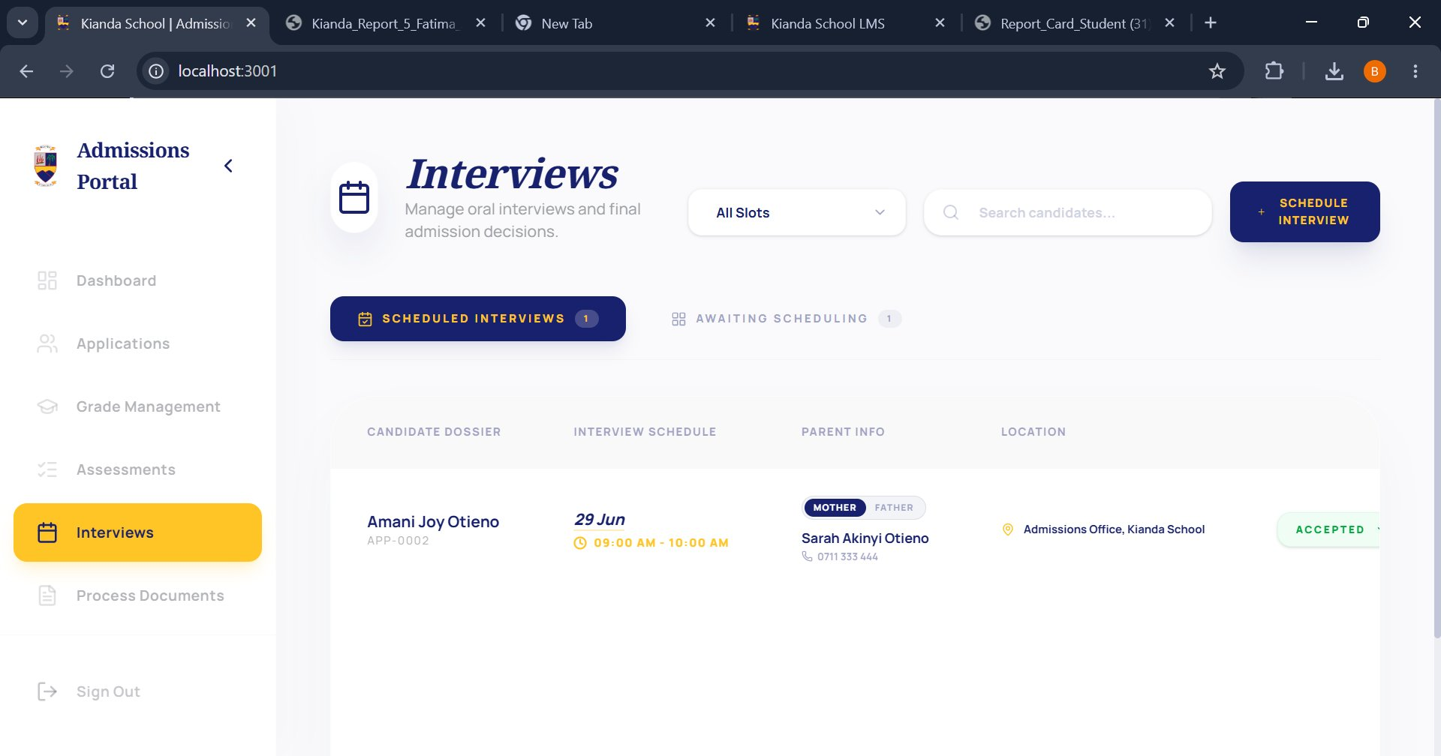
Figure: Interviews page — scheduled interviews with candidate, time, parent contact and status

6.1 Reading the Interviews Page
The page has two tabs:
- Scheduled Interviews — candidates who have been assigned an interview slot (date, time, and venue).
- Awaiting Scheduling — candidates who have passed assessments but have not yet been given an interview slot.
Each row in the Scheduled Interviews tab shows:
- Candidate Dossier — student name and Application ID.
- Interview Schedule — date (e.g. 29 Jun), time slot (e.g. 09:00 AM – 10:00 AM).
- Parent Info — the primary contact (Mother/Father tag), name, and phone number.
- Location — the interview venue (e.g. Admissions Office, Kianda School).
- Status badge — e.g. ACCEPTED (green), PENDING.

6.2 Scheduling an Interview
1 | Click the 'Awaiting Scheduling' tab  This shows all candidates who are ready to be interviewed.

2 | Click '+ SCHEDULE INTERVIEW'  The button is at the top right. A scheduling form will open.

3 | Select the Candidate  Search for the candidate by name or Application ID.

4 | Set Date and Time  Choose the interview date and start/end time.

5 | Set Venue  Enter the interview location (e.g. 'Admissions Office, Kianda School').

6 | Assign an Interviewer  Select or type the name of the staff member conducting the interview.

7 | Save  Click Save. The candidate moves from 'Awaiting Scheduling' to 'Scheduled Interviews'. An optional email notification can be sent to the parent at this point.

6.3 Recording Interview Outcomes
1 | Locate the candidate  Find them in the Scheduled Interviews tab.

2 | Open the interview record  Click on the candidate row or the action button.

3 | Enter interview notes  Record observations from the interviewer in the notes field.

4 | Set the final decision  Select Accept, Reject, or Waitlist. This updates the application status across the entire portal.

5 | Save  The status badge on the interviews list will update immediately.

📋 Note
Accepted status set here will also be reflected in the Applications list and the applicant's parent-facing dashboard. The parent will receive an acceptance notification automatically.

7. Process Documents

The Process Documents section is a document repository where administrators upload official files that guide parents and accepted students through the next steps. Examples include joining instructions, fee structures, and class schedules.

7.1 Uploading a Document
1 | Navigate Process Documents  Click 'Process Documents' in the left sidebar.

2 | Click '+ Upload Document' or the equivalent action button  A form or modal will open.

3 | Enter Document Title  Give the document a clear name, e.g. 'Grade 1 Joining Instructions 2026'.

4 | Select the Category  Choose from: Joining Instructions, Application Procedure, Fee Structure, Class Schedule, Medical Forms, General, or Other.

5 | Select Target Grade(s)  Choose which grade level(s) this document applies to or select 'All Classes' for school-wide documents.

6 | Select Academic Year  Choose the year this document is relevant to.

7 | Upload the PDF file  Click the file upload area and select the PDF from your computer (max 10 MB).

8 | Set Visibility  Toggle 'Visible to Applicants' to Yes if you want accepted parents to be able to view and download this document from their dashboard.

9 | Save  Click Save. The document is now stored and will appear in the document list.

💡 Tip
Documents set to Visible = Yes will automatically appear on the parent dashboard for accepted applicants whose child's grade matches the Target Grade you selected. Make sure you set visibility to Yes only when the document is final and ready for parents.

7.2 Managing Existing Documents
The document list shows all uploaded files. For each document you can:
- Download — click the download icon to view or save the PDF.
- Edit — update the title, category, target grade, or re-upload a revised file. Re-uploading increments the document version automatically.
- Toggle Visibility — quickly shows or hide the document from parents without opening the full edit form.
- Delete — removes the document permanently after a confirmation prompt (soft-delete; the file is archived).

8. End-to-End Workflow Summary

The table below summarizes the complete admissions workflow from setup to final decision, linking each task to the relevant system section.

# | Stage | Action | Where to do it
1 | Setup | Create Admission Cycle (year + dates) | Section 2 — Admission Cycles
2 | Setup | Create Grade levels, set vacancies & venue | Section 3 — Grade Management
3 | Setup | Add Assessment Criteria to each grade | Section 3.3 — Assessment Builder
4 | Setup | Upload Process Documents for parents | Section 7 — Process Documents
5 | Applications | Toggle 'Accepting Applications’ per grade | Section 3 — Grade Management
6 | Applications | Monitor incoming applications and filter by status | Section 4 — Applications
7 | Applications | Review individual applications; mark as Reviewed | Section 4.3 — Application Details
8 | Assessment | Export blank grading sheet (XLSX) for teachers | Section 5.2 — Export
9 | Assessment | Import completed scores; system emails parents | Section 5.3 — Import
10 | Interviews | Schedule interviews for passing candidates | Section 6.2 — Scheduling
11 | Interviews | Record interview outcome and set final decision | Section 6.3 — Outcomes
12 | Post-Admission | Set accepted applicants; parents receive notification | Section 6.3

Kianda School Admissions Portal — Administrator User Manual | Version 1.0 | May 2026
Prepared by Ecorenet Business Solutions | Confidential — For Internal Use Only

