Plots in R

Brandon Gonzalez

January 24, 2018

# Class 05 R graphics intro   
  
#My first boxplot  
x <- rnorm(1000,0)  
boxplot(x, horizontal = TRUE)

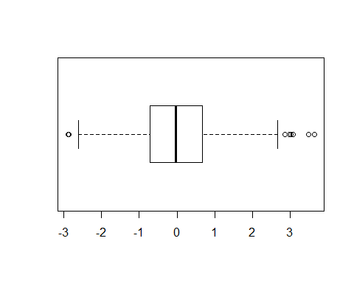

#get summary of x  
summary(x)

## Min. 1st Qu. Median Mean 3rd Qu. Max.   
## -2.89431 -0.71768 -0.02951 -0.01315 0.67607 3.64357

hist(x)

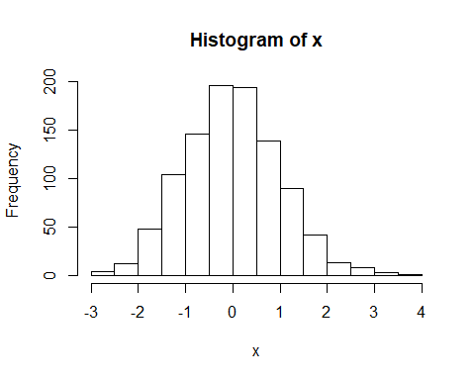

#Hands on session 1  
df_weight <- read.table("./bimm143_05_rstats/weight_chart.txt", header=TRUE)  
plot(df_weight, typ="b", pch=15, cex=1.5, lwd=2, xlab="Age (months)", ylab="Weight (kg)", main="Age and Wt",   
 ylim=c(2,10), col="blue" )

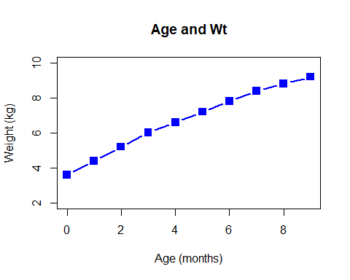

#Barplot with feature counts  
df_featureCounts <- read.table("./bimm143_05_rstats/feature_counts.txt",sep='\t', header=TRUE)  
barplot(height = df_featureCounts$Count,names.arg =df_featureCounts$Feature, horiz=TRUE,  
 main ="Feature Counts", las=1, xlab="Expression", mar=c(7,5,5,3))

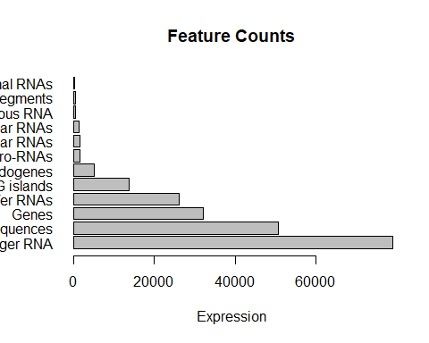

#histogram?  
hist(rnorm(10000), rnorm(10000)+4, breaks=20, col=heat.colors(20))

## Warning in if (freq) x$counts else x$density: the condition has length > 1  
## and only the first element will be used

## Warning in if (!freq) "Density" else "Frequency": the condition has length  
## > 1 and only the first element will be used

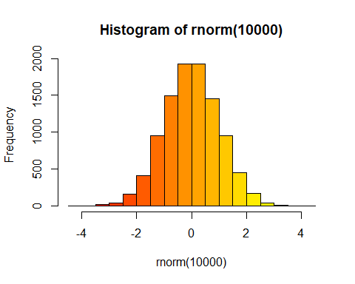

#  
df_maleFemaleCounts <- read.table("./bimm143_05_rstats/male_female_counts.txt",  
 header = TRUE, sep='\t')  
barplot(df_maleFemaleCounts$Count, col = cm.colors(nrow(df_maleFemaleCounts)),  
 ylab="Counts", las=2, names.arg = df_maleFemaleCounts$Sample)

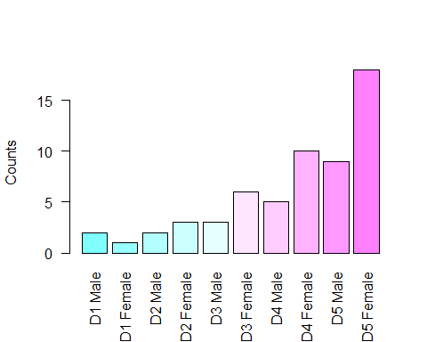

#changing margin so we can see labels  
par(mar=c(5.1,10,4.1,2.1))  
  
#Coloring by value  
df_upDown <- read.table("./bimm143_05_rstats/up_down_expression.txt", header = TRUE)  
palette(c("red","gray","green"))  
plot(df_upDown$Condition1, df_upDown$Condition2, col=df_upDown$State)

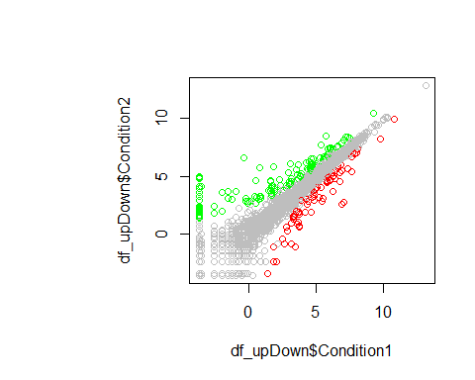

#coloring by density  
meth <- read.table("./bimm143_05_rstats/expression_methylation.txt",header=TRUE,sep='\t')  
#get indexes of expr greater than 0  
indexes <- meth$expression > 0  
#create custom colring based on density  
dcols.custom = densCols(meth$gene.meth[indexes], meth$expression[indexes], colramp=colorRampPalette(c("green2", "yellow","red2","purple2")))  
  
plot(meth$gene.meth[indexes], meth$expression[indexes], pch=20, col=dcols.custom)

