

CPS2002 – Assignment Report

B. Sc. (Hons) Computing Science



**Contents**

Github and Jenkins Links 1

CPS2002 Assignment – Part 2 1

UML Diagram 1

Implementation Design 2

Testing and Coverage. 6

User Manual 7

# Github and Jenkins Links

|  |  |
| --- | --- |
| Assignment Material | Link |
| GitHub | <https://github.com/brandonabela/CPS2002-Software-Engineering-Assignment> |
| Jenkins | <https://jenkins-ict.research.um.edu.mt/job/CPS2002-Software-Engineering-Assignment%20BA_DC/> |

# CPS2002 Assignment – Part 2

## UML Diagram

The below UML diagram shows all the classes used and the dependencies between each class. Till this part in the assignment, there was not any sort of inheritance needed. Although, it can be easily seen that the majority of the data is being stored in the class named **Game**.

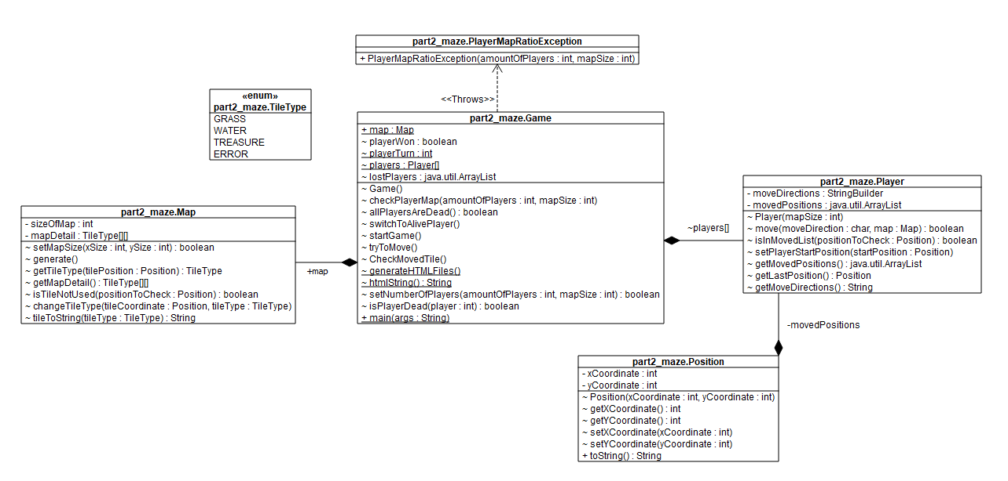

## Implementation Design

The **Game** class constructor first starts by asking the user to input the number of players and the size of the map. To verify that the user input was correct a method called **checkPlayerMap** was implemented to determine if it is a correct ratio between the number of players and the map size as seen below.

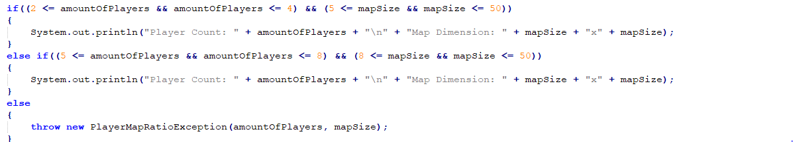

Based on the map to player ratio, a map was generated by using a method within the **Map** class called **generate**. The backend for the map generation is a two-dimensional array of type **TileType** which is an enumerator that contains all possible type of tiles. The generated map will mainly consist of green tiles, some water tiles, and 1 treasure tile. The amount of water tiles within the generated map is randomly generated, however, making sure that there is at least one path which the user can choose to reach the treasure.

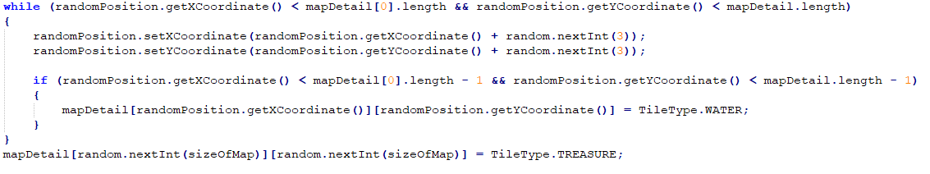

A number of players are created using the method called **setNumberOfPlayers** which can be found in the **Game** class. Every created player has a random starting position with the restriction that the random player position will be a grass tile, meaning that if the random starting position is a water tile or treasure tile the starting position of that player will change to a valid start position.

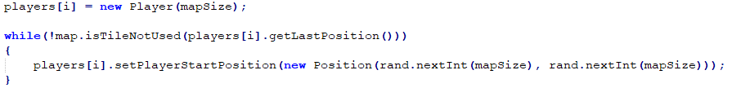

When the generated map and the players are created successfully the **startGame** method is called from the main method of the **Game** class. This illustrated method is responsible for choosing a random player to make the first move. The method continues looping until a player successfully finds the treasure within the randomly generated map.

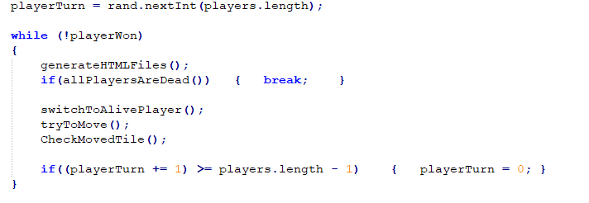

After a player has made a correct move a method is called which is responsible for generating the HTML for the current player who is playing the game. This is done by using the method **generateHTMLFiles** which creates an HTML file which can be found in the ‘**gameFiles**’ folder. A generated HTML file is generated for every player who is currently playing the game. The method which is responsible for generating the HTML makes used of a string builder to make sure each player views the tiles that were visited by the current player.

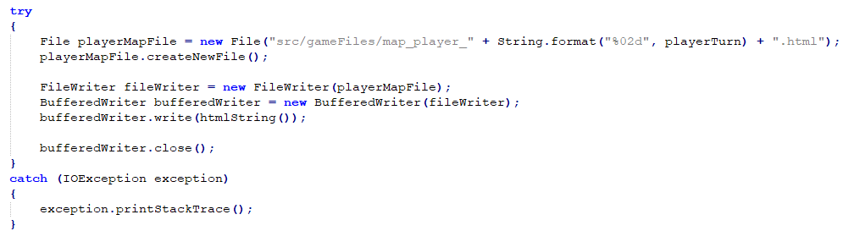

After the HTML file is generated the **startGame** method will make use of another method to check if all players are dead, if so the game stops. However, if the current player is dead the next player will be chosen to play. The **tryToMove** method takes input from the user and calls the **move** method within that player instance to change the current position. This method checks if the position requested is valid if this move is incorrect or not within the game map the method returns false. For example, when a player tries to move to the right bounds, this method makes sure that the current player does not attempt to go outside the game.

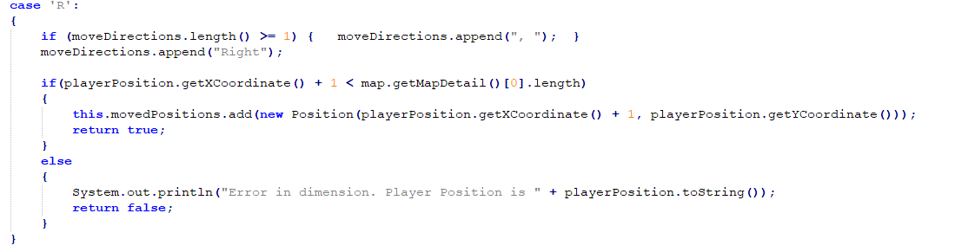

When the player performs a move the method **CheckMovedTile** in the **Game** class is used to check whether the new visited tile is a water tile or a treasure. If it is a water tile the player dies and cannot input any more moves. If the player wins the program notifies all the users that the current player won.

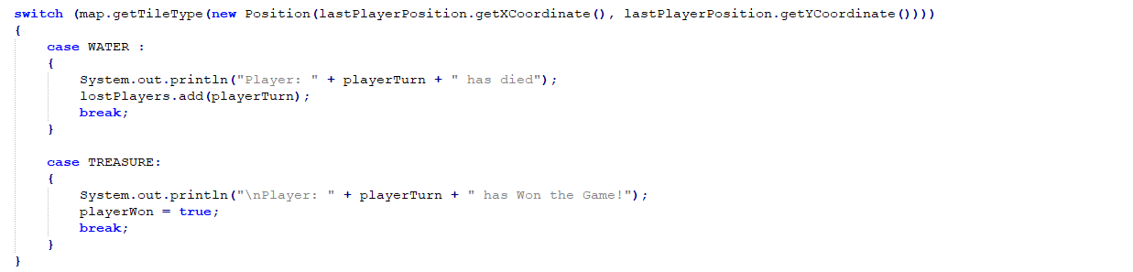

## Testing and Coverage.

All the main classes were successfully tested with a total of **58** tests were created which test different features of all the classes. The tests were separated by each individual class and can be found in the **part2_maze** folder in the test folder. Each test is labelled with the method used and output to generate. Each test class has a before and after method, however, the object created in the before method is not necessarily used within the test method. The amount of coverage in part 2 was **95%** for the methods and **96%** for the number of code lines.

The only method that was covered by the tested was the main method of the **Game** class since testing is generally not done for these types of methods. The main method only responsibility is creating an object for the class **Game** and calls the **startGame** method. In terms of lines, only the **IOException** of the method called **generateHTMLFiles** was not tested since the files were being constantly being created unlike when reading a file. Therefore, we could not lock the file stream buffer correctly to generate that exception.

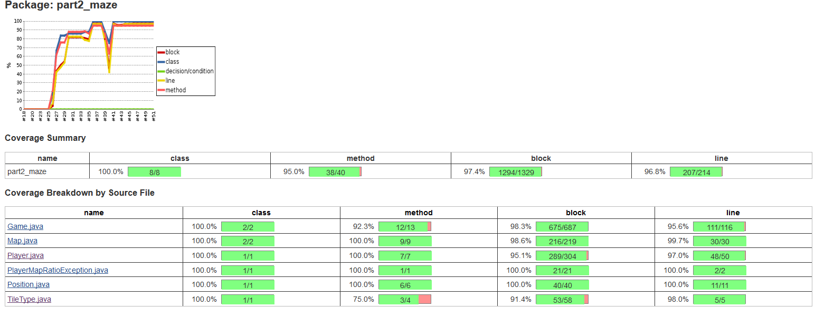

## User Manual

Initially, the user is asked for the number of players and the size of the generated map. If the inputs are incorrect the user re asked to enter these two values again and the program keeps on asking the user for the number of players and the map size until a valid input is made.

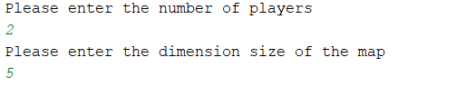

The game will choose a random player to make the first move hence, the program will request the user to input the direction where the player would like to move using the **U**, **D**, **L** and **R** keys.

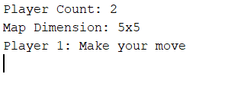

The user currently playing can see the HTML file and choose where to move next. If the input is incorrect the program will ask the user to input a valid direction to move.

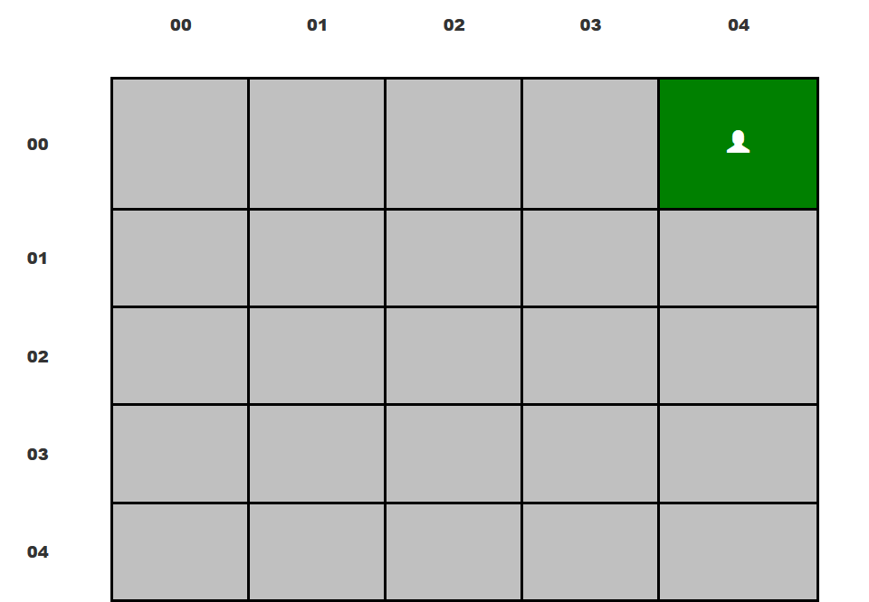

At the top of the generated HTML file, the player has the ability to view all the moves that were performed by the user including the attempted moves.



The game will ask the next player using a descending fashion. This process continues being done until one of the player successfully finds the treasure or until all the players die