Writing rules for the average dandy:
Webpages are made up of elements.

You can access those elements with selectors

Rules have 4 parts

- name
- having a name will allow you to reference it easily in your test cases
- type
- meta – property of the webbrowser, like what the url
- physical – property of the webpage, like what is contained in a named element
- selector
- the actual selector of the element
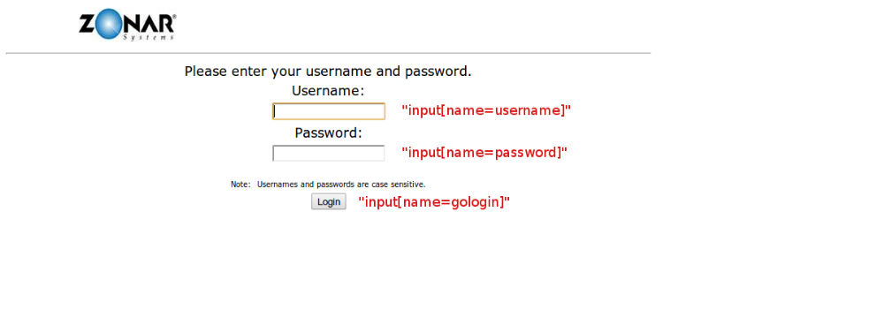
- what we will see to indicate an error
- what the webpage will tell us if there are errors, like “usernames must contain at least one number or special character”

A little more about the 2 types of the selectors
- META – a property of the webBROWSER, like thr url
- a good example of this would be the url=”...home.html” after clicking the home button
- PHYS – a property of the webSITE, like what is in an element
- a good example of this would be that usernames can be between 2-20 characters, so the rule would reference “#errorlog” for the selector.

The next step is to save your rule and use it in your test cases. Most likely you are working in a team, and should discuss naming conventions that work for you and your team. We suggest appending a very SHORT description of the rule to the webpage name (w/o the .html or .php).
Some examples
- login_userinvalidformat
- This would be for a username not following the expected format (like having 1 special character or number to proceed)
- home_usersettings
- this might describe that the user is able to get to the settings menu from the homepage of the website (this would be home.html, or home.php or just home)

Full examples of rules
NameTypeSelectorWhatlogin_userspchPHYS#errorlog liUsernames must contain one special characterlogin_passlengthPHYS#errorlog liPasswords must be between 2-20 characterscontinueMETAURL– test case def – settings_chpassMETAURL– test case def--settings_chemailPHYS#settings #emailFind out latersettings_chuserMETAURL– test case def – …

