WEB/APP PROTOTYPE

EDO ASSIGNMENT GROUP CB04-3

Lecturer: Lara Rojas, John J.G

members of Group 3

Duöng, Phuc G.P. s4321375

Igue, Fredrick O.F. s4387694

Lê, Anh Tuan A.T. s4399889

This is our group project for WEB/APP PROTOTYPE for traveling. Our idea is to make an application for travelers who want to enjoy their trip freely with only using an application packed with all needed information of designated destination. We also concern about our target users since it would be more efficient, doing so would benefit us more in long-term as we could develop optimally . Then, we will demonstrate our raw ideas with sketches and use them to build our very first prototype application interface and its usability. Finally, real-life feedback is the most crucial part of this project. Whether we should keep our design or not depends on this process.

As I mentioned, having a target users base is crucial. So we choose people who love to travel light, mostly young adult, as our main target. They could also adapt easily to any changes in technology and trends so we come to agree that building an application is a better choice.

These two personas represent two of many main target users in this project. One person prefers exploring city wonders, using mainly public transports and booking high-end hotel. The other person prefers cheaper hotel with Intercontinental breakfast, going to bars; clubs; and festival music concert.

This is when we decided to sketch our first idea about our application.

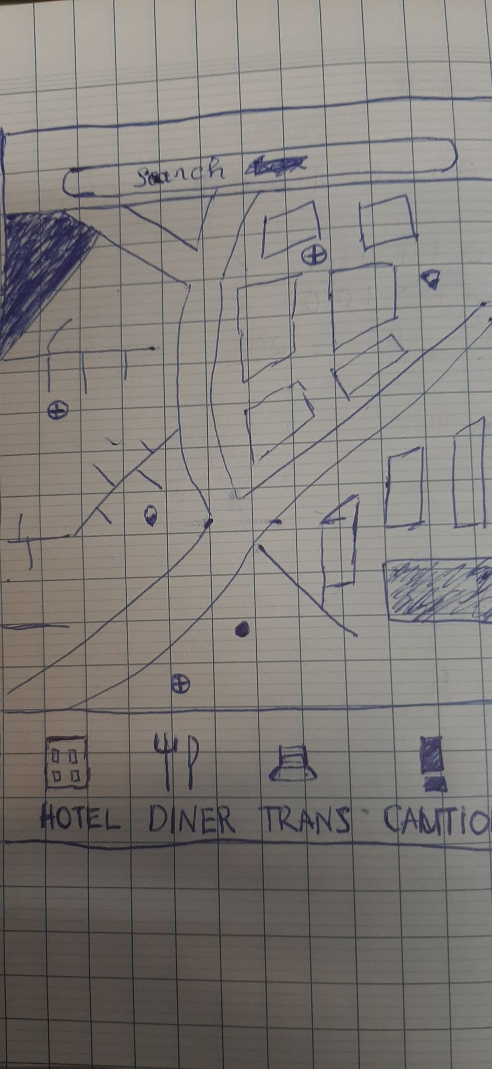

Our idea is to have a map that show current location of user with all indications needed from city wonders to museums, parks that is clear and distinctive. Under the map we have certain icons showing things like hotels, diners, transport and caution. The hotels option is to find hotel with every kind of suggestion of rooms, prices, reviews that could potentially meet users’ requirement. Caution option is to show cautions from government announcement to traffic jam warning that is near your location.

Then, we proceed to make wireframe and prototype for this application

We choose blue theme for this one as we think that it would be more friendly to new user and more visible to everyone. And after several consideration, we decide not to put in HOTELS, TRANS, CAUTIONS option at the bottom of the map screen as it would be redundant and unnecessary. From this, we continue to make a prototype and test it usability.

As we testing it, there is no major issues occurred during the test. However, we experienced several delay when switching between section, a sign of prototype that has been perfected. We also want to know whether this application is practical in real world so we made an interview with a stranger named Marco and let him try our product. First impression is that he likes the color theme of this application as visible and lively. He almost has no problem with the way we arrange this interface. That being said, he would like to have an option to demonstrate some important information due to concerned over Covid-19 lockdown. That brings us back to our very first sketch at the beginning of this project. We realize that having that option in our next prototype is definitely a good choice.

Overall, we have made sketch to generalize our idea after choosing our target users. Wireframe was made to make it more authentic and clear several different in our thinking. Then we made our first interface prototype for this application. We then test it whether this one has a good connection to users or not. Interviewing was made as it when really well, although the interviewee prefer our first idea about having Caution option to track crucial information from government. We shall add it into our next prototype.