CONDUCT SURVEY AND INTERVIEW FOR USER EXPERIENCE DESIGN

EDO ASSIGNMENT GROUP CB04-3

Lecturer: Lara Rojas, John J.G

embers of Group 3

Duöng, Phuc G.P. s4321375

Igue, Fredrick O.F. s4387694

Lê, Anh Tuan A.T. s4399889

This is our group project about one of the most famous video platform that is familiar with everyone for a very long time. That platform is none other than Youtube. Reason behind our decision to choose Youtube is that it is a popular platform and been using by people from many ages and classes. With a wide-range of users like, we obtain some certain information about user experiences that could potentially change and improve Youtube in all aspect so that it could be more friendly, useful, informative, entertained towards different type of users.

Interview:

 The first Interviewee said most of the time she used Youtube for entertaining and how Youtube helps her do things, for examples: Listening to music and follow influencers from around the world, she also mentioned that Youtube is a mobile-friendly app, the app works great on her phone even online or offline and she can use it whenever she wants. She has been using Youtube for 10 years, and she didn’t encounter any difficulty on the first time she used it. She thinks that youtube’s interface is user-friendly, tool bars and channels are arranged nicely. By far, she hasn’t thought of any new features that should be added to Youtube.

The second person being interviewed is 20 years old and goes with the name Kelvin, his main reason for using YouTube is for fun and entertainment. He explained he didn't face any difficulties using it for the first time as the layout was simple to understand, he said some features were hard to find like the play audio in the background feature.

He said he liked the download feature for keeping the files offline so he could watch the videos without internet connectivity, he explained the download feature makes his experience better because it will allow him to use YouTube even if he is offline. He's favorite content is lifestyle vlogs and live streaming of gaming creators, he thinks the menu and user interface for YouTube is plain, simple, it’s also clear, for the color he likes using the dark theme. Lastly, he suggested that the download feature needs to be improved so the users can save the downloads on their phone and not just on the YouTube App.

The third person is Hazel is a 26-year-old Youtube user who loves watching movies and music videos on Youtube. The problem with doing so is that most of her movies have no copyright so it is not possible for her to enjoy those products in the highest quality. She has been using Youtube premium for quite sometimes and she is loving it. It makes her experience with Youtube a lot better since she does not have to watch unwanted advertisements from time to time. User interface is also her favorite since it is concise and simple but giving enough information despite the fact that the color tone for menu is the least of her liking, she wants it to be more colorful and options to customize it to her preferences. Aside from it, she loves Youtube as it is right now. To her, watching her favorite videos and movies is enough. She would be careless about other features from Youtube even if it could drastically change her experience with it a lot, just like other regular Youtube users.

Survey:

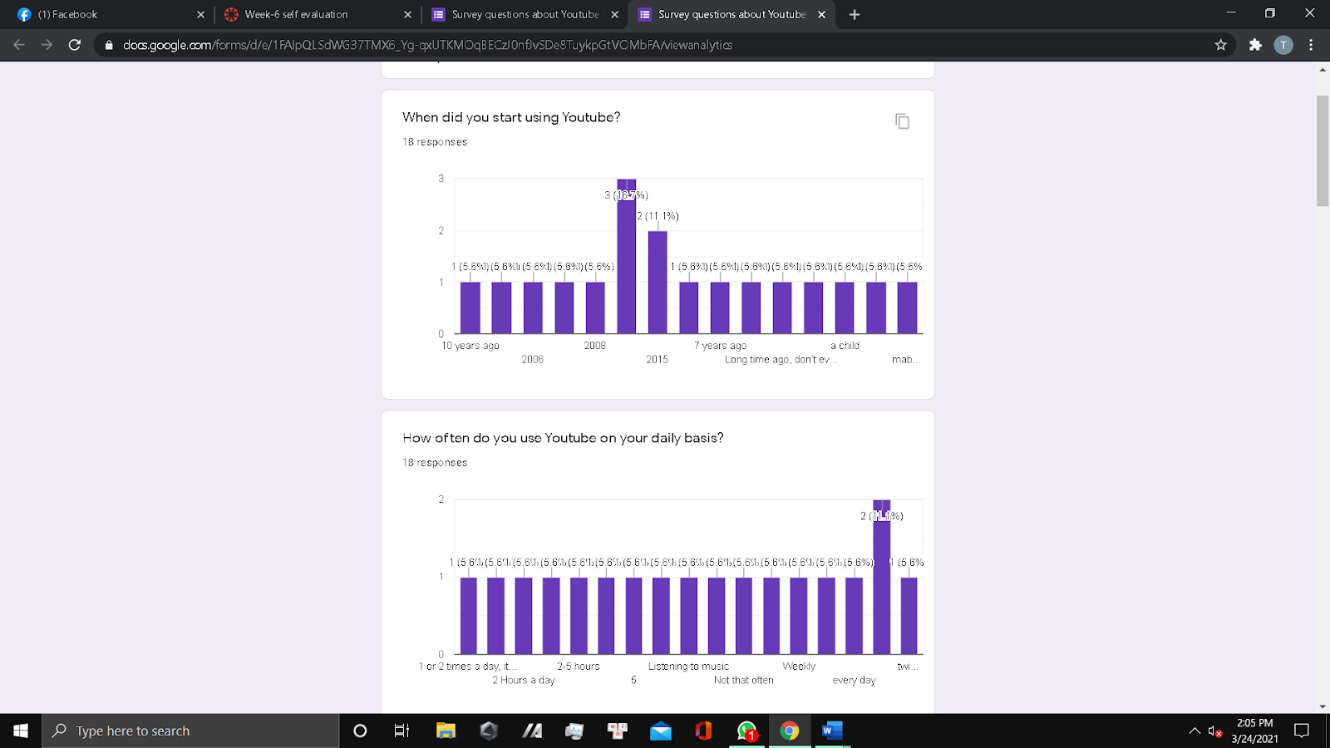

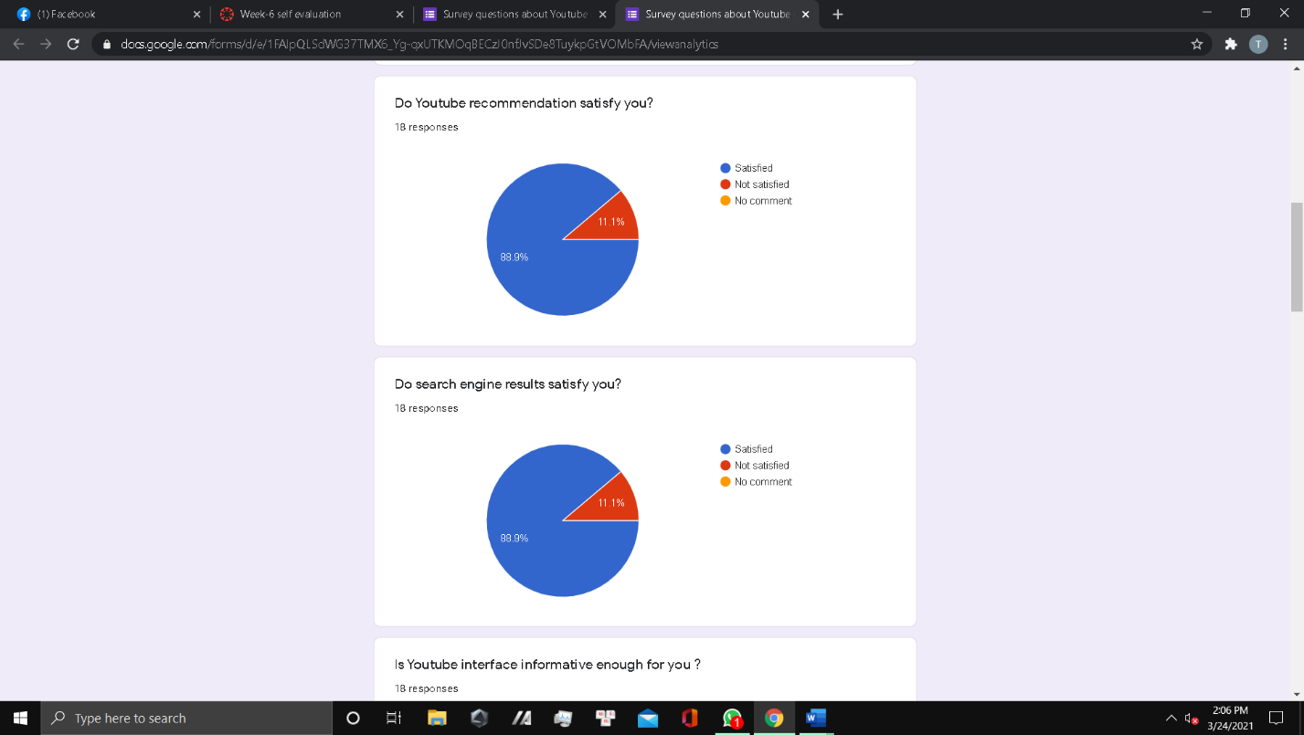

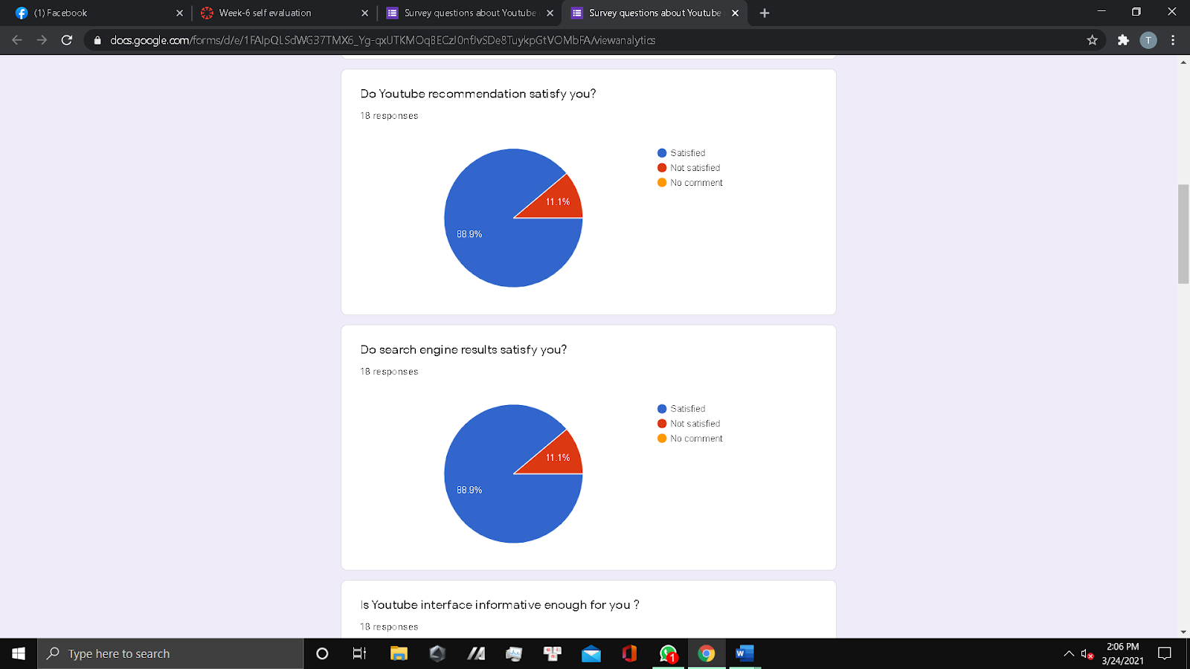

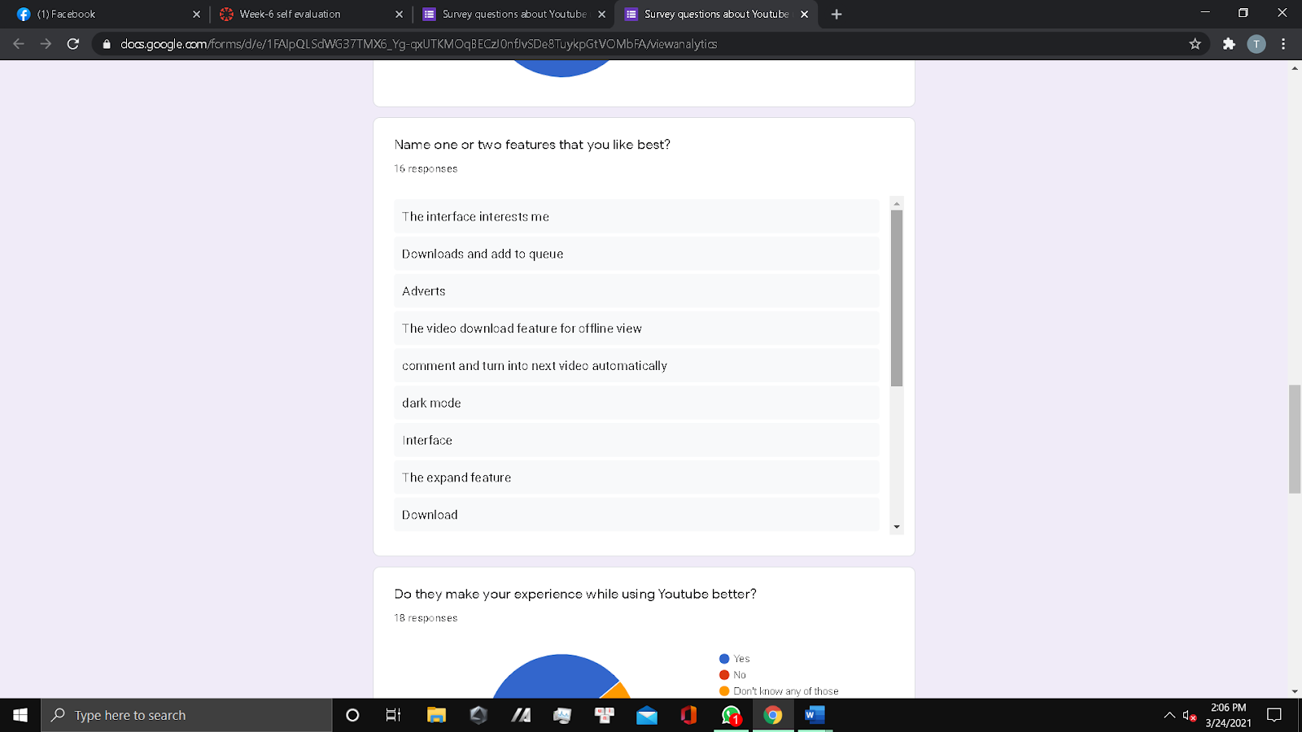



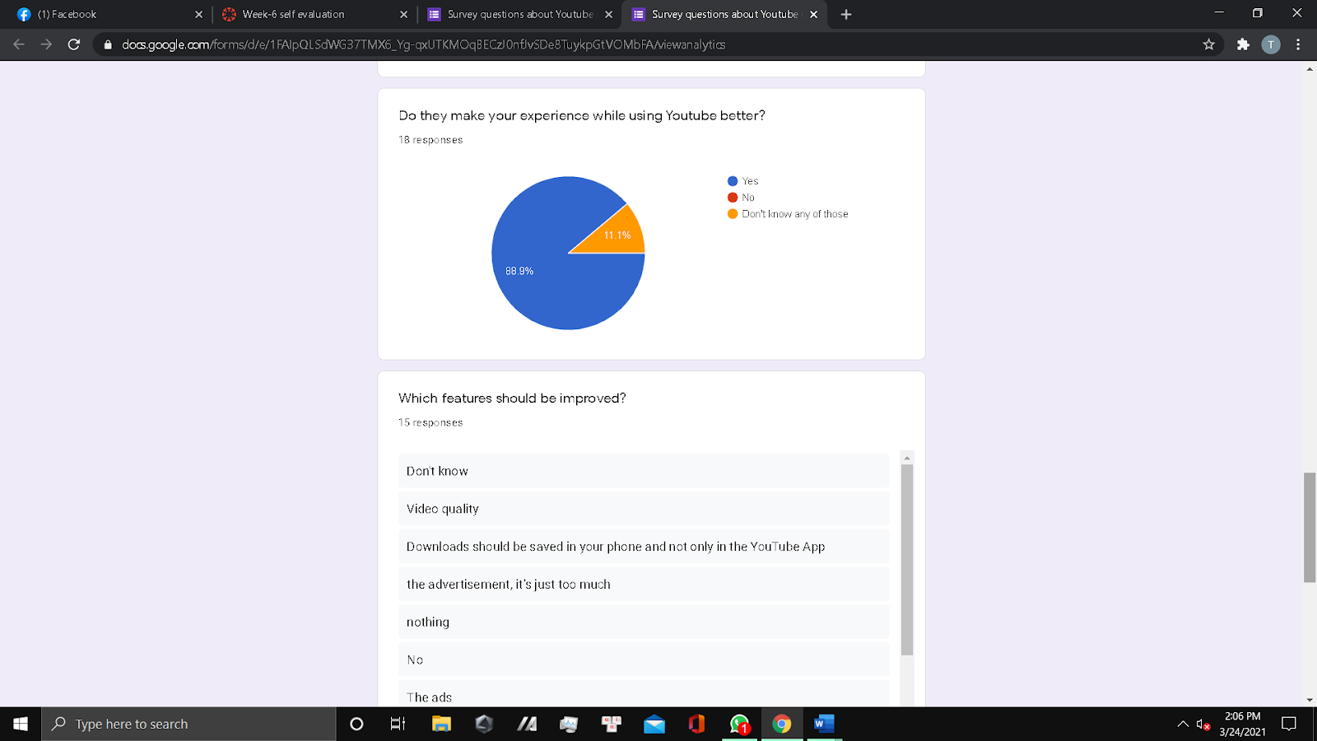

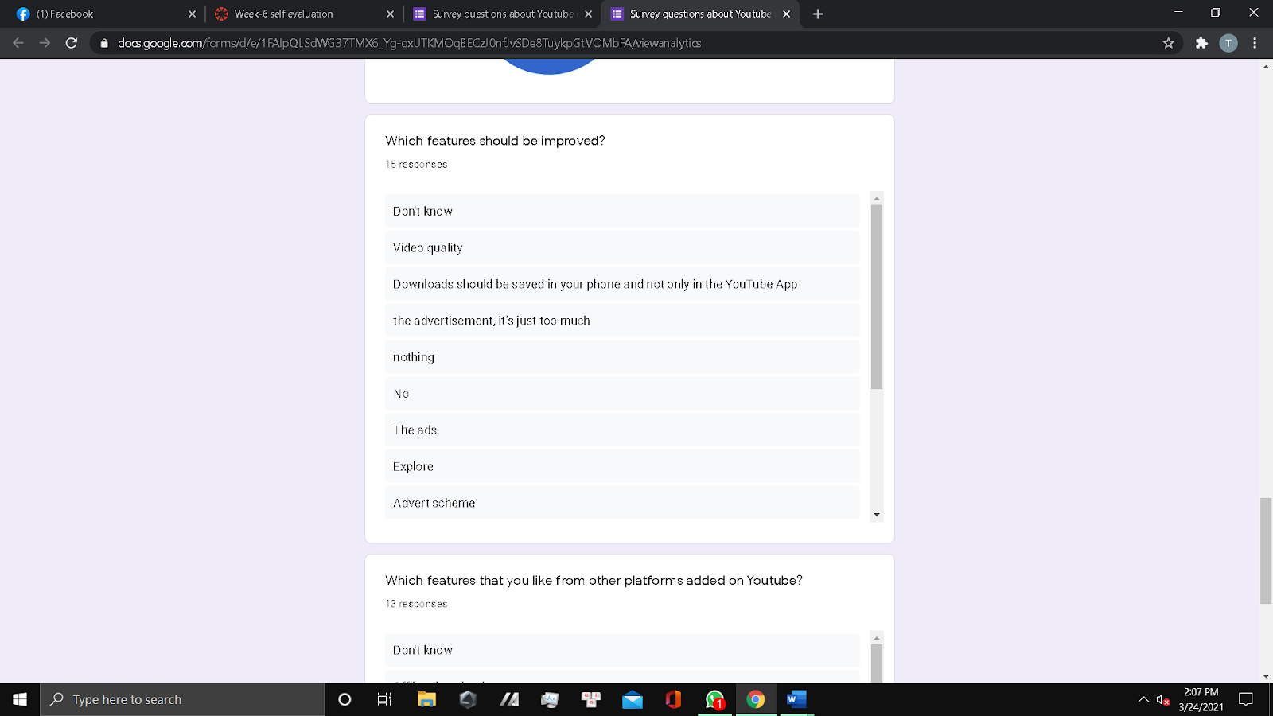

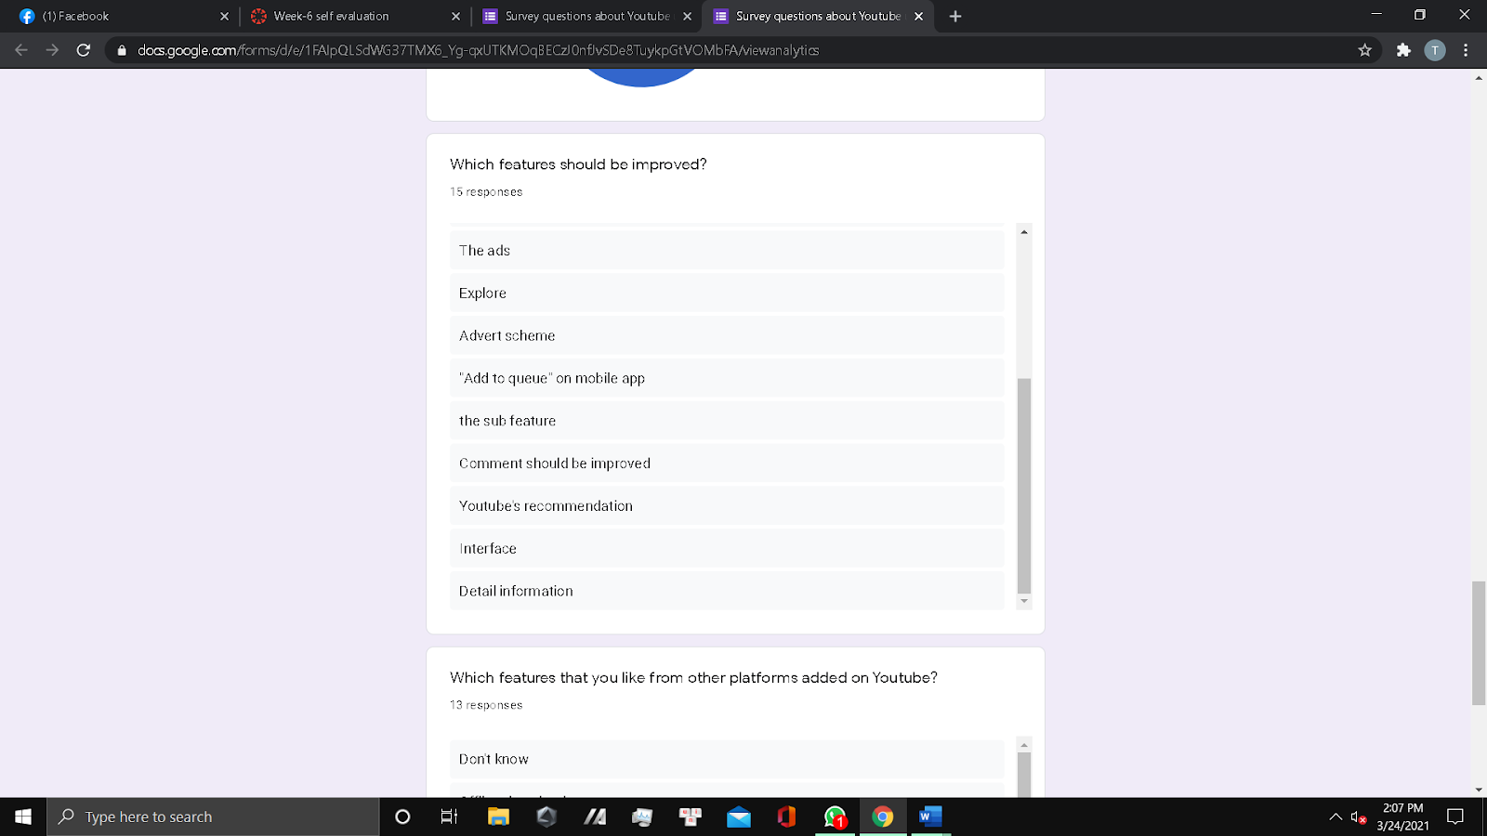

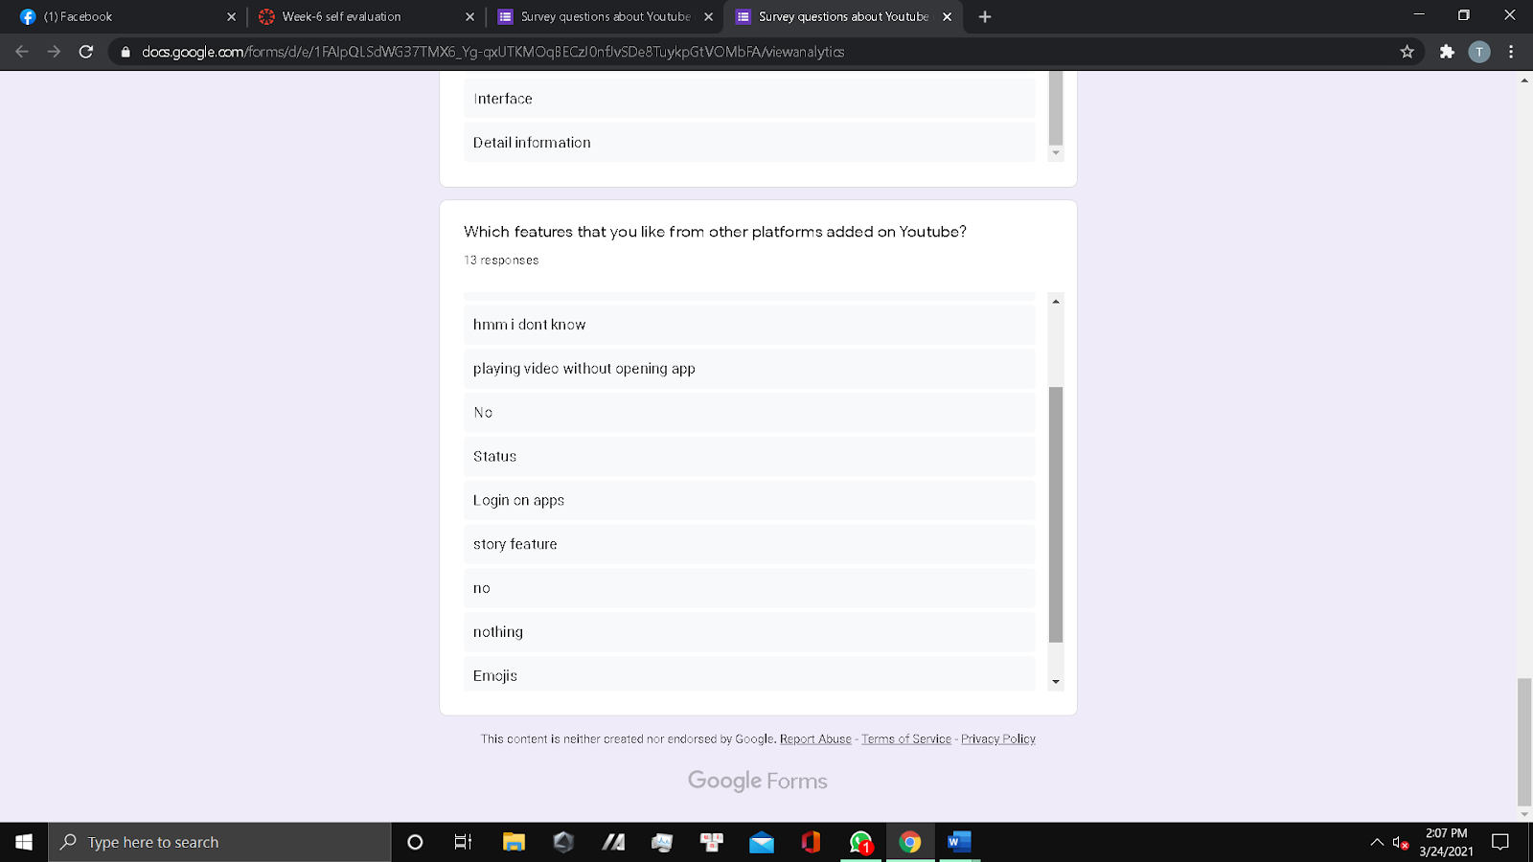

List of requirements:

1. Cut down the number of advertisements to enhance better experience for users.

2. Downloads should preferably be saved on the device and not the YouTube app.

3. Video quality should be improved, this will attract more users to the platform.

4. Implement the add to queue feature on the mobile app.

5. Include playlist on the interface to enable users subscribe to their favorite.

6. Introduce the story feature, so creators can have content posted on their stories.

7. Provide more informative stuffs on the platform for users.

8. The YouTube recommendation video is another feature which needs correction as it recommends unrelated videos.

Personas:

|  |  |
| --- | --- |
| **Name** | Hoang Hai |
| **Age** | 20 |
| **Place of residence** | Ho Chi Minh City, Viet Nam |
| **Occupation** | Student |
| **Goals** | Hai is a hard-working student, he spends most of his time to study, but he also needs a platform/place on internet to relax after long day of studying,so the best choice is short videos, where can entertain him. |
| **Problems with the App/website** | -Some times he encounters bugs, they are not major but does annoy him.  -Lag issue on internet connection which takes lots of time to load  the video.  -Youtube’s video suggestion is sometimes annoying |

|  |  |
| --- | --- |
| **Name** | Kane Howard |
| **Age** | 36 |
| **Place of residence** | Colorado, United states |
| **Occupation** | Youtube influencer |
| **Goals** | He is a famous video creator and also influencer on social platform, he needs a solid environment where  is universially known and used. Additionally, the environment has to have a wide variety of tools to help him create professional video. |
| **Problems with the App/website** | -The server of Youtube is not always stable, Sometimes the server is overloaded and it is down.  -Some minor bugs keep appear sometimes, despite being fixed regularly. |

Survey form: <https://docs.google.com/forms/d/e/1FAIpQLSdWG37TMX6_Yg-qxUTKMOqBECzJ0nfJvSDe8TuykpGtVOMbFA/viewform>

Interview audio:

https://drive.google.com/drive/folders/1xU-ipGa3dD2fIvC17XMlVOjgSXHf-TiL?usp=sharing