SW Engineering CSC648/848 Section-01 Spring 2017



**Milestone 2**

**Team 7**

**Javier Kirksey**, Team Lead |Javier.kirksey21@gmail.com

**Evan Terry**, Technical Lead | eterry@mail.sfsu.edu

**Chohee Kim** | ckim4@mail.sfsu.edu

**Kendrick Kwok** | kkwok@mail.sfsu.edu

**Brandon Chiong**| bchiong@mail.sfsu.edu

**Marc Panlilio**| mpanlili@mail.sfsu.edu

**Ramsay Wong**| ramsayw@mail.sfsu.edu

Date Last Modified: 03/14/2017

1. **Executive Summary**

Located in San Francisco CA, San Francisco State University has a rich history of students who have made major impacts on the world and has shown its ability to produce well rounded individuals. Amongst the local community at SF State there are many students who seek to buy and sell products with one another but there isn’t yet an efficient way to do so. That being said, Gatortraders.com is currently being developed to allow students of San Francisco State to buy and sell products with one another, as well as post the products in which they would like to sell so that other students can view them. Along with posting products, the online platform will also allow students to search for products based on the products name and description.

In terms of funding the project, Gatortraders.com has many features which investors should be interested in. The online platform is connecting students with one another to buy and sell from one another, which allows Gatortraders.com to have customers that will spend much time on the platform. This can be monetized through multiple different ways such as advertisements. Another valuable attribute of GatorTraders.com is the collection of information on what people are interested in buying at the time which is valuable information for many businesses.

The team developing this platform consists of six students who attend San Francisco State University. Not only do the students know how the local community operates, but they also have a great understanding of what college students are interested in, which is key in the development of this product. With six students on the development team, there is a lot of communication and productiveness that will lead to a great product for the students of SF State.

1. **Use Cases**

**Use Case: Seller, Students**

Steve is a fourth year San Francisco State University student who will be graduating once this current spring semester ends. He has stored up all of his textbooks from all four years but since he will be graduating soon, he figured there is not a need for all these textbooks anymore. During one of his classes, he overheard one of his classmate talk about a website that is similar to websites like Craigslist but only for SFSU students. This website allows SFSU students to browse for whatever items they desire and if something catches their eyes, they can buy it then and there. On the other hand, if a student wants to sell an item(s) the website provides that function as well. The website is only provided for students who are SFSU students so to buy or sell anything, one must need their SFSU ID number to create an account to use all the functions of the website. Steve wants to help others by selling his textbooks for a cheaper price since he experienced firsthand how pricey buying textbooks can get. He goes onto the site and decides to post, but is prompted to register or log in. Steve goes through the account creation and verification process, and is approved. He ends up posting up his textbooks and they were all sold by the time next school semester starts when he has officially become a SFSU alumni.

**Use Case: Buyer, Students**

Max is an incoming first year student who will be attending San Francisco State University when fall comes. Since Max is a first year student, he decides to live close to campus by living in one of the dorms provided by the University so that he would not have to commute back to his hometown and so that he would not have to be late to his classes and extracurricular activities by using public transportation. Max needed to buy some items because the housing department did not provide enough of the items he has been using at home. His brother, who is now a San Francisco State Alumni, mentioned that he used this website provided only to SFSU students to sell his textbooks to other SFSU students. Max went onto the website and started browsing what it had to offer. Max wanted to narrow down his search so he searched up specific keywords to reduce the number of results of items in the list. He ended up searching for a lamp, a coffee table, a coffee maker machine, a bed comfortable, a few textbooks, and a calculator. Once his search has been completed, he proceeded to press the message button. Since he does not have a verified account, he will be prompted to log in, but because it is his first time he will press the create account button. From there he will have to verify his SFSU email, and once finished he will be able to buy the items.

**Use Case: Buyer, Guest**

Sarah heard of this website similar to Craigslist that caters to SFSU students. She is looking to buy a couple textbooks for her classes. She goes onto the website and looks through the item listings. She sees the **item name**, **price**, and **descriptions** that people post. Sarah is interested in buying an item, but she is prompted to create an account or login after clicking the Messages button. She sees that there is a warning message that says “You must have an SFSU email to register.”

**Use Case: Administrator**

Allan is an administrator of the website. As he is browsing the listings placed on the site, he stumbles upon a vulgar listing. Allan decides that it is inappropriate and decides to take down the listing from the website. He first informs the student seller that his listing is inappropriate then removes it from the site.

1. **Data Definitions**
2. **Administrator (Admin)**

* Overlooks the website and changes the content that is appropriate. Makes note of bugs and brings forth the issue to fix.

1. **Guests**

* Can access posted items, but can’t see contact information.

1. **Items**

* Products sold from sellers that are usable for users to browse and purchase. Item contains pictures and descriptions of what is to be sold by other users.

a. Item Name

b. Description

c. Price

d. Picture (Optional)

4. **Students**

* Can access all information of posted items and can post items.

a. Buyer

b. Seller

**5. Blockee**

1. **Initial List of Functional Specs**

**Priority 1**

**All Guests**

1. All guests shall be able to visit, browse, and search the site.
2. All guests shall be able to create an account and login.
3. All guests shall provide email address and password to create an account.
4. Guests transition to students impose email restriction based on SFSU email address.

**Students**

1. Students shall be able to list their products for sale.
2. Students shall be able to reply to a posted item for sale.
3. Students shall be able to message other students.

**Administrator**

1. Admin shall be able to visit, browse, and search the site.
2. Admin shall be able to remove posts.
3. Admin shall be able to delete accounts.

**Priority 2**

**All Guests**

1. All guest shall be able to flag posts.

**Students**

1. Students shall be able to save listing to their favorite.
2. Students shall be able to block other students.

**Blocked Students**

1. Blocked students shall not able to access listings by blockee.

**Priority 3**

**Students**

1. Students shall be able rate interaction of other students.
2. Students shall be able to see rating of other students.
3. Students shall be able to see history of sold items.
4. Students shall be able to create a biography for their profile.
5. **List of non-functional specs**
6. Application shall be developed using class provided LAMP stack
7. Application shall be developed using pre-approved set of SW development and collaborative tools provided in the class. Any other tools or frameworks must be explicitly approved by Anthony Souza on a case by case basis.
8. Application shall be hosted and deployed on Amazon Web Services as specified in the class
9. Application shall be optimized for standard desktop/laptop browsers, and must render correctly on the two latest versions of all major browsers: Mozilla, Safari, Chrome.
10. Application shall have responsive UI code so it can be adequately rendered on mobile devices but no mobile native app is to be developed
11. Data shall be stored in the MySQL database on the class server in the team's account
12. Application shall be served from the team's account
13. No more than 50 concurrent users shall be accessing the application at any time
14. Privacy of users shall be protected and all privacy policies will be appropriately communicated to the users.
15. The language used shall be English.
16. Application shall be very easy to use and intuitive. No prior training shall be required to use the website.
17. Google analytics shall be added
18. Messaging between users shall be done only by class approved methods to avoid issues of security with e-mail services.
19. Pay functionality (how to pay for goods and services) shall not be implemented.
20. Site security: basic best practices shall be applied (as covered in the class)
21. Modern SE processes and practices shall be used as specified in the class, including collaborative and continuous SW development
22. The website shall prominently display the following text on all pages *"SFSU Software Engineering Project, Spring 2017. For Demonstration Only"*. (Important so as to not confuse this with a real application).
23. **UI Mockups and Storyboards (high level only)**

**Storyboard 1 – Seller, Student**

Steve is a forth year and would like to post a listing but sees that he must first register an account. He clicks on the register button and is taken to the create account page. Because steve as saved his textbooks throughout college, he would now like to sell them. After the registration process, steve posts his items ponto GatorTraders.com and is able to sell all of his books before the start of the next semester.

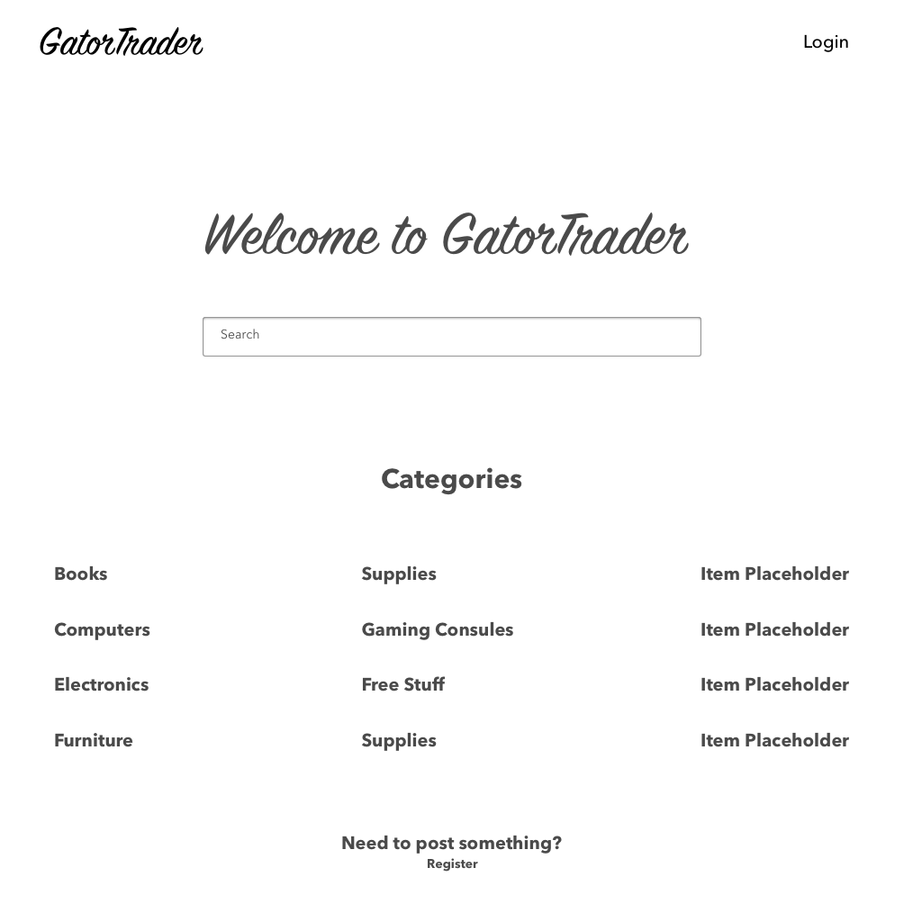

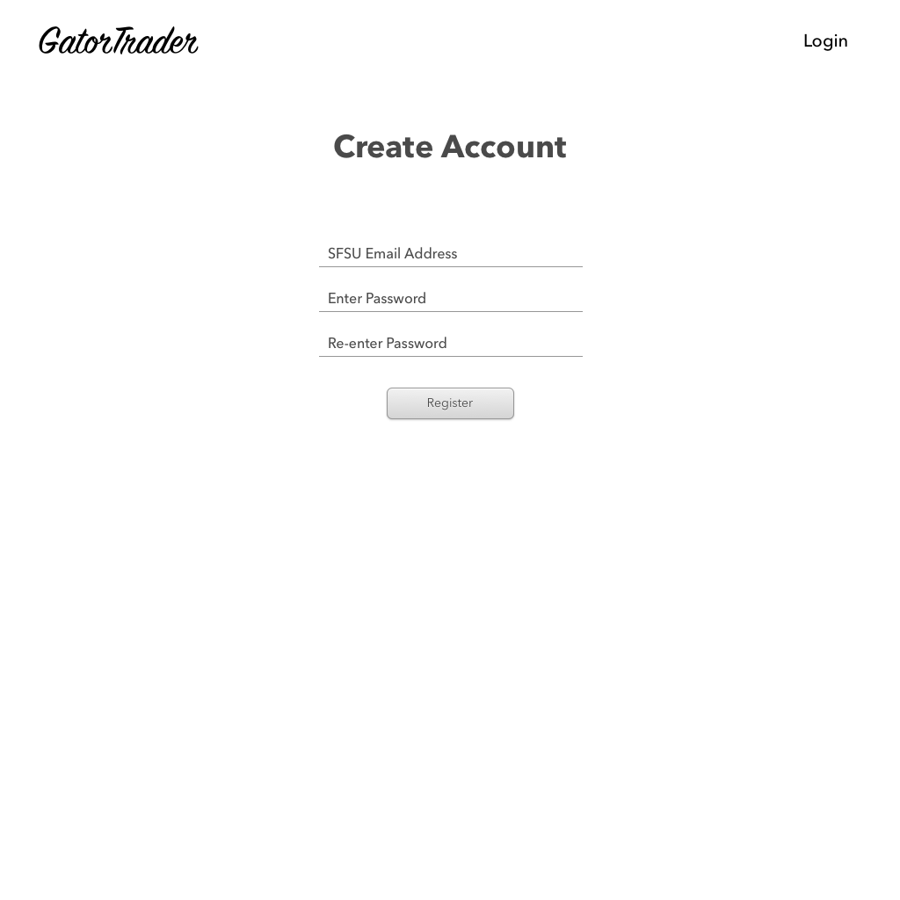

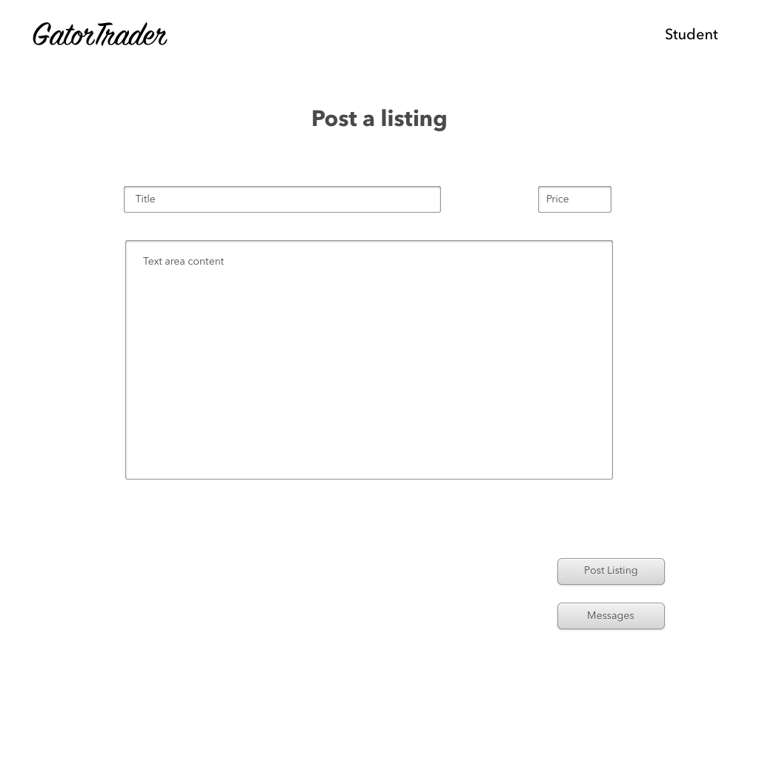

**StoryBoard 2 – Buyer, Student**

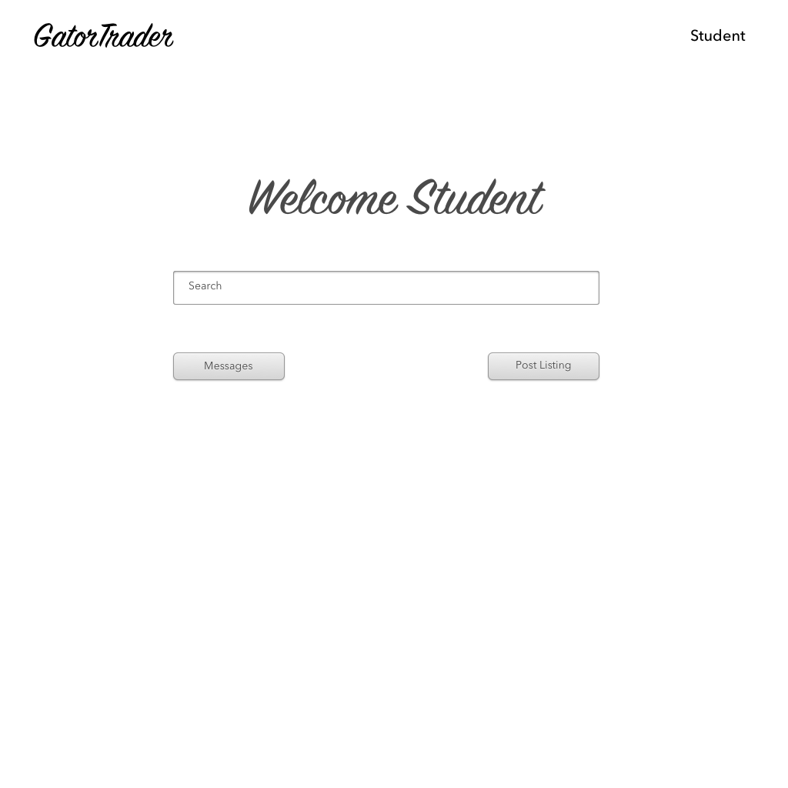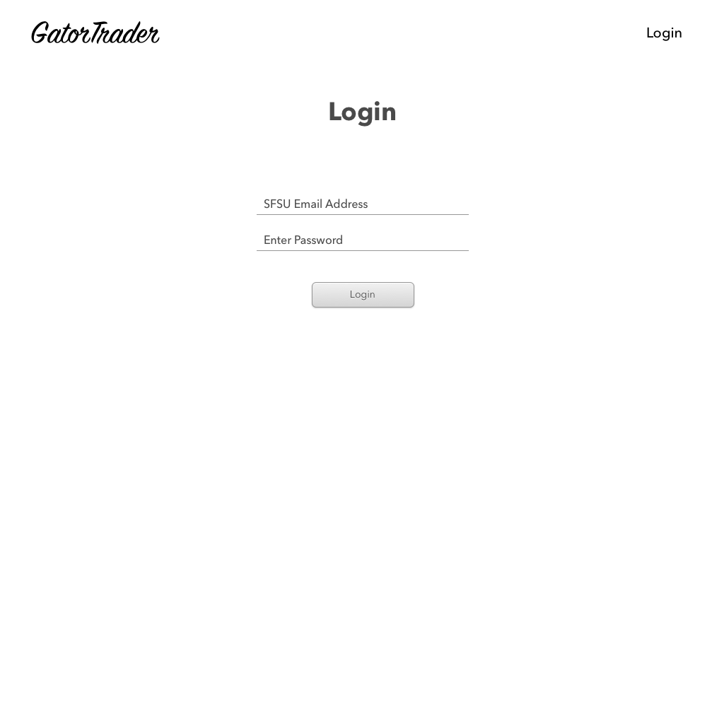Max is an incoming freshman at SFSU. He needs to buy some home supplies for him new dorm on campus . Because he heard of this site from his brother, he decides to browse for multiple items. He finds what he wants but is prompted to log in before purchasing his items. After succesfully logging in, max proceeds by messaging student sellers and goes on to purchase his item.

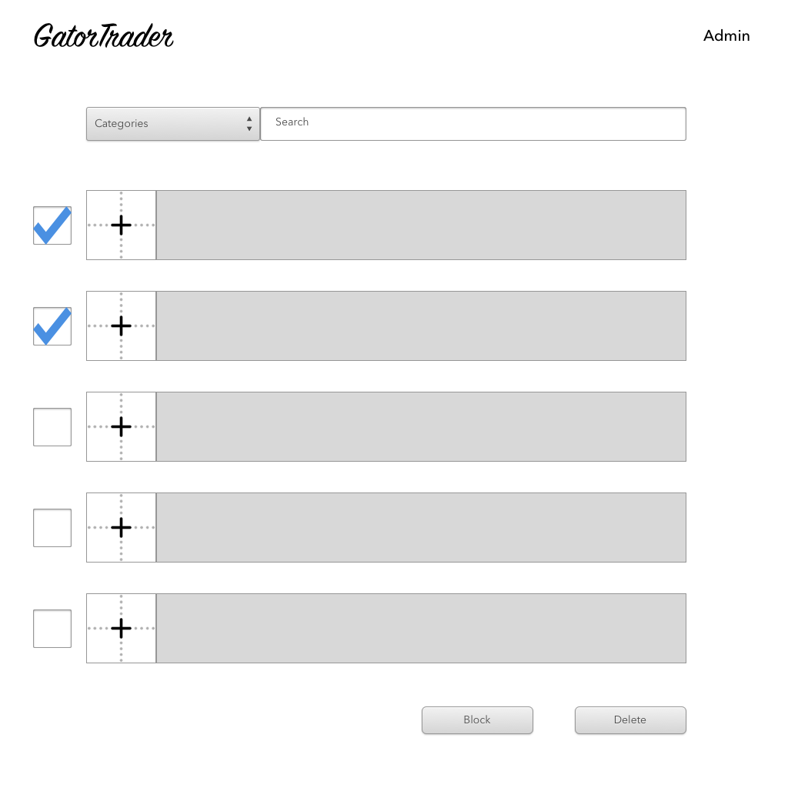

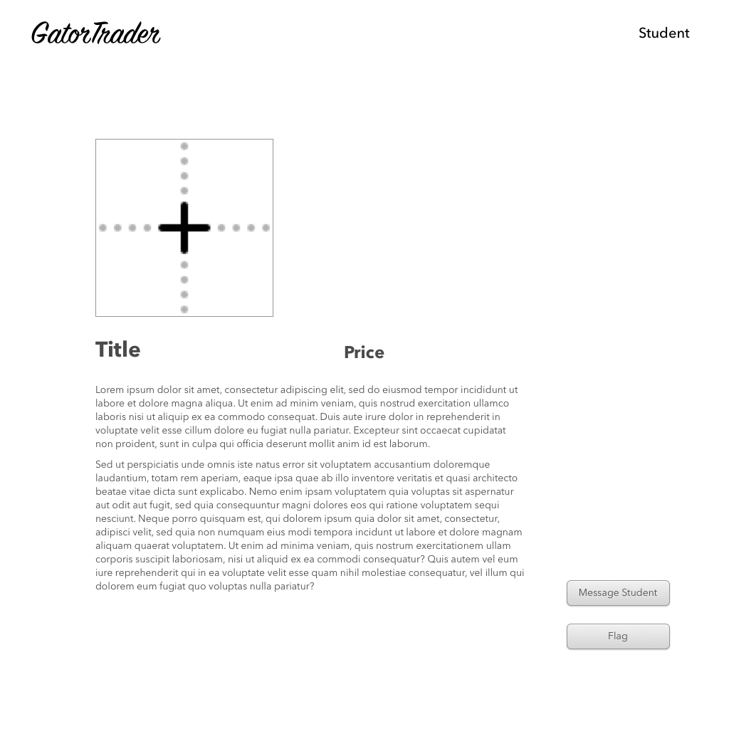

**Storyboard 3 – Buyer, Guest**

Sarah, an SFSU student, heard of GatorTraders because it’s been in conversations on campus. Looking to buy a couple textbooks, she goes on to GatorTraders.com She browses items on her own and comes across an item which she likes. Because she is a guest, she is prompted to create an account before proceeding to messaging and purchasing. After successfully registering, she then has access to message sellers and purchase products.





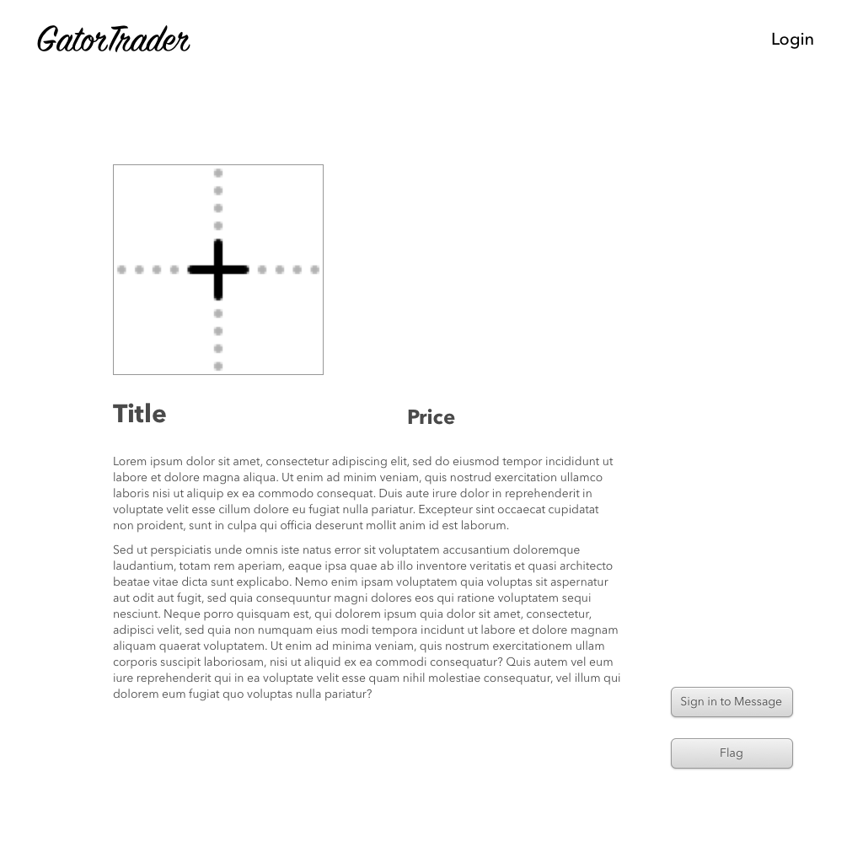

**Storyboard 4 – Administrator**

Allan is an administrator of the website. As he is browsing the listings placed on the site, he stumbles upon a vulgar listing. Allan decides that it is inappropriate and decides to take down the listing from the website. He first informs the student seller that his listing is inappropriate then removes it from the site.

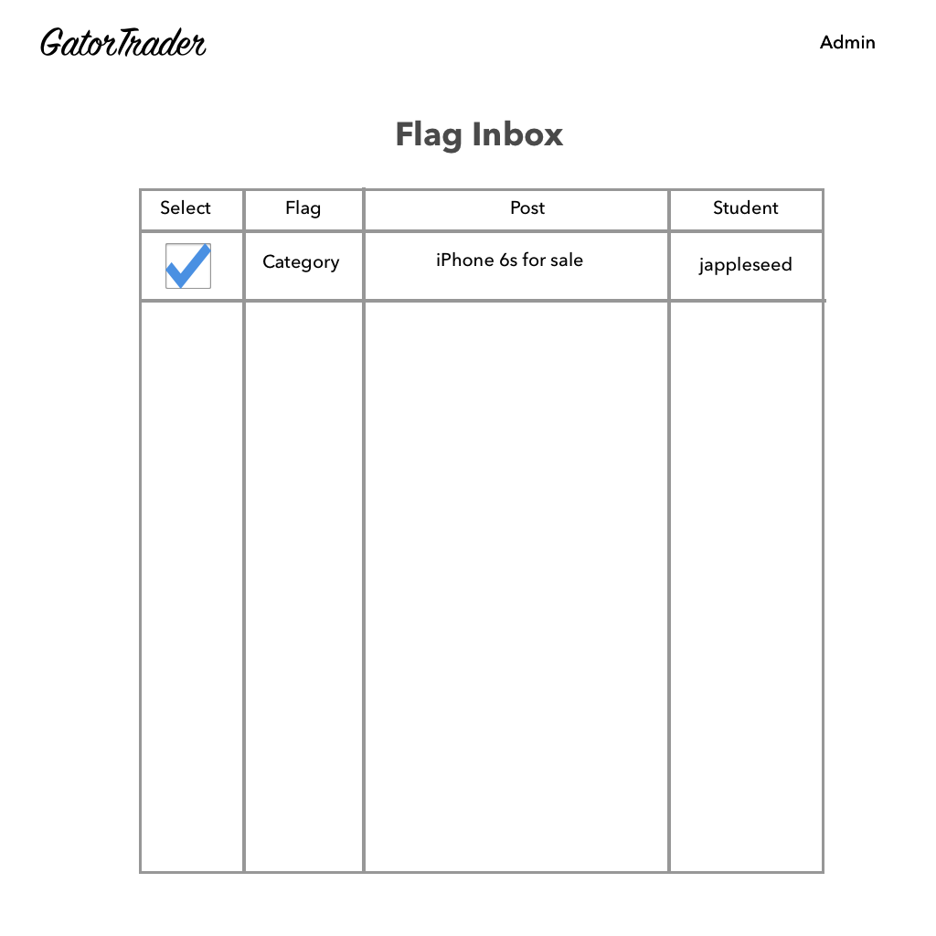

1. **High Level System Architecture**

* The development team is building its product with Amazon Web Service using a Linux, Apache, MySQL, and PHP server, otherwise known as a LAMP Stack. This will provide for optimal uptime, scalability and a greater level of consistency for user’s experience. We have chosen to use the Symfony PHP framework with the deployment of this web application as the framework is widely used which has cultivated abundant resources. For design purposes, we have decided that the Bootstrap Stack will allow for the best browsing experience on the four most relevant browsers used, Google Chrome, Firefox, Safari, and Microsoft Edge. To help with design elements other languages in the Bootstrap Stack such as JQuery, JavaScript, and Less will be used sparingly to implement effects.

**Amazon Web Services**

* Cloud computing platform provided by Amazon. Web services used for remote computing services.

**Apache**

* Unix based web server that are widely used in HTTP servers on the internet.

**Bootstrap**

* Open-source front-end web framework for designing websites and web applications.

**Linux**

* Open sourced operating system modelled for Unix.

**LAMP**

* Linux Operating System
* Apache
* MySQL Database
* PHP programming

**PHP**

* Open source scripting language for web development.

**SQL**

* List of commands used to communicate with a database. SQL statements used to perform updates and retrieve information from a database source.

**Symfony**

* PHP web application framework and has set of usable PHP components and libraries

**Search Architecture**

* Ability to implement cluster rank algorithm. Search architecture ability to narrow filters from words in database to autofill through each letter inputted in search bar.

**Google API – Maps**

* Google API (Maps) is used to determine the location of the seller. It allows the buyer to be able to find directions to the seller immediately.

**Image – Blobs**

* BLOBs will be saved as thumbnail images or images in the databases. BLOB images have around 4000000000 bytes for a full image, and for the thumbnail it will contain around 65000 bytes.

**Database Layout**

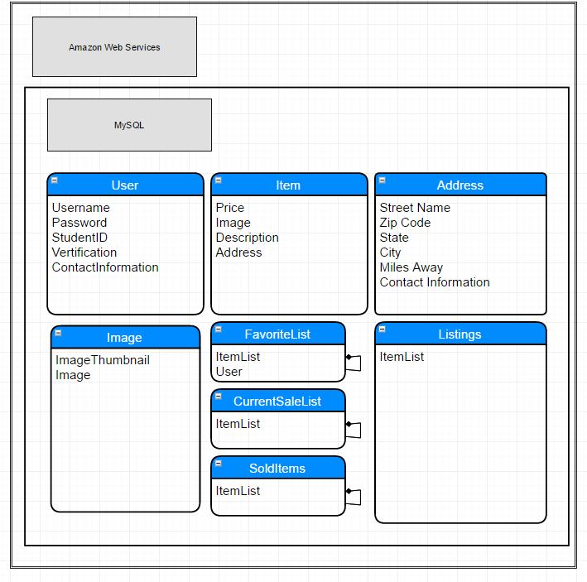

1. **High Level UML Diagrams**

ClassDiagrams (1)

**Deployment Diagrams**

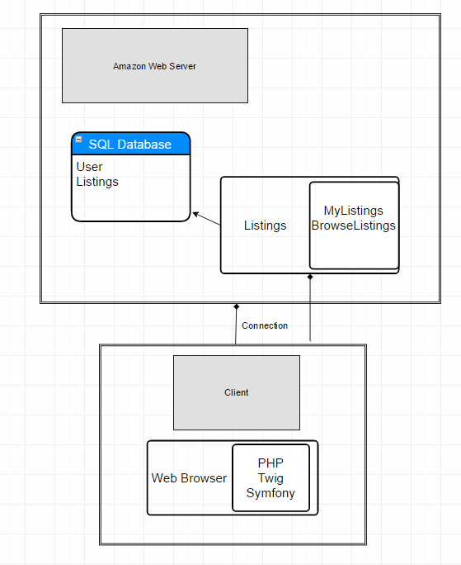

1. **Competitive Analysis**

|  |  |  |  |  |  |
| --- | --- | --- | --- | --- | --- |
|  | **GatorTraders** | **Amazon** | **eBay** | **Craigslist** | **SFSU Bookstore** |
| Local | **+** | **-** | **-** | **+** | **+** |
| User Friendly | **+** | **+** | **+** | **-** | **-** |
| Dynamic Pricing | **+** | **+** | **+** | **+** | **-** |
| No Sales Tax | **+** | **-** | **-** | **+** | **-** |
| Custom SFSU  Textbooks | **+** | **-** | **-** | **-** | **+** |

GatorTraders.com has clear and valuable advantages over its competitors in the market. Its location at the San Francisco State University campus provides students with convenience. The ease of use will attract students looking to buy or sell items. The dynamic and competitive pricing of GatorTraders.com makes it a clear favorite over the SFSU Bookstore for custom SFSU books and supplies. Using GatorTraders.com on campus avoids the hassle of shipping and handling, while also avoiding sales tax.

1. **Key Risks**

|  |  |  |
| --- | --- | --- |
| Risk Type | Risk | Solution |
| Skills Risk | Varying degrees of skills in programming the front and back end of the project. | Set up a meeting outside of the weekly one, to help familiarize members with the tasks they’ll be doing in the project. Share links that are helpful in teaching certain tasks. |
| Schedule Risk | Team members have other projects they are working on. They may not spend as much time on this project compared to the others. | During the weekly group meetings, assign tasks for each member to accomplish. |

1. **Team Organization**

* **Javier Kirksey (CEO)**
  + *Front End/ Back End Development, Project Manager, Data Collection*
    - Responsible for research, data collection, front end management, and team organization. As well as scheduling, and making sure the team functions and operates smoothly.
* **Evan Terry (CTO**)
  + Technical Lead, Back End Management,
    - Responsible for keeping out team running efficiently in relation to our technical needs.
* **Brandon Chiong**
  + Back End Programmer, Backend Manager
    - Responsible for contributing to and helping create a strong back end for gator trader
* **Chohee Kim**
  + Back End Programmer, Backend Manager
    - Responsible for contributing to and helping create a strong back end for GatorTraders.com database.
* **Kendrick Kwok**
  + Front End & Back End Programmer,
    - Responsible for contributing to front end design, as well as relating front end design to system back end. This role oversees the front end and the backend in order to ensure they are both consistent and running smoothly with one another.
* **Marc Panilio**
  + Front End & Back End Programmer,
    - Responsible for contributing to front end design, as well as relating front end design to system back end. This role oversees the front end and the backend in order to ensure they are both consistent and running smoothly with one another.
* **Ramsay Wong**
  + Front End & Data Collection,
    - Responsible for contributing to front end design, as well as improving the GatorTraders.com User Interface to ensure a good user experience. Also to collect data that will be used throughout GatorTraders.com

**Checklist**

* 1. Executive Summary ------------------------------------------------------------------- **Complete**
* 2. Updated and improved use cases ---------------------------------------------------- **Complete**
* 3. Updated and improved Data Definitions ------------------------------------------- **Complete**
* 4. Updated and improved Functional Specs ------------------------------------------- **Complete**
* 5. Updated and improved Non Functional Specs ------------------------------------- **Complete**
* 6. UI Mockups and Storyboard ---------------------------------------------------------- **Complete**
* 7. High Level System Architecture ----------------------------------------------------- **Complete**
  + Database layout ------------------------------------------------------------------- **Complete**
* 8. High Level UML Diagram ------------------------------------------------------------ **Complete**
  + Deployment Diagram ------------------------------------------------------------ **Complete**
* 9. Competitive Analysis ------------------------------------------------------------------ **Complete**
* 10. Key Risks ------------------------------------------------------------------------------ **Complete**
* 11. Team Organization ------------------------------------------------------------------- **Complete**