**Team Charter Document**

**Wisely**

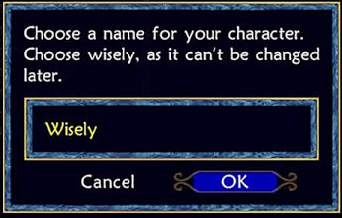



|  |  |  |
| --- | --- | --- |
| **Name** | **Project/Organization Role** | **Contact Information** |
| Jennifer Klimova | Project Manager | shikodingo@gmail.com |
| Lauran Machan | Quality Manager | laurenmachan@hotmail.com |
| Brandon Davies | Product Manager | brandond12@hotmail.com |
| Nathan Nickel | Communications Manager | nthnnckl@yahoo.com |

**Expectations:**In order for our group to operate efficiently and effectively, we agree to the following:

1. Complete work assigned as per the due date agreed by the team.
2. Attend all group meetings prepared for the task on the agenda. If a true emergency comes up, e-mail or contact at least one other group member prior to the meeting to let others know why I am not coming.
3. Proofread all work before submitted to project website and be on time with submissions.
4. Treat other group members with respect and handle all conflicts with tact and diplomacy. Any conflicts are kept confidential within the team.
5. Discuss all work as a group and agree on recommendations before doing it.
6. Agree to fully define and sign off on any changes to intellectual property (IP) agreements amongst ourselves or with industry partners as distinct from the College’s default provisions.

We understand that the policies as outlined by the program or instructor may be applied if I consistently fail to meet these expectations.

Date: ____________ Name: ___________ _______ Signed:

Date: ____________ Name: ___________ _______ Signed:

Date: ____________ Name: ___________ _______ Signed:

Date: ____________ Name: ___________ _______ Signed: