Student Number: 162228 & Kaggle Team Name: BE78

1. Approach

1.1 Why SVM and How Does it Work?

I chose to use a support vector machine in this task; this is a “maximum-margin” extension of a multi-layer perceptron, which attempts to generate an optimal estimate for a decision boundary, a hyperplane in n dimensional space, which will separate instances of the two classes in a binary task. In order to create an optimal decision boundary, it utilizes data points closest to this decision boundary, termed support vectors, to create a margin by which it can quantify the degree of separation of the classes and through this, the optimality of the boundary. The objective is to maximize the minimum margin, meaning that it tries to create a decision boundary which will separate the two closest instances of different classes as much as possible. It also uses data points which are misclassified as support vectors, with a regularized hinge loss function allowing the use of this classifier on non-linearly separable data. This loss function assigns a loss of zero to data points that are correctly classified, and returns one minus the output of those which are misclassified. This scales the amount of loss by the degree of misclassification, determined by the data point’s distance from the decision boundary. It attempts to minimize this loss, while also maximizing the size of the size of the smallest margin, with the importance of the latter determined by lambda, a regularizing parameter that must be set.

A support vector machine benefits from being defined by a convex optimization problem, meaning that the minimum found during optimization will always be a global minimum. It also includes a regularization parameter, allowing avoidance of overfitting and finer control of the bias-variance tradeoff and is good at handling noisy data. One particular drawback of this type of classifier, however, is that it can be hard to optimize properly; the job of reducing overfitting becomes one of choosing the optimum model more so than optimizing the parameters, which places more importance on the data that the model is trained on [1].

1.2 Kernel Functions

SVM allows the use of different kernel functions; these are functions that allow computation of the data as if it were in a higher dimensional space, allowing improved performance and linear separation while keeping

computational costs at those of the feature space. This is possible as the kernel function computes a measure of similarity between instances. This is known as the “kernel trick” and utilizes dot products to make computation easier. Many kernel functions exist and each have their own specific hyperparameter, allowing a further degree of fine tuning the classifier to produce a better model of the relationship between features and outputs and, therefore, a better prediction of the test data.

The ability to use the “kernel trick” was very valuable as this data set had high dimensionality, meaning that transformation to a higher dimension space would have been very costly. The ability to use different kernels with SVM also allows the use of knowledge about the data set to improve the classifier’s performance. I began with a comparison of different kernels including Gaussian, polynomial and sigmoid, while also changing their parameters on early data sets and found that linear and Gaussian models fared best. I continued with these two types of SVM as I implemented different forms of pre-processing and feature selection.

2. Method

2.1 Training and Testing

I split the supplied data set with an 80-20% training-validation split, following pre-processing and feature selection, and carried out five-fold cross validation on the training data, using the MATLAB classification learner app to produce my model.
Cross validation is a method of training that allows the production and comparison of multiple models from a single set of data; this is done by partitioning the data and leaving one partition for training while the rest are used for training the classifier. While looking at the accuracy of the classifier on the training data during cross validation, performance checks were also carried out on the validation split of data in order to check the generalization of the model and whether it was overfitting to the training data. The validation split was treated like test data and parameters were never fit to this data set, only tested on it to get an indicator of model performance in the Kaggle competition.

2.2 Model selection

Model selection is the process by which a specific instance of a classifier is formed through the selection of specific parameters and hyperparameters as well as the form of the data used to train it; this is carried out during cross validation as each set of partitions used in training creates a different model. The benefit of this is that you are able to create a set of models which can be compared in terms of performance and tested for possible overfitting. For my model selection, I trained my classifier while changing the kernel used and the specific parameter of that kernel (such as size). This produced a range of results, and analysis of their performances in terms of percentage accuracy and mean squared error helped me to choose my best model. In this task, there was no type of preference in the type of errors incurred, i.e. false positives versus false negatives, so this information was not considered when comparing performance.

2.3 Pre-processing

I began with feature scaling in order to avoid weights of larger values dominating the model. This was done with min-max normalization of the values in each column through the use of a function I created. I compared this to using the z-score function of MATLAB to carry out standardization of the data, subtracting the mean of each column and dividing them by their respective standard deviations in order to reduce the distance of each data point from the mean.

I then moved onto feature selection, attempting to keep the features that were most salient with respect to predicting the output of the data and discard those that provided little information to the classifier. This included separating the features derived from the convolutional neural network and the GIST features, and creating separate models using each as well as a combination of the two. I also applied principal component analysis (using the inbuilt MATLAB function, as well as my own) in order to reduce the number of dimensions used by finding those with the largest eigenvectors which contribute a large proportion of the variance within the data (90%).

Next, whitening was applied in order to discover whether any unwanted correlations existed within the data; this would be less than ideal as it would impede the elucidation of the relationships between each feature and the output, meaning that an increase in one feature leading to and increased output value may be mediated by an intermediate feature. I utilized principal component analysis whitening to this end.

The extra information proved to be very useful in improving classifier performance as well as overcoming some issues with the initial data set. As the original data set contained a much lower number of samples than dimensions, it was possible that this could lead to good performance of the classifier on training data that was not matched when applied to a larger training data set as the former may be linearly separable but not the latter [2]. Due to this, I first attempted to concatenate the incomplete data that we had been given and replace the unavailable NaN values with a range of others. I first filled these cells with zeros in an attempt to observe the effect of having more data points to train with and, following this, found a method to impute the NaN values in the empty cells of the matrix, replacing these with the mean, median or mode for each column depending on the model being selected [3].

The human annotations of confidence allowed me to remove data points with a low probability and there possibly training the classifier to learn incorrect relationships between features and the output. I filtered through the data points and discarded those with a confidence value below one.

The proportions of classes within the test data allowed me to match this by changing the proportions of the training and validation data sets. This was done by removing some members of positive class as the proportions dictated that the test data was 57.14% negative. The reason for this is that the prior probability of each class learnt by the classifier is partly gained from the occurrence of them in the training data; this means that to truly learn the model the training data must attempt to represent the same proportions of classes as in the test data [4].

3. Results and Discussion

3.1 Results of model selection

During model selection, I found the Gaussian kernel to provide the best performance, with a kernel size of 68 and box constraint of one leading to the greatest reduction in validation error; this was an improvement on linear and cubic SVM variations (fig.1).

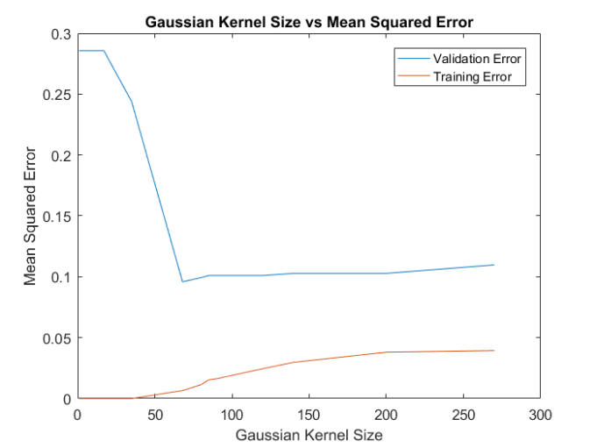
Figure 1. Learning curve showing the effect of changing Gaussian kernel size on mean squared error.
The extra information also provided great increases in the performance of my classifier. Utilising the extra data samples with NaN values imputed over with the median increased the size of the data set drastically, allowing for better training of the classifier [3]. This provided more robust training, with a more generalized model, as it had a larger sample size to learn from.

Annotating the samples with their confidence labels and removing those that were uncertain also provided a substantial increase of 0.013 to the percentage accuracy of my classifier.

An improvement in accuracy of 0.27 on the Kaggle public leaderboard was gained by fixing the training data class proportions, leading me to believe that the similarity in class prevalence between training and test data is a key characteristic in classification task.

In terms of pre-processing, normalization did not prove to be of great help, but standardization was very useful. Feature selection and whitening through the use of PCA proved fruitless, but this may be due to SVM being robust to cases in which a large number of features is use, meaning that effect may been greater if used with another classifier.

3.2 Evaluation

My classifier proved to provide reliable levels of accuracy when tested on different formulations of the validation data and predicted the test data given to a decent degree, suggesting a good level of generalization and a good position within the bias-variance tradeoff. It could, however, be improved through the use of more techniques during model selection and pre-processing. I was not able to implement a range of feature selection techniques such as the use of wrapper methods including recursive feature elimination and L1 norm penalisation, and univariate feature selection. As I currently use the full complement of dimensions I believe that this could improve my classifier performance. In future I would also adjust the processing of confidence annotation data to feature a probabilistic element, providing samples that were annotated with a two out of three agreement to receive a 0.66 chance to be included in the data set, better reflecting the uncertainty as to whether they are correct are not as opposed to simply removing them. I would have liked to optimize the box constraint hyperparameter of my kernel to improve my model selection, as well as utilizing a grid-search algorithm to automate this process and maintain generalization that is difficult to achieve through manual adjustment.

With respect to things I would have done differently, I believe I would have to experiment more with ensemble methods; I believe that these enable a classifier to gain the benefits of various different techniques, however require much more fine-tuning than single models that I was not able to achieve.

4. References

[1]Cawley, G.C. and Talbot, N.L.C. (2010). On over-fitting in model selection and subsequent selection bias in performance evaluation. Journal of Machine Learning Research 11, 2019-2107.

[2] Rasmussen, C.E. and Williams, C.K. I. (2006). Gaussian Processes for Machine Learning, The MIT Press

[3]Sterne, J.A.C. (2009). Multiple imputation for missing data in epidemiological and clinical research: potential and pitfalls. BMJ, 338:b2393
[4] Storkey, J.A. (2009) When training and test sets are different: Characterising learning transfer. The MIT Press. Dataset Shift in Machine Learning, 3-28

