________________________________________________________________________

# Instructions

In this lab session, you will have to answer questions in this document, and complete two java projects: 3DES and RSA.

You can answer in English or French to the questions, with complete sentences.

For question where you are asked to implement java methods, please provide source code in this document.

Example

*Question x. Implement ::helloworld() function*

*void helloworld(){*

*system.out.println(“HelloWorld!”);*

*}*

You can work in team of 2 students (not more).

This document has to be completed, zip it together with your JAVA projects as follows:

* Zip it and rename it to **LabSession1-FirstNameStudent1-FirstNameStudent2.ZIP**

You have to submit the ZIP file on dropbox [here](https://www.dropbox.com/request/s75CTKPHCURvkWSqYnGq).

This lab session will be evaluated on 20 points, and will count for 25% of the final Software Security grade.

3DES

(10 points)

In this exercise, you have to answer to the questions in this document, and complete the file *./src/com/polytech/security/TripleDES.java*.

## Background information

3DES is a symmetric key block cipher, which applies three times the DES cipher/decipher algorithm.

3DES encryption is performed as depicted in the following figure:

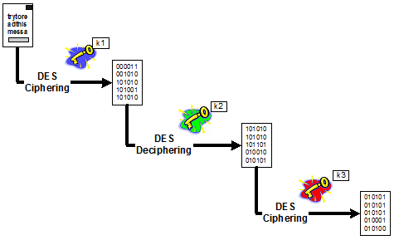

3DES decryption is performed as depicted in the following figure:

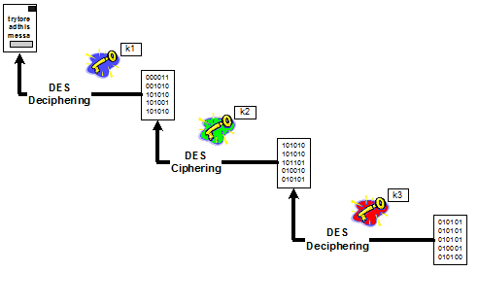

Several keying configuration are possible with 3DES.

**In this lab session, K1, K2 and K3 will be independent.**

## 1. Data Encryption Standard (1 point)

What is the size of DES cipher key's size ? (0.5 point)

What are the size of the cipher blocks ? (0.5 point)

## 2. DES/CBC/NoPadding (4,5 points)

2.1. Explain CBC with diagram (0,5 point)

2.2. Explain NoPadding (0,5 point)

For the next two questions, you are asked to encrypt the following file *./ebc/clearTextFileEBC*

2.3. Perform 3DES in EBC mode encryption in

TripleDES ::private Vector encryptEBC(...) (1,75 points)

2.4. Perform 3DES in EBC mode decryption in

TripleDES ::private void decryptEBC(...) (1,75 points)

## 2. DES/EBC/NoPadding

2.1. Explain EBC and its advantages over CBC with diagram (1 point)

For the two following questions, you are asked to encrypt the following file : ./cbc/clearTextCBC

2.3. Perform 3DES in CBC mode encryption in

TripleDES ::private Vector encryptCBC(...)(2 points)

2.4. Perform 3DES in CBC mode decryption in

TripleDES ::private void decryptCBC(...) (2 points)

RSA Signature Implementation

**(10 points)**

In this exercise, you have to answer to the questions into this document, and complete the file *./src/com/polytech/security/Asymetric.java* and *./src/com/polytech/security/Entity.java*

## 1. Use of Java Signature (3 points)

### 1.1. Generation of a public/private key pair (1 point)

Complete method *Entity::Entity()*

* Generate a keypairgenerator object of type java.security.KeyPairgenerator for RSA.
* Generate a keypair public/private.
* Store them in class members Entity::thePublicKey and Entity::thePrivateKey.

### 1.2. RSA Signature (1 point)

Complete method *Entity::sign()*

* Create an signature object *java.security.signature* for « SHA1withRSA ».
* Initialise the object with the private key in *SIGN_MODE*.
* Sign

### 1.3. Check signature (1 point)

Complete method *Entity::checkSignature()*

* Create an objet *java.security.Signature*
* Initialize it in *VERIFY* mode with the public key
* Check the signature.

## 2. Implementation of your own RSA signature (5 points)

### 2.1. Signature (2.5 points)

Complete method *Entity::mySign()*

Implement your own signature using

* *javax.crypto.Cipher* with *RSA* in *ENCRYPT_MODE* mode
* *java.security.MessageDigest* with *SHA1*.

### 2.2. Check signature (2.5 points)

Complete method *Entity::myCheckSignature()*

Implement your own signature verification using

* *javax.crypto.Cipher* with *RSA* in *DECRYPT_MODE* mode
* *java.security.MessageDigest* with *SHA1*

## 3. RSA Ciphering (2 points)

**Warning : RSA implementation by SUN does not support message greater than 127 bytes.**

### 3.1. RSAEncryption (1 point)

Complete method *Entity::encrypt()*

### 3.2. RSADecryption (1 point)

Complete method *Entity::decrypt().*

________________________________________________________________________

## 3. Secure session key exchange (2 points)

# You have to implement the following protocol between Alice and Bob for a secure session key exchange.

1. Alice sends her public key to Bob.
2. Bob generate a DES session key.
3. Bob encrypts it with Alice’s public key.
4. Alice decrypts the DES key with her private key.
5. Alice sends a message to Bob with her session key
6. Bob decrypts the message with the session key.

Please fill the static method ***KeyExchangeProtocol()*** in ***Asymetric.java***.

You can also refer to the slides from the application security lecture for further details on this secure session key exchange.