Brandon Franz

Homework 1

# Problem 1

1. Linear equations:
2. If , then linear matrix A will be singular, or in other words, the det(A) = 0
3. To compute the coefficients , we need to solve

where A represents the left-hand side of the linear equations defined in i)

where b represents the right-hand side of the linear equations defined in i)

In compute_traj, theta is given as:

In compute_controls, V and om are given as:

1. In the code, the two contraints enforced while rescaling V were as follows:
2. Differential Flatness Figure

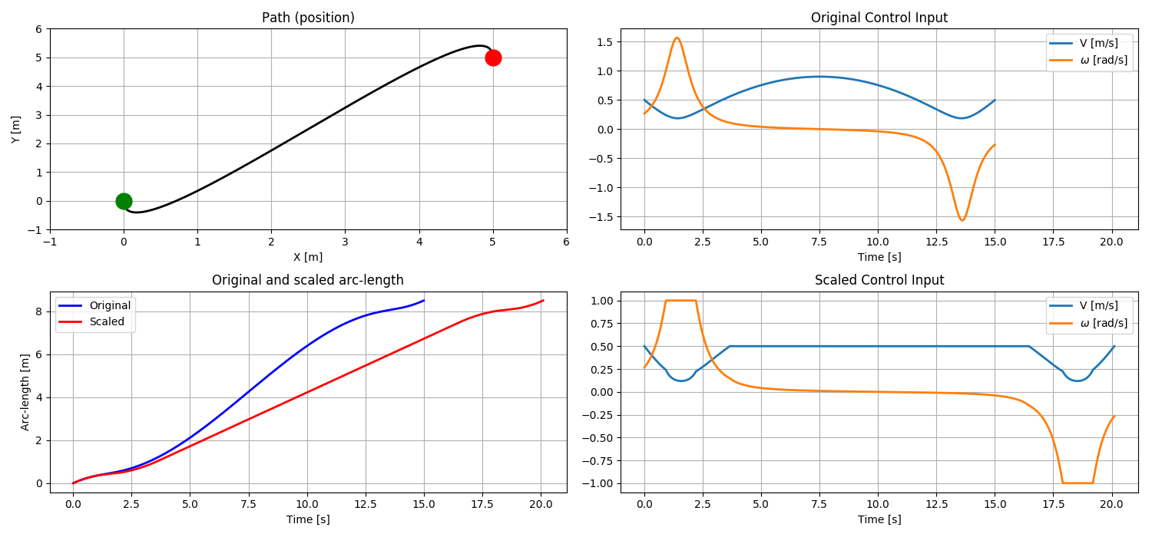

1. Open Loop

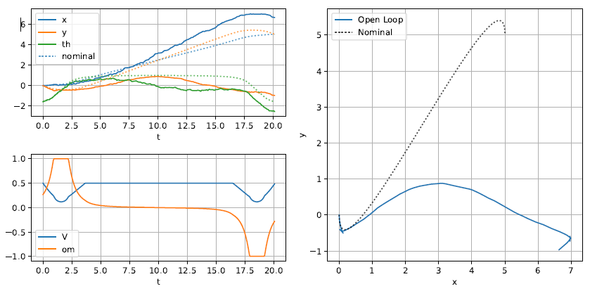

# Problem 2

Forward

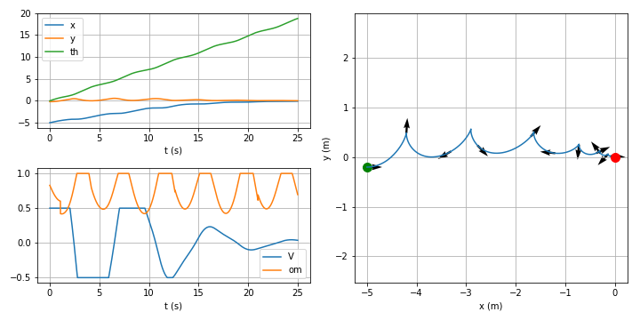

Reverse

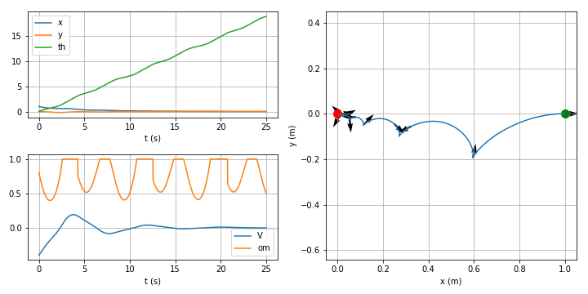

Parallel

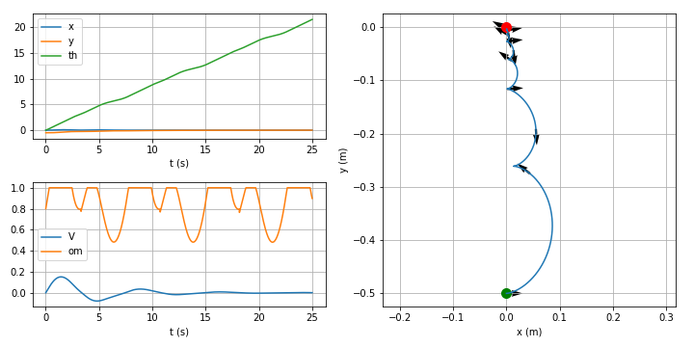

# Problem 3

1. From the notes:

Solving the linear system yields a and . To get V, we need another ODE:

1. Closed Loop (Can’t seem to find the instability here)

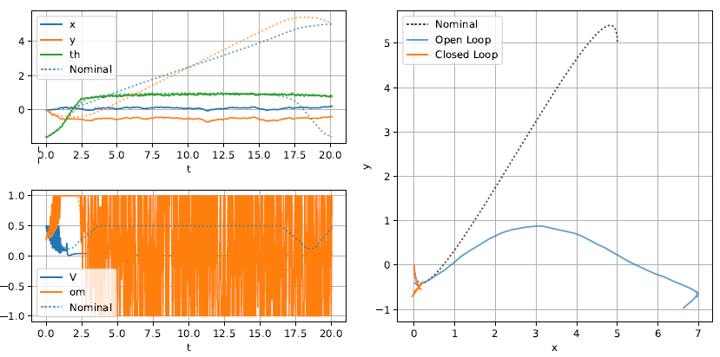

# Problem 4

1. Hamiltonian:

NOCs:

Initial BC:

Final BC:

where and

Optimal Control Plot

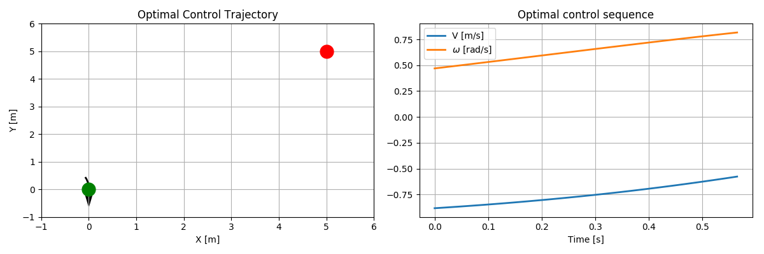

iv-v) Could not complete because I could not get my code to work. Normally I would take the extra days to complete, but I have a quiz in another class I have to study for.