Problem 1

1. Since a force closure is evaluated with both normal and friction forces, if you have a form closure which is evaluated with only normal forces, the addition of friction forces would only enhance the robustness of the grasp, therefore force closure is also achieved. If the forces at the contact points were limited, the addition of friction would decrease the normal force necessary to secure the grasp from the same disturbance.
2. In 2D (assume x-y plane), you have 3 DoF, so 2 contacts are required to restrain positive and negative movement in the x-direction and 2 contacts are required to restrain positive and negative movement in the y-direction
3. 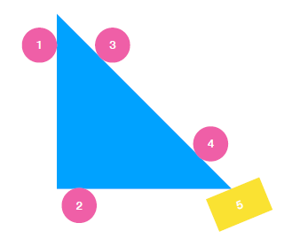

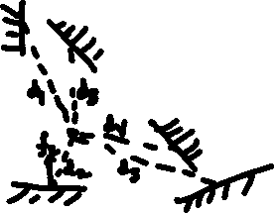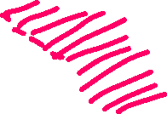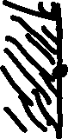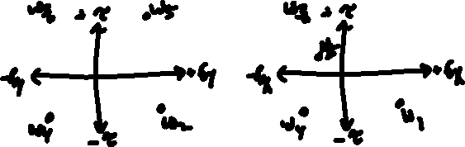

Point 1 is always required because it is the only contact force applied in the positive x direction, while Points 3, 4, and 5 apply forces in the negative x direction. Points 1, 2, and 4 apply positive torque and Points 3 and 5 apply negative torque, so one of each is always required to balance any external torque. Points 2 and 5 apply in the positive y and Points 3 and 4 apply in the negative y. Since all, but the positive x-direction are redundant, we can see that the following are valid subsets of 4 points:

1, 2, 3, 5 1, 2, 4, 5 1, 2, 3, 4 1, 3, 4, 5

1. Derive mu

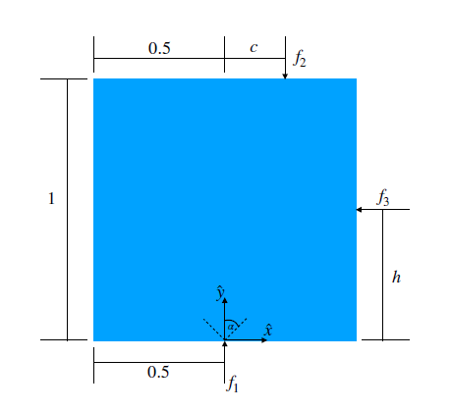

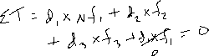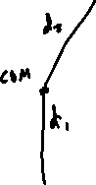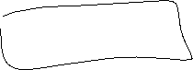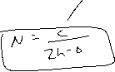

Problem 2

1. Contact Forces and Grasp Map
2. Reformulated SOCP

Problem 3

1. Training Loss: 59.5 Validation Loss: 61.2

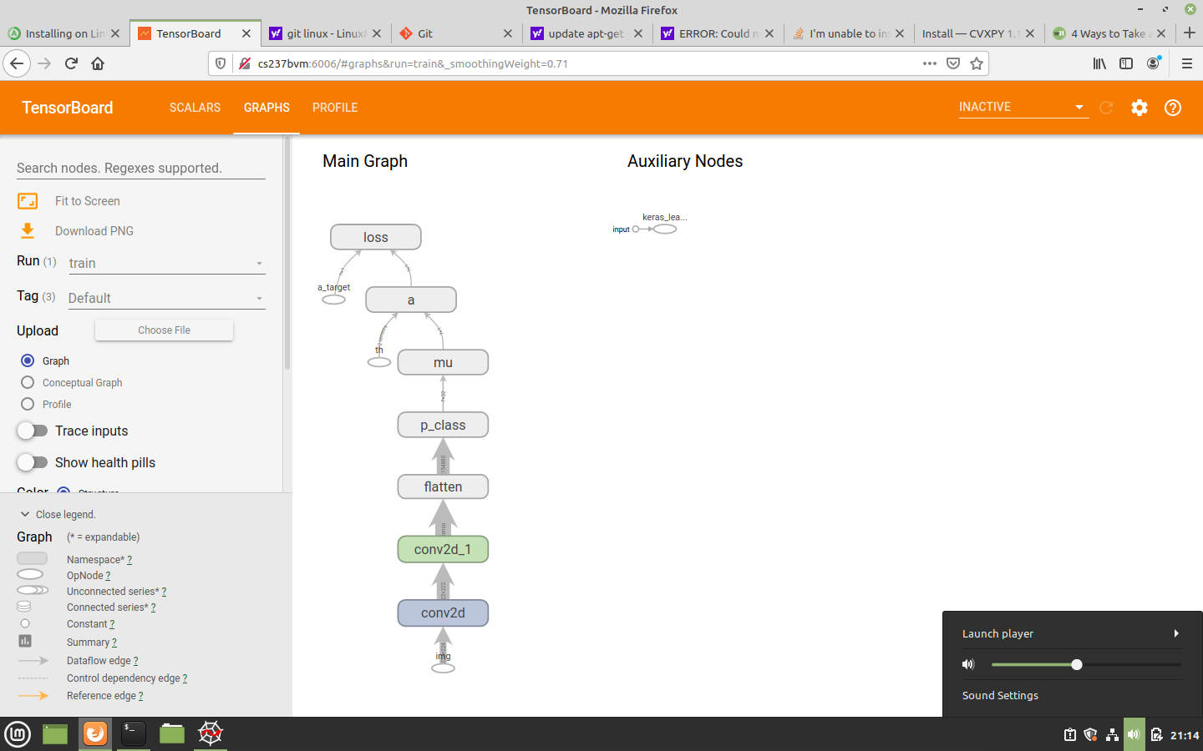

1. I wasn’t able to get a good run with my network. In my case, there would be no negative mu because I implemented a ReLU to prevent this. If I hadn’t I would have implemented the ReLU or similar to ensure positive values.
2. Training Loss: 8.0 Validation Loss: 7.9

Compared to the physics network, it should have been worse. I have some sort of error in my physics network. Incorporating the physical relationship in the problem improves the ability of the network to generalize the weights, since it is constrained by the physical behavior.