Brandon Franz

AA274A Section 1

Sept. 21, 2020

# Section 1 Write-Up

## 1 OS Setup

Currently, I am running Windows 10 with Anaconda, however I plan to either use WSL or dual boot for Linux for the homeworks/projects.

## 2 Using Git

Git is installed

## 3 Python

I successfully ran all the example scripts. I was able to define and plot the sine function, seen below

.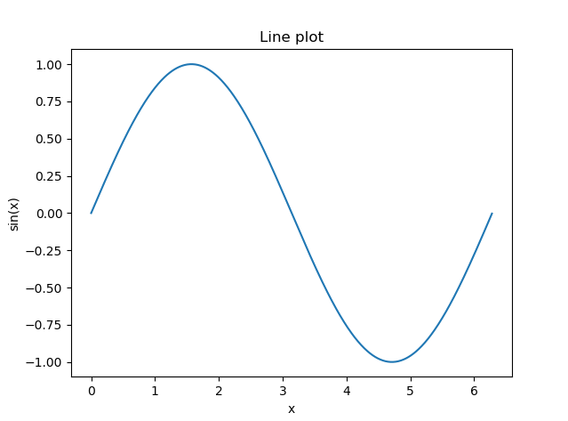

Figure 1: Plot of sine function using Matplotlib

Further, I was able to find the minimum, -1, and the integral from [0,1], 0.460, using SciPy. The code is given below.

#!/usr/bin/env python

#Imports

import numpy as np

import matplotlib.pyplot as plt

from scipy.integrate import quad

from scipy.optimize import minimize

#Functions

x = np.arange(0., 2*np.pi, 0.01)

def sin_np(x):

return np.sin(x)

y = sin_np(x)

#Integrate

def integrand(x):

return sin_np(x)

y_int = quad(integrand, 0, 1)

print("Integral of sin(x) from x=0..1: {}".format(y_int[0]))

#Minimize

x0 = 0

print("Nelder-Mead simplex method:")

res = minimize(sin_np, x0, method='nelder-mead', options={'xtol': 1e-8, 'disp': True})

#Plot

plt.plot(x,y)

plt.title("Plot of Sin(x)")

plt.xlabel("x")

plt.ylabel("sin(x)")

plt.show()

## 4 Jupyter

Jupyter is installed, and I was able to run it.