**Actors and Actions**

1. **Student**
   1. Can register
      1. First Name
      2. Last name
      3. Email address
      4. username
      5. Password

**Registration system can be out of scope for initial development. New Students and teachers can be added by Teacher admin directly.**

* 1. Can login
     1. Username
     2. password
  2. Can change password
     1. Username
     2. Old password
     3. New password
     4. New password confirm
  3. Can forget username
     1. Email address
  4. Can forget password
     1. Email address
  5. Can view assignment
     1. Assignment Pic ( pdf)
     2. Assignment Description( if applicable)
     3. Assignment start date
     4. Assignment completion Date
     5. Assignment Subject
     6. Assignment Topic
     7. Assigned By
     8. Assignment marks (if applicable)
  6. Can download assignment
     1. Download pdf
  7. Can upload assignment response
     1. Upload assignment response ( pdf, jpeg)
     2. Notes
  8. Can review marked assignment
     1. Review marked assignment
     2. Acknowledge review
  9. Can take multiple choice paper
     1. Paper Duration
     2. Paper marks
     3. Start Paper
     4. Submit Response

**Out of scope for initial development**

* 1. Can review marked multiple choice paper
     1. Review marked paper
     2. Acknowledge review

**Out of scope for initial development**

* 1. Can review assignment report
     1. Calendar year
     2. Date range
     3. Assignment rating by teacher
  2. Can review multiple choice paper report
     1. Calendar year
     2. Date range
     3. Paper rating by teacher

**Out of scope for initial development**

1. **Teacher**
   1. Can register
      1. First Name
      2. Last name
      3. Email address
      4. username
      5. Password

**Registration system can be out of scope for initial development. New Students and teachers can be added by Teacher admin directly.**

* 1. Can login
     1. Username
     2. password
  2. Can change password
     1. Username
     2. Old password
     3. New password
     4. New password confirm
  3. Can forget username
     1. Email address
  4. Can forget password
     1. Email address
  5. Can upload assignment
     1. Assignment Subject
     2. Assignment Topic
     3. Assignment Marks
     4. Assignment pic ( pdf)
     5. Assignment Description
  6. Can assign assignment to student/class
     1. Select student(s)/class
     2. Select assignment(s)
     3. Add Start Date
     4. Add completion date
     5. Add assignment Notes( if applicable)
  7. Can change assignment completion date
     1. Select student(s)/class
     2. Select assignment
     3. Change assignment completion date
     4. Reason for change
  8. Can un-assign assignment (self-assigned)
     1. Select student(s)/class
     2. Select assignment
     3. Remove assignment
     4. Reason for removal
  9. Can view assignment response
     1. Review completed assignment
     2. Download completed assignment
     3. Upload marked assignment
     4. Rate Assignment

1. **Teacher Admin**
   1. Add User
      1. First Name
      2. Last name
      3. Email address
      4. username
      5. Password
      6. Role ( Teacher/Student/teacher admin)
   2. Assign Students to teachers
      1. Select student(s)
      2. Select teacher(s)
      3. Complete assignment
   3. Add Class
      1. Class Name
   4. Assign Students to Class
      1. Class Name
      2. Student Name
   5. Add Subjects
      1. Add Subject Name
   6. Add Topics
      1. Select Subject
      2. Topic name
   7. Upload assignment
      1. Assignment Subject
      2. Assignment Topic
      3. Assignment Marks
      4. Assignment pic ( pdf)
      5. Assignment Description
   8. Delete Assignment
      1. Select assignment
      2. Mark deleted
   9. Add multiple choice questions and type
      1. Subject
      2. Topic
      3. Question
      4. Type (select one, select multiple, open ended)
         1. Select one – only one response
         2. Select multiple – multiple responses
         3. Open ended – type text
      5. Answer options ( based on selection above )
      6. Actual Answer ( select or add comment based on question type)

This section is out of scope for initial development

1. **Admin**
   1. Announcement board message ( on home screen)
   2. Lock account
   3. Unlock account

**Wireframes**

**Login Screen**

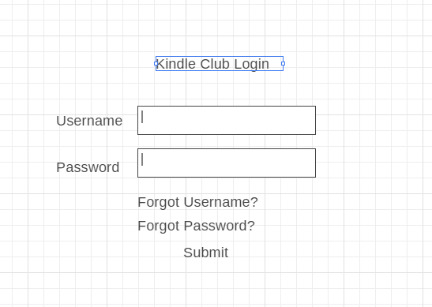

|  |  |  |  |  |
| --- | --- | --- | --- | --- |
| **UI Field Name** | **Field Type** | **Db Field Name** | **UI Validation** | **Default value** |
| **Username** | **Text input** | **Login_information.username** | **10 Characters Text + Numbers only** | **None** |
| **Password** | **Text Input** | **Login_information.password** | **10 Characters**  **Text+ Numbers only** | **None** |

**Change password screen**

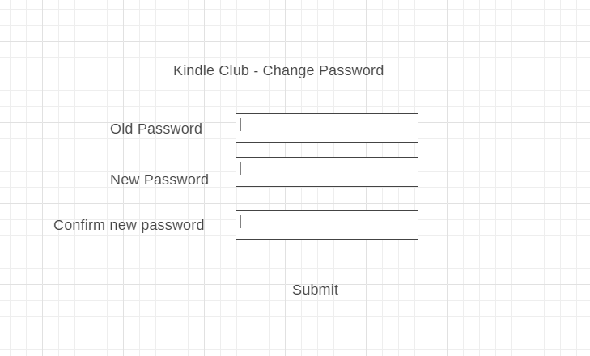

|  |  |  |  |  |
| --- | --- | --- | --- | --- |
| **UI Field Name** | **Field Type** | **Db Field Name** | **UI Validation** | **Default value** |
| **Old Password** | **Text Input** | **Login_information.password** | **10 Characters Text + Numbers only** | **None** |
| **New Password** | **Text Input** | **Login_information.password** | **10 Characters Text + Numbers only** | **None** |
| **New Password Confirm** | **Text Input** | **Login_information.password** | **10 Characters Text + Numbers only** | **None** |

**Forgot username/password screen**

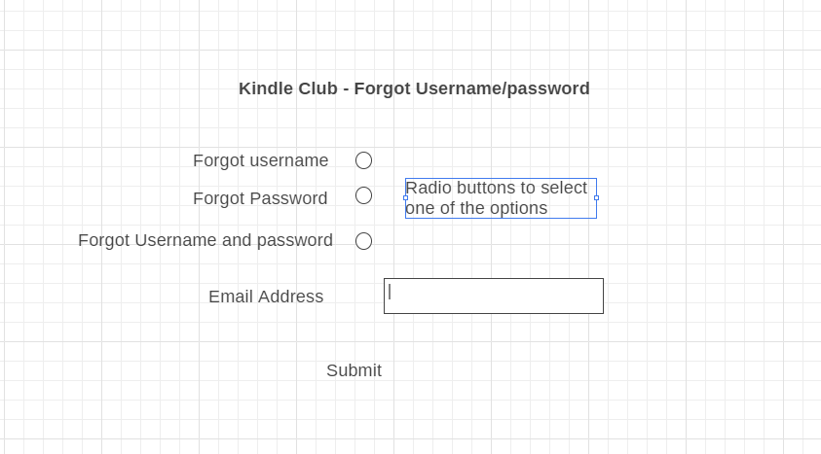

|  |  |  |  |  |
| --- | --- | --- | --- | --- |
| **UI Field Name** | **Field Type** | **Db Field Name** | **UI Validation** | **Default value** |
| Forgot Username | Radio button | None | None | Not selected |
| Forgot password | Radio button | None | None | Not selected |
| Forgot username and password | Radio button | None | None | Not selected |
| Email address | Text Input | Login_information.password | Email validation | None |

**On providing the email address if the email matches the one in db, send an email with username and password. Two separate emails for username and password depending on UI selection**

**Registration Screen**

Role for the user will be identified based on whether they have clicked the “Student Registration” or “Teacher Registration” link on the website.

By default the account will be locked. Users will not be able to access any information unless admin activates the account

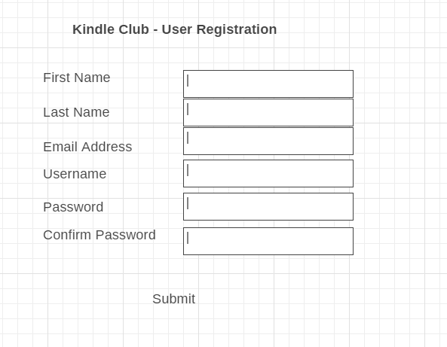

|  |  |  |  |  |
| --- | --- | --- | --- | --- |
| **UI Field Name** | **Field Type** | **Db Field Name** | **UI Validation** | **Default value** |
| **First name** | **Text Input** | **Users. FirstName** | **Text input, Required** | **None** |
| **Last name** | **Text Input** | **Users.LastName** | **Text Input, Required** | **None** |
| **Email** | **Text Input** | **User.EmailAddress** | **Email validation, Required** | **None** |
| **username** | **Text Input** | **Login_information.username** | **10 characters alphanumeric, required** | **None** |
| **password** | **Text Input** | **Login_information.Password** | **10 characters alphanumeric, required** | **None** |
| **Confirm password** | **Text Input** | **None** | **Matches the password, required** |  |

**Not in Scope for initial development**

**View Assignment screen**

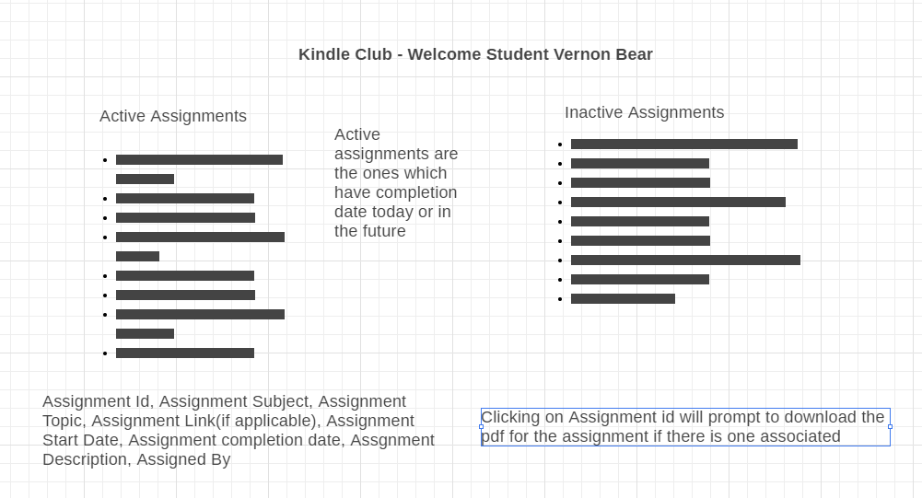

|  |  |  |  |  |
| --- | --- | --- | --- | --- |
| **UI Field Name** | **Field Type** | **Db Field Name** | **UI Validation** | **Default value** |
| **Assignment Id** | **Clickable link** | **Assignment.Assignment_id** |  |  |
| **Subject Name** | **Text Display only** | **Subject.subject_name** |  |  |
| **Topic Name** | **Text Display only** | **Topic.topic_name** |  |  |
| **Assignment Link** | **Pdf display** | **Assignment.Assignment_pic** | **Valid URL** |  |
| **Assignment Start date** | **Text Display** | **Student Assignment Map.assignment_start_date** |  |  |
| **Assignment Completion date** | **Text Display** | **Student Assignment Map.assignment_completion_date** |  |  |
| **Assignment Description** | **Text Display** | **Assignment.Assignment_Description** |  |  |
| **Assignment Marks** | **Text Display** | **Assignment.Assignment_marks** |  |  |
| **Assigned By** | **Text Display** | **User.firstname||lastname** |  |  |

**Complete Assignment screen**

Select the assignment from the screen above by clicking the assignment completion date link Student

**Add new subjects screen**

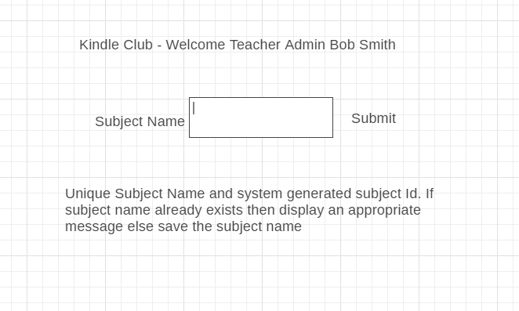

|  |  |  |  |  |
| --- | --- | --- | --- | --- |
| **UI Field Name** | **Field Type** | **Db Field Name** | **UI Validation** | **Default value** |
| **Subject name** | **Text Input** | **Subject.Subject_Name** | **String (alphanumeric).** |  |

**Add new topics screen**

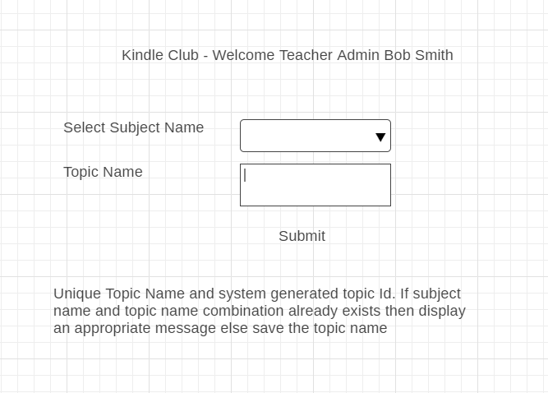

|  |  |  |  |  |
| --- | --- | --- | --- | --- |
| **UI Field Name** | **Field Type** | **Db Field Name** | **UI Validation** | **Default value** |
| **Topic Name** | **Text Input** | **Topic.Topic_name** | **String ( alphanumeric)** |  |

**Add User Screen**

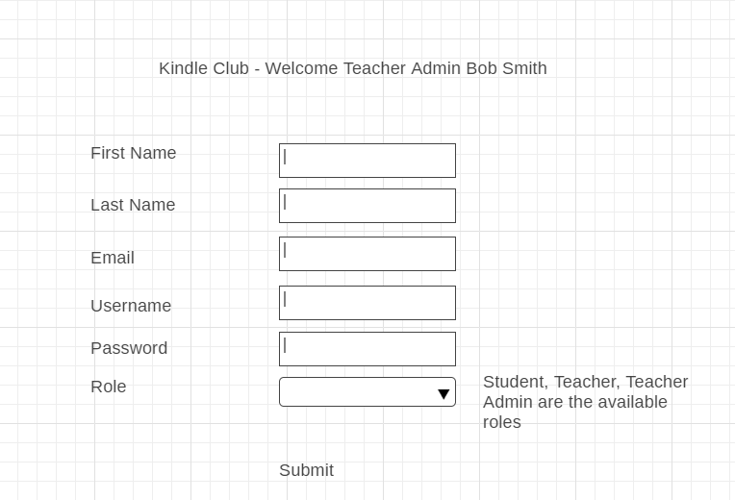

|  |  |  |  |  |
| --- | --- | --- | --- | --- |
| **UI Field Name** | **Field Type** | **Db Field Name** | **UI Validation** | **Default value** |
| **First Name** | **Text Input** | **Users.first_name** | **String( alphanumeric)** |  |
| **Last name** | **Text Input** | **Users.last_name** | **String ( alphanumeric)** |  |
| **Email** | **Text Input** | **Users.email_address** | **Valid email** |  |
| **Username** | **Text Input** | **Login_information.username** | **8 characters -alphanumeric( unique in db)** |  |
| **Password** | **Text Input ( password field)** | **Login_information.password** | **Min 8 characters, alphanumeric** |  |
| **Role** | **Drop down list**   * **Student** * **Teacher** * **Teacher Admin** | **Users.role** | **Select (use values ST,TE,TA)** |  |

**Add Class screen**

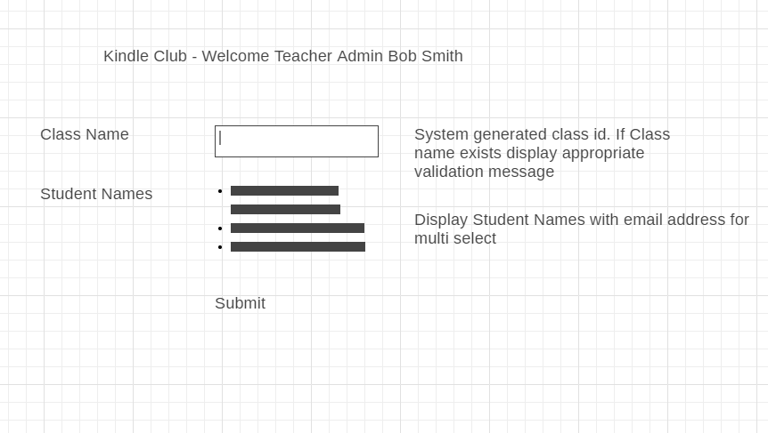

|  |  |  |  |  |
| --- | --- | --- | --- | --- |
| **UI Field Name** | **Field Type** | **Db Field Name** | **UI Validation** | **Default value** |
| **Class Name** | **Input Text** | **Class.class_name** | **Alphanumeric** |  |
| **Student name** | **Display for multiselect** | **Users.First_ Name||Last_Name** |  |  |
| **Email address** | **Display for multiselect** | **Users.email_address** |  |  |
|  |  |  |  |  |

**Upload assignment screen**

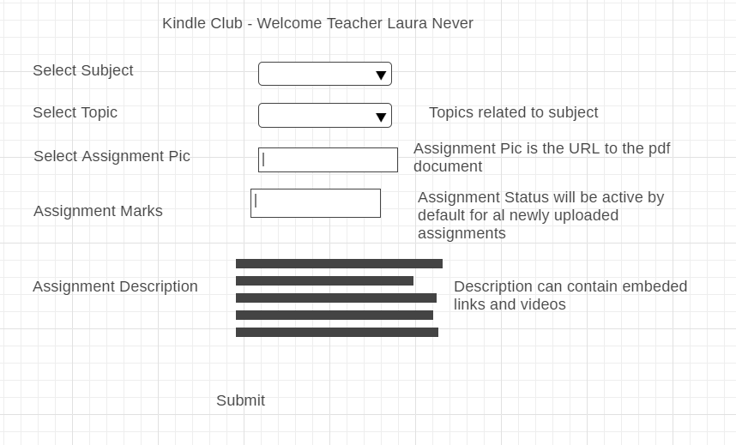

|  |  |  |  |  |
| --- | --- | --- | --- | --- |
| **UI Field Name** | **Field Type** | **Db Field Name** | **UI Validation** | **Default value** |
| **Select subject** | **Drop down** | **Subject.subject_name** |  |  |
| **Select Topic** | **Drop down** | **Topic.Topic_name** |  |  |
| **Select assignment pic( URL)** | **File select** | **Assignemnt.Assignment_pic** |  |  |
| **Assignment marks** | **Text** | **Assignemnt.assignment_marks** | **Alphanumeric** |  |
| **Assignment description** | **Text Area Input** | **Assignemnt.assignment_description** | **alphanumeric** |  |

**Assign Assignment screen**

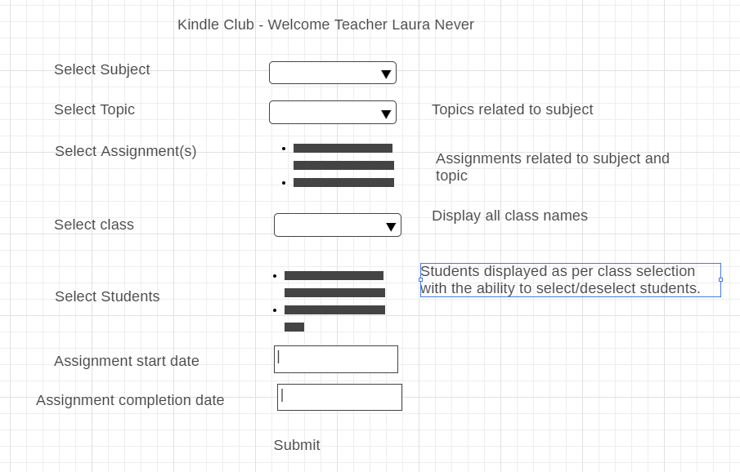

|  |  |  |  |  |
| --- | --- | --- | --- | --- |
| **UI Field Name** | **Field Type** | **Db Field Name** | **UI Validation** | **Default value** |
| **Select Subject** | **Drop down** | **Subject.Subject_name** |  |  |
| **Select Topic** | **Drop down** | **Topic.Topic_name** |  |  |
| **Select assignment(s)** | **10 assignments ( with pagination)** | **Assignment.AssignementId,**  **Assignment.Assignment_Pic**  **Assignement.Assignment_description** |  |  |
| **Select Class** | **Drop down** | **Class.class_name** |  |  |
| **select Students** | **Student names ( all in one page, no pagination)** | **Users.first_name||last_name** |  |  |
| **Assignment start date** | **Date** | **Assignment.assignment_start_date** | **Date** |  |
| **Assignment Completion date** | **Date** | **Assignement.Assignment_completion_date** | **Date** |  |
|  |  |  |  |  |

**Assign student/class to teachers screen**

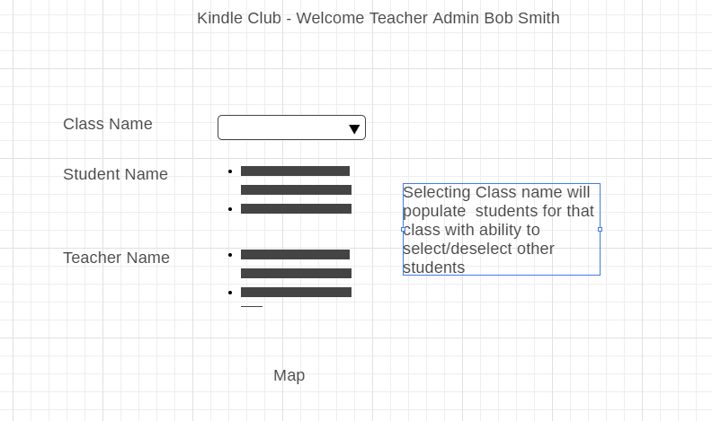

|  |  |  |  |  |
| --- | --- | --- | --- | --- |
| **UI Field Name** | **Field Type** | **Db Field Name** | **UI Validation** | **Default value** |
| **Class Name** | **Drop down** | **Class.classname** |  |  |
| **Student name** | **Multi Select from list** | **Users.userid ( student role)** |  |  |
| **Teacher name** | **Multi select from list** | **Users.userid ( teacher role)** |  |  |

**Lock/unlock account screen**

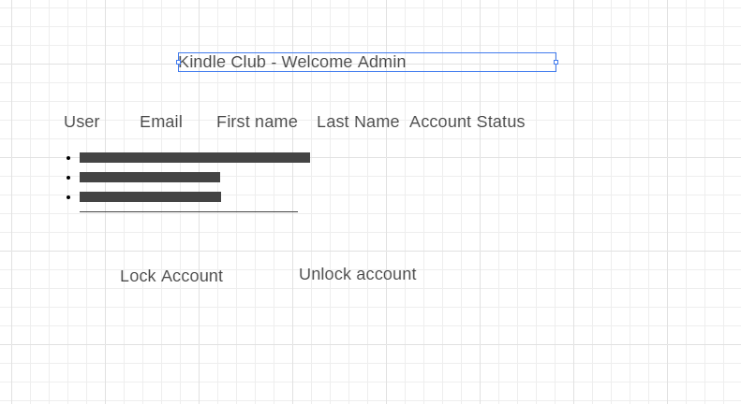

|  |  |  |  |  |
| --- | --- | --- | --- | --- |
| **UI Field Name** | **Field Type** | **Db Field Name** | **UI Validation** | **Default value** |
| **User name** | **Display** | **Login_information.username** |  |  |
| **Email address** | **Display** | **Login_information.email_address** |  |  |
| **First Name** | **Display** | **Users.First_name** |  |  |
| **Last Name** | **Display** | **Users.last_name** |  |  |
| **Account status** | **Checkbox( active, checked, inactive unchecked)** | **Login_information.login_status( active/inactive)** |  |  |

**ER Diagram**

