**Project 2: Counter with Display**

**CS200 (Patrick Kelly)**

Date Submitted: 2/15/13

By

Brandon Horner

**Project Overview**

The purpose of this project is to create a BCD to 7-segment LED converter and also a modulo-10 counter using JK flip flops. Producing these circuits will accomplish the task of practicing combinational and sequential circuits.

**Approach**

I first started by creating a truth table with 4-bits as input (x0-x3) and 7 outputs which are the segments of the 7-segment LED. Using this table I created functions for each segment of the 7-segment LED to which I could create logic gates for. I used a decoder with 4-bit input to create the possible 16 outputs. I only ended up using 8 of the outputs to control the 7-segment LED because all of the segment functions only required outputs E0-E8. Once all of the functions were created in logic gates, I connected the functions to the corresponding inputs to the 7-segment LED.

For the modulo-10 counter, I first recreated the 16-modulo counter found in the book. In order to limit it to a modulo-10 counter I had to reset the JK Flip flops to 0000 after it counted to 9 (1001). When the count reached 10 (0101), the second and fourth JK flip flops were connected by an AND gate, which asynchronously reset each of the other JK flip flops, bringing the count back to 0 (0000).

|  |  |  |  |  |  |  |  |  |  |  |  |
| --- | --- | --- | --- | --- | --- | --- | --- | --- | --- | --- | --- |
| Digit | x0 | x1 | x2 | x3 | SegT | SegTR | SegBR | SegB | SegBL | SegTL | SegM |
| 0 | 0 | 0 | 0 | 0 | on | on | on | on | on | on | off |
| 1 | 0 | 0 | 0 | 1 | off | on | on | off | off | off | off |
| 2 | 0 | 0 | 1 | 0 | on | on | off | on | on | off | on |
| 3 | 0 | 0 | 1 | 1 | on | on | on | on | off | off | on |
| 4 | 0 | 1 | 0 | 0 | off | on | on | off | off | on | on |
| 5 | 0 | 1 | 0 | 1 | on | off | on | on | off | on | on |
| 6 | 0 | 1 | 1 | 0 | on | off | on | on | on | on | on |
| 7 | 0 | 1 | 1 | 1 | on | on | on | off | off | off | off |
| 8 | 1 | 0 | 0 | 0 | on | on | on | on | on | on | on |
| 9 | 1 | 0 | 0 | 1 | on | on | on | on | off | on | on |
| A | 1 | 0 | 1 | 0 | on | on | on | off | on | on | on |
| b | 1 | 0 | 1 | 1 | off | off | on | on | on | on | on |
| C | 1 | 1 | 0 | 0 | on | off | off | on | on | on | off |
| d | 1 | 1 | 0 | 1 | off | on | on | on | on | off | on |
| E | 1 | 1 | 1 | 0 | on | off | off | on | on | on | on |
| F | 1 | 1 | 1 | 1 | on | off | off | off | on | on | on |

T=Top, B=Bottom, R= Right, L = Left, M= Middle

SegT(x3, x2, x1, x0) = (E1 + E4)’

SegTR(x3, x2, x1, x0) = (E5 +E6)’

SegBR(x3, x2, x1, x0) = (E2)’

SegB(x3, x2, x1, x0) = (E1 + E4 + E7)’

SegBL(x3, x2, x1, x0) = (E0 + E2 + E6 + E8)

SegTL(x3, x2, x1, x0) = (E1 + E2 + E3 + E7)’

SegM(x3, x2, x1, x0) = (E0 + E1 + E7)’

Seg8(x3, x2, x1, x0) = 0

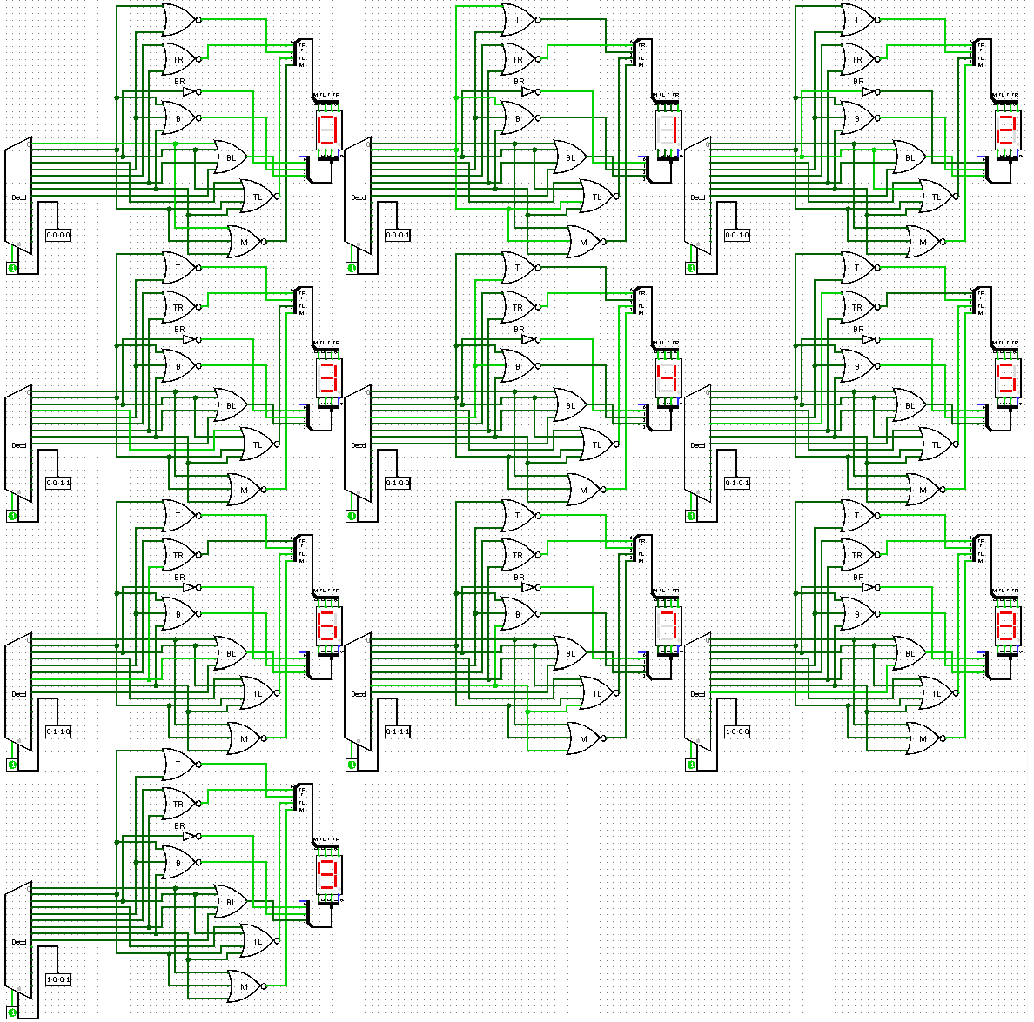**Sample Output - DCB to 7-Seg Converter**

**Sample Output – Modulo 10 Counter**

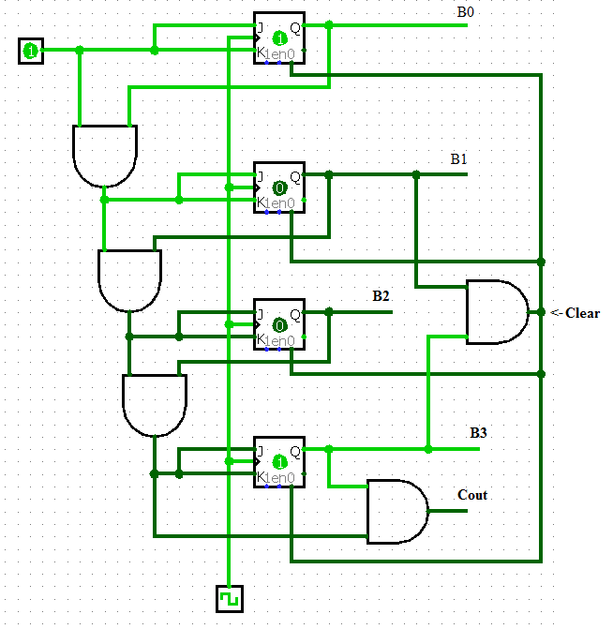

**Conclusion**

Upon completing this project, I feel I have a better understanding of clocks and sequential circuits, as well as how 7-segment LED displays work. Actually creating the circuits has helped more than just looking at already completed circuits. For instance, my first look at the 16-modulo counter ended with me not knowing what exactly does what, but creating the circuit for myself, playing with it and coming up with a way to clear the state each JK flip flop made me realize that these circuits are not all that complicated.

I struggled at first trying to use the 7-segment LED display, because I did not thoroughly think about what each input was doing. When I counted through the DCB to 7-segment converter, my counter stopped at 6, and stopped displaying digits correctly. I was able to look back at my functions and saw that I had not wired last few functions correctly.

The only piece of this project I could not manage to do was connecting my Modulo-10 Counter to a 7-segment LED, however I can still see that my circuit counts from 0-9 by the outputs B0-B3.