Project 1: Domain Setup

CS212

9/12/13

by

Brandon Horner

**Purpose**

The purpose of this project is to begin making a website in HTML. The second part of the project is to put our up in a browser.

**Approach**

This project was pretty simple to start up. I went through the entire setup guide and eventually had the test site up and running. I began by adding in a few basic tags, creating a title for the page included in the head section. I could not think of anything to write on the page due to lack of creativity, so I added some photos from my Facebook using <img> tags and included descriptions above each picture. I added <h3> tags to the descriptions to make them stand out more and a <hr> line under the pictures to separate them from any text that will be below.

After a while of shifting things around and making the pictures the correct sizes, I decided to look around on the internet for simple ways to make my web page more appealing and found the <div>. I used this tag to divide up my page into a more average looking web page. I didn’t add much content to the web page but it turned out alright for now:

[www.cefns.nau.edu/~bkh76/](http://www.cefns.nau.edu/~bkh76/)

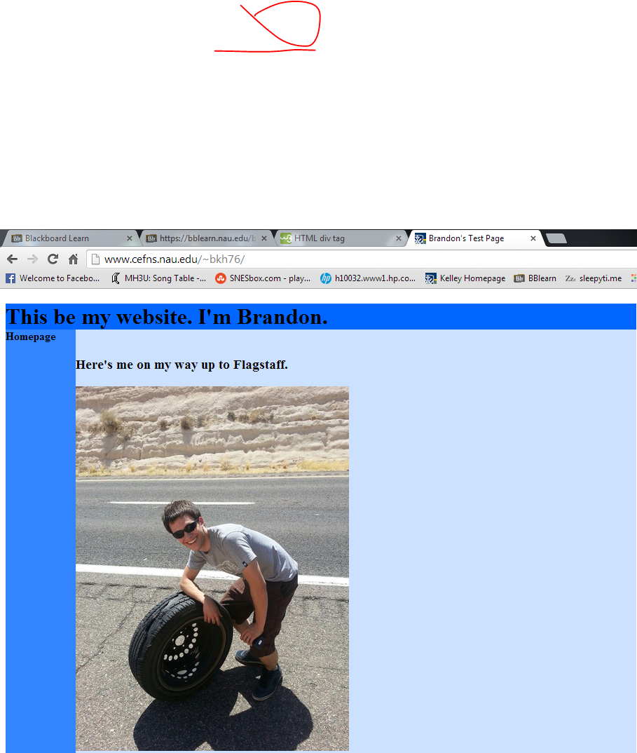

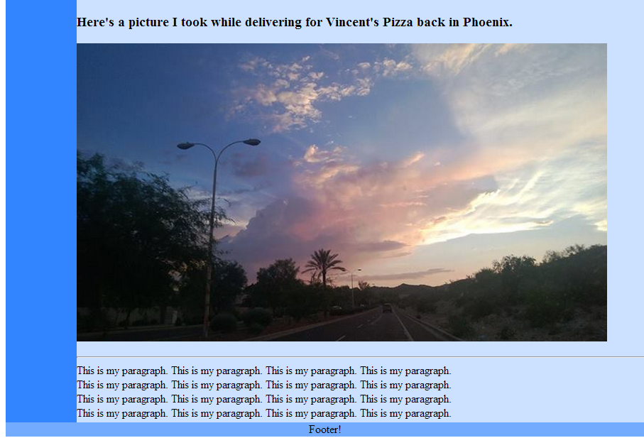

**Conclusion**

I want to add more to the website but I am not sure how to make it less stale yet. I will keep looking for more ways to make my website better aesthetically, even though I would rather learn how to make the functionality of a website to motivate me to continue working on this. Overall this was a very easy project, finding out how to do things in HTML was much simpler than anything I have programmed before. I had a class in middle school that brushed on HTML and showed us how to make a simple website but I imagine we did not do as much as this project.

**Source Code:**

<!DOCTYPE html>

<html>

<body>

<head>

<title>Brandon's Test Page</title>

</head>

<div id="container" style="width:500px">

<div id="header" style="background-color:#0066FF;width:900px">

<h1 style="margin-bottom:0;"><b>This be my website. I'm Brandon.</b></h1></div>

<div id="menu" style="background-color:#3385FF;height:1200px;width:100px;float:left;">

<b>Homepage</b><br>

</div>

<div id="content" style="background-color:#CCE0FF;height:1200px;width:900px;float:center;">

<br>

<h3>Here's me on my way up to Flagstaff.</h3>

<p><img src="http://tinyurl.com/pjbc6uh" width="390" height="520"></p>

<h3>Here's a picture I took while delivering for Vincent's Pizza back in Phoenix.</h3>

<p><img src="http://tinyurl.com/nmj3aud" width="747" height="420"></p>

<hr>

This is my paragraph. This is my paragraph. This is my paragraph. This is my paragraph.<br>

This is my paragraph. This is my paragraph. This is my paragraph. This is my paragraph.<br>

This is my paragraph. This is my paragraph. This is my paragraph. This is my paragraph.<br>

This is my paragraph. This is my paragraph. This is my paragraph. This is my paragraph.

</div>

<div id="footer" style="background-color:#73ABFF;width:900px;text-align:center;">

Footer!</div>

</div>

</body>

</html>