CS249 Data Structures

Worksheet #6

Due: 12/2/14

By Brandon Horner

**Part 1:**

*Transitive Closure Matrix*

|  |  |  |  |  |  |
| --- | --- | --- | --- | --- | --- |
|  | A | B | C | D | E |
| A | 1 | 1 | 1 | 1 | 1 |
| B | 1 | 1 | 1 | 1 | 1 |
| C | 1 | 1 | 1 | 1 | 1 |
| D | 1 | 1 | 1 | 1 | 1 |
| E | 1 | 1 | 1 | 1 | 1 |

(Each node can be reached by any other node with 1 or more hops)

**Part 2:**

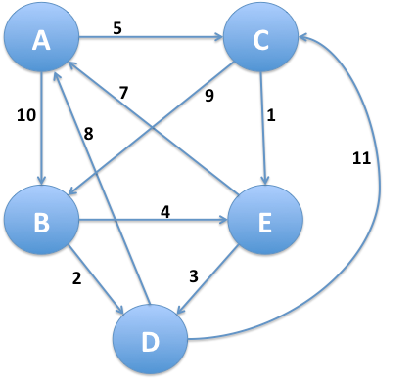*Shortest path from A to every other vertex*

A to A = 13 (A -> C -> E -> A)

A to B = 10 (A -> B)

A to C = 5 (A -> C)

A to D = 9 (A -> C -> E -> D)

A to E = 6 (A -> C -> E)

|  |  |  |  |  |  |
| --- | --- | --- | --- | --- | --- |
|  | A | B | C | D | E |
| A | 0 | 10 | 5 | inf | inf |
| C | 0 | 10 | 5 | inf | 6 |
| E | 13 | 10 | 5 | 9 | 6 |
| D | 13 | 10 | 5 | 9 | 6 |
| B | 13 | 10 | 5 | 9 | 6 |

**Part 3:**

*List all Hamiltonian Cycles*

1. A -> B -> D -> C -> E -> A
2. A -> C -> B -> E -> D -> A
3. B -> D -> C -> E -> A -> B
4. B -> E -> D -> A -> C -> B
5. C -> E -> A -> B -> D -> C
6. C -> B -> E -> D -> A -> C
7. D -> C -> E -> A -> B -> D
8. D -> A -> C -> B -> E -> D
9. E -> A -> B -> D -> C -> E
10. E -> D -> A -> C -> B -> E