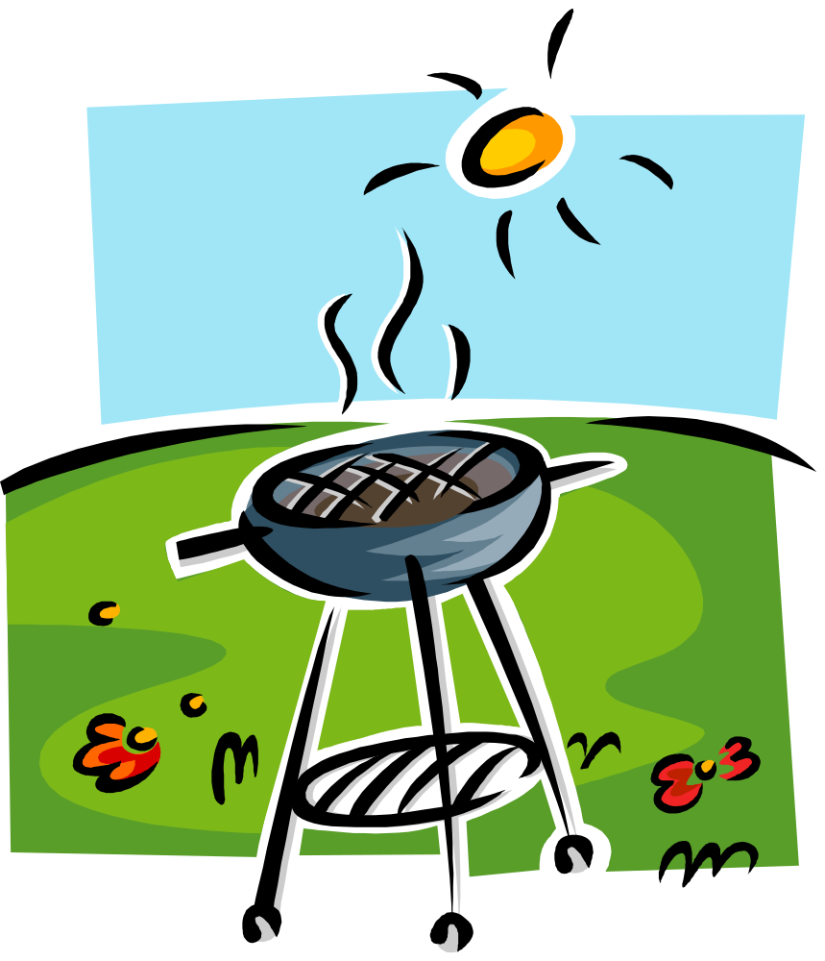
Simple Word Templates are are Dangerous!!!
Everyone
Is Welcome
To come!
Come for a night
of food & fun!
PARTY
With ME

Bring your own meat,
and grill away!

Friday, July 27th, 6 pm
Random park

Bring something to
share with others!

