GRILLPARTY
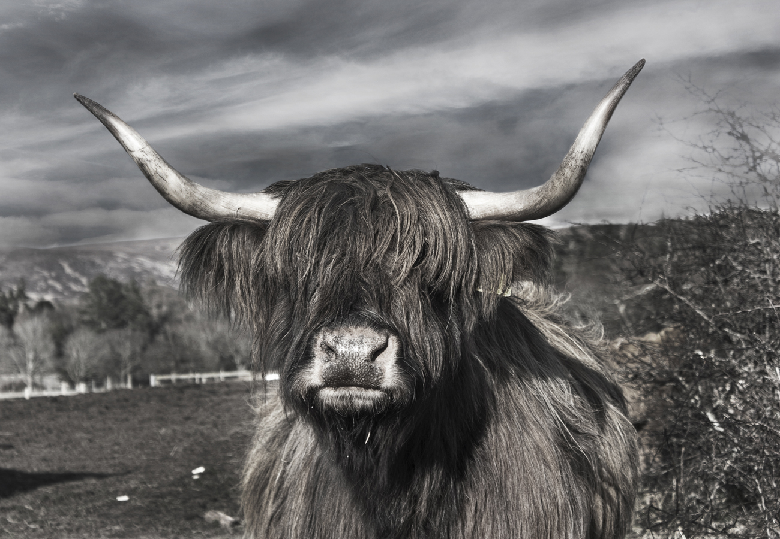

Bring Your Own Beef to Random Park
Friday, July 23 – 6PM

*made in MS Word.

