Final_Project_Shields

Brandon Lloyd Shields

12/6/2021

#load packages needed for analysis  
  
library(dplyr)

## Registered S3 methods overwritten by 'tibble':  
## method from   
## format.tbl pillar  
## print.tbl pillar

##   
## Attaching package: 'dplyr'

## The following objects are masked from 'package:stats':  
##   
## filter, lag

## The following objects are masked from 'package:base':  
##   
## intersect, setdiff, setequal, union

library(tidyr)  
library(caret)

## Loading required package: lattice

## Loading required package: ggplot2

library(keras)  
library(ggplot2)  
library(pROC)

## Type 'citation("pROC")' for a citation.

##   
## Attaching package: 'pROC'

## The following objects are masked from 'package:stats':  
##   
## cov, smooth, var

library(Hmisc)

## Loading required package: survival

##   
## Attaching package: 'survival'

## The following object is masked from 'package:caret':  
##   
## cluster

## Loading required package: Formula

##   
## Attaching package: 'Hmisc'

## The following objects are masked from 'package:dplyr':  
##   
## src, summarize

## The following objects are masked from 'package:base':  
##   
## format.pval, units

library(corrplot)

## corrplot 0.84 loaded

#Motivation  
  
#As I am begining to think about possible career transistion after completing my MSBA degree, I thought about opular industries in Northeast Ohio. The first thing that came to mind was the medical industry with world class hospitals in both Cleveland and Akron. Online job boards further indicate a variety of analyst posistions in this industry across the region. It was for this reason that I was motivated to work with medical data.  
  
#Data Source  
  
# I will be working with a data set from Kaggle (https://www.kaggle.com/andrewmvd/heart-failure-clinical-data/code).   
  
#Dataset from Davide Chicco, Giuseppe Jurman: â€œMachine learning can predict survival of patients with heart failure from serum creatinine and ejection fraction alone. BMC Medical Informatics and Decision Making 20, 16 (2020)  
  
#Cardiovascular disease (CVD) is the number one reason for death globally. There are a variety of behavioral and risk factors that can be used to predict mortality of heart of failure. Having an algorithm that can predict mortality could serve as early detection for high risk patients. The dataset consists of 12 explanatory variables and the target variable (death event)  
  
cvd <- read.csv(file = "~/Downloads/heart_failure_clinical_records_dataset.csv")

summary(cvd)

## age anaemia creatinine_phosphokinase  
## Min. :40.00 Min. :0.0000 Min. : 23.0   
## 1st Qu.:51.00 1st Qu.:0.0000 1st Qu.: 116.5   
## Median :60.00 Median :0.0000 Median : 250.0   
## Mean :60.83 Mean :0.4314 Mean : 581.8   
## 3rd Qu.:70.00 3rd Qu.:1.0000 3rd Qu.: 582.0   
## Max. :95.00 Max. :1.0000 Max. :7861.0   
## diabetes ejection_fraction high_blood_pressure platelets   
## Min. :0.0000 Min. :14.00 Min. :0.0000 Min. : 25100   
## 1st Qu.:0.0000 1st Qu.:30.00 1st Qu.:0.0000 1st Qu.:212500   
## Median :0.0000 Median :38.00 Median :0.0000 Median :262000   
## Mean :0.4181 Mean :38.08 Mean :0.3512 Mean :263358   
## 3rd Qu.:1.0000 3rd Qu.:45.00 3rd Qu.:1.0000 3rd Qu.:303500   
## Max. :1.0000 Max. :80.00 Max. :1.0000 Max. :850000   
## serum_creatinine serum_sodium sex smoking   
## Min. :0.500 Min. :113.0 Min. :0.0000 Min. :0.0000   
## 1st Qu.:0.900 1st Qu.:134.0 1st Qu.:0.0000 1st Qu.:0.0000   
## Median :1.100 Median :137.0 Median :1.0000 Median :0.0000   
## Mean :1.394 Mean :136.6 Mean :0.6488 Mean :0.3211   
## 3rd Qu.:1.400 3rd Qu.:140.0 3rd Qu.:1.0000 3rd Qu.:1.0000   
## Max. :9.400 Max. :148.0 Max. :1.0000 Max. :1.0000   
## time DEATH_EVENT   
## Min. : 4.0 Min. :0.0000   
## 1st Qu.: 73.0 1st Qu.:0.0000   
## Median :115.0 Median :0.0000   
## Mean :130.3 Mean :0.3211   
## 3rd Qu.:203.0 3rd Qu.:1.0000   
## Max. :285.0 Max. :1.0000

#The summary below shows that there are no missing valuables for any of the 13 variables. Some general information that can be gleaned from the summary statitsics include ages ranging from 40 to 95, the average time for follow-up was 130 days.  
  
#age = age  
#anameia = Decrease of red blood cells or hemoglobin (boolean)  
#creatiine_phosphokinase = Level of the CPK enzyme in the blood (mcg/L)  
#diabetes = f the patient has diabetes (boolean)  
#ejection_fraction = Percentage of blood leaving the heart at each contraction (percentage)  
#high_blood_pressure = If the patient has hypertension (boolean)  
#platelets = Platelets in the blood (kiloplatelets/mL)  
#serum_creatinine = Level of serum creatinine in the blood (mg/dL)  
#serum_sodium = Level of serum sodium in the blood (mEq/L)  
#sex = Woman or man (binary)  
#smoking = If the patient smokes or not (boolean)  
#time = follow-up period (days)  
#death_event = If the patient deceased during the follow-up period (boolean)

#Histogram of Values  
  
h_grams <- cvd %>% gather() %>%  
 ggplot(aes(value)) +   
 facet_wrap(~key, scales = "free") +  
 geom_histogram()  
  
h_grams

## `stat_bin()` using `bins = 30`. Pick better value with `binwidth`.

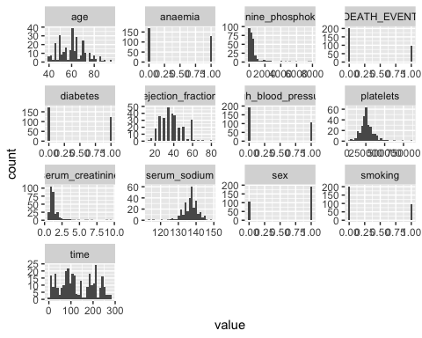

#Histograms below paint a clearer picture of the data. We can see there are some outliers in creatine_phosphokinase and serum creatinine. While some numeric variables follow a gausician distribution, time is the most clear example of one that does not.

#Look to see if there is any correlation betwen variables, paying significant attention to correlation between the target and predictor variables.   
  
corr_cvd <- rcorr(as.matrix(cvd))  
  
flattenCorrMatrix <- function(cormat, pmat) {  
 ut <- upper.tri(cormat)  
 data.frame(  
 row = rownames(cormat)[row(cormat)[ut]],  
 column = rownames(cormat)[col(cormat)[ut]],  
 cor =(cormat)[ut],  
 p = pmat[ut]  
 )  
}  
  
flattenCorrMatrix(corr_cvd$r, corr_cvd$P)

## row column cor  
## 1 age anaemia 0.088006441  
## 2 age creatinine_phosphokinase -0.081583900  
## 3 anaemia creatinine_phosphokinase -0.190741030  
## 4 age diabetes -0.101012385  
## 5 anaemia diabetes -0.012729046  
## 6 creatinine_phosphokinase diabetes -0.009638514  
## 7 age ejection_fraction 0.060098363  
## 8 anaemia ejection_fraction 0.031556971  
## 9 creatinine_phosphokinase ejection_fraction -0.044079554  
## 10 diabetes ejection_fraction -0.004850310  
## 11 age high_blood_pressure 0.093288685  
## 12 anaemia high_blood_pressure 0.038182003  
## 13 creatinine_phosphokinase high_blood_pressure -0.070589980  
## 14 diabetes high_blood_pressure -0.012732382  
## 15 ejection_fraction high_blood_pressure 0.024444731  
## 16 age platelets -0.052354367  
## 17 anaemia platelets -0.043785550  
## 18 creatinine_phosphokinase platelets 0.024463389  
## 19 diabetes platelets 0.092192828  
## 20 ejection_fraction platelets 0.072177466  
## 21 high_blood_pressure platelets 0.049963481  
## 22 age serum_creatinine 0.159187133  
## 23 anaemia serum_creatinine 0.052173604  
## 24 creatinine_phosphokinase serum_creatinine -0.016408480  
## 25 diabetes serum_creatinine -0.046975315  
## 26 ejection_fraction serum_creatinine -0.011302475  
## 27 high_blood_pressure serum_creatinine -0.004934525  
## 28 platelets serum_creatinine -0.041198077  
## 29 age serum_sodium -0.045965841  
## 30 anaemia serum_sodium 0.041881610  
## 31 creatinine_phosphokinase serum_sodium 0.059550156  
## 32 diabetes serum_sodium -0.089550619  
## 33 ejection_fraction serum_sodium 0.175902282  
## 34 high_blood_pressure serum_sodium 0.037109470  
## 35 platelets serum_sodium 0.062124619  
## 36 serum_creatinine serum_sodium -0.189095210  
## 37 age sex 0.065429524  
## 38 anaemia sex -0.094768961  
## 39 creatinine_phosphokinase sex 0.079790629  
## 40 diabetes sex -0.157729504  
## 41 ejection_fraction sex -0.148385965  
## 42 high_blood_pressure sex -0.104614629  
## 43 platelets sex -0.125120483  
## 44 serum_creatinine sex 0.006969778  
## 45 serum_sodium sex -0.027566123  
## 46 age smoking 0.018667868  
## 47 anaemia smoking -0.107289838  
## 48 creatinine_phosphokinase smoking 0.002421235  
## 49 diabetes smoking -0.147173413  
## 50 ejection_fraction smoking -0.067314567  
## 51 high_blood_pressure smoking -0.055711369  
## 52 platelets smoking 0.028234448  
## 53 serum_creatinine smoking -0.027414135  
## 54 serum_sodium smoking 0.004813195  
## 55 sex smoking 0.445891712  
## 56 age time -0.224068420  
## 57 anaemia time -0.141413982  
## 58 creatinine_phosphokinase time -0.009345653  
## 59 diabetes time 0.033725509  
## 60 ejection_fraction time 0.041729235  
## 61 high_blood_pressure time -0.196439479  
## 62 platelets time 0.010513909  
## 63 serum_creatinine time -0.149315418  
## 64 serum_sodium time 0.087640000  
## 65 sex time -0.015608220  
## 66 smoking time -0.022838942  
## 67 age DEATH_EVENT 0.253728543  
## 68 anaemia DEATH_EVENT 0.066270098  
## 69 creatinine_phosphokinase DEATH_EVENT 0.062728160  
## 70 diabetes DEATH_EVENT -0.001942883  
## 71 ejection_fraction DEATH_EVENT -0.268603312  
## 72 high_blood_pressure DEATH_EVENT 0.079351058  
## 73 platelets DEATH_EVENT -0.049138868  
## 74 serum_creatinine DEATH_EVENT 0.294277561  
## 75 serum_sodium DEATH_EVENT -0.195203596  
## 76 sex DEATH_EVENT -0.004316376  
## 77 smoking DEATH_EVENT -0.012623153  
## 78 time DEATH_EVENT -0.526963779  
## p  
## 1 1.289270e-01  
## 2 1.593814e-01  
## 3 9.167881e-04  
## 4 8.119152e-02  
## 5 8.264999e-01  
## 6 8.681796e-01  
## 7 3.003041e-01  
## 8 5.867713e-01  
## 9 4.476233e-01  
## 10 9.334390e-01  
## 11 1.074267e-01  
## 12 5.107290e-01  
## 13 2.235963e-01  
## 14 8.264552e-01  
## 15 6.737687e-01  
## 16 3.669939e-01  
## 17 4.506610e-01  
## 18 6.735340e-01  
## 19 1.116376e-01  
## 20 2.133299e-01  
## 21 3.893106e-01  
## 22 5.803433e-03  
## 23 3.686529e-01  
## 24 7.775144e-01  
## 25 4.183290e-01  
## 26 8.456860e-01  
## 27 9.322860e-01  
## 28 4.778909e-01  
## 29 4.284113e-01  
## 30 4.706118e-01  
## 31 3.047425e-01  
## 32 1.223234e-01  
## 33 2.267684e-03  
## 34 5.226830e-01  
## 35 2.842728e-01  
## 36 1.017081e-03  
## 37 2.593824e-01  
## 38 1.019385e-01  
## 39 1.687830e-01  
## 40 6.274077e-03  
## 41 1.018969e-02  
## 42 7.086549e-02  
## 43 3.054273e-02  
## 44 9.044710e-01  
## 45 6.349606e-01  
## 46 7.478516e-01  
## 47 6.391170e-02  
## 48 9.667444e-01  
## 49 1.083125e-02  
## 50 2.458783e-01  
## 51 3.370299e-01  
## 52 6.267749e-01  
## 53 6.368284e-01  
## 54 9.339471e-01  
## 55 4.440892e-16  
## 56 9.303199e-05  
## 57 1.439130e-02  
## 58 8.721501e-01  
## 59 5.613138e-01  
## 60 4.722292e-01  
## 61 6.357867e-04  
## 62 8.563315e-01  
## 63 9.720948e-03  
## 64 1.305338e-01  
## 65 7.881011e-01  
## 66 6.940836e-01  
## 67 8.916763e-06  
## 68 2.532988e-01  
## 69 2.796112e-01  
## 70 9.733118e-01  
## 71 2.452897e-06  
## 72 1.711495e-01  
## 73 3.971942e-01  
## 74 2.190198e-07  
## 75 6.889112e-04  
## 76 9.407519e-01  
## 77 8.279207e-01  
## 78 0.000000e+00

#The results of the corrleation table shows that correlation is significant at the .005 level between Death_Event and age, ejection_fraction, serum_creatinine and serum_sodium.

#Building Box Plots  
de_age <- ggplot(data = cvd, aes(x = as.character(DEATH_EVENT), y = age)) +   
 geom_boxplot()  
  
de_ejection <- ggplot(data = cvd, aes(x = as.character(DEATH_EVENT), y = ejection_fraction)) +   
 geom_boxplot()  
  
de_serum_cre <- ggplot(data = cvd, aes(x = as.character(DEATH_EVENT), y = serum_creatinine)) +   
 geom_boxplot()  
  
de_serum_sod <- ggplot(data = cvd, aes(x = as.character(DEATH_EVENT), y = serum_sodium)) +   
 geom_boxplot()  
  
#Displaying Box Plots  
de_age

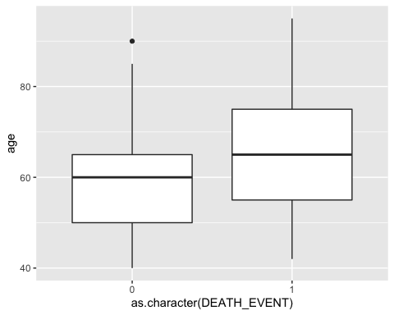

de_ejection

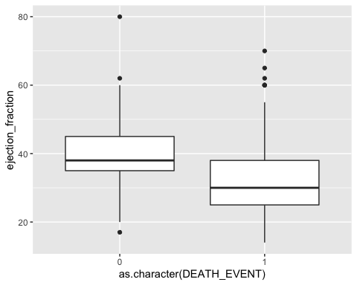

de_serum_cre

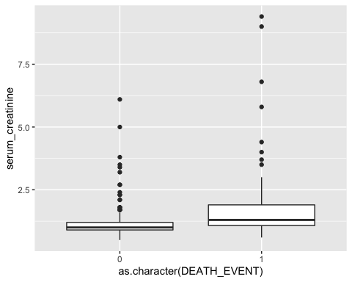

de_serum_sod

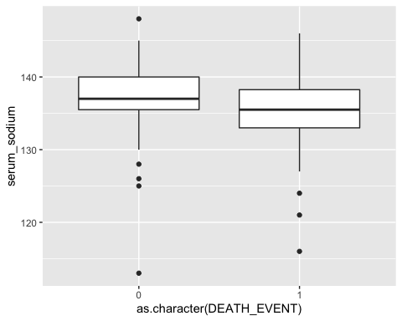

#Model Creation - One Layer - 64 Units  
model_1 <- keras_model_sequential() %>%  
 layer_dense(units = 64, activation = 'relu', input_shape = c(12)) %>% #input shape = features  
 layer_dense( units = 1, activation = 'sigmoid')

## Loaded Tensorflow version 2.6.2

#I will use relu for the activation function  
#I will use sigmoid activation since this is binary classification problem.   
model_1 %>% compile(  
 optimizer = "rmsprop",  
 loss = "binary_crossentropy",  
 metrics = c("accuracy")  
)  
  
#Setting up empty vectors to hold results from folds  
all_acc_histories <- NULL  
all_loss_histories <- NULL  
  
#Specifications for k-fold validation  
k <- 4  
indices <- sample(1:nrow(train_X.norm))  
folds <- cut(indices, breaks = k, labels = FALSE)  
  
#Model Function  
  
for (i in 1:k) {  
 cat("processing fold #", i, "\n")  
 val_indices <- which(folds == i, arr.ind = TRUE)  
 val_data <- as.matrix(train_X.norm[val_indices,])  
 val_targets <- as.matrix(train_y[val_indices,])  
 partial_train_data <- as.matrix(train_X.norm[-val_indices,])  
 partial_train_targets <- as.matrix(train_y[-val_indices,])  
  
 history <- model_1 %>% fit(  
 partial_train_data, partial_train_targets,  
 validation_data = list(val_data, val_targets),  
 epochs = 100, batch_size = 1, verbose = 0)  
   
 acc_history <- history$metrics$val_accuracy  
 all_acc_histories <- rbind(all_acc_histories, acc_history)  
   
 loss_history <-history$metrics$val_loss  
 all_loss_histories <- rbind(all_loss_histories, loss_history)  
  
}

## processing fold # 1   
## processing fold # 2   
## processing fold # 3   
## processing fold # 4

#Compiling Validationa Accuracy and Loss from folds  
average_acc_history <- data.frame(  
 epoch = seq(1:ncol(all_acc_histories)),  
 validation_acc = apply(all_acc_histories, 2, mean)  
)  
  
  
average_loss_history <- data.frame(  
 epoch = seq(1:ncol(all_loss_histories)),  
 validation_loss = apply(all_loss_histories, 2, mean)  
)  
  
#Plotting and Printing results  
ggplot(average_acc_history, aes(x = epoch, y = validation_acc)) + geom_line()

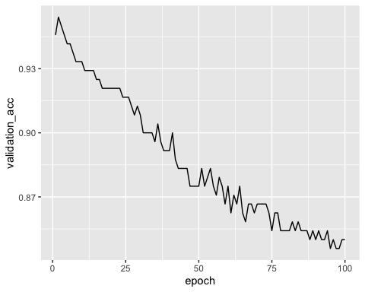

ggplot(average_loss_history, aes(x = epoch, y = validation_loss)) + geom_line()

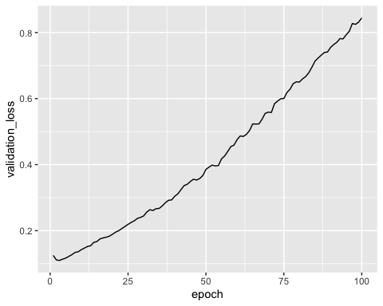

# Overfitting starts occuring after the second epoch as evidence by validation loss and validation accuracy. 64 units may be too many. Lets adjust with one layer and fewer units.

#Model Creation - One layer - 8 Units  
model_2 <- keras_model_sequential() %>%  
 layer_dense(units = 8, activation = 'relu', input_shape = c(12)) %>% #input shape = features  
 layer_dense( units = 1, activation = 'sigmoid')  
  
  
#I will use relu for the activation function  
#I will use sigmoid activation since this is binary classification problem.   
model_2 %>% compile(  
 optimizer = "rmsprop",  
 loss = "binary_crossentropy",  
 metrics = c("accuracy")  
)  
  
#Setting up empty vectors to hold results from folds  
all_acc_histories <- NULL  
all_loss_histories <- NULL  
  
#Specifications for k-fold validation  
k <- 4  
indices <- sample(1:nrow(train_X.norm))  
folds <- cut(indices, breaks = k, labels = FALSE)  
  
#Model Function  
  
for (i in 1:k) {  
 cat("processing fold #", i, "\n")  
 val_indices <- which(folds == i, arr.ind = TRUE)  
 val_data <- as.matrix(train_X.norm[val_indices,])  
 val_targets <- as.matrix(train_y[val_indices,])  
   
 partial_train_data <- as.matrix(train_X.norm[-val_indices,])  
 partial_train_targets <- as.matrix(train_y[-val_indices,])  
   
 history <- model_2 %>% fit(  
 partial_train_data, partial_train_targets,  
 validation_data = list(val_data, val_targets),  
 epochs = 100, batch_size = 1, verbose = 0)  
   
 acc_history <- history$metrics$val_accuracy  
 all_acc_histories <- rbind(all_acc_histories, acc_history)  
   
 loss_history <-history$metrics$val_loss  
 all_loss_histories <- rbind(all_loss_histories, loss_history)  
  
}

## processing fold # 1   
## processing fold # 2   
## processing fold # 3   
## processing fold # 4

#Compiling Validationa Accuracy and Loss from folds  
average_acc_history <- data.frame(  
 epoch = seq(1:ncol(all_acc_histories)),  
 validation_acc = apply(all_acc_histories, 2, mean)  
)  
  
  
average_loss_history <- data.frame(  
 epoch = seq(1:ncol(all_loss_histories)),  
 validation_loss = apply(all_loss_histories, 2, mean)  
)  
  
#Plotting and Printing results  
ggplot(average_acc_history, aes(x = epoch, y = validation_acc)) + geom_line()

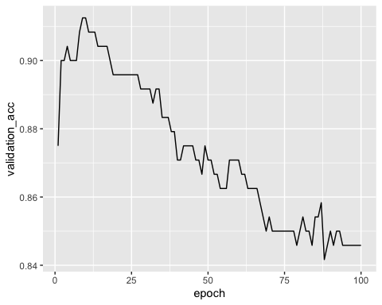

ggplot(average_loss_history, aes(x = epoch, y = validation_loss)) + geom_line()

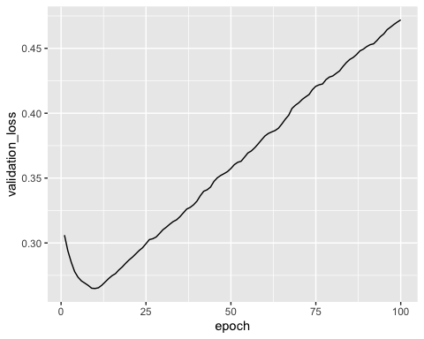

#Still overfitting - will add a second layer of 8 units and along with one dropout layer to reduce overfitting

#Model Creation - Two Layer - 8 Units - dropout  
model_3 <- keras_model_sequential() %>%  
 layer_dense(units = 8, activation = 'relu', input_shape = c(12)) %>% #input shape = features  
 layer_dropout(rate = 0.5) %>%  
 layer_dense(units = 8, activation = 'relu') %>%  
 layer_dense( units = 1, activation = 'sigmoid')  
  
  
#I will use relu for the activation function  
#I will use sigmoid activation since this is binary classification problem.   
model_3 %>% compile(  
 optimizer = "rmsprop",  
 loss = "binary_crossentropy",  
 metrics = c("accuracy")  
)  
  
#Setting up empty vectors to hold results from folds  
all_acc_histories <- NULL  
all_loss_histories <- NULL  
  
#Specifications for k-fold validation  
k <- 4  
indices <- sample(1:nrow(train_X.norm))  
folds <- cut(indices, breaks = k, labels = FALSE)  
  
#Model Function  
  
for (i in 1:k) {  
 cat("processing fold #", i, "\n")  
 val_indices <- which(folds == i, arr.ind = TRUE)  
 val_data <- as.matrix(train_X.norm[val_indices,])  
 val_targets <- as.matrix(train_y[val_indices,])  
 partial_train_data <- as.matrix(train_X.norm[-val_indices,])  
 partial_train_targets <- as.matrix(train_y[-val_indices,])  
  
 history <- model_3 %>% fit(  
 partial_train_data, partial_train_targets,  
 validation_data = list(val_data, val_targets),  
 epochs = 100, batch_size = 1, verbose = 0)  
   
 acc_history <- history$metrics$val_accuracy  
 all_acc_histories <- rbind(all_acc_histories, acc_history)  
   
 loss_history <-history$metrics$val_loss  
 all_loss_histories <- rbind(all_loss_histories, loss_history)  
  
}

## processing fold # 1   
## processing fold # 2   
## processing fold # 3   
## processing fold # 4

#Compiling Validationa Accuracy and Loss from folds  
average_acc_history <- data.frame(  
 epoch = seq(1:ncol(all_acc_histories)),  
 validation_acc = apply(all_acc_histories, 2, mean)  
)  
  
  
average_loss_history <- data.frame(  
 epoch = seq(1:ncol(all_loss_histories)),  
 validation_loss = apply(all_loss_histories, 2, mean)  
)  
  
#Plotting and Printing results  
ggplot(average_acc_history, aes(x = epoch, y = validation_acc)) + geom_line()

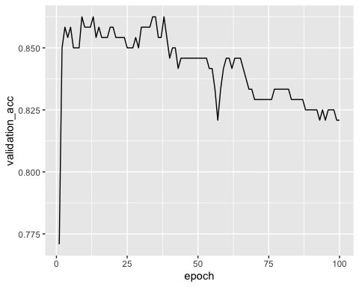

ggplot(average_loss_history, aes(x = epoch, y = validation_loss)) + geom_line()

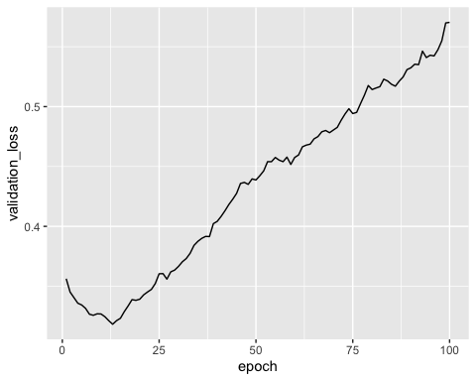

#Model Creation - Two Layer - 8 Units - one dropout = call backs   
model_4 <- keras_model_sequential() %>%  
 layer_dense(units = 8, activation = 'relu', input_shape = c(12)) %>%#input shape = features  
 layer_dropout(rate = 0.5) %>%  
 layer_dense(units = 8, activation = 'relu') %>%  
 layer_dense( units = 1, activation = 'sigmoid')  
  
callbacks_list <- list(  
 callback_early_stopping(  
 monitor = "val_accuracy",  
 patience = 1  
),  
  
callback_model_checkpoint(  
 filepath = "my_model.h4",  
 monitor = "val_loss",  
 save_best_only = TRUE  
) )  
  
#I will use relu for the activation function  
#I will use sigmoid activation since this is binary classification problem.   
model_4 %>% compile(  
 optimizer = "rmsprop",  
 loss = "binary_crossentropy",  
 metrics = c("accuracy")  
)  
  
#Setting up empty vectors to hold results from folds  
all_acc_histories <- NULL  
all_loss_histories <- NULL  
  
#Specifications for k-fold validation  
k <- 4  
indices <- sample(1:nrow(train_X.norm))  
folds <- cut(indices, breaks = k, labels = FALSE)  
  
#Model Function  
  
for (i in 1:k) {  
 cat("processing fold #", i, "\n")  
 val_indices <- which(folds == i, arr.ind = TRUE)  
 val_data <- as.matrix(train_X.norm[val_indices,])  
 val_targets <- as.matrix(train_y[val_indices,])  
 partial_train_data <- as.matrix(train_X.norm[-val_indices,])  
 partial_train_targets <- as.matrix(train_y[-val_indices,])  
  
 history <- model_4 %>% fit(  
 partial_train_data, partial_train_targets,  
 validation_data = list(val_data, val_targets),  
 epochs = 100, batch_size = 1, callbacks = callbacks_list, verbose = 0)  
   
 acc_history <- history$metrics$val_accuracy  
 all_acc_histories <- rbind(all_acc_histories, acc_history)  
   
 loss_history <-history$metrics$val_loss  
 all_loss_histories <- rbind(all_loss_histories, loss_history)  
  
}

## processing fold # 1   
## processing fold # 2

## Warning in rbind(all_acc_histories, acc_history): number of columns of  
## result is not a multiple of vector length (arg 2)

## Warning in rbind(all_loss_histories, loss_history): number of columns of  
## result is not a multiple of vector length (arg 2)

## processing fold # 3   
## processing fold # 4

#Compiling Validationa Accuracy and Loss from folds  
average_acc_history <- data.frame(  
 epoch = seq(1:ncol(all_acc_histories)),  
 validation_acc = apply(all_acc_histories, 2, mean)  
)  
  
  
average_loss_history <- data.frame(  
 epoch = seq(1:ncol(all_loss_histories)),  
 validation_loss = apply(all_loss_histories, 2, mean)  
)  
  
#Plotting and Printing results  
ggplot(average_acc_history, aes(x = epoch, y = validation_acc)) + geom_line()

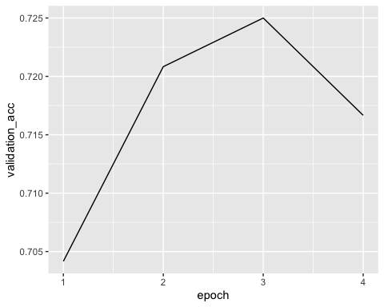

ggplot(average_loss_history, aes(x = epoch, y = validation_loss)) + geom_line()

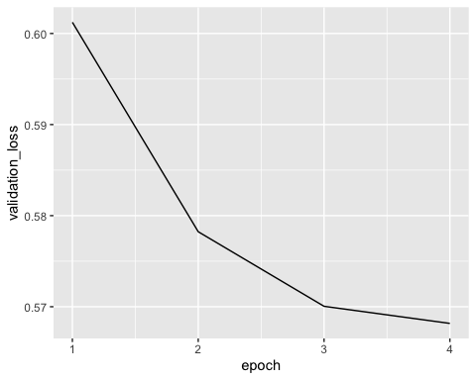

#Model Creation - Two Layer - 16/8 Units - one dropout = call backs   
model_5 <- keras_model_sequential() %>%  
 layer_dense(units = 16, activation = 'relu', input_shape = c(12)) %>%#input shape = features  
 layer_dropout(rate = 0.5) %>%  
 layer_dense(units = 8, activation = 'relu') %>%  
 layer_dense( units = 1, activation = 'sigmoid')  
  
callbacks_list <- list(  
 callback_early_stopping(  
 monitor = "val_accuracy",  
 patience = 1  
),  
  
callback_model_checkpoint(  
 filepath = "my_model.h4",  
 monitor = "val_loss",  
 save_best_only = TRUE  
) )  
  
#I will use relu for the activation function  
#I will use sigmoid activation since this is binary classification problem.   
model_5 %>% compile(  
 optimizer = "rmsprop",  
 loss = "binary_crossentropy",  
 metrics = c("accuracy")  
)  
  
#Setting up empty vectors to hold results from folds  
all_acc_histories <- NULL  
all_loss_histories <- NULL  
  
#Specifications for k-fold validation  
k <- 4  
indices <- sample(1:nrow(train_X.norm))  
folds <- cut(indices, breaks = k, labels = FALSE)  
  
#Model Function  
  
for (i in 1:k) {  
 cat("processing fold #", i, "\n")  
 val_indices <- which(folds == i, arr.ind = TRUE)  
 val_data <- as.matrix(train_X.norm[val_indices,])  
 val_targets <- as.matrix(train_y[val_indices,])  
 partial_train_data <- as.matrix(train_X.norm[-val_indices,])  
 partial_train_targets <- as.matrix(train_y[-val_indices,])  
  
 history <- model_5 %>% fit(  
 partial_train_data, partial_train_targets,  
 validation_data = list(val_data, val_targets),  
 epochs = 100, batch_size = 1, callbacks = callbacks_list, verbose = 0)  
   
 acc_history <- history$metrics$val_accuracy  
 all_acc_histories <- rbind(all_acc_histories, acc_history)  
   
 loss_history <-history$metrics$val_loss  
 all_loss_histories <- rbind(all_loss_histories, loss_history)  
  
}

## processing fold # 1   
## processing fold # 2

## Warning in rbind(all_acc_histories, acc_history): number of columns of  
## result is not a multiple of vector length (arg 2)

## Warning in rbind(all_loss_histories, loss_history): number of columns of  
## result is not a multiple of vector length (arg 2)

## processing fold # 3   
## processing fold # 4

## Warning in rbind(all_acc_histories, acc_history): number of columns of  
## result is not a multiple of vector length (arg 2)  
  
## Warning in rbind(all_acc_histories, acc_history): number of columns of  
## result is not a multiple of vector length (arg 2)

#Compiling Validationa Accuracy and Loss from folds  
average_acc_history <- data.frame(  
 epoch = seq(1:ncol(all_acc_histories)),  
 validation_acc = apply(all_acc_histories, 2, mean)  
)  
  
  
average_loss_history <- data.frame(  
 epoch = seq(1:ncol(all_loss_histories)),  
 validation_loss = apply(all_loss_histories, 2, mean)  
)  
  
#Plotting and Printing results  
ggplot(average_acc_history, aes(x = epoch, y = validation_acc)) + geom_line()

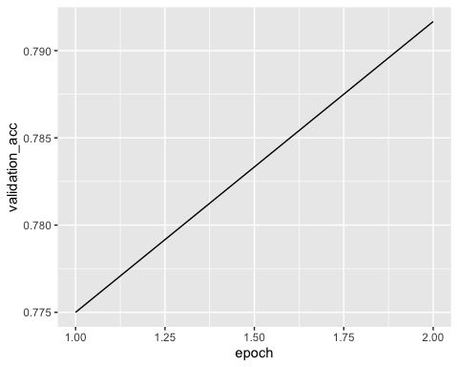

ggplot(average_loss_history, aes(x = epoch, y = validation_loss)) + geom_line()

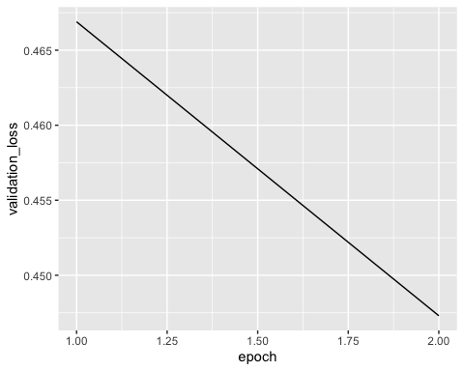

#Model Creation - Two Layer - 16 Units - one dropout = call backs   
model_6 <- keras_model_sequential() %>%  
 layer_dense(units = 16, activation = 'relu', input_shape = c(12)) %>%#input shape = features  
 layer_dropout(rate = 0.5) %>%  
 layer_dense(units = 16, activation = 'relu') %>%  
 layer_dense( units = 1, activation = 'sigmoid')  
  
callbacks_list <- list(  
 callback_early_stopping(  
 monitor = "val_accuracy",  
 patience = 1  
),  
  
callback_model_checkpoint(  
 filepath = "my_model.h4",  
 monitor = "val_loss",  
 save_best_only = TRUE  
) )  
  
#I will use relu for the activation function  
#I will use sigmoid activation since this is binary classification problem.   
model_6 %>% compile(  
 optimizer = "rmsprop",  
 loss = "binary_crossentropy",  
 metrics = c("accuracy")  
)  
  
#Setting up empty vectors to hold results from folds  
all_acc_histories <- NULL  
all_loss_histories <- NULL  
  
#Specifications for k-fold validation  
k <- 4  
indices <- sample(1:nrow(train_X.norm))  
folds <- cut(indices, breaks = k, labels = FALSE)  
  
#Model Function  
  
for (i in 1:k) {  
 cat("processing fold #", i, "\n")  
 val_indices <- which(folds == i, arr.ind = TRUE)  
 val_data <- as.matrix(train_X.norm[val_indices,])  
 val_targets <- as.matrix(train_y[val_indices,])  
 partial_train_data <- as.matrix(train_X.norm[-val_indices,])  
 partial_train_targets <- as.matrix(train_y[-val_indices,])  
  
 history <- model_6 %>% fit(  
 partial_train_data, partial_train_targets,  
 validation_data = list(val_data, val_targets),  
 epochs = 25, batch_size = 1, callbacks = callbacks_list, verbose = 0)  
   
 acc_history <- history$metrics$val_accuracy  
 all_acc_histories <- rbind(all_acc_histories, acc_history)  
   
 loss_history <-history$metrics$val_loss  
 all_loss_histories <- rbind(all_loss_histories, loss_history)  
  
}

## processing fold # 1   
## processing fold # 2

## Warning in rbind(all_acc_histories, acc_history): number of columns of  
## result is not a multiple of vector length (arg 2)

## Warning in rbind(all_loss_histories, loss_history): number of columns of  
## result is not a multiple of vector length (arg 2)

## processing fold # 3

## Warning in rbind(all_acc_histories, acc_history): number of columns of  
## result is not a multiple of vector length (arg 2)  
  
## Warning in rbind(all_acc_histories, acc_history): number of columns of  
## result is not a multiple of vector length (arg 2)

## processing fold # 4

## Warning in rbind(all_acc_histories, acc_history): number of columns of  
## result is not a multiple of vector length (arg 2)  
  
## Warning in rbind(all_acc_histories, acc_history): number of columns of  
## result is not a multiple of vector length (arg 2)

#Compiling Validationa Accuracy and Loss from folds  
average_acc_history <- data.frame(  
 epoch = seq(1:ncol(all_acc_histories)),  
 validation_acc = apply(all_acc_histories, 2, mean)  
)  
  
  
average_loss_history <- data.frame(  
 epoch = seq(1:ncol(all_loss_histories)),  
 validation_loss = apply(all_loss_histories, 2, mean)  
)  
  
#Plotting and Printing results  
ggplot(average_acc_history, aes(x = epoch, y = validation_acc)) + geom_line()

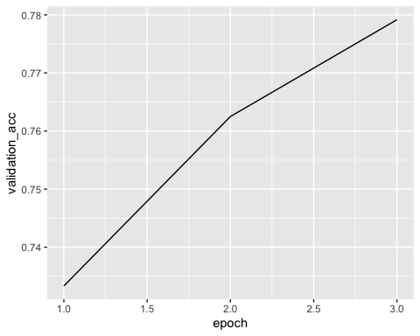

ggplot(average_loss_history, aes(x = epoch, y = validation_loss)) + geom_line()

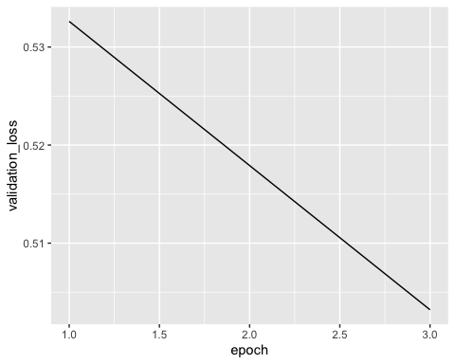

#Model Creation - Two Layer - 32/8 Units - one dropout = call backs   
model_7 <- keras_model_sequential() %>%  
 layer_dense(units = 32, activation = 'relu', input_shape = c(12)) %>%#input shape = features  
 layer_dropout(rate = 0.5) %>%  
 layer_dense(units = 8, activation = 'relu') %>%  
 layer_dense( units = 1, activation = 'sigmoid')  
  
callbacks_list <- list(  
 callback_early_stopping(  
 monitor = "val_accuracy",  
 patience = 3  
),  
  
callback_model_checkpoint(  
 filepath = "my_model.h4",  
 monitor = "val_loss",  
 save_best_only = TRUE  
) )  
  
#I will use relu for the activation function  
#I will use sigmoid activation since this is binary classification problem.   
model_7 %>% compile(  
 optimizer = "rmsprop",  
 loss = "binary_crossentropy",  
 metrics = c("accuracy")  
)  
  
#Setting up empty vectors to hold results from folds  
all_acc_histories <- NULL  
all_loss_histories <- NULL  
  
#Specifications for k-fold validation  
k <- 4  
indices <- sample(1:nrow(train_X.norm))  
folds <- cut(indices, breaks = k, labels = FALSE)  
  
#Model Function  
  
for (i in 1:k) {  
 cat("processing fold #", i, "\n")  
 val_indices <- which(folds == i, arr.ind = TRUE)  
 val_data <- as.matrix(train_X.norm[val_indices,])  
 val_targets <- as.matrix(train_y[val_indices,])  
 partial_train_data <- as.matrix(train_X.norm[-val_indices,])  
 partial_train_targets <- as.matrix(train_y[-val_indices,])  
  
 history <- model_7 %>% fit(  
 partial_train_data, partial_train_targets,  
 validation_data = list(val_data, val_targets),  
 epochs = 25, batch_size = 1, callbacks = callbacks_list, verbose = 0)  
   
 acc_history <- history$metrics$val_accuracy  
 all_acc_histories <- rbind(all_acc_histories, acc_history)  
   
 loss_history <-history$metrics$val_loss  
 all_loss_histories <- rbind(all_loss_histories, loss_history)  
  
}

## processing fold # 1   
## processing fold # 2

## Warning in rbind(all_acc_histories, acc_history): number of columns of  
## result is not a multiple of vector length (arg 2)

## Warning in rbind(all_loss_histories, loss_history): number of columns of  
## result is not a multiple of vector length (arg 2)

## processing fold # 3

## Warning in rbind(all_acc_histories, acc_history): number of columns of  
## result is not a multiple of vector length (arg 2)  
  
## Warning in rbind(all_acc_histories, acc_history): number of columns of  
## result is not a multiple of vector length (arg 2)

## processing fold # 4

## Warning in rbind(all_acc_histories, acc_history): number of columns of  
## result is not a multiple of vector length (arg 2)  
  
## Warning in rbind(all_acc_histories, acc_history): number of columns of  
## result is not a multiple of vector length (arg 2)

#Compiling Validationa Accuracy and Loss from folds  
average_acc_history <- data.frame(  
 epoch = seq(1:ncol(all_acc_histories)),  
 validation_acc = apply(all_acc_histories, 2, mean)  
)  
  
  
average_loss_history <- data.frame(  
 epoch = seq(1:ncol(all_loss_histories)),  
 validation_loss = apply(all_loss_histories, 2, mean)  
)  
  
#Plotting and Printing results  
ggplot(average_acc_history, aes(x = epoch, y = validation_acc)) + geom_line()

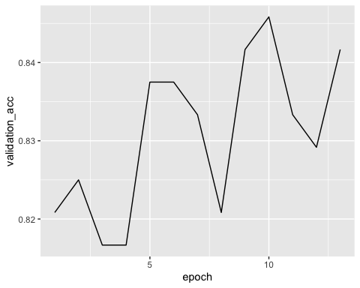

ggplot(average_loss_history, aes(x = epoch, y = validation_loss)) + geom_line()

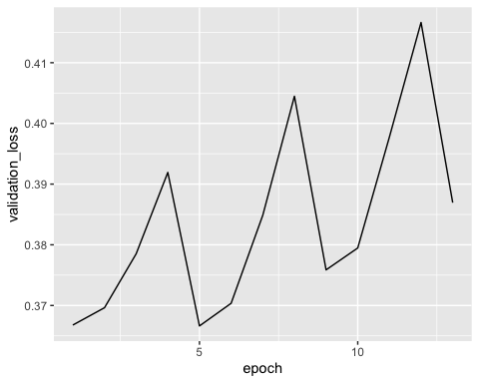

#Evaluate Model Performance on Test Data  
results <- model_7 %>% evaluate(as.matrix(test_X.norm), as.matrix(test_y))  
  
  
#Prediction Values   
predict_prob <- model_7 %>% predict(as.matrix(test_X.norm)) %>% as.data.frame()  
  
# Create Lables based on various thrsholds  
predict_prob_tb <- predict_prob %>% mutate(Death_Event_.2 = ifelse(predict_prob$V1 >= .2,1,0),  
 Death_Event_.3 = ifelse(predict_prob$V1 >= .3,1,0),  
 Death_Event_.4 = ifelse(predict_prob$V1 >= .4,1,0),  
 Death_Event_.5 = ifelse(predict_prob$V1 >= .5,1,0)  
)  
  
  
#preparing Data and Constructing Confusion Matrix  
predict_prob_tb$Death_Event_.2 <- as.factor(predict_prob_tb$Death_Event_.2)  
predict_prob_tb$Death_Event_.3 <- as.factor(predict_prob_tb$Death_Event_.3)  
predict_prob_tb$Death_Event_.4 <- as.factor(predict_prob_tb$Death_Event_.4)  
predict_prob_tb$Death_Event_.5 <- as.factor(predict_prob_tb$Death_Event_.5)  
test_y.factor <- as.factor(test_y$DEATH_EVENT)  
  
confusionMatrix(predict_prob_tb$Death_Event_.5, test_y.factor)

## Confusion Matrix and Statistics  
##   
## Reference  
## Prediction 0 1  
## 0 31 7  
## 1 9 12  
##   
## Accuracy : 0.7288   
## 95% CI : (0.5973, 0.8364)  
## No Information Rate : 0.678   
## P-Value [Acc > NIR] : 0.2459   
##   
## Kappa : 0.3956   
##   
## Mcnemar's Test P-Value : 0.8026   
##   
## Sensitivity : 0.7750   
## Specificity : 0.6316   
## Pos Pred Value : 0.8158   
## Neg Pred Value : 0.5714   
## Prevalence : 0.6780   
## Detection Rate : 0.5254   
## Detection Prevalence : 0.6441   
## Balanced Accuracy : 0.7033   
##   
## 'Positive' Class : 0   
##

confusionMatrix(predict_prob_tb$Death_Event_.4, test_y.factor)

## Confusion Matrix and Statistics  
##   
## Reference  
## Prediction 0 1  
## 0 30 6  
## 1 10 13  
##   
## Accuracy : 0.7288   
## 95% CI : (0.5973, 0.8364)  
## No Information Rate : 0.678   
## P-Value [Acc > NIR] : 0.2459   
##   
## Kappa : 0.4115   
##   
## Mcnemar's Test P-Value : 0.4533   
##   
## Sensitivity : 0.7500   
## Specificity : 0.6842   
## Pos Pred Value : 0.8333   
## Neg Pred Value : 0.5652   
## Prevalence : 0.6780   
## Detection Rate : 0.5085   
## Detection Prevalence : 0.6102   
## Balanced Accuracy : 0.7171   
##   
## 'Positive' Class : 0   
##

confusionMatrix(predict_prob_tb$Death_Event_.3, test_y.factor)

## Confusion Matrix and Statistics  
##   
## Reference  
## Prediction 0 1  
## 0 28 5  
## 1 12 14  
##   
## Accuracy : 0.7119   
## 95% CI : (0.5792, 0.8224)  
## No Information Rate : 0.678   
## P-Value [Acc > NIR] : 0.3433   
##   
## Kappa : 0.3983   
##   
## Mcnemar's Test P-Value : 0.1456   
##   
## Sensitivity : 0.7000   
## Specificity : 0.7368   
## Pos Pred Value : 0.8485   
## Neg Pred Value : 0.5385   
## Prevalence : 0.6780   
## Detection Rate : 0.4746   
## Detection Prevalence : 0.5593   
## Balanced Accuracy : 0.7184   
##   
## 'Positive' Class : 0   
##

confusionMatrix(predict_prob_tb$Death_Event_.2, test_y.factor)

## Confusion Matrix and Statistics  
##   
## Reference  
## Prediction 0 1  
## 0 25 5  
## 1 15 14  
##   
## Accuracy : 0.661   
## 95% CI : (0.5261, 0.7792)  
## No Information Rate : 0.678   
## P-Value [Acc > NIR] : 0.66682   
##   
## Kappa : 0.3179   
##   
## Mcnemar's Test P-Value : 0.04417   
##   
## Sensitivity : 0.6250   
## Specificity : 0.7368   
## Pos Pred Value : 0.8333   
## Neg Pred Value : 0.4828   
## Prevalence : 0.6780   
## Detection Rate : 0.4237   
## Detection Prevalence : 0.5085   
## Balanced Accuracy : 0.6809   
##   
## 'Positive' Class : 0   
##