PR #205 Production Screenshot Report
  - Effective change type: bug-fix / public surface remediation | Canonical PRD required: No
PR | #205 - duplicate card content, empty-tab gate removal, category taxonomy reconciliation
Source of truth | Cowork eliminate-only analysis 2026-05-08; Cowork UX analysis 2026-05-06; production screenshot context; Product Position.pdf principles; PR #202; PR #204
Merge commit | 646b84a08d7e15db645570daa22c8070874440f0
Merged at | 2026-05-08T05:18:06Z
Production | daily-intelligence-aggregator-ybs9.vercel.app
Deploy | dpl_5V8kHwFtKD29tvKdBAGWivq3jyAx | 2026-05-08 13:18:09 GMT+0800 Asia/Taipei
  - Evidence Summary
- Fix A PASS: homepage cards no longer repeat the lead summary as a bullet.
- Fix B PASS: empty Politics tab shows only the honest empty state; no signup gate/buttons.
- Fix C PASS: public labels are Tech, Finance, Politics; Finance and Tech tabs route to matching cards.
- Route checks PASS: /, /signals, and /briefing/2026-05-06 returned HTTP 200.
- Residual: signed-in homepage category tabs still showed empty Tech/Finance in Chrome QA; detail-page Ranking Signals and Developing/Updated badges remain outside PR #205 scope.
Screenshots follow. The report is intentionally compact for tracking: one summary page plus one page per screenshot.

Figure 1. Homepage production QA
Public homepage after PR #205: three cards, no duplicate summary bullets, and updated category labels.
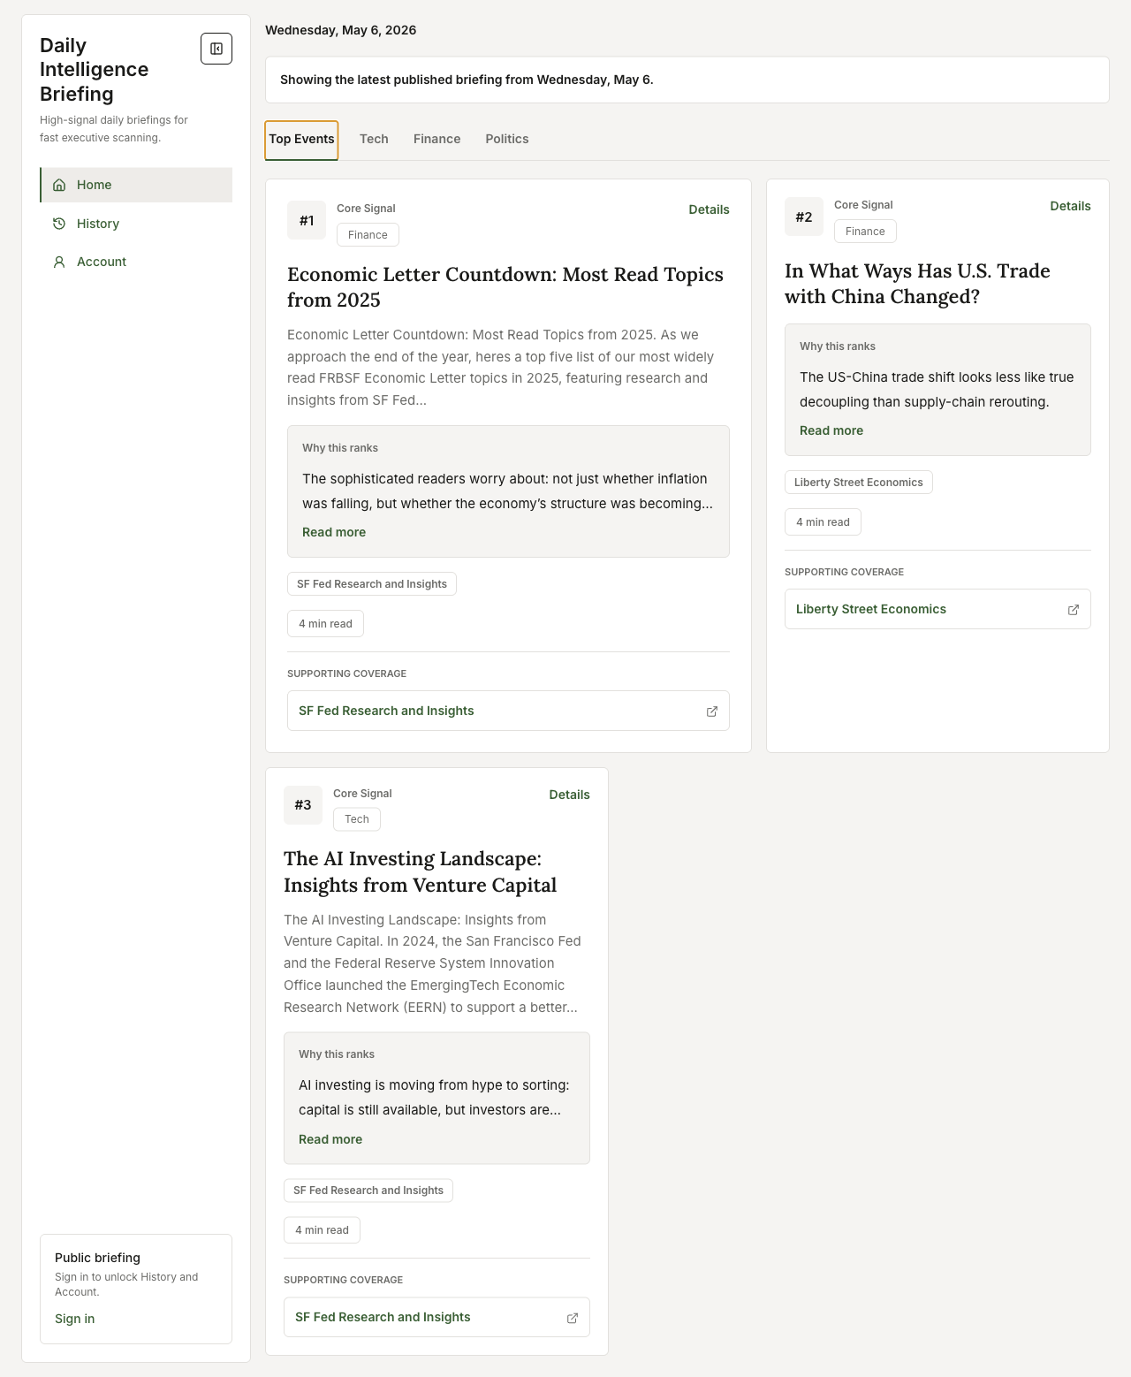

Figure 2. Finance tab populated
Finance tab surfacing Card #1 and Card #2 from the 2026-05-06 briefing.
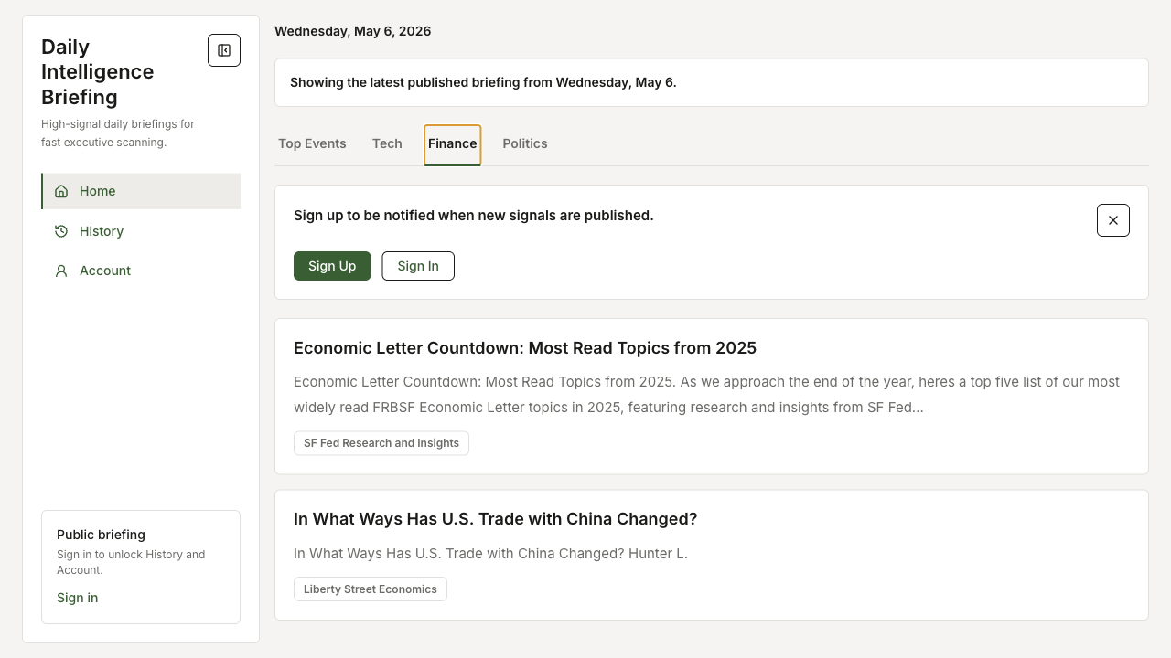

Figure 3. Politics tab empty state
Politics tab with only the honest empty-state sentence and no signup gate/header/buttons.
