Brandon Montez

UID: 306064560

STAT 147

Mar. 5, 2024

Q1

The number of rows did not change, but the number of fields expanded from 13 to 16. The left join maintains the data in main_data.csv and joins the fields of the long_lat.csv file.

Q2

1. UCLA had the highest number of applicants at 139,489. The percent admitted at this highly esteemed institution is 11%.

7. The R^2 value for the linear trend line is 0.339095.

Q3

Q4

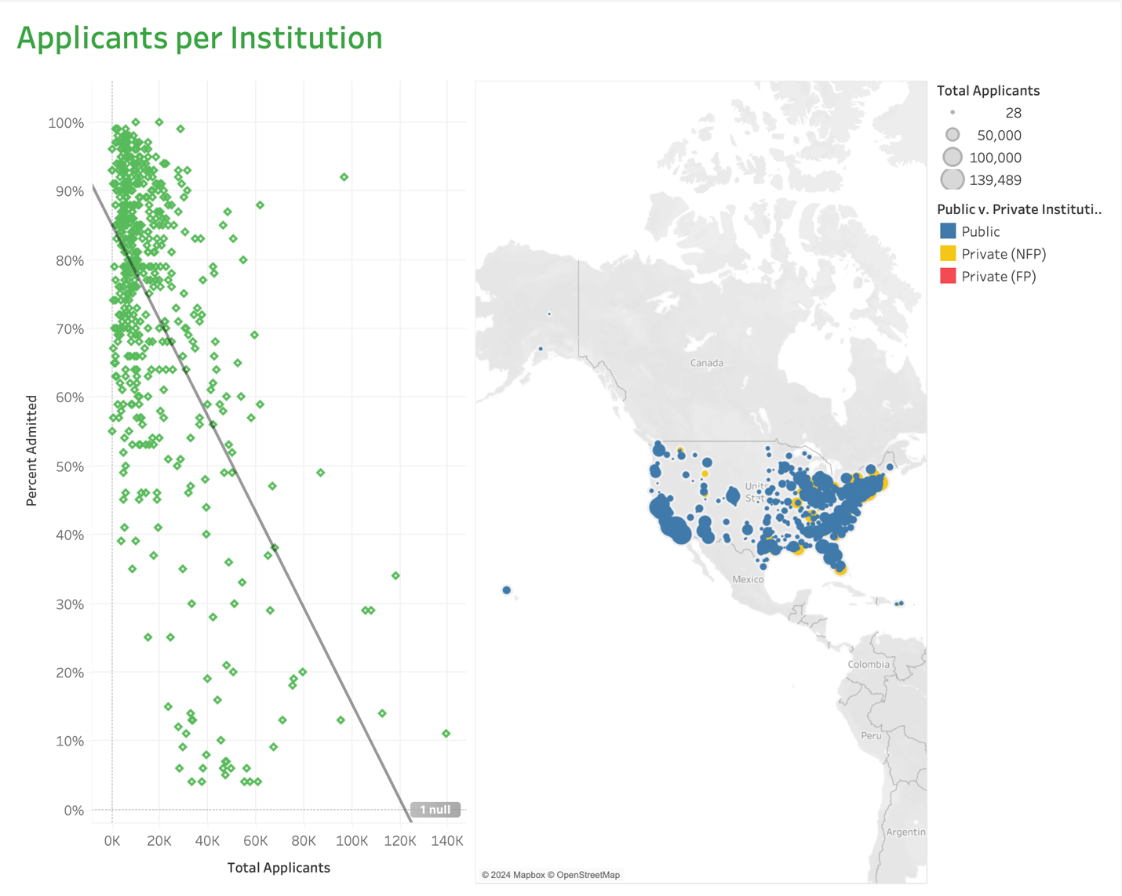

4. The total number of applicants at University of Hawaii at Manoa is 19,607 and the percent admitted is 70%.

Q5 (Bonus)

