Final Project for EngLit 0647:

Harry Potter: The Text Adventure

By Brandon Palonis

Table of Contents

Analysis ……………………………………………………………………… 3

Works Cited ………………………………………………………………….. 6

Instructions …………………………………………………………………….. 7

Analysis

The question of whether video games are art is a hotly debated topic among critics today. Proponents who disagree, like film critic Roger Ebert, say that games are not an experience and are simply an industry, and that gamers experience games through the lens of “profit participation.” Ebert recounts sitting through a lecture by game designer Kellee Santiago that has the purpose of defending video games as art. After the argument has been made in the lecture, he feels validated by the fact the next slides contained the supposed six major areas of gaming “Development, Finance, Publishing, Marketing, Education, and Executive Management.” He also believes that games are not art is because one “can win a game,” and that the game has “rules, points, objectives, and an outcome.” He also says even games with an immersive story cease to be games and are instead a representation of a story. “Santiago might cite a[n] immersive game without points or rules, but I would say then it ceases to be a game…a novel, a play, dance, a film. Those are things you cannot win; you can only experience them” (Ebert). I would argue games are art for this very reason, they offer a representation of a story, but one in where the user is in control and the story is written as the user plays. The reason I wanted to make a game for my final is that I see the immersive potential in video games. Whereas as someone could read Harry Potter and experience Harry’s story as a secondhand account, in a game the players are Harry and they experience his story through participation. This is not to say that reading Harry’s story does not let the user connect with him, but playing a game wherein the players are given the chance to perform an action like Harry does allows them to experience his story from a whole new perspective.

Many fans and readers of Harry Potter have always experienced the series through a secondhand lens. We watch as Harry opens his first letter to Hogwarts and feel the excitement he feels when finds out he is a wizard. Rowling has written Harry as a relatable character throughout the books. He is not descended from royalty or the best in his class. He is an average child who is thrown into a destiny must bigger than himself. Lois Lowry, a writer for the New York Times, says that “kids are from the start such powerless people, and what adolescence is all about, really, is a search for power. Even in a Potteresque world there are the same things that exist in ordinary, unmagical life: the same uncertainties, missteps and pitfalls” (Times). Harry appealed to his audience because, like all kids, he started powerless and attained power in his own fashion. Along the way, however, he experiences life: worrying about exams, uncertainty about love, and the longing for family to comfort him. Although the books contain magic at every turn, and at times otherworldly experiences, it is grounded in reality because Harry is as well. Transferring his journey to a game form works since Harry is already relatable to the audience, they can also follow his logic and make his decisions. Now not only is the audience able to interact with Harry’s story, they can understand what it is really like to be him.

The first level of the game is a recreation of the scene wherein Harry meets Hagrid and receives his letter to Hogwarts. As the level starts, the game says, “Forced into leaving Privet Drive by your aunt and uncle because for once in your life you got a letter.” Here I establish to my audience immediately the situation Harry is in. He has no control over his life because of his aunt and uncle and gets no letters or communication. Now that the audience has an insight into the character they can properly empathize with him, and now they can attempt to make his decisions. Later the dialogue prompts tell the user that Hagrid is handing them their letter to Hogwarts, and they can either type ‘take’ to take it, or type ‘noth’ to do nothing. Now if the user empathized with Harry and wanted to see him accept his destiny, they can take the letter, or if for whatever reason they did not, the game instead ends with a slightly humorous ending that says Harry ends up going to a school for criminal boys. The act of being able to choose helps players take on the role as Harry, put themselves in his shoes, and then make a decision that they think Harry would make.

Writer Sam Liberty defines a role-playing game as a game where a player controls a specific character and makes decisions as if they were that character. The character also should have narrative relationships with other story elements (Liberty). This is what my game does, the player makes decisions as if they were Harry. In the first level the player, as Harry, asks Hagrid about his reasons for coming to the shack and why Hagrid knows Harry’s parents. Being able to narratively interact with other characters as your character is important to be able to role-play in the game. The player understands the weight of Harry’s legacy in the wizarding world because they too are just being told that they are secretly a wizard. Later in the game, the player also gets to take part in Harry’s narrative: fighting the Basilisk, saving himself and Sirius, and competing in the Triwizard Tournament. Each of these narrative pieces add to Harry’s story as a whole, and as the player plays they are inadvertently writing Harry’s journey, from small boy in a shack, to a young wizard that confronts Voldemort.

Video games as medium offer a level of interaction that is not available in a book. In a video game the player can pretend that they are Harry, as opposed to watching Harry. They know everything he knows, and they can do anything he can do. Such interaction with a narrative is only truly available in a game. This is not to say that books cannot be immersive and interactive, but in a literal sense a book cannot be as interactive as a video game. Books do not take user input and change accordingly, books exist as a static story that readers can put themselves into. Games exist as a dynamic story, one that changes with the decisions of the player. I chose to make a game for my project because there is just as much narrative value in performing Harry’s story as there is in reading it.

Works Cited

Ebert, Roger. “Video Games Can Never Be Art.” *RogerEbert.com*, Brian Grazer, 16 Apr. 2016, [www.rogerebert.com/rogers-journal/video-games-can-never-be-art](http://www.rogerebert.com/rogers-journal/video-games-can-never-be-art).

Liberty, Sam. “What Are Role Playing Games Even? How Are They That?” *Medium.com*, Medium, 15 Dec. 2017, medium.com/@SA_Liberty/what-are-role-playing-games-even-how-are-they-that-50071c5552e2.

Times, The New York. “A Round Table on Harry Potter.” *The New York Times*, The New York Times, 12 Aug. 2007, www.nytimes.com/2007/08/12/books/review/potter-roundtable.html.

Instructions

* Every level of the game is a representation of that moment in the books. Some dialogue is lifted directly from the books, some is paraphrased for time purposes. The goal of every level is to follow the correct sequence of commands to complete the level.
* At the beginning of the game the player is asked for their name, and then is given a token of the form $[n]> where [n] is the name previously entered with vowels and spaces removed. Whenever the player is prompted with $[n]> that means a command can be entered to advance the story. If $[n]> appears and you are unsure what to type, type ‘man’ to see the list of commands.
* If the $[n]> token is not on screen DO NOT attempt to type or enter anything.
* Do not worry about typing incorrect commands, the game will simply tell you if you have entered an incorrect command and wait for a correct one.
* Should the game enter an infinite loop or have a bug, it can be ended by pressing ctrl + C at the same time while the command prompt is selected.

TO RUN THE GAME:

1. Open windows command line by opening the start menu, searching ‘cmd’, and clicking on the first result. It should look like this:
   1. 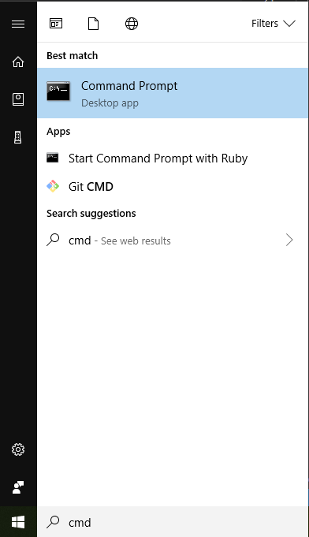
   2. 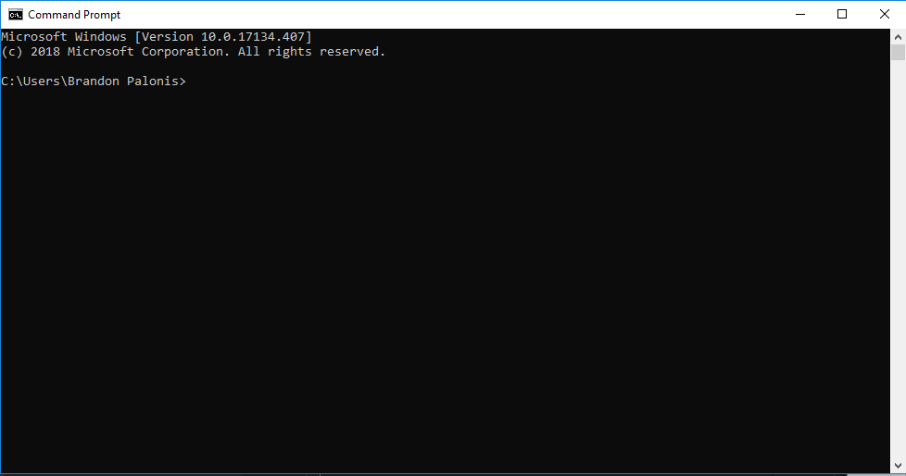
2. From the command prompt, type cd [directory] where [directory] is replaced by the exact location of the main.rb file.
   1. To find the location of main.rb, go to it in the file explorer and navigate to the folder containing main.rb like so:
      1. 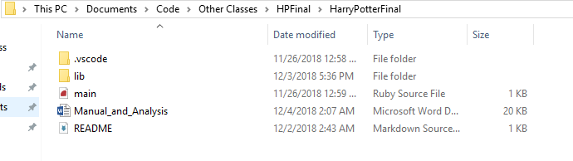
   2. Copy the address of this directory by selecting it and pressing ctrl + c
      1. 
   3. Now type the cd command, add a space, and then paste the file path by right clicking:
      1. 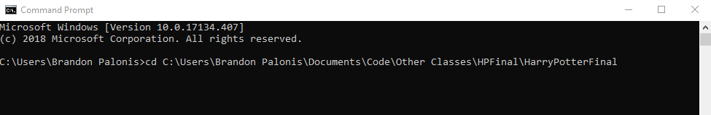
   4. Press enter and you should now be in that directory
      1. 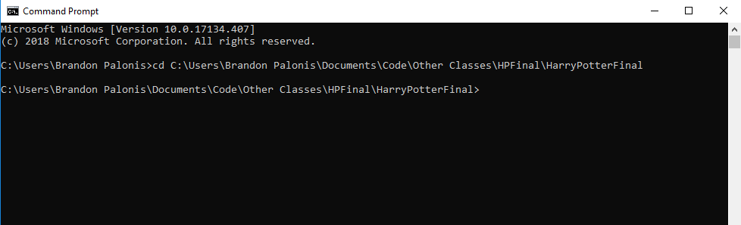
   5. Now to run the game simply type ‘ruby main.rb’ and press enter, your screen should look like this afterwards:
      1. 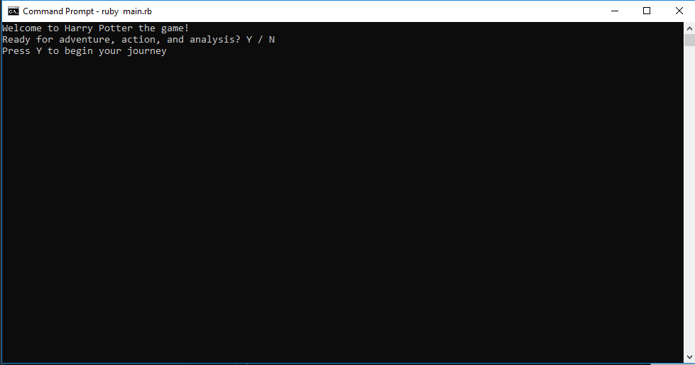

Commands

General

All commands must be typed and enter must be pressed to activate that command

* Typing ‘man’ will reveal a list of commands for each level.
  + Commands are returned as a list in the form:
    - Command – Keyword
    - Countdown to Birthday - count
    - Nothing - noth
  + Not every level will have the countdown to birthday command, this is just merely an example for teaching purposes
* Typing ‘clear’ will clear the screen of all clutter.
* I recommend trying all possible commands for each level. Some might make you lose the game, but may have humorous dialogue options.