Team Leader

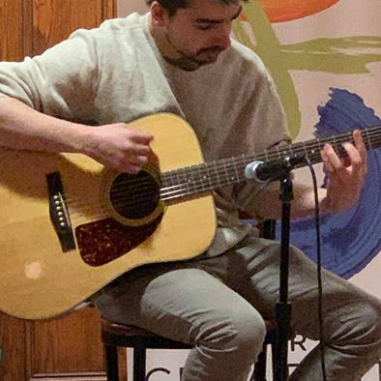

- 4 years professional development experience with PHP.

- 2 years professional development experience with C#.

- 6 years professional experience with relational databases such as MySQL, PostgreSQL and SQL Server.

Pierce Sams

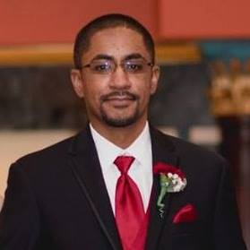

Brandon Palonis

-2 years professional experience in Javascript

-2 years professional experience in AngularJS

-1 year professional experience in Python

-2 years professional experience in SQL

-2 years professional experience in C#

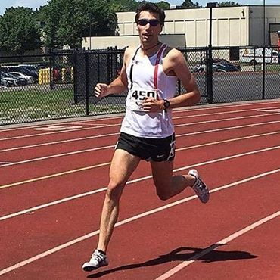

Josh Guarino

- 2 years professional development experience with PHP.

- 2 years professional development experience with JavaScript.

- 4 years professional experience software testing with 2 years automation testing.

- 2 years professional experience with python.

- 4 years working with SQL databases (MS SQL Server, MySql, postgres)

- 1 year professional VR/AR/MR app development in c#

- 2 years of full stack development using php, css, html, js, cold fusion

CMS - Cascade, Wordpress Hosting - Bluehost, GoDaddy, HostGator

- 3 years of academic and professional SQL usage

- 3 years of academic no-SQL usage ajax, xml, json

- 2 years client service

- 6 years academic/volunteering leadership roles

Brian Kelly



Team rAPIdash