Name: __Ronald Kim_________ Date: 10/9/18__________________

Pledge: I pledge my honor that I have abided by the Stevens Honor System – Ronald Kim ___________

For each of the graphs below, list the order in which the vertices are visited in a **breadth-first search**, starting with vertex 1. If there are multiple vertices adjacent to a given vertex, visit the adjacent vertex with the lowest value first. Then repeat the process for **depth-first search**.

1. 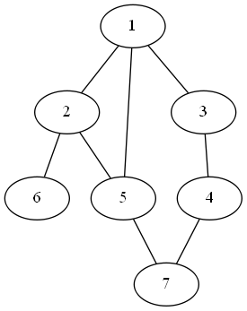

BFS: __1,2,3,5,4,6,7_____________________________________________________

DFS: __1,2,5,7,6,3,4_____________________________________________________

1. 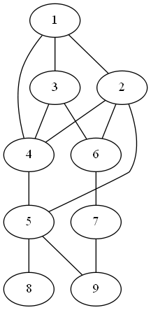

BFS: __1,2,3,4,5,6,7,8,9_____________________________________________________

DFS: _1,2,4,5,8,9,6,7,3______________________________________________________

1. 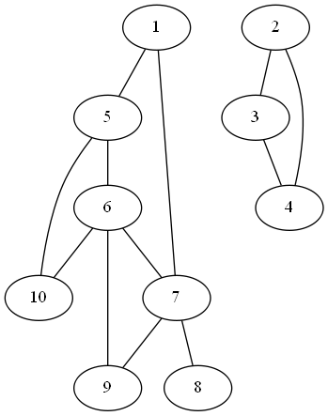

BFS: _1,2,3,4,5,7,6,8,9,10______________________________________________________

DFS: _1,5,6,7,8,9,10,2,3,4______________________________________________________

For each of the graphs below, list the order in which the vertices are visited in a **topological sort**, starting with vertex 1. If there are multiple vertices adjacent to a given vertex, visit the adjacent vertex with the lowest value first.

1. 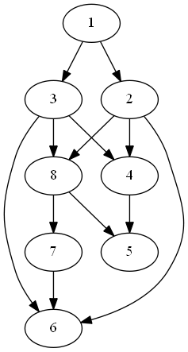

Topological sort: __1,2,3,4,8,5,7,6_____________________________________________________

1. 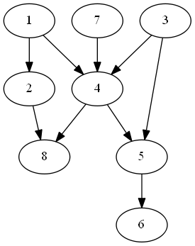

Topological sort: _1,2,3,7,4,5,6,8______________________________________________________