Brandon Patton

* 1. 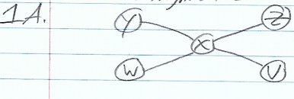
  2. With node X being in the middle, it is on every shortest path between every pair of nodes therefore it is a pivotal node.
  3. 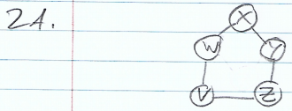
  4. This arrangement ensures that every node is pivotal for at least one pair of nodes because the nodes are connected cyclically as opposed to across the graph. Since there are only 5 nodes this means that in order to reach other nodes than their direct neighbors, they must go through another node which is the shortest path. This applies to each node on the graph; therefore, every node is pivotal for at least one pair of nodes.
  5. C, E
  6. Node C is a gatekeeper since every path from node A to any node in the left part of the graph must go through node C; there are no alternate paths for node A to reach any node other than through node C. Node E is a gatekeeper since there is no alternate path from any node on the left side of node E to the right side without passing through node E (ex: D to F, C to G, B to F).
  7. F, G, A
  8. These are not local gatekeepers because they do not connect two nodes who aren’t connected themselves. There are no node pairs such that each have edges to nodes F, G, or A and not to each other, thusly nodes F, G, A are not local gatekeepers.
  9. C, E
  10. Node C is on the shortest path between node A and every other node on the graph, thus node C is a pivotal node. Node E is on the shortest path between all nodes on the left side of it and all nodes on the right side, thus node E is a pivotal node (ex: D to F, C to G, B to F).
  11. This network was probably designed in this way to prevent any lapse in communication between each node. Every entity involved is able to reach any other entity through any other entity and communication is not streamlined through any one node. This is useful because if one node goes down, communication can still be had between any two nodes on the network.
  12. UCSB, STAN
  13. These nodes do not reside on every shortest path between the nodes that are connected to them. For example, one could take the path: SRI, UCSB, UCLA which would be the exact same as: SRI, STAN, UCLA. This means there are two shortest paths, and each contains a different would-be pivotal node, thus nodes UCSB and STAN are not pivotal.
  14. A triadic closure occurs when there are two nodes who are each connected to a common node. The two nodes are highly likely to become directly connected in the future because of their mutual connection, thus closing the relationship in a triangular shape.
  15. I would expect the edge connected nodes B and C to be labeled as a weak tie.
  16. This is because both pairs A, B and C, D satisfy the strong triadic closure assumption and share a weak tie between their counterpart respectively. Since pair A, D exhibits a weak tie and are connected similarly, pair B, C should follow suit and share a weak tie.
  17. There will be a strong tie connecting pairs B and E.
  18. B and E will eventually share a strong tie because of the strong triadic closure assumption.
  19. 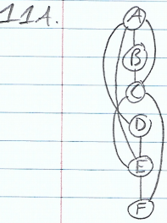
  20. Nodes A, C, and E display a bipartite organization meaning that its nodes can be divided into two sets in such a way that every edge connects a node in one set to a node in the other set.
  21. This network on 90 people is not balanced.
  22. This is because each village is mutual enemies with every other village in the relationship.
      1. AB; +; Triangles: ABD, ABE, ABC; Balanced: 1, Unbalanced: 2
      2. AC; +; Triangles: ACD, ACB, ACE; Balanced: 1, Unbalanced: 2
      3. CE; +; Triangles: CED, CEB, CEA; Balanced: 1, Unbalanced: 2
      4. DE; +; Triangles: DEA, DEC, DEB; Balanced: 1, Unbalanced: 2
      5. BD; +; Triangles: BDE, BDC, BDA; Balanced: 1, Unbalanced: 2
      6. BC; - ; Triangles: BCE, BCD, BCA; Balanced: 2, Unbalanced: 1
      7. AE; - ; Triangles: AED, AEB, AEC; Balanced: 2, Unbalanced: 1
      8. AD; - ; Triangles: ADE, ADB, ADC; Balanced: 2, Unbalanced: 1
      9. CD; - ; Triangles: CDA, CDB, CDE; Balanced: 2, Unbalanced: 1
      10. BE; - ; Triangles: BEA, BED, BEC; Balanced: 2, Unbalanced: 1

I pledge my honor that I have abided by the Stevens Honor System

Brandon Patton