Brandon Patton

Assignment 04

QUESTIONS:

* 1. 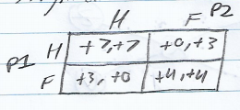
  2. If both players hunt, they both get the highest yield of food, therefore hunting is a strictly dominant strategy.
  3. (H, H) is a Nash Equilibria since it is the best response between the two players to each other’s choice.

1. 1. 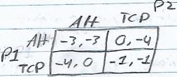
      1. If P1 knows that P2 is using TCP, P1 would use the alternative to get 0 lag.
      2. If P1 knows that P2 is using the alternative, P1 would also use the alternative to avoid the -4 attributed to choosing TCP in response.
      3. Therefore, using the alternative is the strictly dominant strategy.
   2. (Alt, TCP) and (TCP, Alt) are Nash Equilibria because they are the best response between the two players to each other’s choice; maximizes payoff by one being aggressive and one not.
   3. 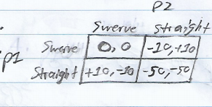
      1. If P1 knows that P2 will swerve, staying straight is optimal.
      2. If P1 knows P2 will stay straight, swerving will prevent -50 for both parties.
      3. Therefore, there is no dominant strategy.
   4. (Swerve, Straight) and (Straight, Swerve) are both pure strategy Nash Equilibria because one player plays one pair of strategies and the other chooses the opposite strategy.
2. 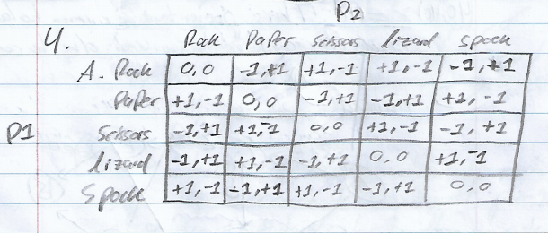
   1. 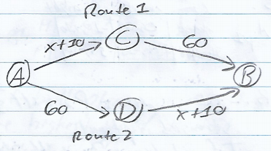
   2. If all cars chose to use Route 1, the travel time would be: 80 + 10 + 60 = 150 minutes
   3. The Nash Equilibria value of x is 40.
   4. Since the only Nash Equilibria can be an equal balance of cars, the Nash Equilibria value of x has to be 40. This prevents an uneven balance and the incentive to switch due to congestion.
   5. If all cars chose Route III: 80 + 10 + 80 + 10 = 180.
   6. If all cars chose Route IV: 60 + 60 = 120.
   7. Total travel time increases as a result because everyone would want to take the potentially faster path.
   8. By assigning 30 cars to Route I, 20 to Route II, and 20 to Route III the total travel time is reduced from part c (110) to 100. Travel time per each route:
      1. Route I: 100 minutes (30 cars)
      2. Route II: 100 minutes (30 cars)
      3. Route III: 60 minutes (20 cars)
   9. My firm should submit a bid of (true) value c. This is because if c is the winning bid, and say value d is the second-place bid, the payoff is c-d. Since we will only have to pay d if we win, there’s no reason to bet any higher or lower. If we do not win, payoff = 0 so there is no risk.
   10. Our bid depends on other firms who show up because it essentially increases the possibility of a firm that bids higher than our true value of c. Depending upon the true value of each new firm, our bid’s likelihood to succeed fluctuates. Since the values are private, we cannot know for sure how to change our own bid value, so the best plan would be to stick with our true value c.
   11. 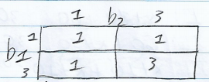
       1. Each choice has a probability of 0.25, therefore 0.25\*(1+1+1+3) = 6/4.
   12. With 3 bidders there would be 8 combinations possible with (3, 3, 3) giving the highest expected revenue value of 3, any other combination would yield 1. Therefor, 1/8 \* (1+1+1+1+1+1+1+3) = 10/8.
   13. Increasing bidders decreases the chances of the highest expected revenue value of 3. This is because all bidders must max-bid in order to yield 3, and the more bidders there are the more possible it becomes that they bet low thus reducing the expected revenue value from the max (3 -> 1).

I pledge my honor that I have abided by the Stevens Honor System.

Brandon Patton