**Assignment – Analytics & Data Visualization using Tableau**

Tableau is a recognized leader in data visualization and has a wide variety of customers from smaller organizations to fortune 500 companies.

To use their software for instruction purposes, Tableau partners with Teradata University Network (TUN) and provides multiple options for faculty and student use including a free trial download and free access to Tableau Desktop.

Click on <https://www.teradata.com/Partners/Tableau-Software-Inc>

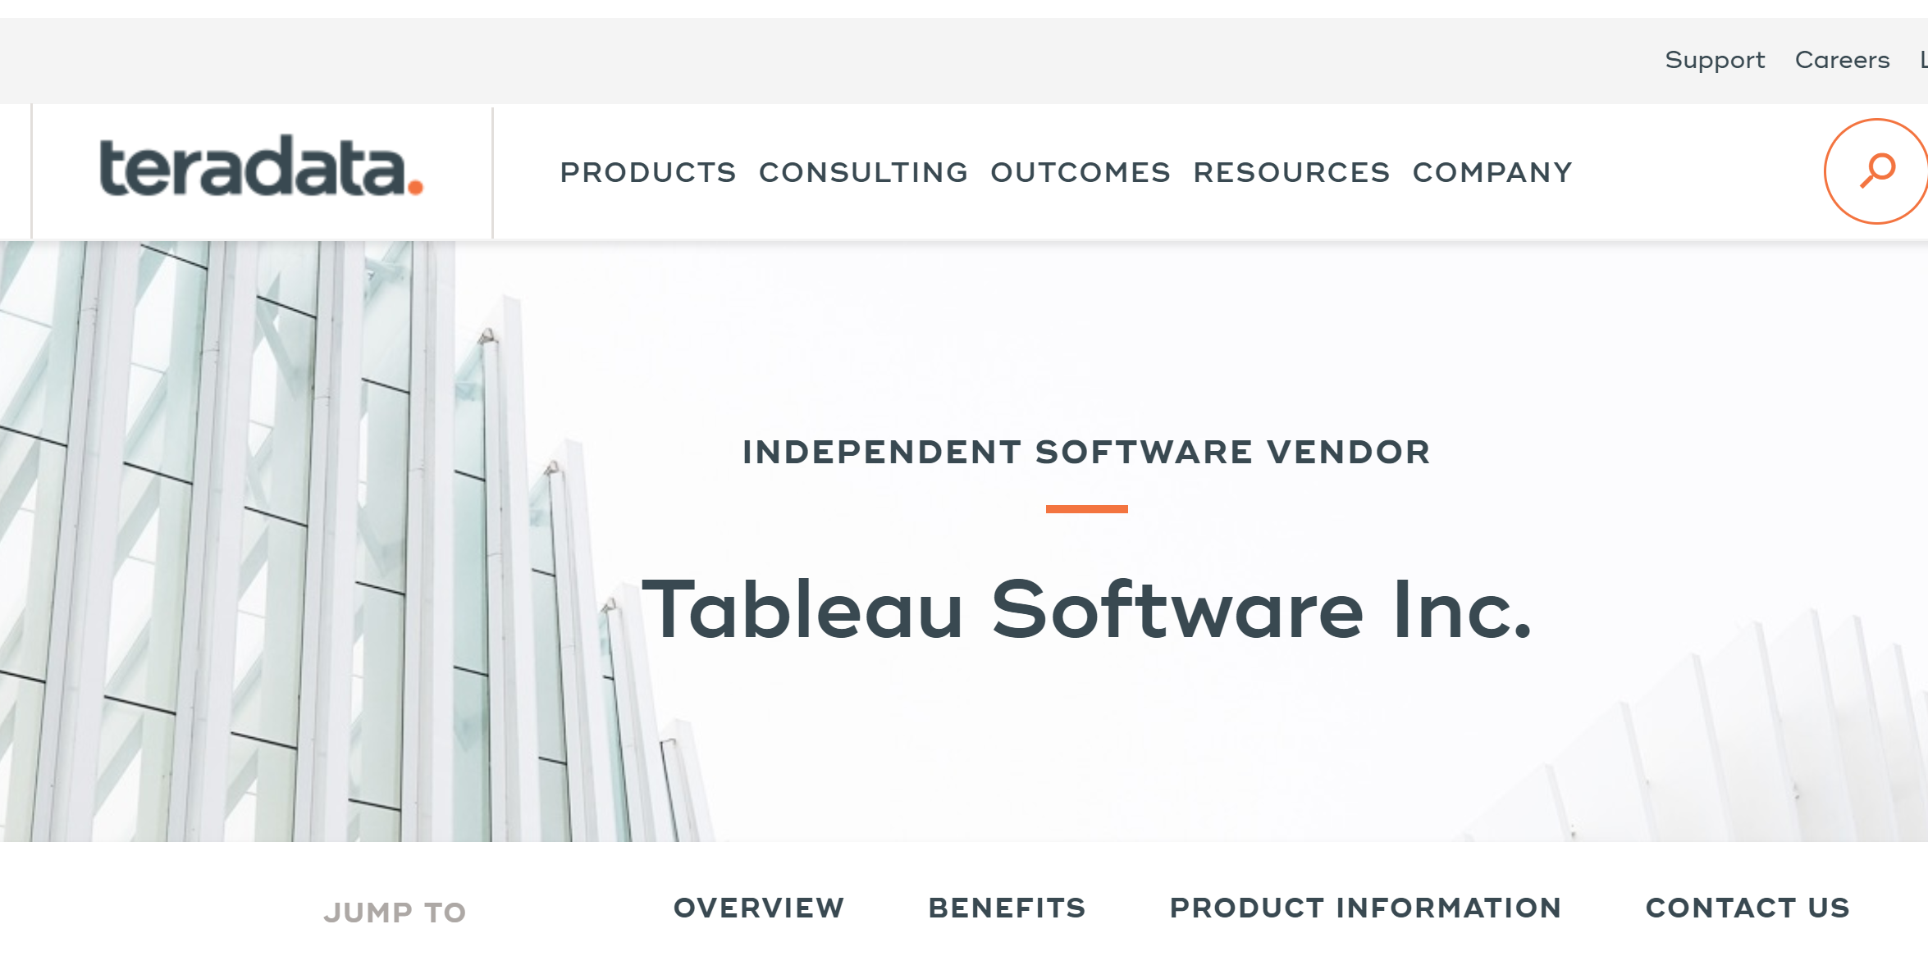

Scroll Down to **Download Free Trail.**

Click on Download Free Trial and download it.

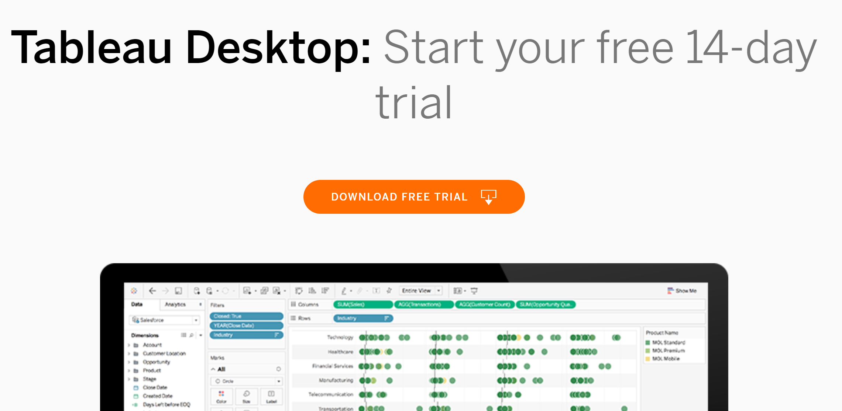

On the Tableau Website ([http://www.tableausoftware.com/learn/training)](http://www.tableausoftware.com/learn/training), there are short videos that can be helpful. I recommend viewing the first video, Getting Started.

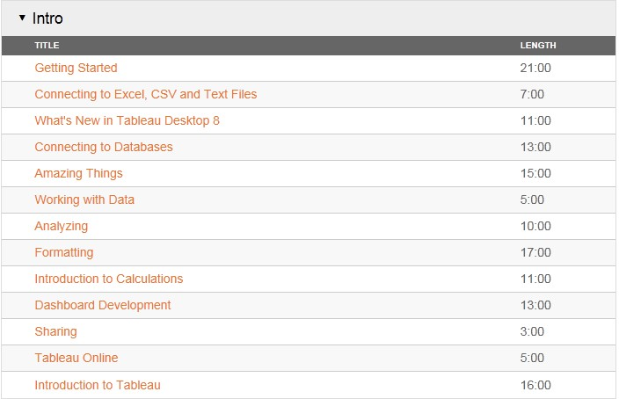

Now for the project. There is no fixed answer. I’m interested in how you develop your skill at using a data visualization tool for business intelligence and problem solving/investigation. In part, this means picking an appropriate kind of visualization to really help find patterns in the data and present a convincing view of the issues. Each student, I’m sure, will come up with a different result.

Here is the situation: assume you are a marketing manager in this coffee house chain and you have a sense that there are profitability issues in your products. You don’t know exactly how to define the problem nor what factors contribute to the issues. But, you want to explore this situation by visualizing the data you’ve received from those kind folks in IT (your data mart in a single Access table—well, not the normal BI data source, but it will do).

I have attached the coffee House Chain Data to explore. As you explore

1. What products are under performing?
2. What correlates with profit?

Are there issues with certain product lines, products, markets, pricing structures (margins), costs, ....?

Please produce a report that includes:

1. Identify a question that you can ask that will give an overall picture of the issues that impact profitability. You should have identified at least 2 issues based on your report.
2. Provide an explanation of what you discovered and generate at least 6 (you can go higher) screen shots from your analysis to show the logic of how you reached your conclusions and to convince me you found the issue.
3. The screen shots should display your progressive investigation, and different capabilities of Tableau (e.g., using the different shelves, filtering data, different styles of graphs -- Tableau does a lot of automatic generation of what it thinks is the right type of graph).
4. With each screen shot please define what question you are asking, what you observe, and why you went where you did next in your step-by-step problem exploration.