Project 20-2: Assign incidents

For this project, you’ll create an application that assigns an incident to a technician. (*Required reading: chapters 1-6, 12, and 18-20*)

The Select Incident page

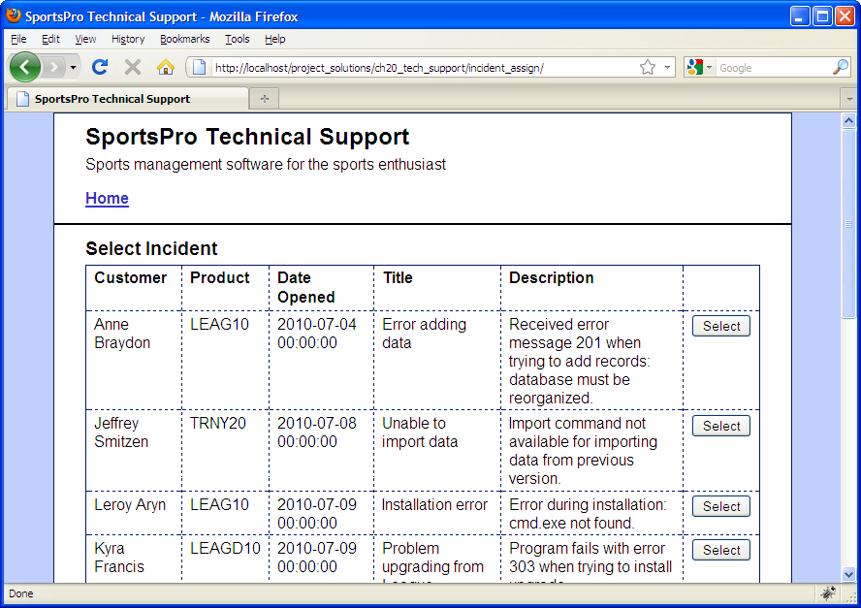

Operation

* When this application starts, the Select Incident page uses a table to display all of the incidents that have not been assigned to a technician (techID IS NULL).
* When the admin user clicks the Select button for an incident, the Select Technician page is displayed.

Specifications

* Use a join in the SELECT statement for this page so it retrieves data from the incidents and customers tables.
* Save the incident ID in the $_SESSION array so it can be used later in the application.

The Select Technician page

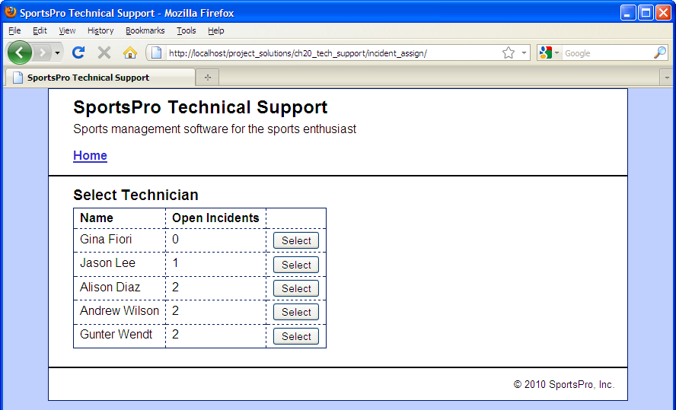

Operation

* When the user clicks the Select button for a technician, the Assign Incident page is displayed.

Specifications

* To get the number of open incidents for each technician, use a SELECT statement that includes a correlated subquery.
* Save the technician ID in the $_SESSION array so it can be used later in the application.

The Assign Incident page (view 1)

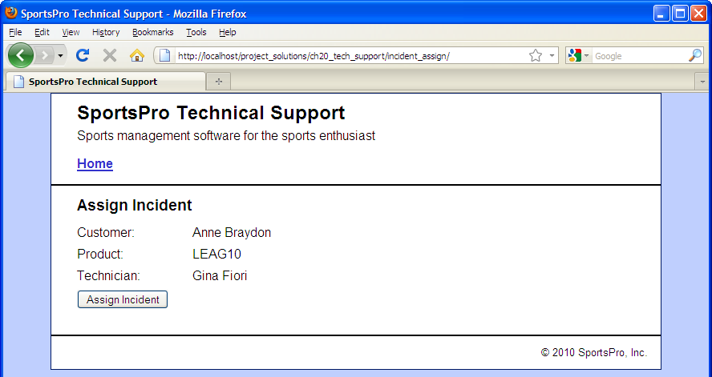

Operation

* When the user clicks the Assign Incident button, the selected incident is updated with the ID for the selected technician. If successful, this displays a message like the one shown below. Otherwise, an appropriate error message is displayed.

The Assign Incident page (view 2)

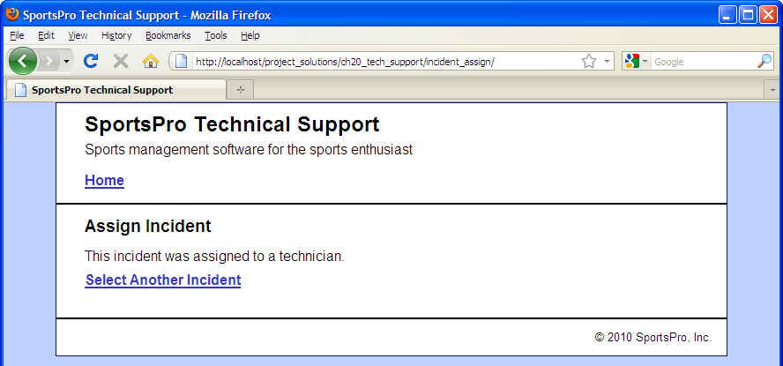

Operation

* When the user clicks on the Select Another Incident link, the Select Incident page is displayed.

Project 20-3: Update incidents

For this project, you’ll create an application that lets technicians update the rows in the incidents table. (*Required reading: chapters 1-6, 10, 12, and 18-20*)

The Technician Login page

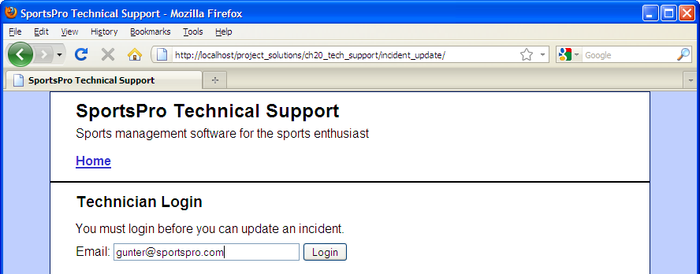

Operation

* After the technician logs in, the Select Incident page displays all incidents that have been assigned to the technician and have not been closed.

The Select Incident page

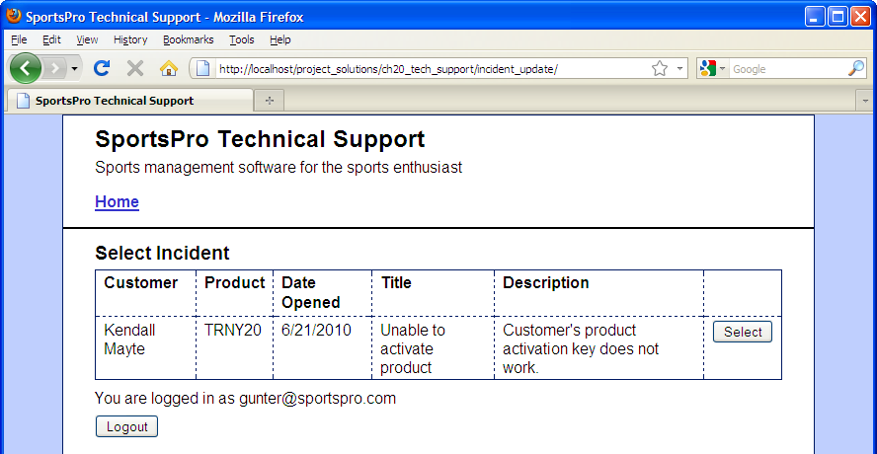

Operation

* To select an incident, the technician can click on the Select button that corresponds to the incident. This displays the Update Incident page.
* To log out, the user can click the Logout button.
* If there are no open incidents for the current technician, this page does not display a table of incidents. Instead, it displays a message that indicates that there are no open incidents and a Refresh List of Incidents link. However, this link only displays new incidents if new incidents have been assigned to the technician.

The Update Incident page (view 1)

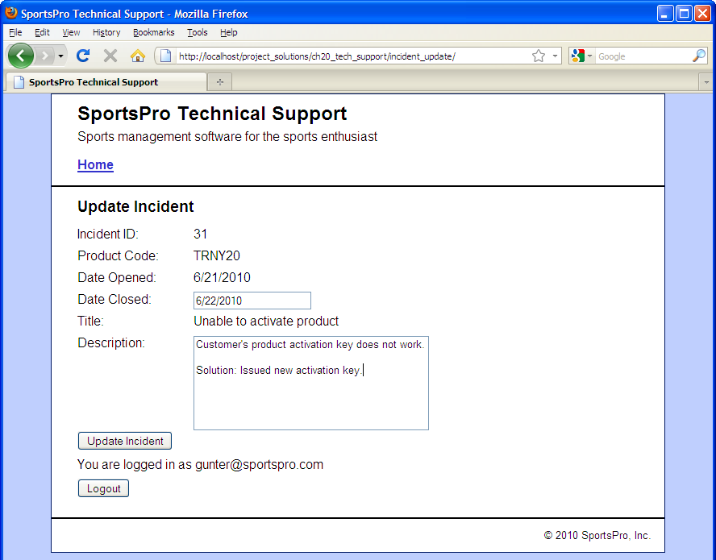

Operation

* To update an incident, the technician can modify the description and optionally enter the date the incident was closed and click on the Update Incident button. If successful, this displays a message like the one shown below. Otherwise, an appropriate error message is displayed.
* To log out, the user can click the Logout button.

The Update Incident page (view 2)

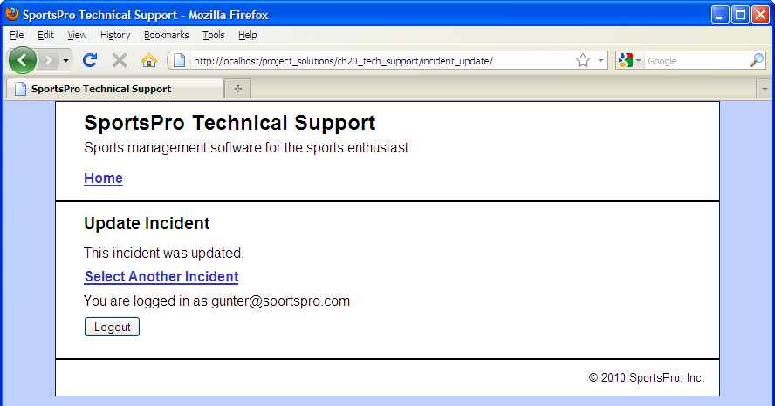

Operation

* To view a list of the remaining open incidents, the technician can click on the Select Another Incident link. This skips the Technician Login page and goes directly to the Select Incident page.
* If there are no open incidents for the current technician, this page does not display a table of incidents. Instead, it displays a message that indicates that there are no open incidents and a Refresh List of Incidents link. However, this link only displays new incidents if new incidents have been assigned to the technician.