[Brandon Pollack]
[2/1]
[23754365]

Elementary Analog Filter Design – Report

Introduction
This module is about designing a very small bandwidth passband filter. My frequency was 4365 Hz, which is the last four digits of my UFID. The specification dictates that my filter should have a -30 DB/decade stopband attenuation and a passband attenuation of no more than .25 on either side dB, with a gain of 0 dB. The bandwidth was meant to be under 100 Hz.
To do this, filterpro, software by TI, was used to choose all of these specifications and pick a filter type, order, and op amp for design. After this, the circuit was tested in LTspice to see if it met specifications, and then physically built.
Design
First step was the filter pro result, which is included below in figure 1.
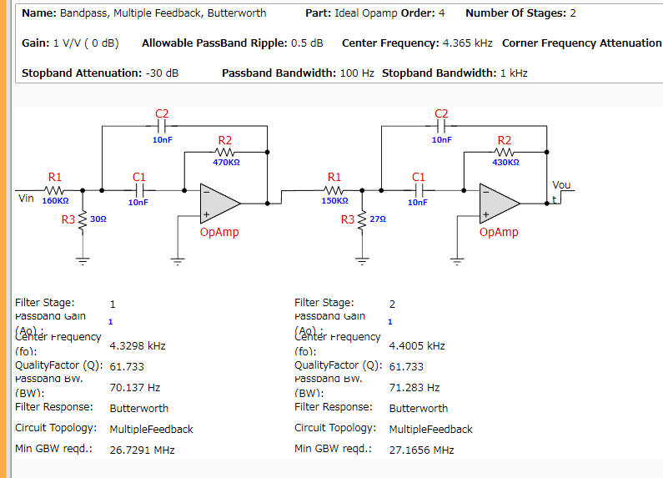
Figure 1
Then the circuit was laid out in LTspice. No matter what values I seemed to change, I couldn’t get the bandwidth 100Hz around the center frequency, so I added more poles to my filter system by adding a 3rd stage, which put me at about 30Hz bandwidth in LTspice. Since no strict specifications were given, I decided that I could just do a voltage divider at the end of the circuit to fix the gain, if necessary, so I didn’t mind the high gain (also LTspice has been tending to be wrong about AC analysis gain by quite a lot, so I thought that 10 dB on the third stage as shown in the simulation would come out to real life about 0 dB. See figure 2 I found the bandwidth by subtracting 3dB from the max dB on LTspice (about 7.7 on either side) 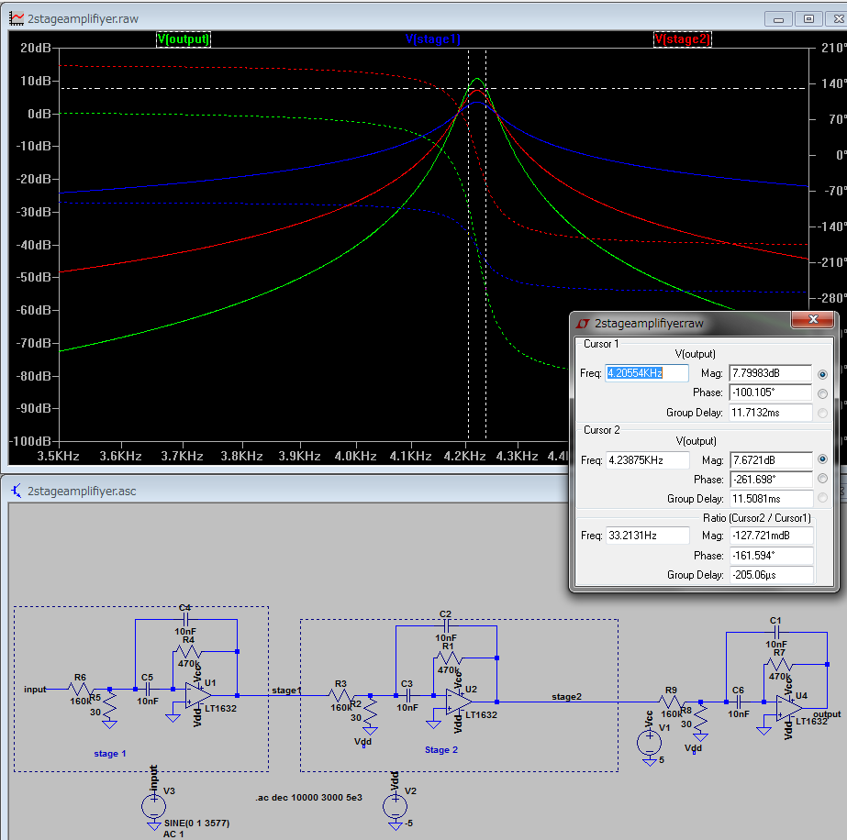
Figure 2

The actual circuit output ended up being much less gain, and the input resistor to the voltage divider on the negative input node had to be reduced to about 51K Ohms to have the right gain. This didn’t affect the frequency response too much otherwise. The real life bandwidth was still 140 Hz, but since that is below 5% of my frequency center, it was accepted. The scopes we use are analog so I cannot include a screenshot of the scope readout.
Bill of Materials

Name | Quantity | Part Number | Value | Tolerance | Description | Manufacturer
R1 (Stage 1) | 1 | Standard | 160KOhms | E24: 5% | Resistor
R2 (Stage 1) | 1 | Standard | 470KOhms | E24: 5% | Resistor
R3 (Stage 1) | 1 | Standard | 30Ohms | E24: 5% | Resistor
C1 (Stage 1) | 1 | Standard | 10nF | E24: 5% | Capacitor
C2 (Stage 1) | 1 | Standard | 10nF | E24: 5% | Capacitor
OpAmp (Stage 1) | 1 | Standard |  |  | Ideal OpAmp
R1 (Stage 2) | 1 | Standard | 150KOhms | E24: 5% | Resistor
R2 (Stage 2) | 1 | Standard | 430KOhms | E24: 5% | Resistor
R3 (Stage 2) | 1 | Standard | 27Ohms | E24: 5% | Resistor
C1 (Stage 2) | 1 | Standard | 10nF | E24: 5% | Capacitor
C2 (Stage 2) | 1 | Standard | 10nF | E24: 5% | Capacitor
OpAmp (Stage 2) | 1 | Standard |  |  | Ideal OpAmp
R1 (Stage 3) | 1 | Standard | 150KOhms | E24: 5% | Resistor
R2 (Stage 3) | 1 | Standard | 430KOhms | E24: 5% | Resistor
R3 (Stage 3) | 1 | Standard | 27Ohms | E24: 5% | Resistor
C1 (Stage 3) | 1 | Standard | 10nF | E24: 5% | Capacitor
C2 (Stage 3) | 1 | Standard | 10nF | E24: 5% | Capacitor
OpAmp (Stage 3) | 1 | Standard |  |  | Ideal OpAmp
Resistor/Capacitor costs are neglible in bulk and each op amp costs about 5 dollars if you buy in bulk, so the total cost of this filter seems to be about 17-18 dollars (which seems overpriced, in the future I would research op amps more to find cheaper ones).
Conclusion
Overall it seems that filterpro was very useful in determining layout and getting started picking resistors, LTspice helped with experimentation with values and determining which values affected the response in what way. Most of the real work was in the actual circuit. Some bugs come up that someone unexperienced (like myself) would not expect, like the need of a bypass capacitor, or how to measure the 3dB point.
Overall I learned much from this module, especially about how I need to be careful when applying things I learn in class, and consider real life implications, and limitations, much more.

Note 1: Uploaded report will be automatically reviewed in E-learning

Note 2: Effective technical reports convey the key essential information in a concise and clear manner (Focus on quality, not length)

