[NAME]
[DATE]
[UFID]

MODULE 1 Elementary Pre-/Amplifier Design – Report

Introduction
This module is about creating a pre amplifier. We were allowed to pick between LT1634 and LT1390 op amps for this pre amp. This was designed for audio, so it rolled in at 100 HZ and off at at least 15khz. Then a true amp designed for audio was used, and had some differences. LT1632 was chosen because of its much higher GBW product
Design
The amp was designed for a gain of 20 V/V, which is done using a simple inverting configuration. However, the amp could only have one supply, so a virtual ground (center other than ground) had to be used and fed into the non inverting input. The gain is equal to feedback resistance/input resistance, and before the input resistance, an decoupling capacitor was included to filter out DC and low frequency (60 Hz) components. This amp works well with an open circuit, however the max output current of this amp (has no voltage repeating transistor on the output) is only about 40 mA according to the data sheet, so it cannot drive a load without another BJT on the output. That is when the LM386 from TI came in handy (it also default gained to 20 V/V with no external parts).
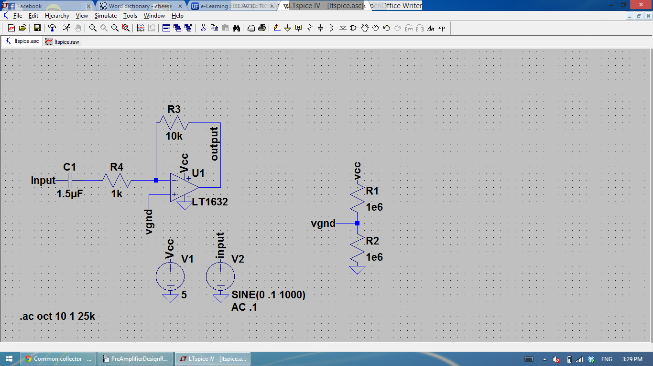

Conclusion
As suspected, the original op amp could not drive such a small load because of it's max output, I learned much about op amps and what to consider when picking them.

Note 1: Uploaded report will be automatically reviewed in E-learning

Note 2: Effective technical reports convey the key essential information in a concise and clear manner (Focus on quality, not length)

