Brandon Pollack
04/25
2375-4365

FINAL PROJECT – Report

Introduction
The goal of my project was to make an electronic instrument tuner. This would consist of a few major parts, a microprocessor (atmel324PA), a DAC (Lt1661), BNC connection (for input), battery, voltage regulation, and current amplifier (simple MOSFET).
Unfortunately, it turns out that some lower frequency notes are within about 5% of each other, so I could not have a tuner with a reasonable error and be able to tell if a note was sharp or flat at lower frequencies without a more accurate clock. The solution for this was to instead make a simple frequency detector.
Design
Bill of Materials
Item | Cost
1 Atmega 324PA | $7.00
1 LTC1661 | $3.40
1 2n7000 | $0.06
1 battery holder | $4.00
1 LED | $0.05
1 pushbutton switch | $0.10
1 BNC connector | $3.00
1 SPDT switch | $0.50
1 8 ohm speaker | $2.00
1 PCB | $50.00
Various capacitors and resistors | $1.00
1 voltage regulator | $0.50
1 LCD | $20.00
TOTAL | 91.61

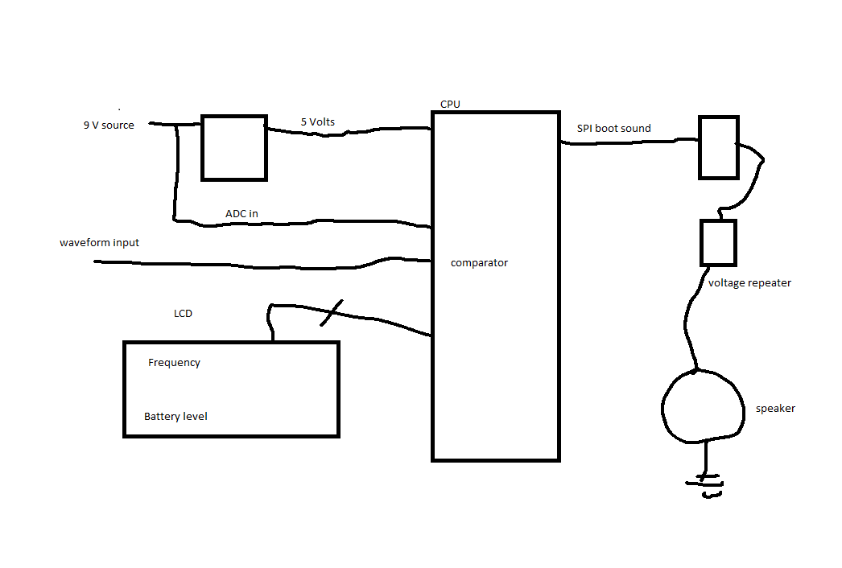Hardware Block Diagram

Software description:
The software was mostly interrupt driven. The boot sound was played through the speaker via a timer interrupt as all of the other set up took place. When a frequency set off the comparator, this caused an input capture on another timer, which allowed the period of the wave to be measured. The adc also ran on the overflow on that timer to make it sufficiently infrequent. The main loop read all of these values, did some math to find the frequency from the period, and displayed them on the LCD.
Conclusion
Unfortunately, a tuner was not possible for me with a clock this inaccurate, however as a frequency detector, the circuit was more than sufficient and operated well within 5% error. It did only go up to 700 Hz, which can be explained by code inefficiency, in that it took longer to find the frequency than before the next interrupt. This can be fixed by disabling interrupts when finding period, and optimizing code.

Note 0: The Final Project code must be uploaded separately.

Note 1: Uploaded report will be automatically reviewed in E-learning

Note 2: Effective technical reports convey the key essential information in a concise and clear manner (Focus on quality, not length)

