Brandon Pollack

Lab7

Summary

Prelab:

1. Period .2 ms

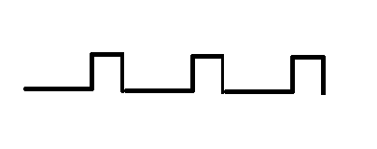

1. Sine wave can be made by putting a PWM into a low pass filter (capacitor and resistor) or by using the DAC, which can make other wave shapes as well.

Problems encountered: none

What I learned:

How to effectively use timer/counters and the RTC

Files:

Summary.pdf

Report.pdf

Lab7_part1_BRP

Lab7_part2_BRP

Circuit and flowcharts