Brandon Pollack

Microprocessor lab1

Brandon Pollack

Lab1 Summary

Prelab

1: RAM starts at address 2000 so that is where any written memory should begin.

2: Program memory is a separate section of the memory than the data memory. Program memory is where the program (application) and other things are stored on non volatile Flash memory. Data memory has some memory mapped EEPROM, SRAM, IO memory, and external memory if it is available.

3. You can use XYZ registers to point to data in the program memory, these are stored in regiesters 26-31. All other registers can be loaded data, but only registers 16 and up can be used to compare immediate data.

Problems encountered:

For some reason I don’t yet understand, the assembler shifts all ORGS left one bit, I compensated by simply shifting back right.

Future application:

I know assembly a little better now and can manipulate data well.

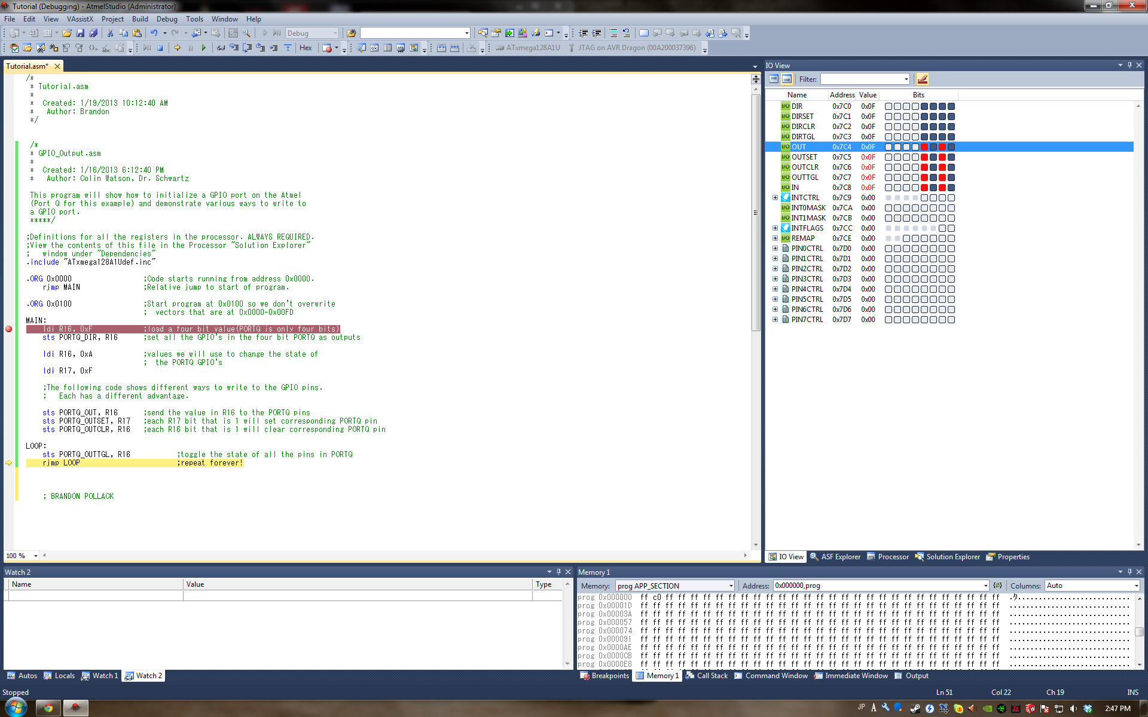

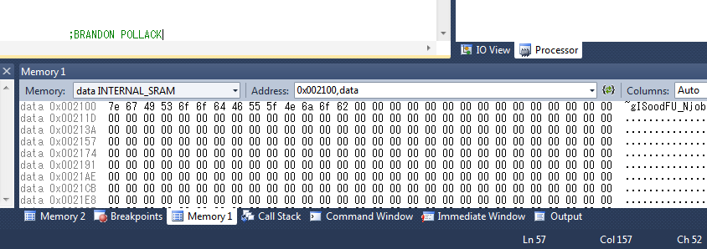This is the Simulated filtered table

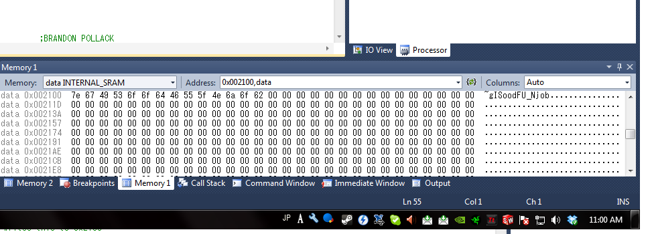

This is emulated directly with the AVR CPU

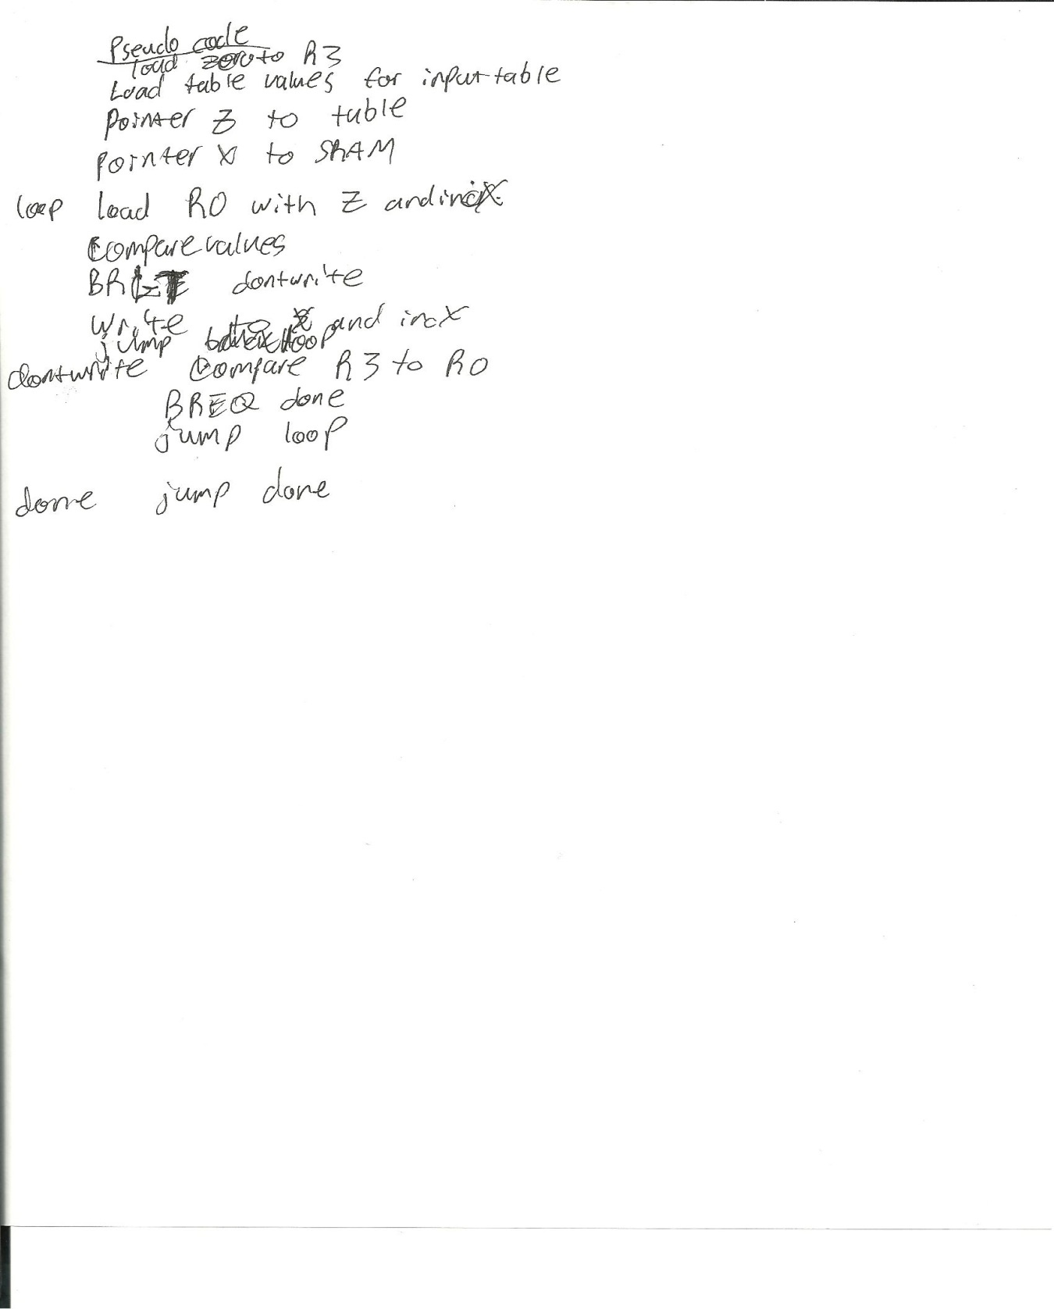Pseudo code