Brandon Pollack

Lab4

Report

Decode

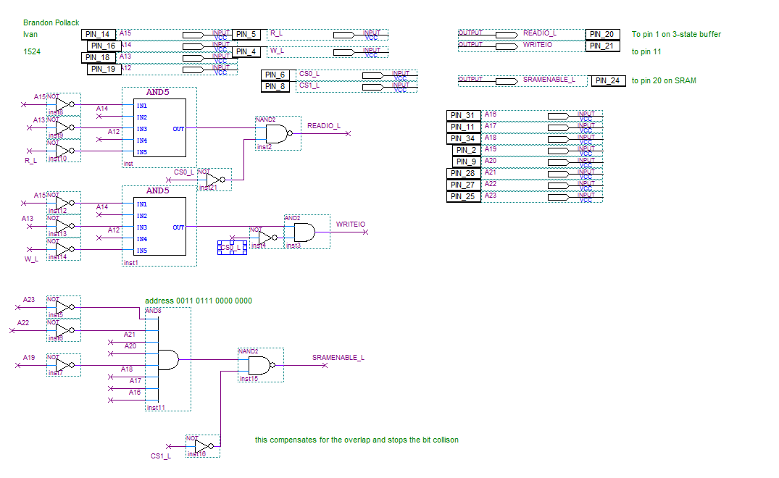

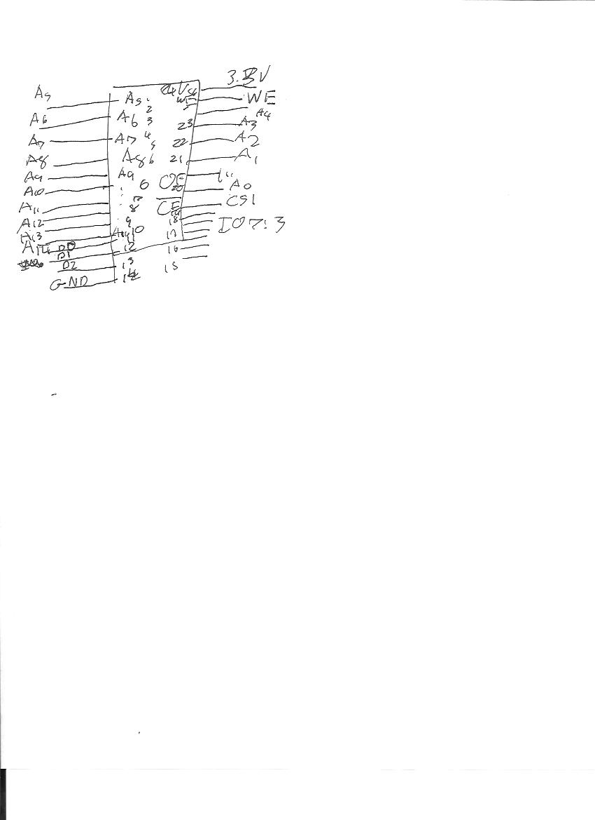

SRAM

ASM Files are attached to the email