Brandon Pollack

Lab4 Summary

Prelab Questions:

1. You do not need the CPLD to decode for the SRAM, we can use the CS pins.
2. 23:0 would need to be present for full address decoding.
3. 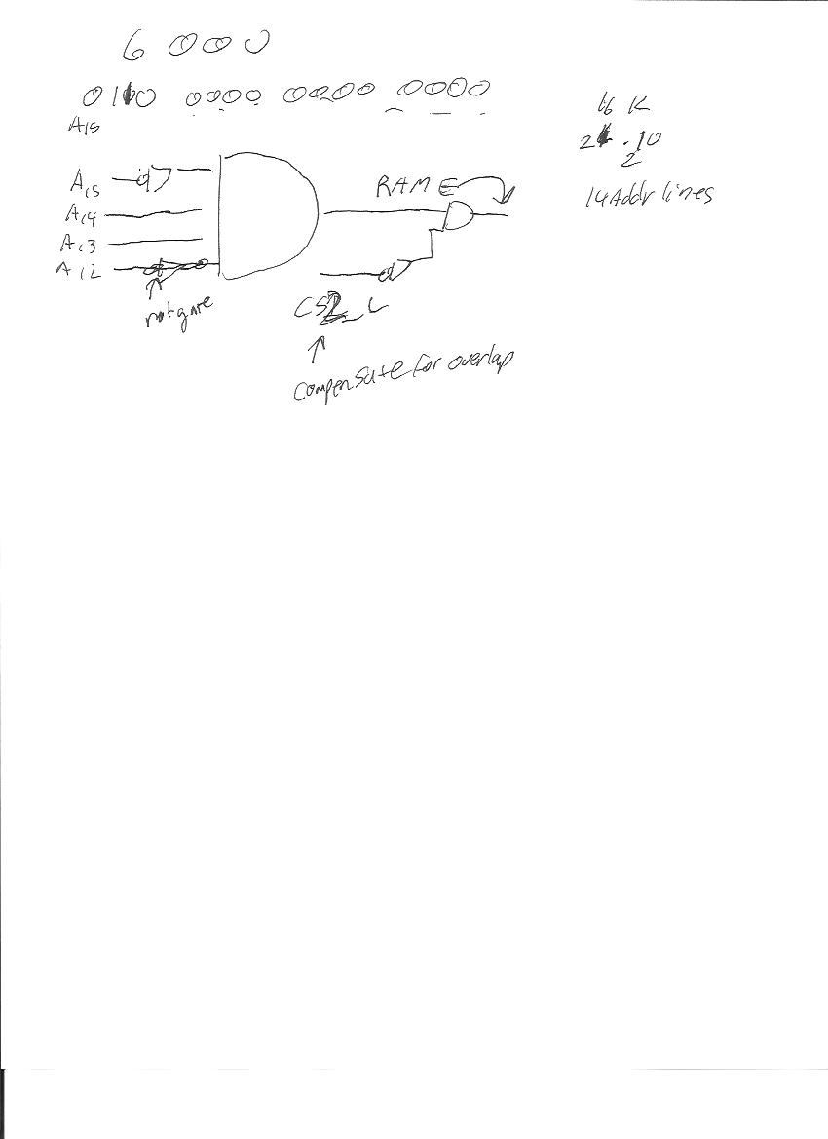

Problems encountered:

A bit of trouble setting up the EBI correctly, turns out I forget to set CS0 and CS1 as outputs (as well as make them high since they are active low).

Things learned

How to configure SRAM correctly, add it in Atmel Studio so I can see it as I debug

Files:

Summary

Lab4_part1_BRP

Lab4_part2_BRP

Report

BrandonPollack.qar