Brandon Pollack

Lab 5 report

All ASM files including the includes

EBI_INIT.asm

/* A collection of inits for the EBI and stack init at the bottom */

.set IOPORT = 0x5000

.set SRAMPORT = 0x370000

.macro TRIPORT_ALE_ONE_INIT

ldi R16, 0b00110111

sts PORTH_DIR, R16 //set port pins as outputs for RE and ALE and WE CS1 and CS0

ldi R16, 0b00110011

sts PORTH_OUTSET, R16 //WE and RE and CS pins are active low so it must be set

ldi R16, 0xFF

sts PORTJ_DIR, R16 //set datalines as outputs (manual says so)

sts PORTK_DIR, R16 //set address lines as outputs

ldi R16, 0x01

sts EBI_CTRL, R16 //turn on 3 port SRAM ALE1 EBI

.endmacro

.macro CS0_INIT

ldi ZH, HIGH(EBI_CS0_BASEADDR) //all the set up for CS0, since EBI won't work without it

ldi ZL, LOW(EBI_CS0_BASEADDR)

ldi R16, ((IOPORT>>8) & 0xF0)

st Z+, R16

ldi R16, ((IOPORT>>16) & 0xFF)

st Z, R16

ldi R16, 0x11

sts EBI_CS0_CTRLA, R16

.endmacro

.macro CS1_INIT

.equ SRAMPORT = 370000

ldi ZH, HIGH(EBI_CS1_BASEADDR) //set up CS1 for the SRAM

ldi ZL, LOW(EBI_CS1_BASEADDR)

ldi R16, ((SRAMPORT>>8) & 0xF0)

st Z+, R16

ldi R16, ((SRAMPORT>>16) & 0xFF)

st Z, R16

ldi R16, 0b00011101

sts EBI_CS1_CTRLA, R16

.endmacro

.macro STACK_INIT

ldi R16, 0xFF

out CPU_SPL, R16

ldi R16, 0x3F

out CPU_SPH, R16 //init stack pointer

.endmacro

UART_INITS

/* Brandon Pollack

* HW4

* SCI Subroutines

*/

.macro SCI_C_INIT

.equ BSEL = 51

.equ BSCL = -2

ldi R16, 0x18

sts USARTC0_CTRLB, R16 ;this buts a one in RXEN and TXEN, enabling transmission and receive

ldi R16, 0x03

sts USARTC0_CTRLC, R16 ;No parity, 8 bit data, a single stop bit

ldi R16, BSEL

sts USARTC0_BAUDCTRLA, R16 ;setting baud to 9600 HZ involves some calculation from the manual

ldi R16, ((BSCL << 4) & 0xF0) | ((BSel >> 8) & 0x0F)

sts USARTC0_BAUDCTRLB, R16 ;set the scale to -2 as per the formula to get 9600 HZ from the Fper and BSCL, upper 4 bits of BSEL stay the same

; now begins the set up of the PORTC to output and input serial

ldi R16, 0x08

sts PORTC_DIR, R16

sts PORTC_OUT, R16 ; set the direction of the TX line as out and default as 1 as per docs

.endmacro

/*SPI_C_INIT:

.macro

.equ BSEL = 51

.equ BSCL = -2

ldi R16, 0x18

sts USARTC0_CTRLB, R16 ;this buts a one in RXEN and TXEN, enabling transmission and receive

ldi R16, 0b01000011

sts USARTC0_CTRLC, R16 ;No parity, 8 bit data, a single stop bit, synchronous transmission

ldi R16, BSEL

sts USARTC0_BAUDCTRLA, R16 ;setting baud to 9600 HZ involves some calculation from the manual

ldi R16, ((BSCL << 4) & 0xF0) | ((BSel >> 8) & 0x0F)

sts USARTC0_BAUDCTRLB, R16 ;set the scale to -2 as per the formula to get 9600 HZ from the Fper and BSCL, upper 4 bits of BSEL stay the same

; now begins the set up of the PORTC to output and input serial

ldi R16, 0x08

sts PORTC_DIR, R16

sts PORTC_OUT, R16 ; set the direction of the TX line as out and default as 1 as per docs

.endmacro

*/

OUT_CHAR:

.org 0x200

push R17 ;save this value

isdatasent:

lds R17, USARTC0_STATUS

sbrs R17, 6 ;poll TXIF in status register, if it is clear we are not done

rjmp isdatasent

sts USARTC0_DATA, R16

pop R17

ret

OUT_STRING:

push R16 ;I chose to use z so this sub works for program or data memory (remember to shift left if program memory)

beginwritingstring:

ld R16, Z+ ;at the end of this sub, z will point to one address past the end of the string

breq donewritingstring

call OUT_CHAR

rjmp beginwritingstring

donewritingstring:

pop R16

ret

IN_CHAR:

push R17

isdatarecieved:

lds R17, USARTC0_STATUS

sbrs R17, 7

rjmp isdatarecieved

lds R16, USARTC0_DATA

pop R17

ret

IN_STRING: ;be sure to have X point where you want this data to go

push R16

beginreadingstring:

call IN_CHAR ;puts the character in R16

cpi R16, 0

breq donereadingstring

st X+, R16

rjmp beginreadingstring

donereadingstring:

pop R16

ret

Lab5_part1_BRP

/*

* Brandon Pollack

* Ivan

* 1524

* A program that uses an input on a port as an interupt

*/

.include "Atxmega128A1udef.inc"

.include "EBI_INITS.asm"

.org 0

rjmp main

.org PORTC_INT0_VECT

rjmp EXT_INT_countup

main:

.org 0x100

ldi R16, 0x01

sts PORTC_INTCTRL, R16 ;set this port as a low level interrupt

ldi R16, 0x04

sts PORTC_INT0MASK, R16 ;set pin 2 as the interrupt, since it is the only one with full asynch support

sts PORTC_DIRCLR, R16 ;make certain that pin is an input

ldi R16, 0x02

sts PORTC_PIN2CTRL, R16 ;set pin 2 to trigger an interrupt on only a falling edge

ldi R16, 0x01

sts PMIC_CTRL, R16 ;turn on low level interrupts

sei ;turn on interrupts

TRIPORT_ALE_ONE_INIT ;turn on EBI so I can write to my LEDs

CS0_INIT ;not really needed but I think my CPLD uses it now so lets turn it on

ldi R16, 0x0 ;set the init value of our count to 0

sts IOPORT, R16

loopforever:

rjmp loopforever

EXT_INT_countup:

nop

nop

nop

nop

nop

nop

nop

nop

nop

nop

nop

nop

nop

nop

nop

nop

nop

nop

nop

nop

nop

nop

nop

nop

nop

nop

nop

nop

nop

nop

nop

nop

nop

nop

nop

nop

ldi R17, 0x00

sts PORTC_INTFLAGS, R17

inc R16

sts IOPORT, R16 ;simply increments R16 and writes it out to the IO ports

reti

Lab5_part2_1

/*

*Brandon Pollack

*Ivan

*1352

*UART Port C program to interface with a terminal

*/

.include "Atxmega128A1udef.inc"

.include "EBI_INITS.asm"

.equ CR = 0x0D

.equ LF = 0x0A

.equ stringlocation = 0x1000

.org stringlocation

.DB "My name is Brandon Pollack, my favourite movie is Pulp Fiction, my favourite class is EEL4744, my favourite TV show is Star Trek." CR, LF, "Instructor: Dr. Eric M. Schwartz, TA: IVAN", CR, LF, 0x00

.org 0x0

rjmp main

main:

.org 0x100

STACK_INIT

.equ BSEL = 144

.equ BSCL = -6

ldi R16, 0x18

sts USARTC0_CTRLB, R16 ;this buts a one in RXEN and TXEN, enabling transmission and receive

ldi R16, 0x03

sts USARTC0_CTRLC, R16 ;No parity, 8 bit data, a single stop bit

ldi R16, BSEL

sts USARTC0_BAUDCTRLA, R16 ;setting baud to 9600 HZ involves some calculation from the manual

ldi R16, ((BSCL << 4) & 0xF0) | ((BSel >> 8) & 0x0F)

sts USARTC0_BAUDCTRLB, R16 ;set the scale to -2 as per the formula to get 9600 HZ from the Fper and BSCL, upper 4 bits of BSEL stay the same

; now begins the set up of the PORTC to output and input serial

ldi R16, 0x08

sts PORTC_DIR, R16

sts PORTC_OUT, R16 ; set the direction of the TX line as out and default as 1 as per docs

ldi ZL, low(stringlocation << 1)

ldi ZH, high(stringlocation << 1) ;string location shifted by one

call OUT_STRING

done: rjmp done

OUT_CHAR:

.org 0x200

push R17 ;save this value

isdatasent:

lds R17, USARTC0_STATUS

sbrs R17, 5 ;poll TXIF in status register, if it is clear we are not done

rjmp isdatasent

sts USARTC0_DATA, R16

pop R17

ret

OUT_STRING:

push R16 ;I chose to use z so this sub works for program or data memory (remember to shift left if program memory)

beginwritingstring:

lpm R16, Z+ ;at the end of this sub, z will point to one address past the end of the string

cpi R16, 0x0

breq donewritingstring

call OUT_CHAR

rjmp beginwritingstring

donewritingstring:

pop R16

ret

Lab5_part2_2

/*

* Brandon Pollack

* Ivan

* 1524

* A program that uses interrupts to manage UART

*/

.include "Atxmega128A1udef.inc"

.include "EBI_INITS.asm"

.org 0x0

rjmp main

.org USARTC0_RXC_vect

rjmp RX_ISR

.org 0x100

main:

.equ BSEL = 144

.equ BSCL = -6

ldi R16, 0x18

sts USARTC0_CTRLB, R16 ;this buts a one in RXEN and TXEN, enabling transmission and receive

ldi R16, 0x03

sts USARTC0_CTRLC, R16 ;No parity, 8 bit data, a single stop bit

ldi R16, BSEL

sts USARTC0_BAUDCTRLA, R16 ;setting baud to involves some calculation from the manual

ldi R16, ((BSCL << 4) & 0xF0) | ((BSel >> 8) & 0x0F)

sts USARTC0_BAUDCTRLB, R16 ;set the scale and last 4 bits of BSEL

; now begins the set up of the PORTC to output and input serial

ldi R16, 0x08

sts PORTC_DIR, R16

sts PORTC_OUT, R16 ; set the direction of the TX line as out and default as 1 as per docs

//done with UART setup (except Interrupt drives, whcih I will do after I initilize PMIC)

ldi R16, 0x01

sts PMIC_CTRL, R16 //globally enable low level interrupts

ldi R16, (0x01 << 4)

sts USARTC0_CTRLA, R16 //set RXINTLVL to a low level interrupt

sei //globally enable all interrupts

TRIPORT_ALE_ONE_INIT

CS0_INIT

STACK_INIT

ldi XL, low(IOPORT)

ldi XH, high(IOPORT)

ldi R16, 0xFF

st X, R16

loopforever:

ldi R16, 0xFF

st X, R16

call DELAY500

ldi R16, 0x00

st X, R16

call DELAY500

rjmp loopforever

RX_ISR:

push R17

push R16

lds R16, USARTC0_DATA

isdatasent:

lds R17, USARTC0_STATUS

sbrs R17, 5 ;poll DATA in status register, if it is clear we are not done

rjmp isdatasent

sts USARTC0_DATA, R16

pop R16

pop R17

reti

DELAY500:

push R16

push R17

ldi R16, 0

ldi R17, 0

AGAIN:

NOP

NOP

NOP

NOP

NOP

NOP

NOP

NOP

NOP

NOP

NOP

NOP

NOP

NOP

NOP

INC R16

CPI R16, 0

BREQ CARRY

BACK:

CPI R17, 0xFF

BRNE AGAIN

BREQ RETURN

CARRY:

INC R17

rjmp BACK

RETURN:

pop R17

pop R16

RET

Lab5_part2_3

/*

* Lab5_part2_3.asm

*

* Created: 3/3/2013 3:41:22 PM

* Author: Brandon

*Brandon Pollack

*Ivan

*1352

*UART Port C program to interface with a terminal, now taking input

*/

.include "Atxmega128A1udef.inc"

.include "EBI_INITS.asm"

.equ CR = 0x0D

.equ LF = 0x0A

.equ menulocation = 0x1000

.equ TAB = 0x09

.equ CC = 0x12

.org menulocation

.db "Brandon's Favourite:",CR,LF,"0:", TAB,"Sport",CR,LF,"1:",TAB,"TV Show",CR,LF,"2:",TAB,"Book",CR,LF,"3:",TAB,"Food",CR,LF,"4:",TAB,"Movie",CR,LF,"5:",TAB,"Display menu",CR,LF,"ESC: exit",CR,LF,0x00

fsport:

.db "Baseball",CR,LF,0

fTV:

.db "Star Trek",CR,LF,0

fBook:

.db "Ender's Game",CR,LF,0

fFood:

.db "Tonkotsu Ramen",CR,LF,0

fMovie:

.db "Pulp Fiction",CR,LF,0

exitprint:

.db "Done!",0

.org 0x0

rjmp main

main:

.org 0x100

STACK_INIT

.equ BSEL = 144

.equ BSCL = -6

ldi R16, 0x18

sts USARTC0_CTRLB, R16 ;this buts a one in RXEN and TXEN, enabling transmission and receive

ldi R16, 0x03

sts USARTC0_CTRLC, R16 ;No parity, 8 bit data, a single stop bit

ldi R16, BSEL

sts USARTC0_BAUDCTRLA, R16 ;setting baud to 9600 HZ involves some calculation from the manual

ldi R16, ((BSCL << 4) & 0xF0) | ((BSel >> 8) & 0x0F)

sts USARTC0_BAUDCTRLB, R16 ;set the scale to -2 as per the formula to get 9600 HZ from the Fper and BSCL, upper 4 bits of BSEL stay the same

; now begins the set up of the PORTC to output and input serial

ldi R16, 0x08

sts PORTC_DIR, R16

sts PORTC_OUT, R16 ; set the direction of the TX line as out and default as 1 as per docs

loop:

ldi ZL, low(menulocation << 1)

ldi ZH, high(menulocation << 1) ;string location shifted by one

call OUT_STRING

recievenewchar:

call IN_CHAR

cpi R16, 0x1B

breq exitroutine

cpi R16, '0'

breq sport

cpi R16, '1'

breq TVshow

cpi R16, '2'

breq book

cpi R16, '3'

breq food

cpi R16, '4'

breq movie

cpi R16, '5'

breq loop

rjmp recievenewchar

exitroutine:

ldi ZL, low(exitprint << 1)

ldi ZH, high(exitprint << 1)

call OUT_STRING

done:

rjmp done

sport:

ldi R16, CC

call OUT_CHAR

ldi ZL, low(fsport << 1)

ldi ZH, high(fsport << 1)

call OUT_STRING

rjmp loop

TVshow:

ldi R16, CC

call OUT_CHAR

ldi ZL, low(fTV << 1)

ldi ZH, high(fTV << 1)

call OUT_STRING

rjmp loop

book:

ldi R16, CC

call OUT_CHAR

ldi ZL, low(fbook << 1)

ldi ZH, high(fbook << 1)

call OUT_STRING

rjmp loop

food:

ldi R16, CC

call OUT_CHAR

ldi ZL, low(fFood << 1)

ldi ZH, high(fFood << 1)

call OUT_STRING

rjmp loop

movie:

ldi R16, CC

call OUT_CHAR

ldi ZL, low(fmovie << 1)

ldi ZH, high(fmovie << 1)

call OUT_STRING

rjmp loop

IN_CHAR:

push R17

isdatarecieved:

lds R17, USARTC0_STATUS

sbrs R17, 7

rjmp isdatarecieved

lds R16, USARTC0_DATA

pop R17

ret

OUT_CHAR:

push R17 ;save this value

isdatasent:

lds R17, USARTC0_STATUS

sbrs R17, 5 ;poll TXIF in status register, if it is clear we are not done

rjmp isdatasent

sts USARTC0_DATA, R16

pop R17

ret

OUT_STRING:

push R16 ;I chose to use z so this sub works for program or data memory (remember to shift left if program memory)

beginwritingstring:

lpm R16, Z+ ;at the end of this sub, z will point to one address past the end of the string

cpi R16, 0x0

breq donewritingstring

call OUT_CHAR

rjmp beginwritingstring

donewritingstring:

pop R16

ret

Lab5_part3

/*

* Brandon Pollack

* Ivan

* 1524

* A program that uses interrupts to manage UART

*/

.include "Atxmega128A1udef.inc"

.include "EBI_INITS.asm"

.org 0x0

rjmp main

.org USARTC0_RXC_vect

rjmp RX_ISR

.org 0x100

main:

.equ BSEL = 144

.equ BSCL = -6

ldi R16, 0x18

sts USARTC0_CTRLB, R16 ;this buts a one in RXEN and TXEN, enabling transmission and receive

ldi R16, 0x03

sts USARTC0_CTRLC, R16 ;No parity, 8 bit data, a single stop bit

ldi R16, BSEL

sts USARTC0_BAUDCTRLA, R16 ;setting baud to involves some calculation from the manual

ldi R16, ((BSCL << 4) & 0xF0) | ((BSel >> 8) & 0x0F)

sts USARTC0_BAUDCTRLB, R16 ;set the scale and last 4 bits of BSEL

; now begins the set up of the PORTC to output and input serial

ldi R16, 0x08

sts PORTC_DIR, R16

sts PORTC_OUT, R16 ; set the direction of the TX line as out and default as 1 as per docs

//done with UART setup (except Interrupt drives, whcih I will do after I initilize PMIC)

ldi R16, 0x01

sts PMIC_CTRL, R16 //globally enable low level interrupts

ldi R16, (0x01 << 4)

sts USARTC0_CTRLA, R16 //set RXINTLVL to a low level interrupt

sei //globally enable all interrupts

TRIPORT_ALE_ONE_INIT

CS0_INIT

STACK_INIT

ldi XL, low(IOPORT)

ldi XH, high(IOPORT)

ldi R16, 0xFF

st X, R16

loopforever:

ldi R16, 0xFF

st X, R16

call DELAY500

ldi R16, 0x00

st X, R16

call DELAY500

rjmp loopforever

RX_ISR:

push R17

push R16

lds R16, USARTC0_DATA

isdatasent:

lds R17, USARTC0_STATUS

sbrs R17, 5 ;poll DATA in status register, if it is clear we are not done

rjmp isdatasent

sts USARTC0_DATA, R16

pop R16

pop R17

reti

DELAY500:

push R16

push R17

ldi R16, 0

ldi R17, 0

AGAIN:

NOP

NOP

NOP

NOP

NOP

NOP

NOP

NOP

NOP

NOP

NOP

NOP

NOP

NOP

NOP

INC R16

CPI R16, 0

BREQ CARRY

BACK:

CPI R17, 0xFF

BRNE AGAIN

BREQ RETURN

CARRY:

INC R17

rjmp BACK

RETURN:

pop R17

pop R16

RET

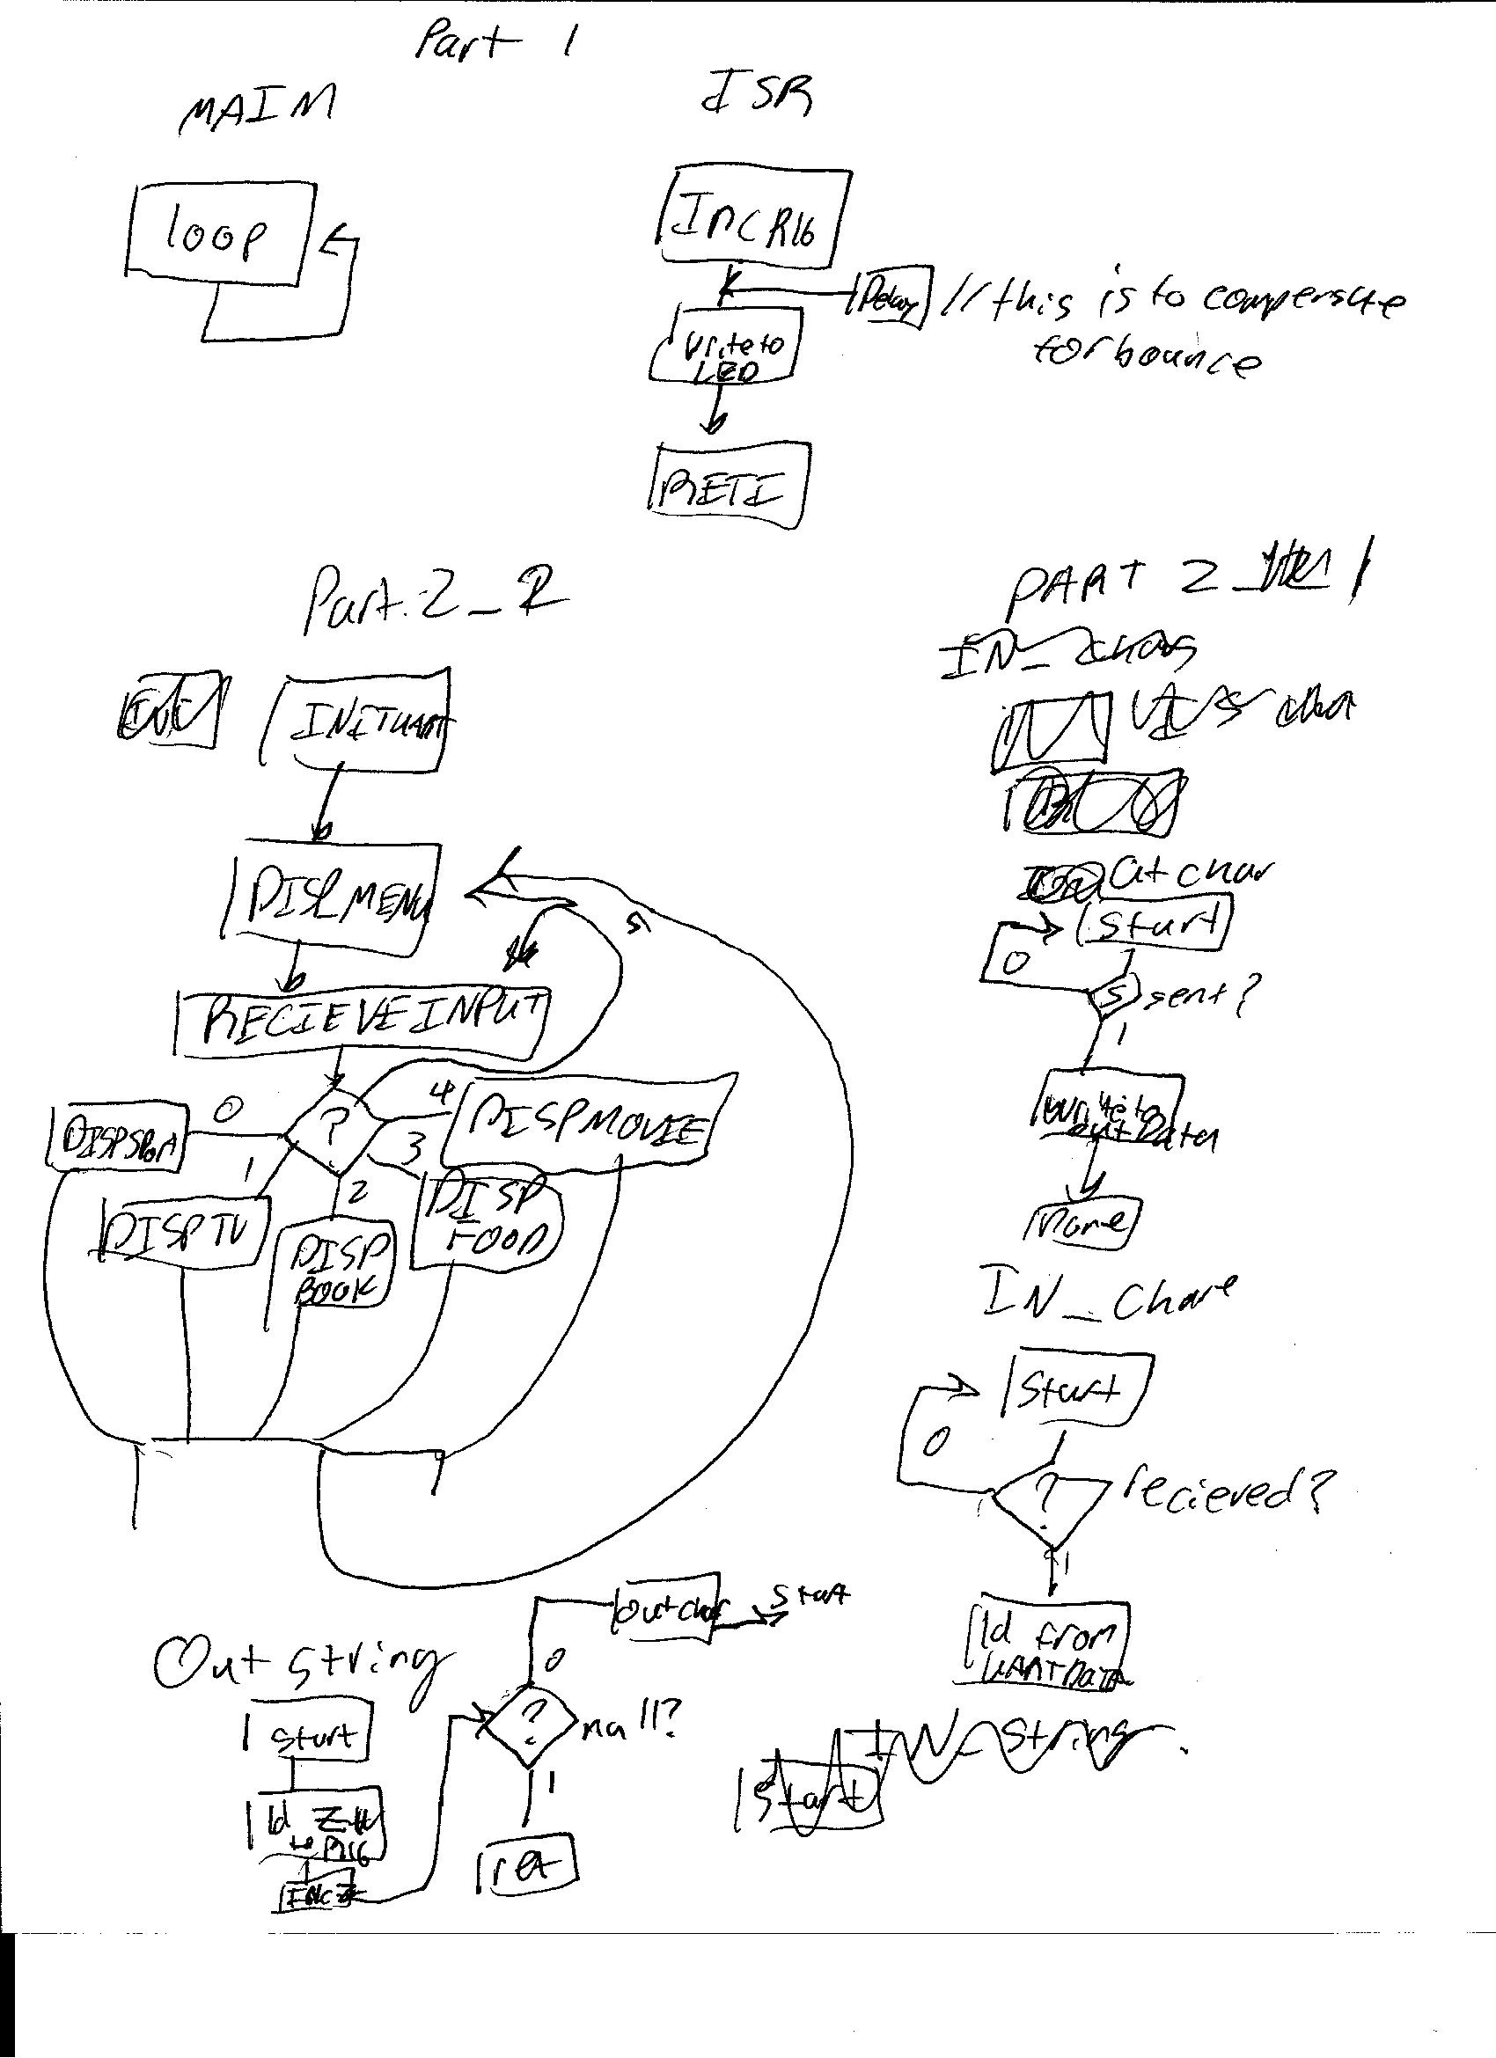

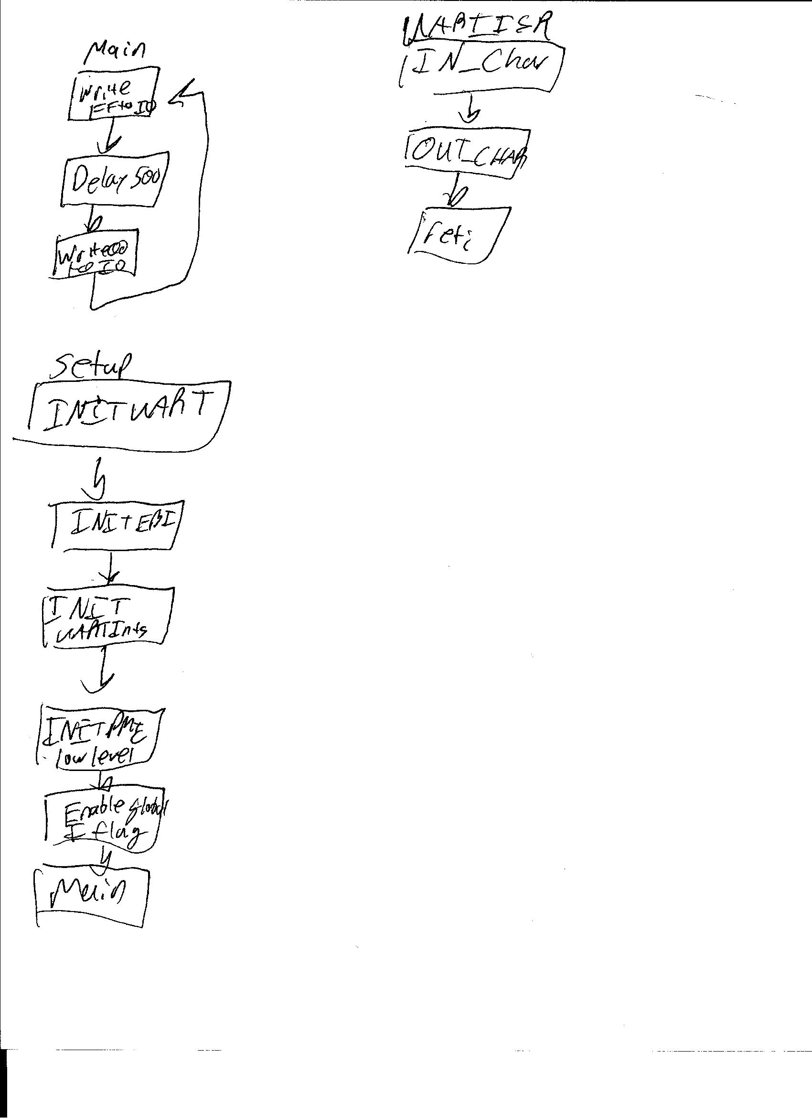

Part 3

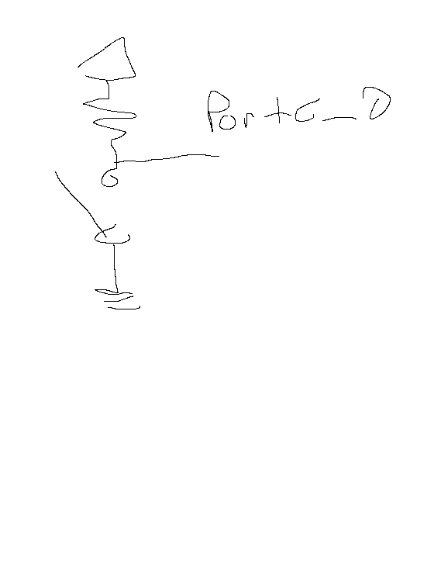

Interrupt port