4 Information requirements
This clause specifies the information requirements for the Part and zone laminate tables application module. The information requirements are specified as the Application Reference Model (ARM) of this application module.
NOTE 1 A graphical representation of the information requirements is given in Annex C.
NOTE 2 The mapping specification is specified in 5.1. It shows how the information requirements are met by using common resources and constructs defined or imported in the MIM schema of this application module.
This clause defines the information requirements to which implementations shall conform using the EXPRESS language as defined in ISO 10303-11. The following begins the Part_and_zone_laminate_tables_arm schema and identifies the necessary external references.
EXPRESS specification:
*)
SCHEMA Part_and_zone_laminate_tables_arm;
(*

4.1 Required AM ARMs
The following EXPRESS interface statements specify the elements imported from the ARMs of other application modules.
EXPRESS specification:
*)
USE FROM Composite_constituent_shape_arm; -- ISO/TS 10303-1767
USE FROM Ply_orientation_specification_arm; -- ISO/TS 10303-1772
USE FROM Shape_property_assignment_arm; -- ISO/TS 10303-1032
USE FROM Stock_material_arm; -- ISO/TS 10303-1771
(*
NOTE 1 The schemas referenced above are specified in the following part of ISO 10303:
Composite_constituent_shape_arm | ISO/TS 10303-1767
Ply_orientation_specification_arm | ISO/TS 10303-1772
Shape_property_assignment_arm | ISO/TS 10303-1032
Stock_material_arm | ISO/TS 10303-1771
NOTE 2 See Annex C, Figures C.1, C.2and C.3 for a graphical representation of this schema.

4.2 ARM type definitions
This subclause specifies the ARM types for this application module. The ARM types and definitions are specified below.

4.2.1 component_class_for_assembly
The component_class_for_assembly type allows for the designation of the data types Composite_assembly, Filament_laminate, Part_view_definition, Ply, Ply_laminate, and Processed_core.
EXPRESS specification:
*)
TYPE component_class_for_assembly = SELECT
(Composite_assembly,
Filament_laminate,
Part_view_definition,
Ply,
Ply_laminate,
Processed_core);
END_TYPE;
(*

4.2.2 filament_assembly_material
The filament_assembly_material type allows for the designation of the data types Braided_assembly, Filament_assembly, and Woven_assembly.
EXPRESS specification:
*)
TYPE filament_assembly_material = SELECT
(Braided_assembly,
Filament_assembly,
Woven_assembly);
END_TYPE;
(*

4.2.3 point_select
The point_select type allows for the designation of the data types Cartesian_point, Degenerate_pcurve, Point_on_curve, and Point_on_surface.
EXPRESS specification:
*)
TYPE point_select = SELECT
(Cartesian_point,
Degenerate_pcurve,
Point_on_curve,
Point_on_surface);
END_TYPE;
(*

4.2.4 thickness_laminate_table_component
The thickness_laminate_table_component type allows for the designation of the data types Filament_laminate, Ply, and Processed_core.
EXPRESS specification:
*)
TYPE thickness_laminate_table_component = SELECT
(Filament_laminate,
Ply,
Processed_core);
END_TYPE;
(*

4.3 ARM entity definitions
This subclause specifies the ARM entities for this module. Each ARM application entity is an atomic element that embodies a unique application concept and contains attributes specifying the data elements of the entity. The ARM entities and definitions are specified below.

4.3.1 Composite_assembly
A Composite_assembly is a type of Constituent_part that is made of multiple materials that are bonded together. A Composite_assembly may be made from any combination of materials. A completed Composite_assembly need not be a rigid shape. A Composite_assembly may also be used as a composite part.
EXPRESS specification:
*)
ENTITY Composite_assembly
SUBTYPE OF (Constituent_part);
layup_part : Composite_assembly_table;
shape : OPTIONAL composite_assembly_shape;
END_ENTITY;
(*
Attribute definitions:
layup_part: specifies a role of the Composite_assembly_table for the Composite_assembly.
shape: specifies a role of the composite_assembly_shape for the Composite_assembly. The value of this attribute need not be specified.

4.3.2 Composite_assembly_sequence_definition
A Composite_assembly_sequence_definition is a single unique sequence or layer within a Composite_assembly. The sequence or layer contains an unordered bag of one or more constituent parts. When more than one constituent part resides in the same sequence or layer, the constituents must not overlap.
NOTE If constituents do overlap, they must be put on separate sequence or layers.
EXPRESS specification:
*)
ENTITY Composite_assembly_sequence_definition;
components_in_sequence : BAG[1:?] OF component_class_for_assembly;
END_ENTITY;
(*
Attribute definitions:
components_in_sequence: specifies a role of the component_class_for_assembly for the Composite_assembly_sequence_definition. There shall exist one or more component_class_for_assembly for the Composite_assembly_sequence_definition

4.3.3 Composite_assembly_table
A Composite_assembly_table is a type of Part_laminate_table that provides an ordered list of constituent parts. The ordered list provides basic placement position within the laminate (see Figure 1 ).

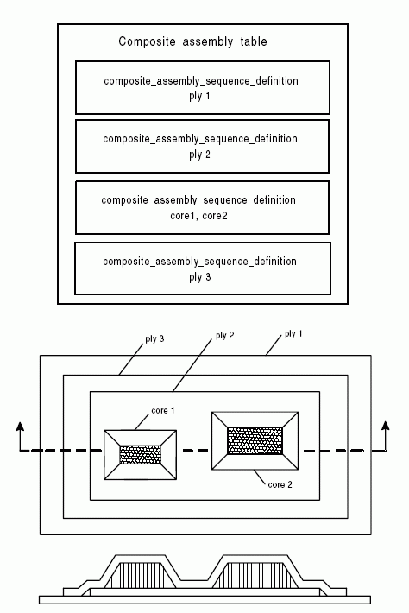

Figure 1 — Composite assembly table

EXPRESS specification:
*)
ENTITY Composite_assembly_table
SUBTYPE OF (Part_laminate_table);
sequence_groups : LIST[2:?] OF Composite_assembly_sequence_definition;
END_ENTITY;
(*
Attribute definitions:
sequence_groups: specifies a role of the Composite_assembly_sequence_definition for the Composite_assembly_table. There shall exist not less than twoComposite_assembly_sequence_definitions for the Composite_assembly_table.

4.3.4 Constituent_part
A Constituent_part is a type of Part_view_definition. A Constituent_part may, but need not be, defined in a component-assembly relationship. A Constituent_part may be a Ply, or a Ply_piece, or a Ply_laminate, or a Filament_laminate, or a Processed_core, or a Composite_assembly.
EXPRESS specification:
*)
ENTITY Constituent_part
SUPERTYPE OF (ONEOF (Ply,
Ply_piece,
Ply_laminate,
Filament_laminate,
Processed_core,
Composite_assembly))
SUBTYPE OF (Part_view_definition);
SELF\Product_view_definition.id RENAMED constituent_part_identification : STRING;
weight : OPTIONAL Mass_data_element;
END_ENTITY;
(*
Attribute definitions:
constituent_part_identification: an attribute inherited from the Product_view_definition that specifies the composite item.
weight: quantifies the mass of the Constituent_part. The value of this attribute need not be specified.

4.3.5 Edge_zone_shape
An Edge_zone_shape is a type of Zone_structural_makeup_shape_representation that depicts the outline of a zone or area of a part.
NOTE An Edge_zone_shape might not be a distinguishable physical edge. It could be where a smooth transition in thickness of the part starts or stops.
EXPRESS specification:
*)
ENTITY Edge_zone_shape
SUBTYPE OF (Zone_structural_makeup_shape_representation);
boundary : boundary_class_zone;
END_ENTITY;
(*
Attribute definitions:
boundary: specifies a role of the boundary_class_zone for the Edge_zone_shape.

4.3.6 Filament_laminate
A Filament_laminate is a type of Constituent_part that is a bonded material of two or more bundles of filament construction. The Filament_laminate defines a volume to fill with filament assemblies.

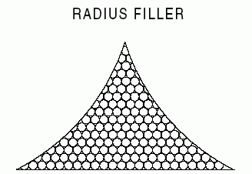

Figure 2 — Filament laminate

NOTE 1 The shape of a Filament_laminate may be defined by a cross-section and a length.
NOTE 2 When a Filament_laminate is made from a Filament_assembly, it usually refers to individual tows, yarns, and rovings. These volumes can be as simple as the cross section and length of a radius filler to as complex as a filament wound vessel. Filament_laminates that are made by pulling and forming processes, called pultrusions, may use a tape form of Filament_assembly.
NOTE 3 The difference between a ply and a Filament_laminate, when referencing a Filament_assembly, is that a ply describes a constant thickness area to be filled by a Filament_assemblyand a Filament_laminate describes a general volume to be filled by a Filament_assembly.
EXAMPLE Pultruded shapes, radius fillers, and filament wound structure are types of Filament_laminate (see Figure 2 ).
EXPRESS specification:
*)
ENTITY Filament_laminate
SUBTYPE OF (Constituent_part);
made_from : filament_assembly_material;
shape : OPTIONAL Filament_laminate_shape;
END_ENTITY;
(*
Attribute definitions:
made_from: specifies the stock Filament_assembly that is used to make the Filament_laminate. The Filament_assembly is in the form of a tow, yarn or roving, and sometimes tape.
shape: specifies a role of the Filament_laminate_shape for the Filament_laminate. The shape specifies the geometry that defines the cross-sectional area of a Filament_laminate. The value of this attribute need not be specified.

4.3.7 Filament_laminate_shape
A Filament_laminate_shape is a two-dimensional geometric shape representation for the cross-sectional area of a Filament_laminate.
EXPRESS specification:
*)
ENTITY Filament_laminate_shape;
cross_section : Shape_description_association;
END_ENTITY;
(*
Attribute definitions:
cross_section: represents the cross-sectional area of a Filament_laminate.

4.3.8 Laminate_table
A Laminate_table is a type of Part_view_definition. A Laminate_table defines the internal constituents or structural makeup of an overall part or a particular zone, area, or point on the part. A Laminate_table may either a Part_laminate_table or a Zone_structural_makeup.
EXPRESS specification:
*)
ENTITY Laminate_table
SUPERTYPE OF (ONEOF (Part_laminate_table,
Zone_structural_makeup))
SUBTYPE OF (Part_view_definition);
basis : Reinforcement_orientation_basis;
resulting_surface : OPTIONAL Surface;
base_surface : OPTIONAL Surface_with_direction;
resulting_boundary : OPTIONAL Ply_shape;
handedness : OPTIONAL text;
END_ENTITY;
(*
Attribute definitions:
basis: specifies the orientation direction for the load carrying reinforcements within the Laminate_table.
resulting_surface: specifies the opposing Surface that forms from the physical material being placed on the base_surface. The value of this attribute need not be specified.
base_surface: specifies a role of the Surface_with_direction used to define the lamination or layers. The layers or lamination are defined to start from the surface and to be laminated or layered in the specified direction and order. The value of this attribute need not be specified.
resulting_boundary: specifies the boundary of the laminate resulting from a sum of the plies in the Laminate_table. The value of this attribute need not be specified.
handedness: specifies that the Laminate_table is to be interpreted as left-hand rule. The left-hand rule Laminate_table Rosettes (where a Rosette is a term used to represent the coordinate frame specifying the fiber directions) are to be interpreted according to left-hand rule as are all associated ply orientation angles. If this value is specified then the 22 or Y axis is oriented in the opposite direction of a 22 axis in a right-hand rule Rosette, and therefore the 11 and 33 directions are unchanged. The value of this attribute need not be specified. If this attribute is not specified then the Laminate_table Rosettes and associated ply orientation angles are to be interpreted as right-hand rule.

4.3.9 Part_laminate_table
A Part_laminate_table is a type of Laminate_table that applies to the overall laminate. It is used to provide allocation of each physical constituent through the use of an ordered placement list. A Part_laminate_table may be either a Composite_assembly_table or a Ply_laminate_table.
EXPRESS specification:
*)
ENTITY Part_laminate_table
SUPERTYPE OF (ONEOF (Composite_assembly_table,
Ply_laminate_table))
SUBTYPE OF (Laminate_table);
END_ENTITY;
(*

4.3.10 Percentage_laminate_table
A Percentage_laminate_table is a type of Zone_structural_makeup that defines the percentage of the total thickness within a zone or point that each uniquely oriented constituent stock material makes up.
NOTE For a simple laminate just made out of plies (Ply_laminate), a Percentage_laminate_table is used to capture the percentages of different fiber orientations within the zone based on the overall thickness of the zone.
EXAMPLE An example would be 40% 0 degree fibers, 30% 90 degree fibers, 15% +45 degree fibers, and 15% -45 degree fibers. The sum of the percents (%) have to equal 100.
The sum of volume_percent must equal 100.
EXPRESS specification:
*)
ENTITY Percentage_laminate_table
SUBTYPE OF (Zone_structural_makeup);
table_components : SET[1:?] OF Percentage_ply;
total_thickness : Length_data_element;
END_ENTITY;
(*
Attribute definitions:
table_components: specifies a role of the Percentage_ply for the Percentage_laminate_table. There shall exist one or more Percentage_ply for the Percentage_laminate_table.
total_thickness: specifies a role of the Length_data_element for the Percentage_laminate_table.

4.3.11 Percentage_ply
A Percentage_ply is an idealization of a ply that represents a portion (percentage) of the thickness of a Percentage_laminate_table with a particular fiber orientation (if required) and material type. This represents a way to relate anisotropic material properties to the varied orientations that exist in a composite part. A Percentage_ply always corresponds to the area within the zone of the Laminate_table of which it is a portion.
EXPRESS specification:
*)
ENTITY Percentage_ply;
strength_orientation : OPTIONAL Ply_orientation_angle;
material : Stock_material;
makeup_and_properties : OPTIONAL Zone_structural_makeup;
volume_percent : Ratio_data_element;
END_ENTITY;
(*
Attribute definitions:
strength_orientation: specifies a role of the Ply_orientation_angle for the Percentage_ply. The value of this attribute need not be specified.
material: specifies a role of the Stock_material for the Percentage_ply.
makeup_and_properties: specifies a role of the Zone_structural_makeup for the Percentage_ply. The value of this attribute need not be specified.
volume_percent: specifies a role of the Ratio_data_element for the Percentage_ply.

4.3.12 Ply
A Ply is a type of Constituent_part that defines one of the layers of constant thickness material that make up a composite part. A Ply is a contiguous structure with a defined boundary that is made of one or more Ply_piece objects (see Figure 3 ).

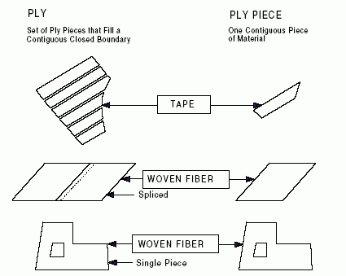

Figure 3 — Ply

EXPRESS specification:
*)
ENTITY Ply
SUBTYPE OF (Constituent_part);
constituents : OPTIONAL LIST[1:?] OF Ply_piece;
ply_thickness : Length_data_element;
material_orientation : Ply_orientation_angle;
material_type : ply_stock_material;
shape : OPTIONAL Ply_shape;
END_ENTITY;
(*
Attribute definitions:
constituents: specifies the Ply_piece objects that make up the Ply. There shall exist one or more Ply_pieces for the Ply. The value of this attribute need not be specified.
ply_thickness: specifies the measure of the thickness that the Ply will contribute to part thickness after curing. The ply_thickness is constant over the whole area of the Ply.
material_orientation: specifies the direction of the reinforcement fibers within a Ply. For materials with multiple orientations of fibers, orientation shall correspond to the warp direction of the material.
material_type: specifies the ply_stock_material used to make the Ply.
shape: specifies the Ply_shape for the Ply. The value of this attribute need not be specified.

4.3.13 Ply_laminate
A Ply_laminate is a type of Constituent_part that is formed by two or more Ply objects that mate with each other. The plies have unique orientation and shape within the Ply_laminate.

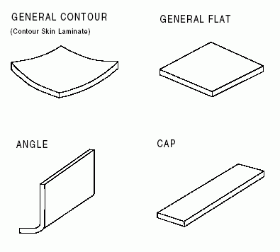

Figure 4 — Ply laminate

NOTE A Ply_laminate shape may include constituents such as angle, cap, flat, general contour, simple contour, complex contour, channel, etc. (see Figure 4 ).
EXPRESS specification:
*)
ENTITY Ply_laminate
SUBTYPE OF (Constituent_part);
shape : OPTIONAL ply_laminate_shape;
ply_table : Ply_laminate_table;
END_ENTITY;
(*
Attribute definitions:
shape: specifies a role of the ply_laminate_shape for the Ply_laminate. The value of this attribute need not be specified.
ply_table: specifies a role of the Ply_laminate_table for the Ply_laminate.

4.3.14 Ply_laminate_sequence_definition
A Ply_laminate_sequence_definition is an illustration of a single unique sequence or layer within a Ply_laminate.
EXPRESS specification:
*)
ENTITY Ply_laminate_sequence_definition;
plies_in_sequence : SET[1:?] OF Ply;
END_ENTITY;
(*
Attribute definitions:
plies_in_sequence: specifies the Ply objects that are laminated at the sequence. There shall exist one or more Ply for the Ply_laminate_sequence_definition.

4.3.15 Ply_laminate_table
A Ply_laminate_table is a type of Part_laminate_table that provides an ordered list of Ply objects. The ordered list provides basic placement position within the laminate (see Figure 5 ).
NOTE 1 The valid components of a Ply_laminate_table are plies only.
NOTE 2 The Ply_laminate_table is only valid to describe a Part_laminate_table.

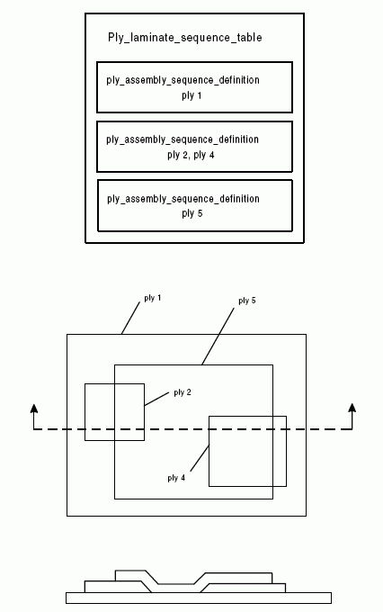

Figure 5 — Ply laminate table

EXPRESS specification:
*)
ENTITY Ply_laminate_table
SUBTYPE OF (Part_laminate_table);
sequence : LIST[2:?] OF Ply_laminate_sequence_definition;
END_ENTITY;
(*
Attribute definitions:
sequence: specifies a role of the Ply_laminate_sequence_definition for the Ply_laminate_table. There shall not less than twoPly_laminate_sequence_definitions for the Ply_laminate_table.

4.3.16 Ply_piece
A Ply_piece is a type of Constituent_part. It is a single portion of a Ply that may be combined with other ply pieces on the same layer to make up the Ply. A Ply_piece has the same material and orientation direction as defined for the Ply of which it is a portion.
EXPRESS specification:
*)
ENTITY Ply_piece
SUBTYPE OF (Constituent_part);
shape : OPTIONAL ply_piece_shape;
warp_surface : LOGICAL;
END_ENTITY;
(*
Attribute definitions:
shape: specifies a role of the ply_piece_shape for the Ply_piece. The value of this attribute need not be specified.
warp_surface: specifies whether or not the material warp surface is away from the basis surface, when the value of this attribute is set to true or false respectively. Material warp surface is the side of the material where the majority of the fibers are located.

4.3.17 Point_zone_shape
A Point_zone_shape is a type of Zone_structural_makeup_shape_representation that specifies a point on the edge of or within the shape of a part. It also specifies the singular volume a piercing line would make as it traveled through the part, normal to the part's surface at the point.
EXPRESS specification:
*)
ENTITY Point_zone_shape
SUBTYPE OF (Zone_structural_makeup_shape_representation);
location : point_select;
END_ENTITY;
(*
Attribute definitions:
location: specifies the Point that defines the position of the local pierced point of the Point_zone_shape.

4.3.18 Processed_core
A Processed_core is a type of Constituent_part that is the central component of a sandwich construction to which faces or skins are attached. The primary structural purpose of Processed_core is the transfer of shear loads between the faces or skins. Processed_core is Stock_core that has been machined, formed, stabilized and/or bonded together (see Figure 6 ). A core may have a potting compound or adhesive applied to it to make it more rigid, or provide solid attachment points or both.

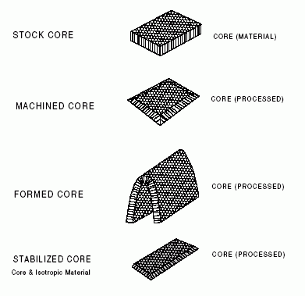

Figure 6 — Processed core

EXPRESS specification:
*)
ENTITY Processed_core
SUBTYPE OF (Constituent_part);
added_material : OPTIONAL LIST[0:?] OF Ply;
cell_direction : Ply_orientation_angle;
made_from_stock : Stock_core;
made_from_processed_core : OPTIONAL SET[1:?] OF Processed_core;
shape : OPTIONAL core_shape;
END_ENTITY;
(*
Attribute definitions:
added_material: specifies a role of the Ply for the Processed_core. The Ply identifies the area where the added_material is applied. There shall exist zero or more Ply for the Processed_core. The value of this attribute need not be specified.
cell_direction: identifies the ribbon direction of the honeycomb core.
made_from_stock: specifies the Stock_core core that is processed to get the Processed_core configuration. The types of processes include machining, forming, stabilizing, and bonding.
made_from_processed_core: specifies a role of the Processed_core that has another process performed on it. There shall exist one or more Processed_cores for the Processed_core. The value of this attribute need not be specified.
shape: specifies a role of the core_shape for the Processed_core. The value of this attribute need not be specified.

4.3.19 Smeared_material
A Smeared_material is a type of Zone_structural_makeup that provides the material properties for an idealized zone or area of a part.
NOTE A Smeared_material can represent the material properties of a single Stock_material by having the Percentage_laminate_table reference one Stock_material and set its percent value of that material’s constituent to 100%.
EXPRESS specification:
*)
ENTITY Smeared_material
SUBTYPE OF (Zone_structural_makeup);
total_thickness : Length_data_element;
END_ENTITY;
(*
Attribute definitions:
total_thickness: specifies the thickness or depth of the zone defined by the Smeared_material.

4.3.20 Surface_with_direction
A Surface_with_direction is the specification of a Surface and a Direction. The Direction defines the side of the Surface that is the material side.
EXPRESS specification:
*)
ENTITY Surface_with_direction;
defining_surface : Surface;
material_direction : Direction;
END_ENTITY;
(*
Attribute definitions:
defining_surface: specifies the Surface that is used in the definition.
material_direction: specifies a role of the Direction for the Surface_with_direction.

4.3.21 Thickness_laminate_table
A Thickness_laminate_table is a type of Zone_structural_makeup that is used to capture the ordered list of constituents that make up a zone.
EXPRESS specification:
*)
ENTITY Thickness_laminate_table
SUBTYPE OF (Zone_structural_makeup);
table_components : LIST[2:?] OF thickness_laminate_table_component;
END_ENTITY;
(*
Attribute definitions:
table_components: specifies the thickness_laminate_table_component that make up the zone. There shall exist not less than twothickness_laminate_table_components for the Thickness_laminate_table.

4.3.22 Zone_structural_makeup
A Zone_structural_makeup is a type of Laminate_table that describes the structural makeup of a particular zone, area, or point within a laminate. A Zone_structural_makeup may be a Thickness_laminate_table and a Smeared_material, or a Percentage_laminate_table and a Smeared_material, or aThickness_laminate_table or a Percentage_laminate_table or a Smeared_material.
NOTE 1 Structural makeup information consists of: 1) the smear material properties based on one or more constituents that reside in that zone or point; 2) the percentage of the total thickness within a zone or point that each constituent type makes up; and 3) the ordered list of physical constituents based on position within a zone or point. These three pieces of structural makeup information can coexist in any order to describe a zone or point within a laminate.
NOTE 2 A single Zone_structural_makeup could apply to the whole part. This would be the case for a homogeneous structural part or a simple laminate of constant thickness and material constituents.
EXPRESS specification:
*)
ENTITY Zone_structural_makeup
SUPERTYPE OF (ONEOF ((Thickness_laminate_table
AND Smeared_material), (
Percentage_laminate_table
AND Smeared_material),
Thickness_laminate_table,
Percentage_laminate_table,
Smeared_material))
SUBTYPE OF (Laminate_table);
boundary : OPTIONAL Zone_structural_makeup_shape_representation;
END_ENTITY;
(*
Attribute definitions:
boundary: specifies a role of the Zone_structural_makeup_shape_representation for the Zone_structural_makeup. The boundary specifies the shape of the Zone_structural_makeup as a point, one or more unique list of curves, or a face. When the boundary is not defined for an instance of a Zone_structural_makeup, the Zone_structural_makeup applies to the whole part. This would be the case for a homogeneous structural part.

4.3.23 Zone_structural_makeup_shape_representation
A Zone_structural_makeup_shape_representation is the shape of a either zone or area of a part.
NOTE The zone can be a point, a specific area, or the entire part.
A Zone_structural_makeup_shape_representation may be a Point_zone_shape or a Edge_zone_shape.
EXPRESS specification:
*)
ENTITY Zone_structural_makeup_shape_representation
SUPERTYPE OF (ONEOF (Point_zone_shape,
Edge_zone_shape));
END_ENTITY;
(*
*)
END_SCHEMA; -- Part_and_zone_laminate_tables_arm
(*
© ISO 2019 — All rights reserved

