Install VirtualBox 7 on Debian 12
Kifarunix
|
Last Updated:
|
Virtualization, HowTos, VirtualBox
|
5 Comments
This guide will take you through how to install VirtualBox 7 on Debian 12. VirtualBox is a general-purpose full virtualizer for x86 hardware, targeted at server, desktop and embedded use.

Table of Contents
- Install VirtualBox 7 on Debian 12 Desktop
  - VirtualBox Features Overview
  - Install VirtualBox 7 on Debian 12
    - Install VirtualBox 7 on Debian 12 using Linux DEB Binary
    - Install VirtualBox 7 on Debian 12 from VirtualBox Repositories

  - Running VirtualBox 7 on Debian 12

  - What is the ROOT Password?
  - Uninstall VirtualBox 7 on Debian 12
  - Other Tutorials

Install VirtualBox 7 on Debian 12 Desktop

VirtualBox Features Overview
VirtualBox ships with a handful of features. Read about features offered by VirtualBox 7 on Features page.

Install VirtualBox 7 on Debian 12
VirtualBox 7.0.8 is the current stable release version of VirtualBox 7 as of this writing.

There are two ways to install VirtualBox 7 on Debian 12 desktop:
- Install VirtualBox 7 using Linux DEB Binary
- Install VirtualBox 7 from VirtualBox 7 repository

Install VirtualBox 7 on Debian 12 using Linux DEB Binary
You can always download the DEB binary from the VirtualBox 7 downloads page. However, there is no official DEB binary for Debian 12 bullseye, as of this writing. We will use DEB for Debian 11 in the meantime.
wget \
https://download.virtualbox.org/virtualbox/7.0.8/virtualbox-7.0_7.0.8-156879~Debian~bullseye_amd64.deb \
-P ~/Downloads/
There are some package dependencies required to successfully install VirtualBox 7.0.8 as of this writing on Debian 12;

The following information may help to resolve the situation:

The following packages have unmet dependencies:
virtualbox-7.0 : Depends: libssl1.1 (>= 1.1.1) but it is not installable
Depends: libvpx6 (>= 1.6.0) but it is not installable
Recommends: libsdl-ttf2.0-0 but it is not going to be installed
Recommends: linux-headers-generic or
linux-headers-generic-pae but it is not installable or
linux-headers-686-pae but it is not installable or
linux-headers-amd64 but it is not going to be installed or
linux-headers-2.6-686 but it is not installable or
linux-headers-2.6-amd64 but it is not installable or
linux-headers but it is not installable
Recommends: linux-image but it is not installable
E: Unable to correct problems, you have held broken packages.
Thus, to circumvent this, install the following Debian 11 repository list;
echo 'deb http://ftp.de.debian.org/debian bullseye main ' | sudo tee /etc/apt/sources.list.d/debian11.list
Run system update and install VirtualBox;

sudo apt update
sudo apt install ~/Downloads/virtualbox-7.0_7.0.8-156879~Debian~bullseye_amd64.deb
After that, remove the debian 11 repos installed above;
rm -rf /etc/apt/sources.list.d/debian11.list

Install VirtualBox 7 on Debian 12 from VirtualBox 7 Repositories
The default Debian 12 repositories do not provide VirtualBox 7, at least as of this writing.
apt-cache policy virtualbox
virtualbox:
Installed: (none)
Candidate: (none)
Version table:
Also, as of this writing, no official repository for Debian 12 Bullseye.Hence, run the command below to add the sources list for Debian 11 Buster.

echo \
"deb [arch=amd64] https://download.virtualbox.org/virtualbox/debian bullseye contrib" | \
sudo tee /etc/apt/sources.list.d/virtualbox.list
Next, install the repository GPG signing keys;
sudo apt install gnupg2
wget -q https://www.virtualbox.org/download/oracle_vbox_2016.asc -O- | \
sudo gpg --dearmor -o /etc/apt/trusted.gpg.d/vbox.gpg
Similarly, install this repo;
echo 'deb http://ftp.de.debian.org/debian bullseye main ' | sudo tee /etc/apt/sources.list.d/debian11.list
Next, ensure your package cache is up-to-date by running the command below;
sudo apt update
VirtualBox 7 can then be installed by running the command below;
sudo apt install virtualbox-7.0

Running VirtualBox 7 on Debian 12
You can now start using VirtualBox 7.
Luanch;
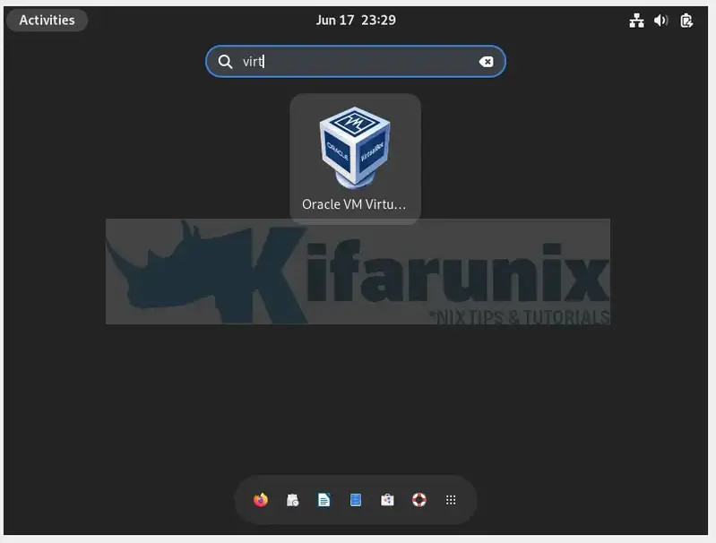
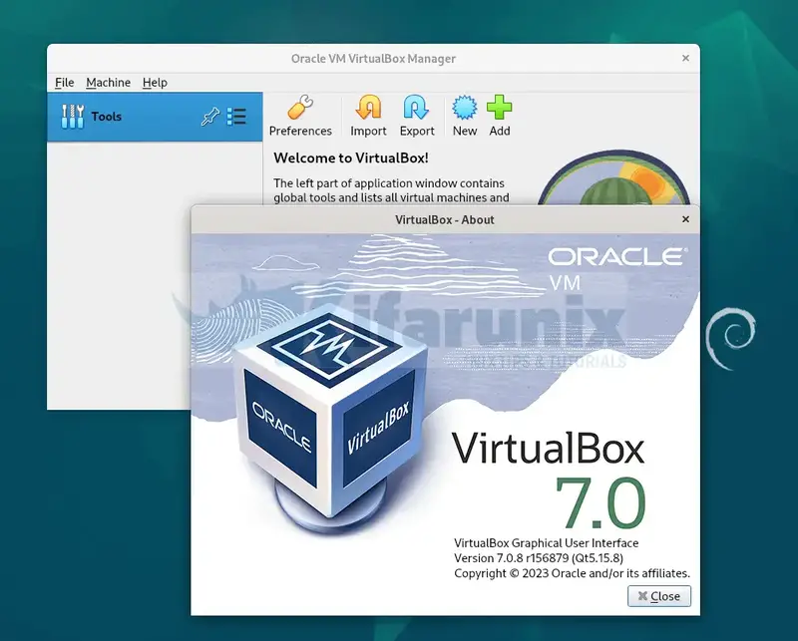

What is the ROOT Password?
You might be wondering what could be the root password or how to set the password.
Well, the root password is to be same as the standard user password you created during the installation.

Simply switch to root as;
su -
Use the standard user password created before.
You can then assign your standard user account sudo rights to allow you execute administrative tasks.

usermod -aG sudo USERNAME

Uninstall VirtualBox 7 on Debian 12
If for some reasons you want to remove VirtualBox 7, run the command below.
apt remove --purge --auto-remove virtualbox-7.0
Please note that this wont delete your VMs.
You can also remove the repo list after the installation;
rm -rf /etc/apt/sources.list.d/debian11.list
And that concludes our guide on how to install VirtualBox 7 on Debian 12.

