Directions: Type all answers. Include your name, student number, course number, and course code on every page. Create a zip file containing your Word document and source code files. Use Electronic Submission to submit this assignment. All problems are 4 points.

1. Derive the string +ddd with the grammar of Figure 7.2 and draw the corresponding syntax tree.
The derivation of the valid signed integer +ddd is as follows:
I => FM Rule 1
=> FdM Rule 5
=> FddM Rule 5
=> Fddd Rule 6
=> +ddd Rule 2

The corresponding syntax tree for +ddd:
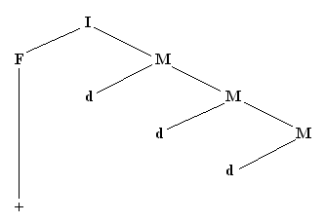

2. For the grammar of Figure 7.8 draw the syntax tree for <statement> from the following strings, assuming that S1, S2, S3, S4, C1 and C2 are valid <expression>s.
{
if (C1)
if (C2)
S1;
else
S2;
else
S3;
S4;
}

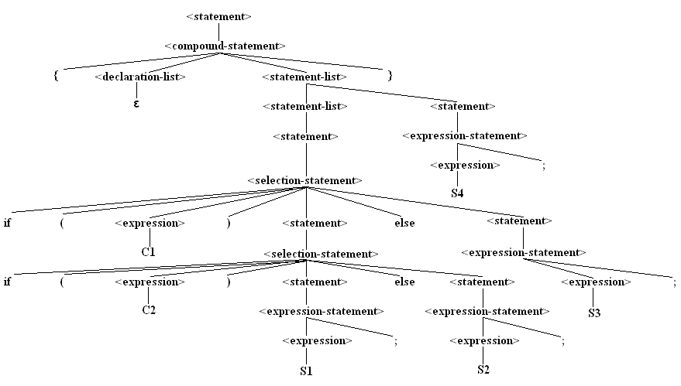

3. Draw a deterministic FSM that recognizes strings of 1’s and 0’s that end in 101.

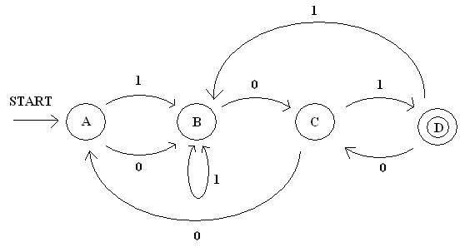

4. A hexadecimal digit is composed of ‘0’..’9’, ‘a’..’f’, or ‘A’..’F’. A hexadecimal constant consists of one to four hexadecimal digits. Examples are 3, a, 0d, FF4e. Use the direct-code technique for implementing a finite state machine as in the program of Figure 7.26 to parse a hexadecimal constant and convert it to a nonnegative integer. The input/output should be similar to that in the figure, with invalid input producing an error message and a valid hexadecimal input string producing the nonnegative integer value. You may find the following functions in <cctype> helpful. In each, ch has type char.
isxdigit(ch), returns true if ch is hexadecimal digit
isdigit(ch), returns true if ch is a decimal digit
isupper(ch), returns true if ch is upper-case letter
islower(ch), returns true if ch is lower-case letter
toupper(ch), returns upper-case of ch if ch is lower-case letter, otherwise returns ch
tolower(ch), returns lower-case of ch if ch is upper-case letter, otherwise returns ch.

#include <sstream>
#include <iostream>
#include <cctype>
using namespace std;

#include <string>
using std::string;

// Global buffer
const int LINE_LENGTH = 128;
char line[LINE_LENGTH];
int lineIndex;

4. (continued)
void getLine () {
// Get a line of characters.
// Install a newline character as sentinel.
cin.getline (line, LINE_LENGTH);
line[cin.gcount () - 1] = '\n';
lineIndex = 0;
}

enum State {eI, eF, eM, eSTOP};

void convertToDecimal (string& num, int length) {
// takes a valid hexadecimal value
// converts to base 10
// converts integer back into a string
int total = 0;
for (int i = 0; i < length; i++)
{
int temp = 0;
int power = 1;
if (isdigit(num[i])) // string is array of char's
{
temp = num[i] - '0'; // convert ASCII to decimal
for (int j = i; j < length - 1; j++)
power *= 16; // raise to the power
total += temp * power;
}
else if (isxdigit(num[i]))
{
if (islower(num[i])) // if lowercase
num[i] = toupper(num[i]);
temp = num[i] - '7'; // convert ASCII to decimal
for (int j = i; j < length - 1; j++)
power *= 16; // raise to the power
total += temp * power;
}
}
// convert integer to string
std::string s;
std::stringstream out;
out << total;
s = out.str();
num = s;
} // end function convertToDecimal

void parseNum (bool& v, string& n) {
State state;
char nextChar;
v = true;
state = eI;

do {
nextChar = line[lineIndex++];
switch (state) {
case eI:
4. (continued)
if (isdigit(nextChar)) {
n += nextChar;
state = eI;
}
else if (isxdigit(nextChar)) {
n += nextChar;
state = eI;
}
else if (nextChar == '\n') {
state = eSTOP;
}
else {
v = false;
}
break;
}
}
while ((state != eSTOP) && v);
// n contains valid hexadecimal number
if (v)
convertToDecimal(n, lineIndex - 1);
}

int main () {
bool valid;
string num;
cout << "Enter a hexadecimal number: ";
getLine();
parseNum (valid, num);
if (valid) {
cout << "Number = " << num << endl;
}
else {
cout << "Invalid entry." << endl;
}
return 0;
}

5. Draw a state transition table for the FSM in procedure getToken in Figure 7.32.

Current State | Next State
Current State | Letter | + | - | Digit
START | IDENT | SIGN | SIGN | INTEGER
IDENT | IDENT |  |  | IDENT
SIGN |  |  |  | INTEGER
INTEGER

6. The loader in Figure 8.3 executes with the following input:
04 00 05 00 00 31 00 03 39 00 03 50 00 0A 41 00
12 00 54 68 61 74 27 73 20 61 6C 6C 2E 0A 00 zz
Assume that the loop from FC5D to FC97 is executing for the 27th time. State the values in register A after LDA at FC7C. Express the value in register A in hexadecimal.

The 27th iteration focuses on the input of hexadecimal numbers ‘6’ and ‘C’. At address FC60 the LDA instruction puts the ASCII value for ‘6’, 36 into the low byte of register A [0036]. At address FC72 register A is shifted to the left by four bits to send the digit to the most significant position in the byte [0360]. Finally at address FC7C the LDA instruction puts the ASCII value for ‘C’, 43, into the low byte of register A. Register A contains the hexadecimal value: 0343

Use this program in answering questions 7 – 9.
0000 04005 BR main ; branch around data
0003 0000 num: .BLOCK 2 ; global variable
;
0005 310003 main: DECI num,d ; input decimal value
0008 390003 DECO num,d ; output decimal value
000B 50000A CHARO '\n',i
000E 410012 STRO msg, d ; output message
0011 00 STOP
0012 546861 msg: .ASCII "That’s all.\n\x00"
742773
20616C
6C2E0A
00
001F .END

7. The above program executes, generating an interrupt for DECI. For Figure 8.6, the entry to and exit from the trap handler, state the value in X after SUBX at FCBA.

At address FC9E the LDBYTEX instruction puts 0031 into the index register. At address FCB8 through address FCB9 the addressing mode bits are discarded via the ASRX instruction leaving 0006 in X. Then at address FCBA the SUBX instruction subtracts 5 from X resulting in the value of 0001 in the index register.

8. The above program executes, generating an interrupt for DECO. For Figure 8.6, the entry to and exit from the trap handler, state the value in the PC after CALL at FCBE.

FCC6 is the value in the PC after CALL at FCBE because it is the corresponding address of the nonunary trap routine for the DECO subroutine.

9. The above program executes, generating an interrupt for STRO. For Figure 8.6, the entry to and exit from the trap handler, state the value in the PC after RETTR at FCCI.

At address FCCI the PC contains the value FC9B.

