**Introduction/Methodology**

The purpose of any conjoint analysis is to pick apart which features/attributes regarding a product matters most to customers and determine what motivates people to choose one product over another.

The approach is to not directly ask what features customers prefer in a product but instead, to serve various combinations of product profiles to choose which entire product is preferred. The features included in the survey are:

1. Seating Level (Floor, Mid, Top)
2. Seating Location (Front Half, Back Half)
3. IMAG inclusion (IMAG, No IMAG)
4. Length of Concert (1 hr, 2hrs)
5. Composer Tier (1, 2, or 3)
6. Price ($25, $50, $75, $100)

As an example, using one of the questions directly asked within the survey:

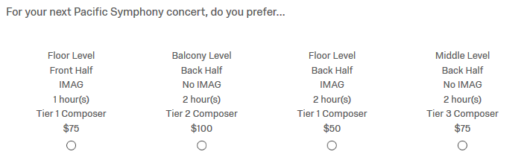

Each question creates four unique versions of the product by randomly combining one of each of the six features provided above. The survey we used included eight (8) total questions providing four (4) unique product options making a total of 32 unique product combinations throughout the survey.

Each attribute within the six features are – nearly – equally represented to avoid bias.

Upon receiving the results, we can run a machine learning algorithm to pick apart the attributes and features that are the most important and separately, the most positively and negatively impactful in determining customers’ purchasing behavior.

**Results**

Initially, we ran a tester internally with just Pacific Symphony employees to see what features/attributes are valued by our own people before branching out to customers.

We received survey responses from forty (40) internal employees of Pacific Symphony.

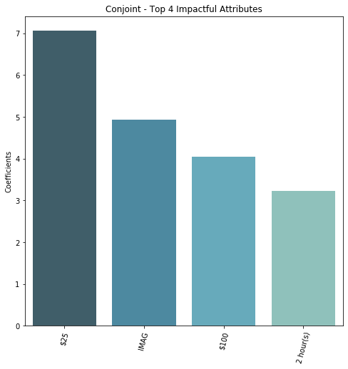From this, we were able to pull apart the most impactful attributes (ranked from highest to lowest:

The coefficients on the y-axis represent the output from the algorithm. Since our scoring was simply based on votes, an attribute with a coefficient of +7 compared with another with a coefficient of -2, would indicate that the first attribute is predicted to receive 9 more votes than the second, all other attributes held equal (this is based on the 40 total voters that we had from respondents).

Regarding all of our respondents, we can see that the $25 price tag was the most impactful attribute by a wide margin. Next, was the inclusion of IMAG, after that came the $100 price tag, and finally the 2-hour length of concert.

It’s important to note that these are not indicating positive coefficients, simply that these are the most impactful. The next graph will show exactly this in determining how positive and how negatively each attribute influences purchasing decisions.

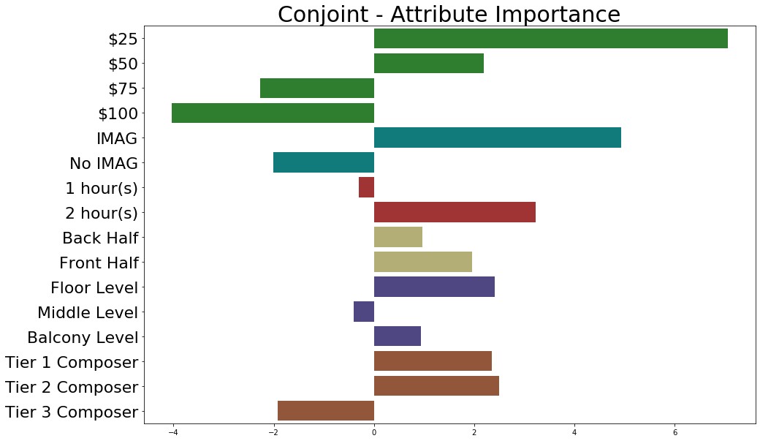

Each feature is colored separately – all prices are same color, IMAG attributes are same color, location, etc. – to make it easy to see how each of the attributes within the feature positively or negatively impact the purchasing behavior. The neutral point is at the 0 coefficient on the x-axis meaning any bar going to the right of that point is a positively impacting attribute and vice versa for the bars spanning left.

We can see that the location features – level of seat and front vs back half – are not good predictors. In fact, the front and back half attributes are both pointing positively indicating that it is statistically insignificant in predicting purchasing behavior.

The floor level, however, is the one attribute within both features that is important towards predicting purchasing in that, people seem to positively react to being able to sit on the floor level but are indifferent if it’s middle or balcony.

The composer tier results are also interesting to consider as it would appear tier 2 drives slightly more positively than tier 1. This is likely to be a result of bias within the randomization that is influencing that.

All of that said, we now have a solid understanding of what features are most important while driving purchasing decisions and can point to what is important to advertise to positively influence customers.

**Segmentation**

Next, I was curious if there was much of a difference between genders.

Note: We didn’t receive enough data back from those categorized as ‘other’ to have significant results and so, was excluded from this exercise.

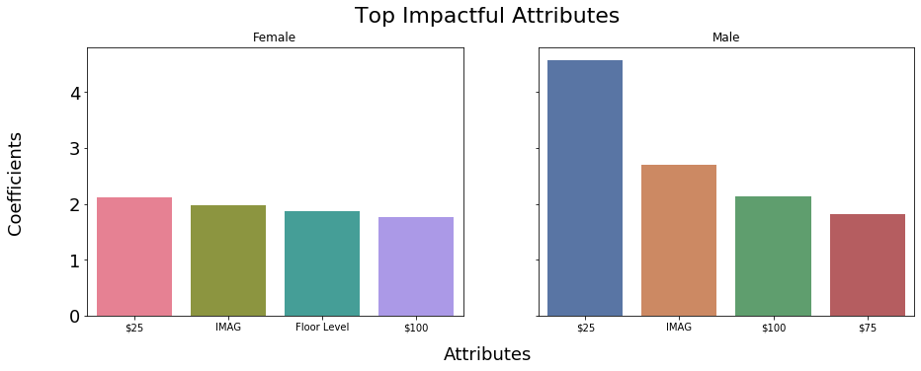

Comparing the differences between male and female, males are far more dramatic in their purchasing decisions through looking at individual features as using that one to drive their decisions while females tend to be more balance and are likely analyzing the product combinations more deeply.

Females have ‘Floor Level’ as their third highest impactful attribute while it’s not included in the males’ top four. Seating location matters far less for males than it does for females.

For males, three of the top four most impactful attributes include price. While price is important for females, it is far less so than it is for males.

The next step is to see the attribution plot:

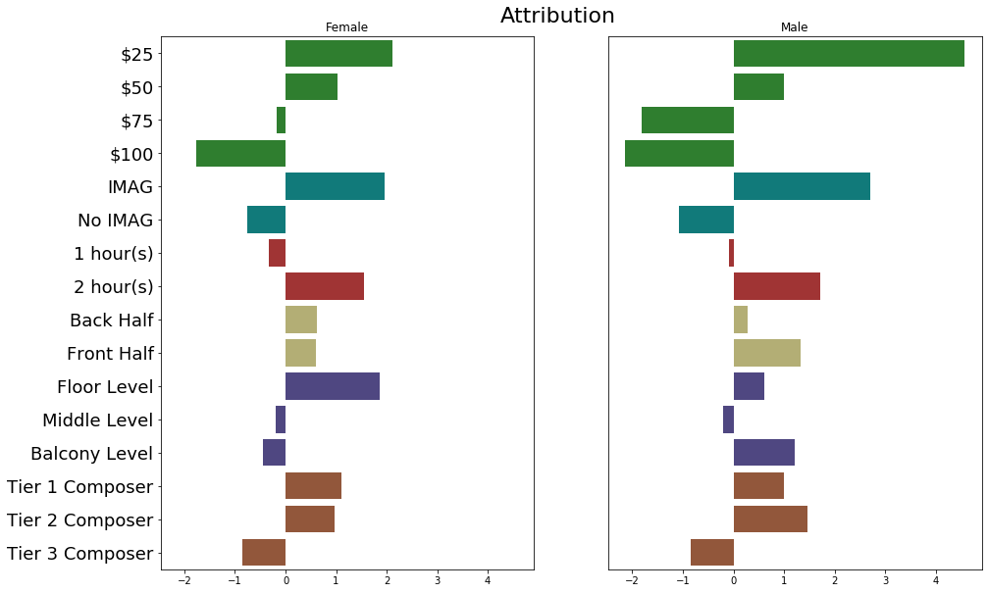

Outside of what was mentioned above, there isn’t much difference between the male and female patterns.

To summarize, females are more balanced across attributes while males focus in on one or a few. Females are uniquely, positively influenced by sitting on the floor level while males are indifferent across the board regarding their seating location. Males are focused almost exclusively on price to drive their preferred product.

**Next Steps**

The next thing to do with this is to improve the survey itself, improve the randomization of the features, add more appropriate features, and distribute to unique customers we are interested in learning more about.

To do that, first it would be beneficial to work with others that are more familiar with the unique features of the product itself and mainly the ones that we are able to influence from the concert itself or marketing.

Then we can determine who we’d want to learn more about, for example if we want to understand better about what product features our board members prefer, we can distribute one to them and another to lapsed subscribers to better understand what they’re looking for.

This will help us hone-in-on the product and marketing strategy, what to build, who for, and how to target them.