Project Proposal

Human Interface for Robotic Control

SYSC 4907 - 4th Year Project

|  |  |
| --- | --- |
| Brandon To | 100874049 |
| Minh Mai | 100845949 |
| Yuzhou Liu | 100853392 |

Team Members:

Supervised by: Richard Dansereau

September 18th 2015

Carleton University

# Objective

The project aims to develop a robotic arm system that mimics human movement. The system will be developed with capabilities for remote control over the internet and a feature to memorize previous movements. Focus will be put on system performance with minimal latency and high accuracy.

# Motivation

In the past, developing robotic systems with complex hardware designs were great challenges due to unavailability and high costs. The challenges with hardware limited the possibilities of developing robotics systems for time and budget constrained projects.

With recent advances in 3D printing technology and motion sensor capabilities, integrating complex robotics hardware designs are now practical and cost-effective. This greatly expands the opportunities available for students, researchers, and hobbyists.

The vision of this project is to develop a true embedded robotics platform that can serve as the foundations for developing robotic applications to replicate human movements. Possible applications for this project range from manufacturing plant assembly lines, to bomb diffusion, and remote surgery. Features such as remote control over internet and record/playback of user action were added to the platform to widen the scope of future development opportunities.

The work done in this project will be made open source to contribute back to the robotics community. Our individual goals are to apply the knowledge in both electronics and software development gained throughout undergraduate studies to develop a complete system. This exercise will provide experience in firmware development, socket programming and project management.

# Technical Overview

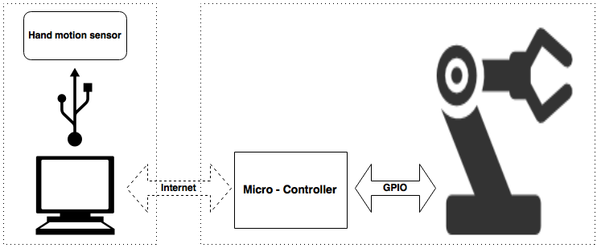

Figure 1: High Level System Architecture

In this project, the motions of the human hands are captured and sent to a computer. The program on the computer processes the data and sends it to the microcontroller via internet. Upon receiving the data, the microcontroller guides the robotic hand to replicate the user movements.

The hardware design consists of four main components: a hand motion sensor, a computer, a microcontroller, and a 3D printed robot hand (see Figure 1). The hand motion sensor used in this project is the Leap Motion. A Texas Instrument CC3200 SimpleLink Wi-Fi LaunchPad is chosen as a microcontroller. The hand will come from the InMoov open source robot project.

The software design consists of two component: the interface application on the computer and the firmware on the microcontroller. These components will be discussed below:

## Interface Application

The Leap Motion controller is a small USB peripheral device that provides accurate hand and finger tracking through the use of the sensor embedded in the device. A C++ program will be written which query the Leap device for relevant data, serialize the data, and stream it across the network. The decision of whether to use TCP or UDP for this has not yet been finalized. We would like to avoid using UDP if possible, to save ourselves the trouble of implementing our own reliability and network congestion protocol. Knowing this, we will initially develop our system under the assumption that we will be using TCP, and only switch to UDP if the transmission rate does not meet our expectations.

Here are some problems that we have identified that must be addressed in the communication across IP:

* The IP address of the microcontroller would have to be static and port forwarded on the router in order for an application to communicate with it from a different network.
* One group member who used the CC3200 WiFi shield (the WiFi module on our microcontroller) for a different project last year and mentioned that the shield does not work with enterprise WiFi.

To work around both of these limitations, we are planning on bringing our own router (set to bridging mode) to the poster fair demonstration.

## Firmware

The microprocessor controls the robotic hand upon receiving the relevant data from the Interface Application. Firmware will be written to use the received data to calculate the speed at which the joints are moving, and will configure the PWM accordingly in order to simulate that movement using the servo motors.

Here are some problems that we have identified that must be addressed at this point in the system:

* The speed at which the robotic hand can move will likely be much slower than the potential speed of our hand. We must handle the cases where the tracked hand moves faster than the servos can handle. As of now, our group believes that we should implement a queuing system in order to buffer the movement input before InMoov mimics it.
* The Leap Motion controller only tracks hand and finger motion. In order to incorporate arm movement, we must improvise. One idea is to only allow 1D arm movement, that is, only allow the arm to rotate along one axis. We can then use one previously untracked measurement (for example, the height of the hand) in order to dictate the movement of the entire arm. This is an overly simplified solution to a very complex problem that stems from hardware limitations, but it could be a first step.
* For the robotic hand to physically pick up items, we would need to include pressure sensors on the fingers in order to detect that we have actually come into contact with the object. The readings from this sensor will notify the microcontroller to stop the robotic hand from gripping too tightly since the tracked hand will likely be out of sync with the robotic hand after it comes into contact with an object.

# Milestones and Timeline

The project is divided into 3 milestones:

**Milestone 1:** Hardware Complete

The robotic hand and arm are assembled with functional servo motors.

**Milestone 2:** Interface Established between Leap Motion and Robotic Hand

The robotic hand is able to perform basic hand movements with Leap Motion as input.

**Milestone 3**: Remote Control over IP

The robotic system can be controlled remotely over Internet Protocol. System is fine-tuned and range of motion is expanded.

**Stretched Milestone 4:** Additional Functional Capabilities

Arm movements/control, Fingertip Sensors, and Record Motion Feature

Please see Timeline attached in Appendix A.

# Required Components

Listed below are the components that we need. These are subject to change.

|  |  |
| --- | --- |
| Hardware | |
| InMoov 3D Printed Robot (hand, wrist and arm) | $55 |
| Leap Motion Controller | - |
| TI CC3200-LAUNCHXL | $43 |
| HS-311 Servo Motors (6) | $75 |
|  | |
| Software | |
| C++/Python - interfacing with Leap Motion Controller | - |
| Berkeley Socket API - IP communication | - |
| C - Microcontroller programming | - |

Table 1: Components List

# Appendix A: Timeline

