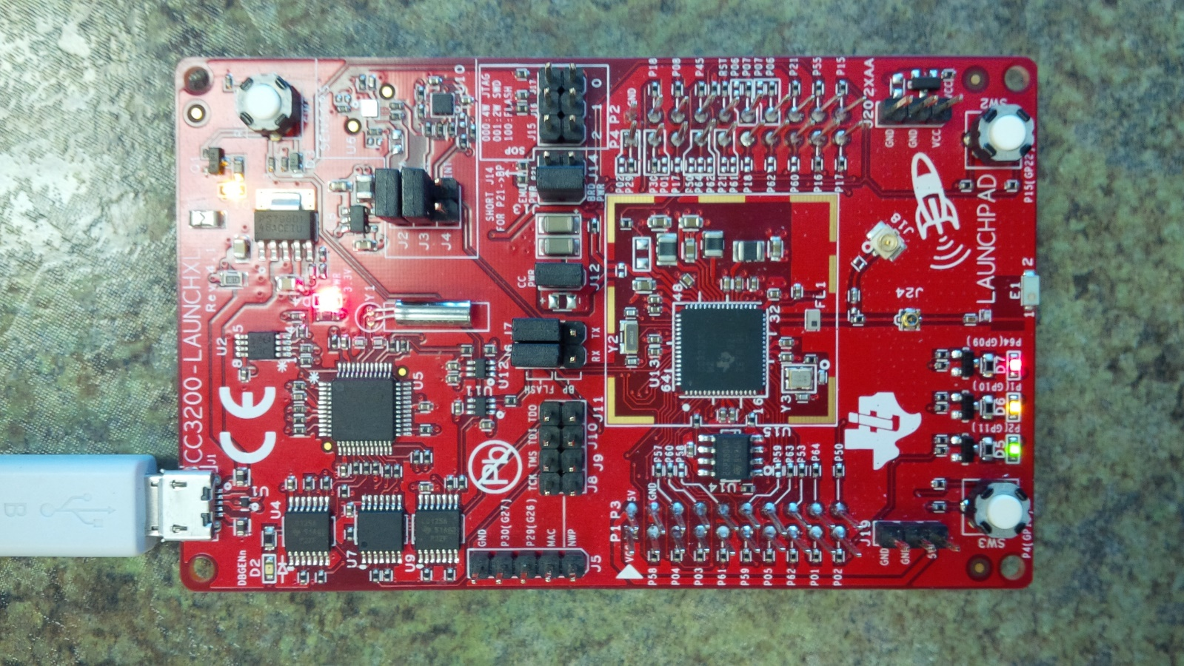

[Servo] Wrist J11/P17/JTAG-TDO

[Servo] Pinky J8/P19/JTAG-TCK

[Servo] Index P64

[Servo] Middle P02

[Servo] Thumb P01

[Servo] Ring Finger P21