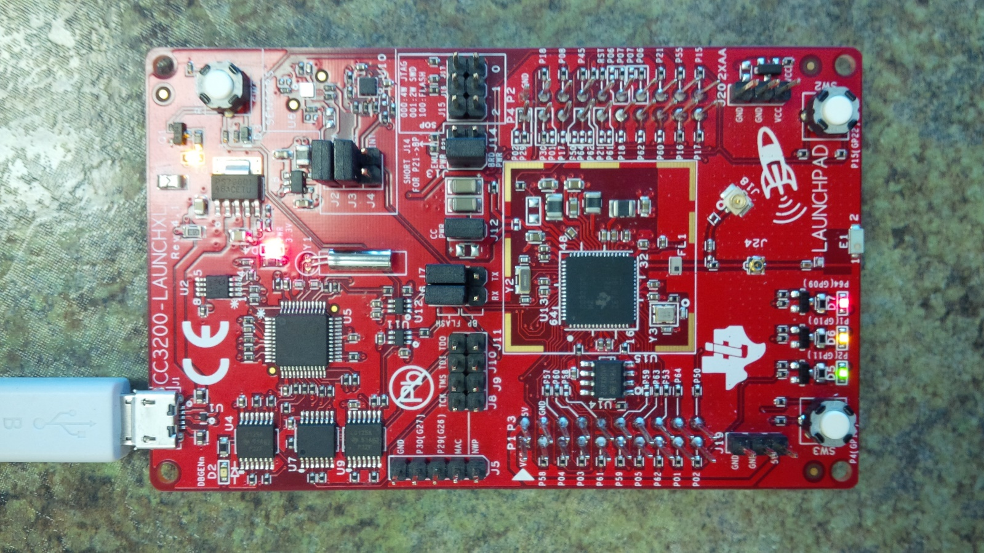

[Sensor] Middle P59

[Sensor] Index P58

[Servo] Pinky J8/P19/JTAG-TCK

[Servo] Wrist J11/P17/JTAG-TDO

[Sensor] Ring P60

[Sensor] Thumb P57

[Servo] Ring Finger P21

[Servo] Index P64

[Servo] Thumb P01

[Servo] Middle P02