## Download and Setup

1. Download [Uniflash](http://software-dl.ti.com/dsps/forms/self_cert_export.html?prod_no=uniflash_setup_3.4.0.00003.exe&ref_url=http://software-dl/ccs/esd/uniflash/):
2. Open UniFlash. The start-up screen looks like:

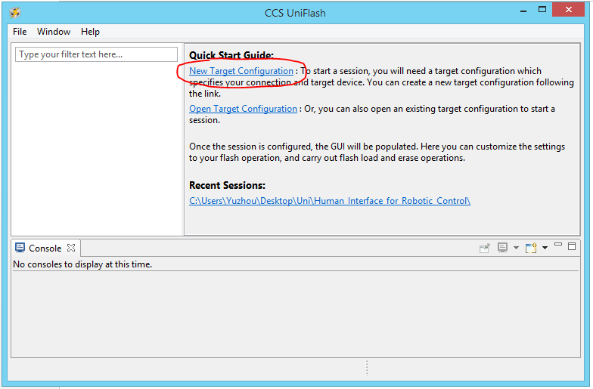

1. Click “New Target Configuration” and configure as follows:

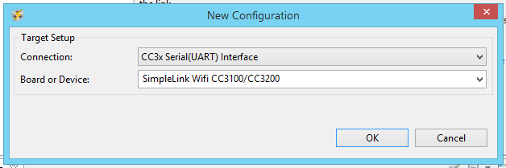

1. The following screen should appear. Click File -> Save Configuration As. Save the .ucf so you don’t need to do steps 1 - 4 anymore.

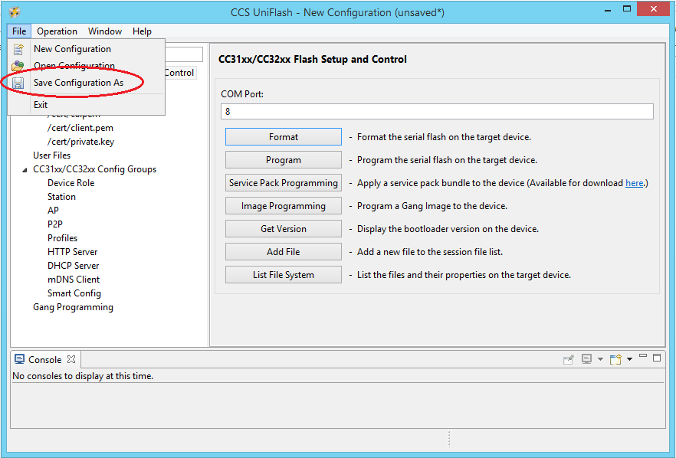

## Flashing a Program onto the board

1. Start CCS Uniflash and click “Open Target Configuration”.

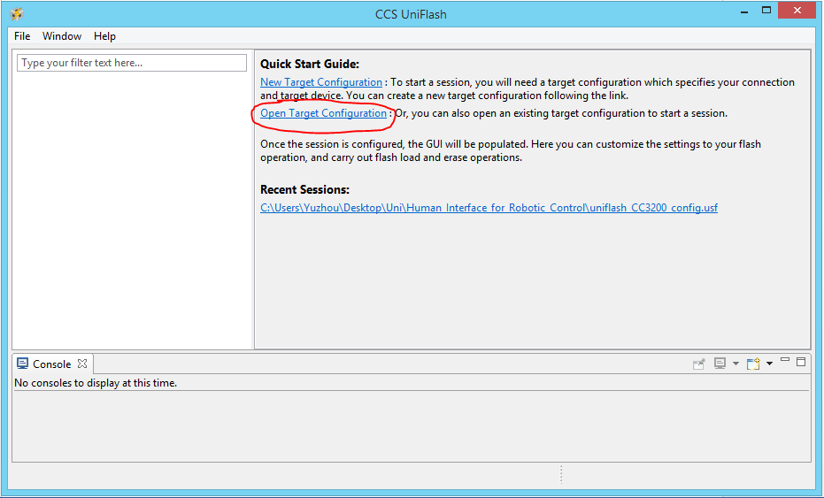

Load the .ucf file you saved from before.

1. You should see the following screen. Ensure the COM Port is correct (check Device Manager).

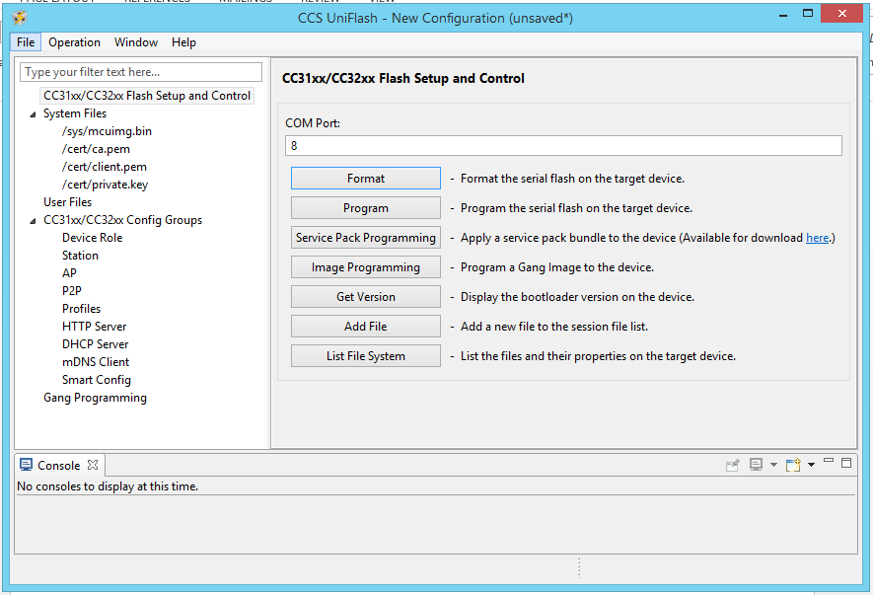

1. Click Format and set capacity to 1MB. Click ok

