Weather data stimulation

The provided solutions is programed in C# language in Visual studio **2015 update 3**

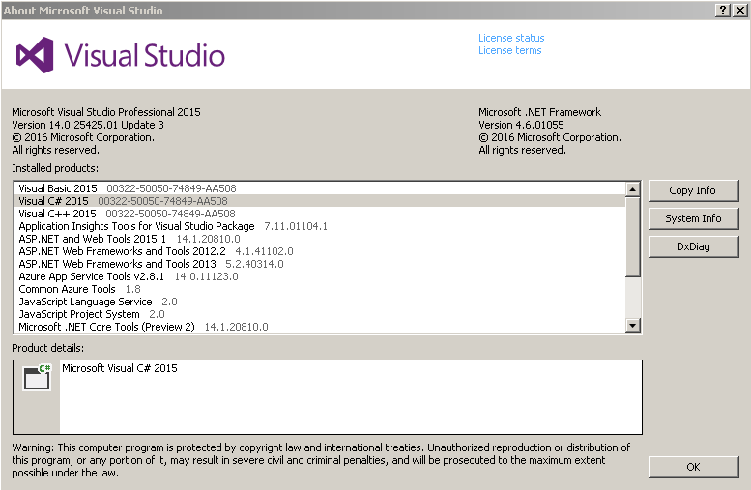

The solution consists of 2 projects. One is console project and another one is unit test project.

1. The console project:

* The main purpose of this project is to print out into the console the requested weather data in the right format for the game from 10 different cities.
* To exit the console, type “exit”, otherwise keeps pressing Enter key will return different data results.
* I could have done it in the web service API way but to keep it simple I decided to go with console project
* There are some assumptions that I have implemented which might not be the reality:
  + Location name, Latitude, Longitude, and elevation are the fixed factors, not something can change over the short time like temperature, pressure, etc.…
  + Latitude, Longitude should be the 2 main parameters to determine almost everything else of the weather data.
  + I have the restriction between the condition and temperature.
    - When the temperature is below 0 degree, the condition should be Snow
    - When the temperature is over 0 degree, the condition can be either Sunny or Rain

I am sure there are lots of rules like above between pressures, elevation, and temperature but in my knowledge, I could only come up with the above restriction.

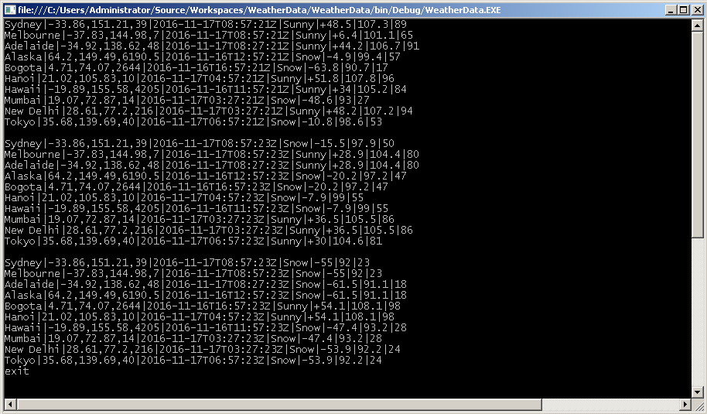

1. The unit testing project

* The main purpose of this project is to test the service functions which returns any data of the weather based on the location

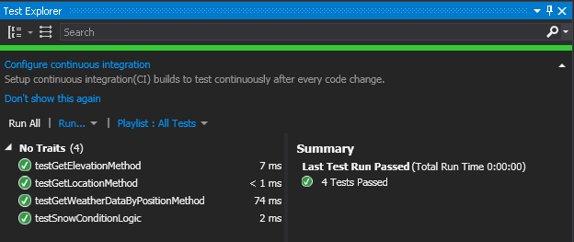

Any questions, feel free to contact me on my mobile 0432 898 289 or via email [Brandon.truong@outlook.com](mailto:Brandon.truong@outlook.com)