

**Beginner – Add/Edit Records**

*How do I enter / view my data?*

To enter or view individual records, you can navigate to the Data Collection section on the left menu bar. Depending on your project type, you will see Survey Distribution Tools, Record Status Dashboard, and Add / Edit Records. To create a new record, click on Add / Edit Records. To update an existing record, you can click on either Add / Edit Records or Record Status Dashboard.

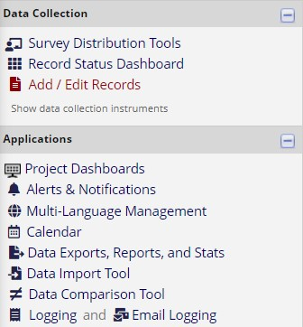

*(Data Collection section of the left-side panel. Depending on your project configurations, your side panel may have different links.)*

**Add / Edit Records**

You may view an existing record/response by selecting it from the drop-down list next to Choose an existing Study ID. To create a new record/response, type a new value in the text box next to Enter a new or existing Study ID and then hit [Tab] or [Enter] (if the project does not have auto-numbering enabled), or by clicking on Add new record (if the project has auto- numbering enabled). To quickly find an existing record without using the dropdowns, the text box will auto-populate with existing record names as you begin to type in it, allowing you to select it (if auto-numbering is not enabled).

