**Codebook - REDCap** – **How-To Guide**

The Codebook is a list of your projects questions and serves as a quick reference for viewing the attributes of any given field in the project without having to download and interpret the Data Dictionary or access the Online Designer. This is particularly helpful when you are in Production mode since the only way you can access an instrument via the Online Designer is by entering into Draft Mode.

Times when it may be helpful to access the Codebook:

* When you are writing conditional logic for an Automated Survey Invitation
* When you are writing calculated fields
* When you are using piping

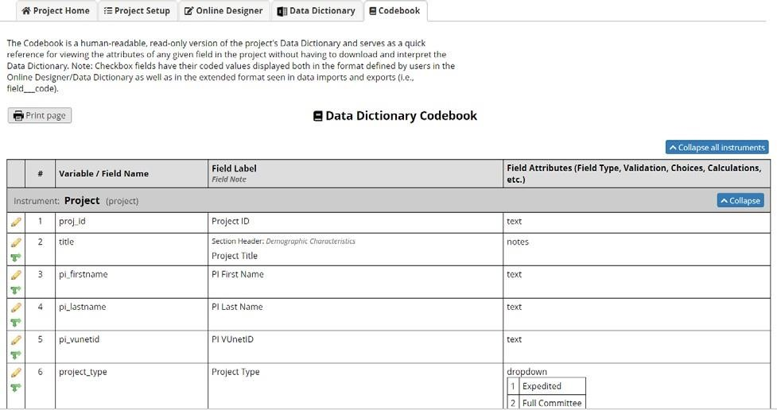

Access

the

codebook

view

by

clicking

the

**Codebook**

button

(

)

on

the

left

-

hand

navigation

bar

Under

Project

Home

and

Design.

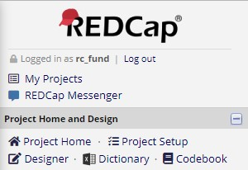

# Collapse/expand instruments in Codebook

If you have multiple instruments and many fields within your project, the Codebook page can be very long. There may be times when you want to only look at the fields for a specific instrument. To condense the page so that you are only viewing the specific instrument you wish to look at, you can use the ‘collapse’ option.

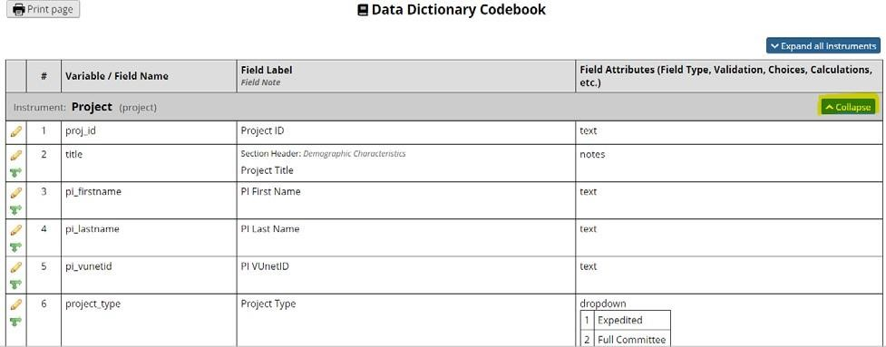

Likewise, when all instruments are collapsed, you can expand them.

